Electronic Supplementary Material

Selective and sensitive ratiometric fluorescent probe for copper(II) cations in an aqueous solution based on resonance energy transfer and «1,8-naphthalimide-styrylpyridine» dyad bearing dipicolylamine receptor
Pavel A. Panchenko ()¹, Marina A. Pavlova¹, Anastasija V. Efremenko², Uliana A. Kutsevalova¹, Maria A. Ustimova¹, Alexey V. Feofanov², Yuri V. Fedorov¹, Olga A. Fedorova¹
1 A. N. Nesmeyanov Institute of Organoelement Compounds of Russian Academy of Sciences (INEOS RAS), 119334 Moscow, Russia
2 Shemyakin-Ovchinnikov Institute of Bioorganic Chemistry of Russian Academy of Sciences, 117997 Moscow, Russia

E-mail: pavel@ineos.ac.ru

CONTENTS

1. Synthesis of the compounds…………………………………………...……...………..…..…S2
2. Theoretical calculation of RET efficiency by the Förster theory......…....…...…..….………..S5
3. Figures S1–S25…….....……………………….……….………….………..…………...…….S6

1. Synthesis of the compounds
The reaction course and purity of the final products was followed by TLC on silica gel (DC-Alufolien Kieselgel 60 F254, Merck). Flash chromatography was carried out using a Biotage IsoleraTM Prime system. Melting points were measured on Melt-temp melting point electrothermal apparatus and were uncorrected. Elemental analysis was conducted on a Carlo Erba 1108 elemental analyzer at the Laboratory of Microanalysis of INEOS RAS. LC-ESI-MS and MALDI-MS analyses were performed in acetonitrile or methanol solutions on a Shimadzu LCMS-2020 liquid chromatography mass spectrometer and a MALDI-TOF Shimadzu AXIMA Confidence mass spectrometer using α-cyano-4-hydroxycinnamic acid (CHCA) as a matrix.
¹H and ¹³C NMR spectra were recorded on an Avance 300, Avance 400 (Bruker) and Inova 400 (Agilent) spectrometers. The NMR chemical shifts (given as δ) were determined with an accuracy of 0.01 ppm relative to the signals corresponding to the residual solvents and recalculated to the internal standard (TMS); the spin-spin coupling constants (J) were measured with an accuracy of 0.1 Hz. The assignment of signals in the NMR spectra of compounds 3, 5 and NI-SP was based on 2D NMR experiments (HMBC, HSQC/HMQC, ¹H COSY), which were performed using standard pulse sequences from the Bruker library. The numbering of atoms in the compounds used by us for the description of ¹H and ¹³C NMR spectra is shown Scheme S1.
Scheme S1. Atom numbering for naphthalimide and styrylpiridine fragments in the NI-SP structure.
Compound 3. A mixture of 1 (0.232 g, 0.76 mmol) and 2 (0.195 g, 0.76 mmol, 1 equiv.) with DIPEA (0.264 ml, 1.51 mmol, 2 equiv.) and CuI (43 mg, 0.23 mmol, 0.3 equiv.) in 33 ml DMF was stirred at 80°C in argon atmosphere for 48 h. Then the solvent was evaporated and crude residue was chromatographed on Al₂O₃ using CH₂Cl₂/MeOH as eluent (gradient elution, v/v from 1:0 to 6:1) to give 0.110 g of product as a light beige solid (yield 26%). M.p. 99 − 100°C. ¹H NMR (300.13 MHz, DMSO-d₆, 21°C, δ / ppm, J / Hz): 0.92 (t, 3H, CH₃ (Bu), J = 7.3), 1.31 ‒ 1.40 (m, 2H, CH₂CH₃), 1.55 ‒ 1.65 (m, 2H, CH₂CH₂CH₃), 2.53 ‒ 2.63 (m, 5H, N⁺CH₂CH₂CH₂, CH₃(Py)), 4.04 (t, 2H, CH₂(CH₂)₂CH₃, J = 7.1), 4.51 (t, 2H, N⁺CH₂CH₂CH₂), J = 6.2), 4.61 (t, 2H, N⁺CH₂CH₂CH₂CH₂, J = 7.8), 5.55 (s, 2H, OCH₂), 7.58 (d, 1H, H (3), J = 8.9), 7.80 − 7.87 (m, 1H, H (6)), 7.98 (d, 2H, H (3’), H (5’)), J = 6.2), 8.41 (s, 1H, CH(triazole)), 8.47 − 8.55 (m, 3H, H (2), H (5), (7)), 8.90 (d, 2H, H (2’), H (6’), J = 6.6). ¹³C ЯМР (100.60 MHz, DMSO-d₆, 18°C, δ / ppm): 13.69 (CH₃ (Bu)), 19.77 (CH₂CH₃), 21.34 (CH₃C₅H₄N), 29.69 (CH₂CH₂CH₃), 30.60 (N⁺CH₂CH₂CH₂), 39.88 (CH₂(CH₂)₂CH₃), 46.48 (N⁺CH₂CH₂CH₂), 57.48 (N⁺CH₂CH₂CH₂), 62.46 (OCH₂), 107.52 (C(3)), 114.61 (C(1)), 121.96 (C(8)), 122.84 (C(4a)), 124.99 (CH(triazole)), 126.47 (C(6)), 128.30 (C(3’), C(5’), C(2) or C(5) or C(7)), 128.61 (C(8a)), 131.10 (C(2) or C(5) or C(7)), 133.05 (C(2) or C(5) or C(7)), 141.95 (C^{IV}(triazole)), 143.88 (C(2’), C(6’)), 158.87 (C(4) or C(4’)), 158.95 (C(4) or C(4’)), 162.87 (C(8b) or C(8c)), 163.51 (C(8b) or C(8c)). ESI-MS in MeCN, m/z, found: 484.30; calculated: 484.23 [C₂₈H₃₀N₅O₃]⁺.
Compound 5. A solution of 1-(3-azidopropyl)-4-methylpyridinium bromide 2 (0.136 g, 0.53 mmol), aldehyde 4 (0.125 g, 0.53 mmol), piperidine (20 μl, 0.21 mmol) in absolute n-butanol was heated at 100°C in a microwave reactor for 3 h. Then the solvent was evaporated and the residue was purified by column chromatography on SiO₂ in the dichloromethane – methanol system using gradient elution (v/v from 1:0 to 4:1). Orange oil, yield 25% (0.07 g). ¹H NMR (400.13 MHz, DMSO-d₆, 20°C, δ / ppm, J / Hz): 2.12 – 2.17 (m, 2H, CH₂CH₂CH₂N₃), 3.46 (t, 2H, CH₂N₃, J = 6.9), 4.48 (t, 2H, CH₂CH₂CH₂N₃, J = 6.9), 4.94 (s, 4H, 2×CH₂N), 6.77 (d, 2H, H(11), H(13), J = 8.8), 7.14 (d, 1H, H(7), J_{trans} = 16.3), 7.27 ‒ 7.33 (m, 4H, 2×H(b), 2×H(c)), 7.50 (d, 2H, H(10), H(14), J = 8.8), 7.76 (t, 2H, 2×H(d), J = 7.5), 7.88 (d, 1H, H(8), J_{trans} = 16.3), 8.05 (d, 2H, H(3), H(5), J = 6.3), 8.57 (d, 2H, 2×H(e), J = 5.0), 8.77 (d, 2H, H(2), H(6), J = 6.3). ¹³С NMR (150.93 MHz, DMSO-d₆, 25°С, δ / ppm): 29.50 (CH₂CH₂CH₂N₃), 47.61 (CH₂N₃), 56.67 (2×NCH₂), 56.92 (CH₂CH₂CH₂N₃), 112.56 (C(11), C(13)), 117.72 (C(7)), 121.23 (2×С(b)), 122.37 (2×C(c)), 122.56 (C(3), C(5)), 123.26 (C(9)), 130.12 (C(10), C(14)), 136.91 (2×С(d)), 141.92 (C(8)), 143.76 (C(2), C(6)), 149.43 (2×C(e)), 150.29 (C(12)), 153.76 (C(4)), 158.15 (2×C(a)). ESI-MS in MeOH, m/z, found: 462.30; calculated: 462.24 [C₂₈H₂₈N₇]⁺. Found (%): C, 61.91; H, 5.25; N, 18.04. C₂₈H₂₈N₇Br. Calculated (%): C, 61.99; H, 5.20; N, 18.07.
Compound NI-SP. A solution of compounds 3 (0.05 g, 0.08 mmol), aldehyde 4 (0.02 g, 0.08 mmol), piperidine (13 μl, 0.1 mmol) in absolute n-butanol was heated at 100°C in a microwave reactor for 4 h. Then the solvent was evaporated and the residue was purified by column chromatography on SiO₂ in the dichloromethane – methanol system using gradient elution (v/v from 1:0 to 4:1). Red oil, yield 33% (0.22 g). ¹H NMR (400.13 MHz, DMSO-d₆, 20°C, δ / ppm, J / Hz): 0.91 (t, 3H, CH₃(Bu), J = 8.8); 1.30 – 1.36 (m, 2H, CH₂CH₃); 1.56 – 1.61 (m, 2H, CH₂CH₂CH₃); 2.52 – 2.54 (m, 2H, CH₂CH₂CH₂N⁺); 4.03 (t, 2H, CH₂(CH₂)₂CH_{3,} J = 7.8); 4.48 – 4.52 (m, 4H, CH₂CH₂CH₂N₃); 4.93 (s, 4H, 2×NCH₂); 5.50 (s, 2H, OCH₂); 6.73 (d, 2H, H(11’), H(13’), J = 8.6); 7.07 (d, 1H, H(7’), J_{trans} = 16.0); 7.27 – 7.33 (m, 4H, 2H(b), 2H(c)); 7.43 (d, 2H, H(10’), H(14’), J = 8.6); 7.52 (d, 1H, (H(3), J = 8.2); 7.73-7.82 (m, 4H, H(6), H(8’), 2H(d)); 7.98 (d, 2H, H(3’), H(5’), J = 6.6); 8.37 (s, 1H, CH(triazole)); 8.46 (d, 1H, H(2), J = 8.2); 8.47 – 8.51 (m, 2H, H(5), H(7)); 8.56 (d, 2H, 2H(e), J = 5.0); 8.69 (d, 2H, H(2’), H(6’), J = 6.6). ¹³С NMR (150.93 MHz, DMSO-d₆, 25°С, δ / ppm): 14.14 (CH₃(Bu)); 20.22 (CH₂CH₃); 30.14 (CH₂CH₂CH₃); 30.86 (CH₂CH₂CH₂N⁺); 39.2 (CH₂(CH₂)₂CH₃); 47.10 (CH₂N⁺); 57.08 (2×NCH₂); 57.31 (CH₂CH₂CH₂N⁺); 62.91(OCH₂); 107.93 (C(3)); 112.93 (C(11’), C(13’)); 115.04 (C(1)); 118.04 (C(7’)); 121.65 (C(8)); 122.38 (C(4a)); 122.85 (2С(b)); 122.93 (C(5’), C(3’)); 123.30 (2C(c)); 123.62 (C(9’)); 125.31 (CH(triazole)); 126.97 (C(6)); 128.75 (C(5)); 129.06 (C(8a)); 130.51 (C(10’), C(14’ )); 131.61 (C(7)); 133.55 (C(2)); 137.37 (2С(d)); 142.30 (C(8’)); 142.50 (C^{IV}(triazole); 144.05 (C(2’), C(6’)); 149.83 (2C(e)); 150.67 (C(12’)); 154.16 (C(4’)); 158.52 (2C(a)); 159.35 (C(4)); 163.39 (C(8b)); 164.03 (C(8c)). ESI-MS in MeOH, m/z, found: 769.35, 385.25; calculated: 769.36 [C₄₇H₄₅N₈O₃]⁺, 385.18 [C₄₇H₄₆N₈O₃]²⁺. Found (%): C, 66.45; H, 5.37; N, 13.17. C₄₇H₄₅N₈O₃Br. Calculated (%): C, 66.43; H, 5.34; N, 13.19.
Mixture of compounds NI-SP, 6 and 7. Method A. A solution of compounds 1 (19 mg, 0.06 mmol), 5 (34 mg, 0.06 mmol), DIPEA (23 μl, 0.129 mmol) and CuI (3.7 mg, 0.019 mmol) in 2.8 ml DMF was stirred at 80 °C in argon atmosphere for 43 h. After solvent evaporating the obtained residue was crystallized from CH₂Cl₂/MeOH mixture to give 8 mg of solid substance, which was identified as a mixture of the target product NI-SP and products of the elimination of one and two picolyl groups 6 and 7. Mass (MALDI) in MeCN, m/z, found: 587.85, 678.96, 770.06; calculated: 587.28 [C₃₅H₃₅N₆O₃]⁺, 678.32 [C₄₁H₄₀N₇O₃]⁺, 769.36 for [C₄₇H₄₅N₈O₃]⁺. Method B. A mixture of 1 (18 mg, 0.06 mmol), 5 (33 mg, 0.06 mmol), sodium ascorbate (3.1 mg, 0.016 mmol) and CuSO₄ (2.6 mg, 0.011 mmol) in 5.0 ml H₂O/CH₂Cl₂ (v/v = 3:7) was kept under vigorous stirring in argon atmosphere for 18 hours at room temperature and then 23 hours at 40˚C. After solvents evaporating the residue was purified by column chromatography on SiO₂ in the dichloromethane – methanol system using gradient elution (v/v from 1:0 to 4:1) to give 24 mg of crude product NI-SP contaminated with products of the elimination of one and two picolyl moieties 6 and 7. ESI-MS in MeCN, m/z, found: 587.30, 678.30, 769.35; calculated: 587.28 [C₃₅H₃₅N₆O₃]⁺, 678.32 [C₄₁H₄₀N₇O₃]⁺, 769.36 [C₄₇H₄₅N₈O₃]⁺.

2. Theoretical calculation of RET efficiency by the Förster theory
Resonance energy transfer efficiencies $Φ_{RET}$ in RET pairs «NI (donor) – SP (acceptor)» and «NI (donor) – (SP)∙Cu²⁺ (acceptor)» were calculated by the Equation (S1)¹
$$Φ_{RET}=\frac{R_{0}^{6}}{R_{0}^{6}+r^{6}} ,$$ | (S1)
where $r$ is the distance between the donor and the acceptor and $R_{0}$ is the critical Förster radius at which 50% of the excited donors deactivate through the RET pathway (i.e. $Φ_{RET}=0.5$). The value r used in the calculations was found from the optimized ground state geometry of NI-SP (r = 16.9 Å, see Fig. S19 and computation details in the figure’s caption), and R₀ (Å) was calculated according to the Equation (S2)¹
$${\text{R}}_{\text{0}}^{\text{6}} \text{=}\text{ 8.79}\text{∙}{10}^{-5}\left[{\text{κ}}^{\text{2}}∙{\text{n}}^{\text{–4}}∙φ_{D,0}^{\text{fl}}∙J(\text{λ})\right] ,$$ | (S2)
where κ² is an orientation factor which depends on the mutual disposition of the donor and acceptor transition dipole moments (taken equal to 2/3 for a random orientation), $φ_{D,0}^{\text{fl}}$is the fluorescence quantum yield of the donor in the absence of the acceptor ($φ^{fl}$ of the compound NI, Table 1), n is the refractive index of the solvent, N_{A} is Avogadro constant and $J(\text{λ})$ is the overlap integral (taken in M^{–1}·cm^{–1}·nm⁴ units) which defines the extent of overlap between the emission spectrum of the donor (F_{D}(λ)) and the absorption spectrum of the acceptor (ε_{A}(λ)). The values $J(\text{λ})$ were calculated according the Equation (S3)¹
$$J\left(\text{λ}\right)={\int_{\text{0}}^{\text{∞}}{{\text{F}}_{\text{D}}\left(\text{λ}\right){\text{ε}}_{\text{A}}\left(\text{λ}\right){\text{λ}}^{\text{4}}\text{dλ}}}/{\int_{\text{0}}^{\text{∞}}{{\text{F}}_{\text{D}}\left(\text{λ}\right)\text{dλ}}} .$$ | (S3)
Calculation results are summarized in Table S1.
Table S1. Characteristics of RET pairs «NI (donor) – SP (acceptor)» and «NI (donor) – (SP)∙Cu²⁺ (acceptor)» in acetonitrile – water mixture (40 vol. % MeCN).
RET pair | $J\left(\text{λ}\right)$ / M^{–1}·cm^{–1}·nm⁴ | $R_{0}$ / $Å$ | $r$ / $Å$ | $$Φ_{RET}$$
«NI (donor) – SP (acceptor)» | 1.15·10¹⁵ | 48.5 | 16.9 | 0.998
«NI (donor) – (SP)∙Cu²⁺ (acceptor)» | 2.56·10¹³ | 25.7 | 16.9 | 0.925

¹J.R. Lakowicz, Principles of fluorescent spectroscopy, Springer Science & Business Media, New York, 2006

3. Figures S1–S25
Figure S1. Fluorescence spectrum of NI-SP (5.6 μM) in acetonitrile – water mixture (40 vol. % MeCN) at pH 6.0 (0.06 M acetate buffer) collected at $λ_{ex}$ = 370 nm (4). Dashed line 3 represents the fitting curve which is a superposition of emission peaks of naphthalimide (1) and styrylpiridinium (2) fragments. The fraction of naphthalimide emission calculated as the ratio of area underneath curve 1 to the area underneath curve 3 is 70%.
Figure S2. MALDI-MS of the mixture of NI-SP, 6 and 7 obtained by the method A.
Figure S3. ¹H NMR spectrum of the mixture of NI-SP, 6 and 7 obtained by the method B in DMSO-d₆. Possible positions of proton signals of compound 6 and 7 are marked with the spot.
Figure S4. ESI-MS of the mixture of NI-SP, 6 and 7 obtained by the method B.
Figure S5. ¹H NMR spectrum of compound 3 in DMSO-d₆.
Figure S6. ¹³C NMR spectrum of compound 3 in DMSO-d₆.
Figure S7. ESI-MS of compound 3 in MeCN.
Figure S8. ¹H NMR spectrum of compound 5 in DMSO-d₆.
Figure S9. ¹³C NMR spectrum of compound 5 in DMSO-d₆.
Figure S10. ESI-MS of compound 5 in MeOH.
Figure S11. ¹H NMR spectrum of compound NI-SP in DMSO-d₆.
Figure S12. ¹³C NMR spectrum of compound NI-SP in DMSO-d₆.
Figure S13. ESI-MS of compound NI-SP in MeOH.

Figure S14. Absorption (a) and fluorescence (b) spectrum of compound SP (10.0 μM) in aqueous HEPES buffer (0.01 M) at different pH values and the plot of the fluorescence intensity at 590 nm versus pH (c). Excitation wavelength 440 nm.

Figure S15. Fluorescence spectrum of SP (10.0 μM) in acetonitrile – water mixture (40 vol. % MeCN) at pH 6.0 (0.06 M acetate buffer) upon gradual addition of copper (II) perchlorate. The insert shows zoomed area of the graph and the SP spectrum in the presence of 20 equiv. Cu²⁺. Excitation wavelength 380 nm.
Figure S16. Absorption (a) and normalized fluorescence (b) spectrum of compound NI (4.0 μM) in acetonitrile – water mixture (40 vol. % MeCN) at pH 6.0 (0.06 M acetate buffer). Excitation wavelength 370 nm.
Figure S17. Changes in the fluorescence spectrum of compound NI-SP (5.6 μM) in acetonitrile – water mixture (40 vol. % MeCN) at pH 6.0 (0.06 M acetate buffer) upon addition of copper (II) perchlorate collected at 370 nm (a) and 464 nm (b) excitation wavelength. The ratio of fluorescence intensities I₄₆₀ / I₆₀₀ is increased 4.8 times (a). The ratio I₅₂₀ / I₆₀₀ is increased 7.7 times (b).
Figure S18. Overlap between the normalized emission spectrum of NI (1) and absorption spectra of SP (2) and (SP)·Cu²⁺ (3) in acetonitrile – water mixture (40 vol. % MeCN) at pH 6.0 (0.06 M acetate buffer). Excitation wavelength 370 nm. Absorption spectrum (SP)·Cu²⁺ corresponds to the spectrum of ligand SP collected in the presence of 15 equiv. Cu²⁺.
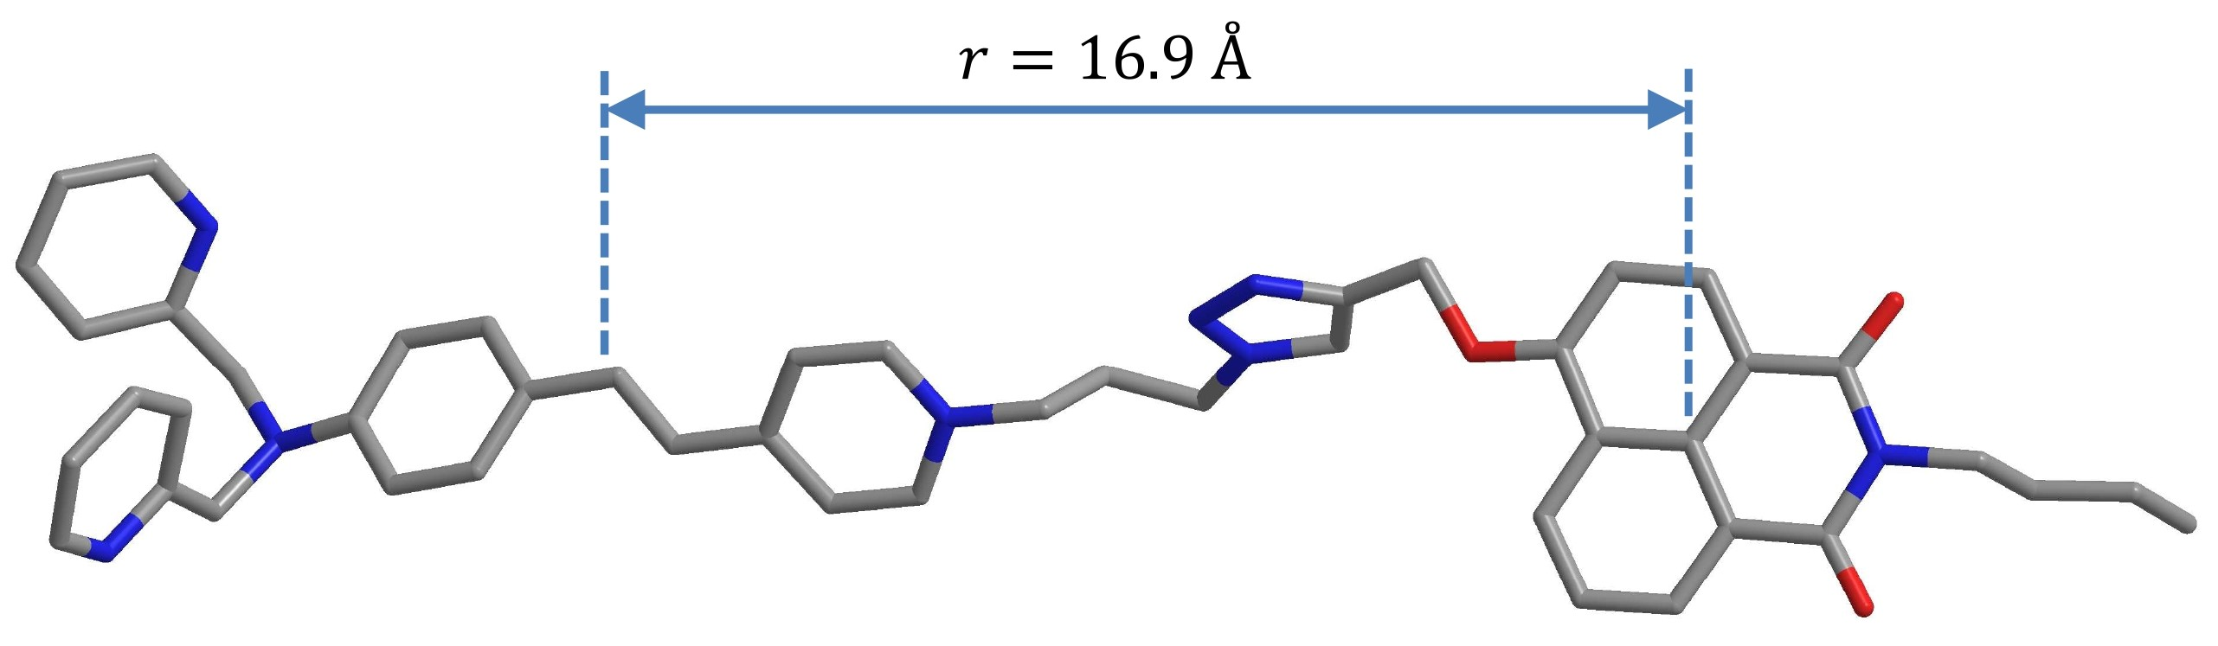
Figure S19. Optimized ground state geometry of NI-SP. The three dimentional structure of NI-SP was obtained with MOPAC 2016 program package using PM6 semiempirical method². The solvent effect was included in geometry optimizations following the «COnductorlike Screening Model» (COSMO) implemented in MOPAC. A dielectric constant of ε = 80 and a refraction index of solvent (n) such that n² = 2 were used.
Figure S20. Ratio of fluorescence intensity at 460 nm to that at 600 nm (R) upon alternant addition of Cu(ClO₄)₂ and EDTA to the solution of probe NI-SP (10.0 μM) in MeCN – H₂O mixture (40 vol. % MeCN) at pH 5.9 (0.06 M acetate buffer). Excitation wavelength 405 nm. 1 – free ligand NI-SP, 2 – 3 equiv. Cu²⁺ added, 3 – 5 equiv. EDTA added, 4 – 6 equiv. Cu²⁺ added, 5 – 9 equiv. EDTA added, 6 – 10 equiv. Cu²⁺ added, 7 – 15 equiv. EDTA added.
Figure S21. Plot of the ratio of fluorescence intensity at 460 nm to that at 600 nm (R) of compound NI-SP (10.0 μM) versus pH in the absence and presence of 10 equiv. Cu²⁺ in acetonitrile – water mixture (40 vol. % MeCN). Excitation wavelength 405 nm.

²J. Mol. Model. 13 (2007) 1173–1213.
Figure S22. Absorption (a) and fluorescence (b) spectra of compound NI-SP (10.0 μM) in the absence and presence of Cu(ClO₄)₂ in MeCN – H₂O mixture (40 vol. % MeCN). Before the addition of Cu²⁺, pH was 7.9 (HEPES buffer). Excitation wavelength 405 nm.
Figure S23. Absorption (a) and fluorescence (b) spectra of compound SP (10.0 μM) in the absence and presence of Cu(ClO₄)₂ in MeCN – H₂O mixture (40 vol. % MeCN). Before the addition of Cu²⁺, pH was 7.9 (HEPES buffer). Excitation wavelength 405 nm.

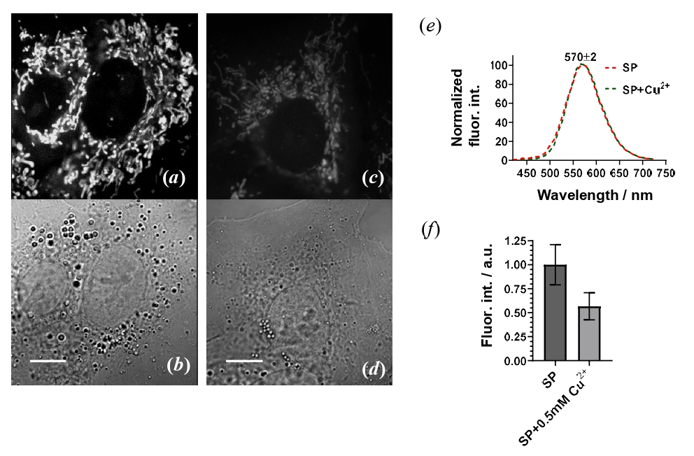
Figure S24. Confocal fluorescent images of SP in the absence (a) and presence (b) of Cu²⁺ in A549 cells. (a, c) – Intracellular distribution of NI-SP. (b, d) – Images of cells in transmitted light. The cells were incubated with 5 µM SP for 30 min (a, b) or incubated with 0.5 mM Cu(ClO₄)₂ (1 h), washed twice with Hanks' solution and incubated with 5 µM SP (30min) (c, d). Fluorescence was excited at 405 nm and was recorded in the range 420 – 730 nm. The scale label is 10 µm. (e) – Normalized intracellular fluorescence spectra of SP in the absence and presence of Cu²⁺. (f) – A histogram of the average values of fluorescence intensities of SP in the absence and presence of Cu²⁺. The results were obtained and averaged over 35 – 40 cells in each sample group.
Figure S25. Absorption (a) and fluorescence (b) spectra of compound NI-SP (10.0 μM) in glycerol – water mixtures with various concentrations of glycerol (mass. %). Excitation wavelength 405 nm.

