Electronic Supplementary Material
Density functional theory study on the selective oxidation of ethylene glycol to glycolic acid over Pt_{n} (n = 4–55) clusters
Shiping Wu^{1,2}, Yanhong Quan^{1,2}, Jun Ren ()^{1,2}
1 State Key Laboratory of Clean and Efficient Coal Utilization, Taiyuan University of Technology, Taiyuan 030024, China
2 College of Chemistry and Chemical Engineering, Taiyuan University of Technology, Taiyuan 030024, China

E-mail: renjun@tyut.edu.cn
- For reproducibility, CIF files of the optimized geometries were provided and were presented in the terms of the linked files, as follow:
(a)
(b)
(c)
(d)
- The most stable adsorption configurations along with their corresponding energies of reactants, possible intermediates and products on the Pt_{n} (n=4-55) clusters
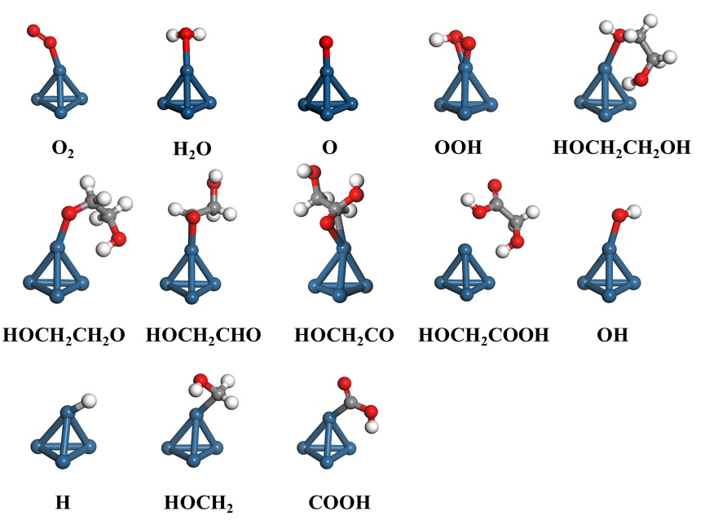
Fig. S1 Adsorbed configurations of all possible species involved in GA formation on Pt₄ clustre surface. Color-coding: C, grey; Pt, blue; O, red; H, white.
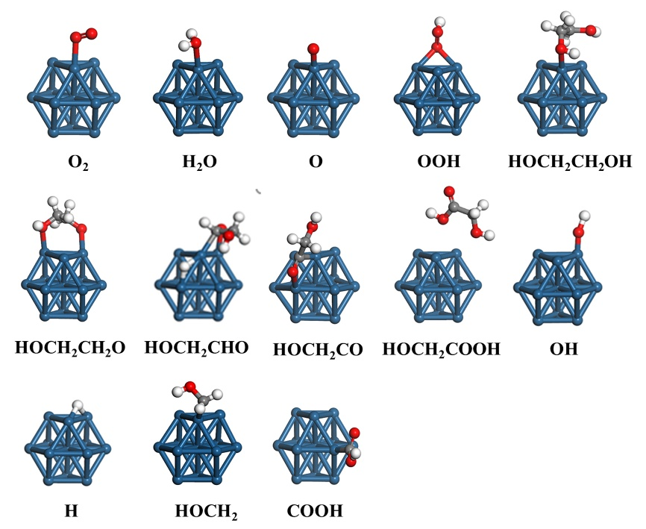
Fig. S2 Adsorbed configurations of all possible species involved in GA formation on Pt₁₃ clustre surface. Color-coding: C, grey; Pt, blue; O, red; H, white.
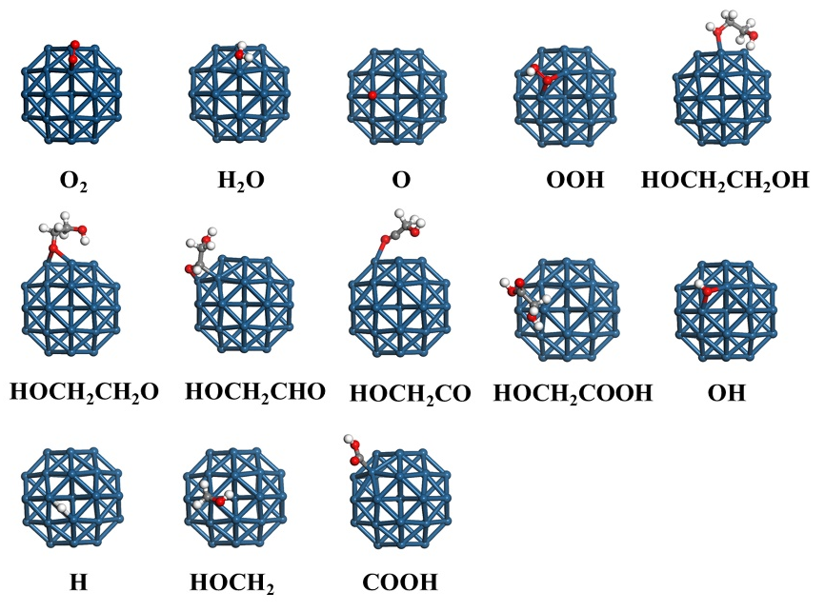
Fig. S3 Adsorbed configurations of all possible species involved in GA formation on Pt₃₈ clustre surface. Color-coding: C, grey; Pt, blue; O, red; H, white.
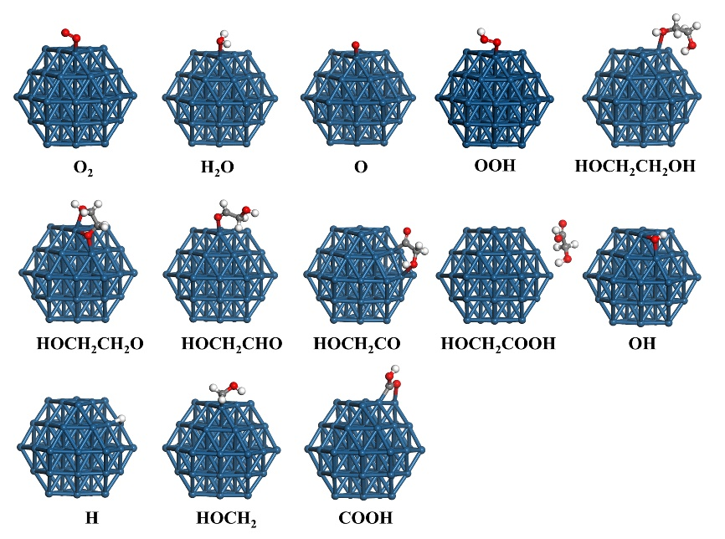
Fig. S4 Adsorbed configurations of all possible species involved in GA formation on Pt₅₅ clustre surface. Color-coding: C, grey; Pt, blue; O, red; H, white

Table S1 Adsorption energies (E_{ads}, kJ/mol) of species involved in GA formation on Pt₄, Pt₁₃, Pt₃₈, Pt₅₅ cluster and Pt(111) surfaces.
Species | Pt₄ |  | Pt₁₃ |  | Pt₃₈ |  | Pt₅₅ |  | Pt(111)
Species | Sites | E_{ads} | Sites | E_{ads} | Sites | E_{ads} | Sites | E_{ads} | Sites | E_{ads}
O₂* | Top | -157.5 | Top | -258.2 | Top-I | -145.4 | Top-I | -85.4 | Top | -42.0
O* | Top | -499.2 | Top | -403.4 | Top-I | -601.4 | Top-I | -399.7 | Hcp | -338.0
H₂O* | Top | -88.8 | Top | -63.4 | - | -33.7 | Top-I | -54.3 | Top | -46.0
OOH* | Top | -216.6 | Bri | -187.9 | Top-I | -123.3 | Bri-II | -181.4 | Top | -109.9
OH* | Top | -296.5 | Top | -344.0 | Bri-I | -300.7 | Bri-II | -298.7 | Top | -213.1
H* | Top | -340.1 | Top | -361.5 | Bri-I | -296.2 | Bri-I | -298.6 | Fcc | -271.5
HOCH₂CH₂OH | Top | -120.3 | Top | -160.5 | Top-I | -95.7 | Top-I | -108.5 | Top | -64.4
HOCH₂CH₂O | Top | -317.7 | Top | -364.6 | Bri-I | -262.2 | Top-I, Bri-II | -267.4 | Top | -184.8
HOCH₂CHO | Top | -177.8 | Top | -219.8 | Top-I, Top-II | -132.0 | Top-I | -99.1 | Top | -60.3
HOCH₂CO | Top | -348.2 | Top | -336.7 | Top-II | -106.8 | Top-I, Top-II | -307.3 | Top | -280.8
HOCH₂COOH | Top | -96.4 | - | -65.9 | - | -65.9 | - | -67.2 | - | -30.4
HOCH₂ | Top | -282.5 | Top | -324.9 | Top-I | -269.3 | Top-I | -273.1 | Top | -228.1
COOH | Top | -331.3 | Top | -334.1 | Top-II | -277.6 | Top-I | -302.2 | Top | -242.1

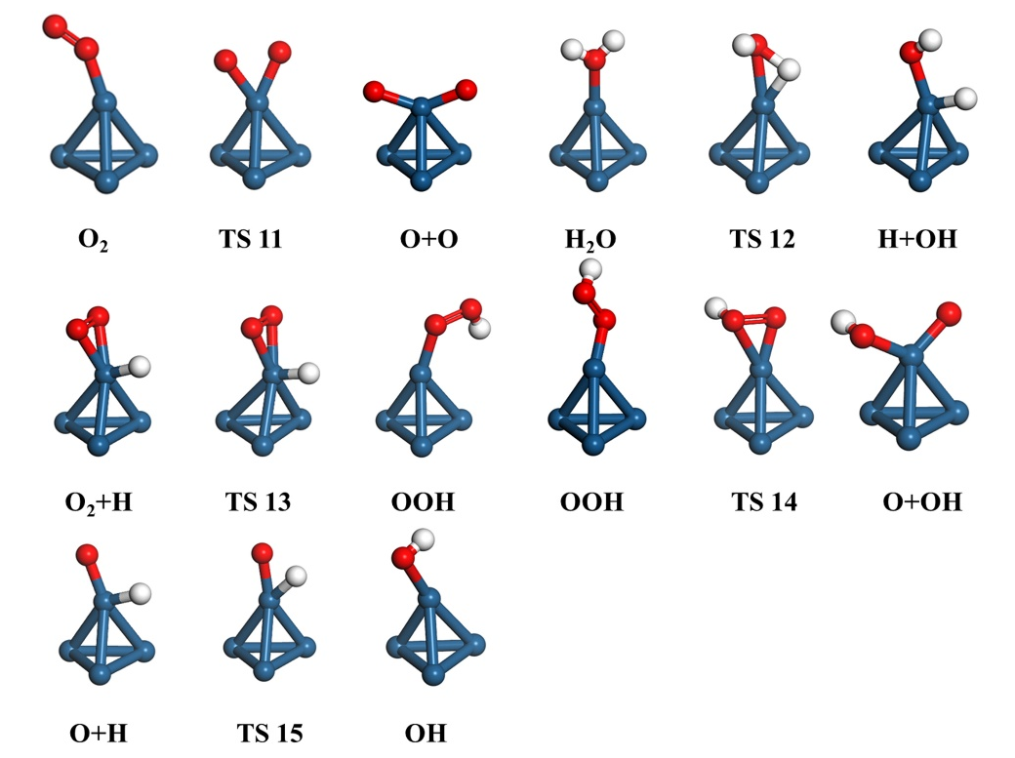
Fig. S5 Side views of the initial states, transition states, and final states involved in O₂ activation (R1-R5) over Pt₄ surface
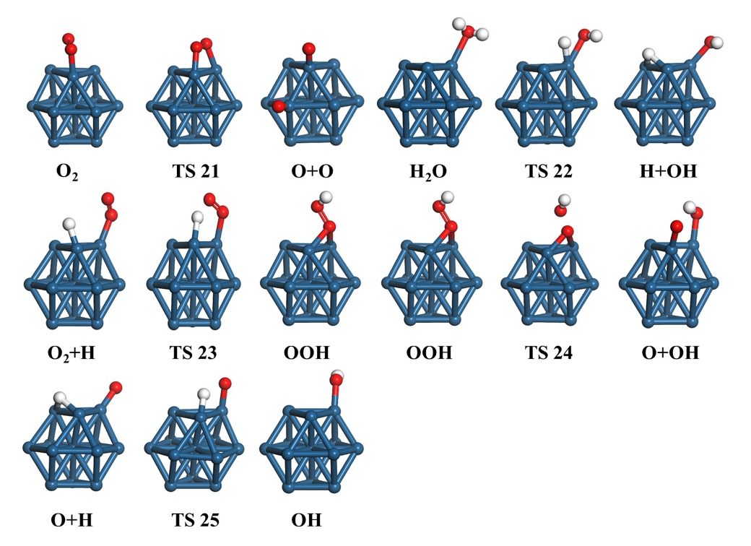
Fig. S6 Side views of the initial states, transition states, and final states involved in O₂ activation (R1-R5) over Pt₁₃ surface
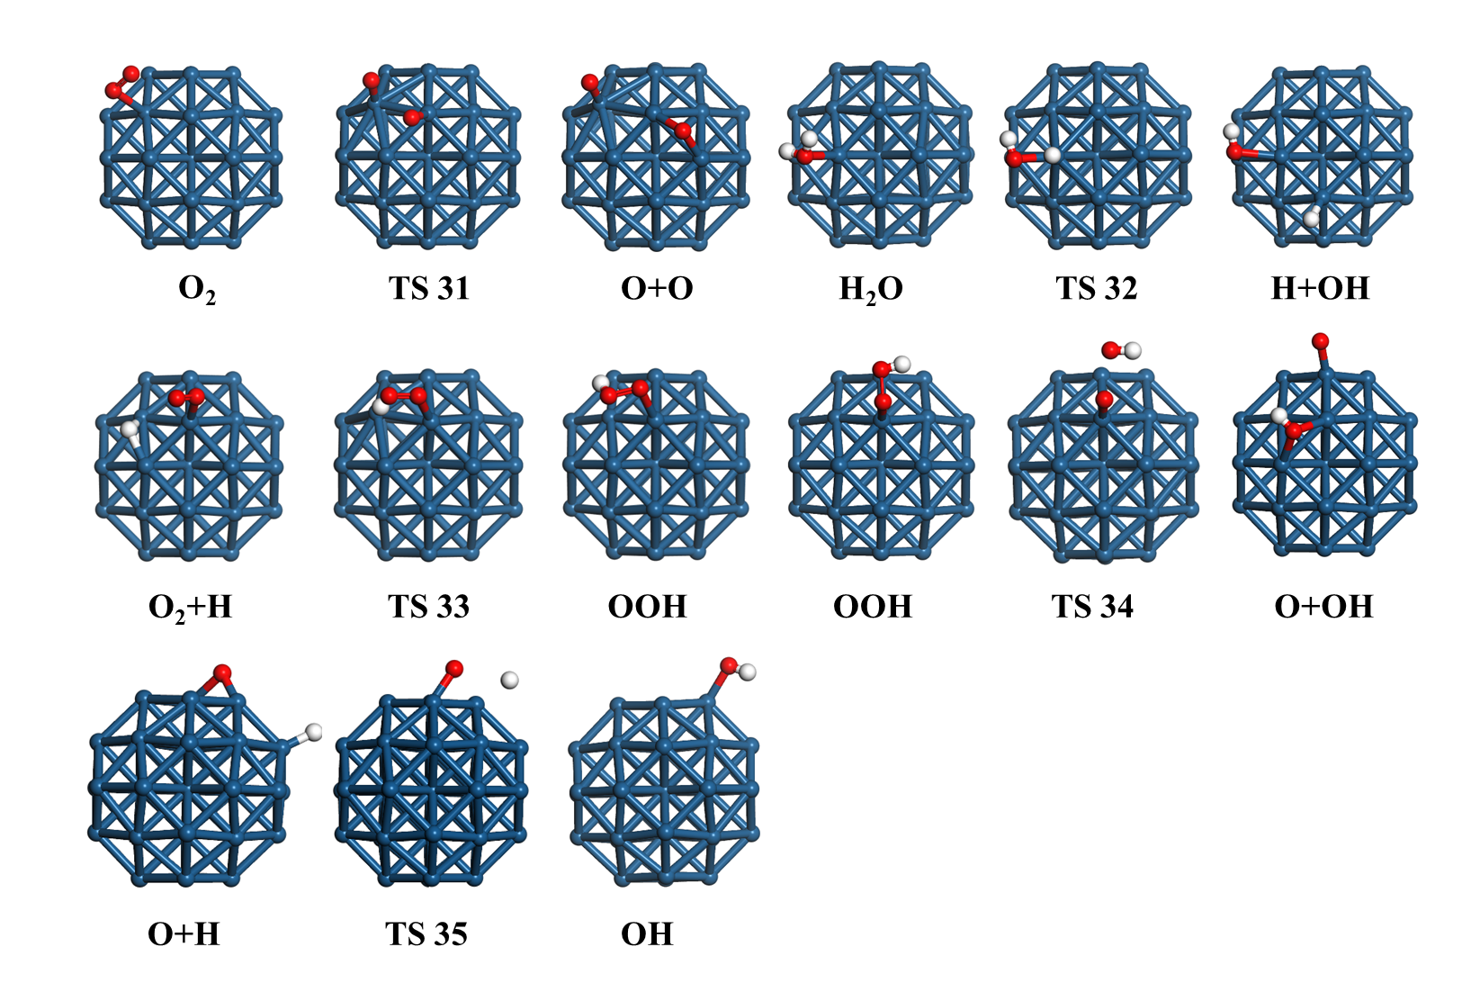
Fig. S7 Side views of the initial states, transition states, and final states involved in O₂ activation (R1-R5) over Pt₃₈ surface
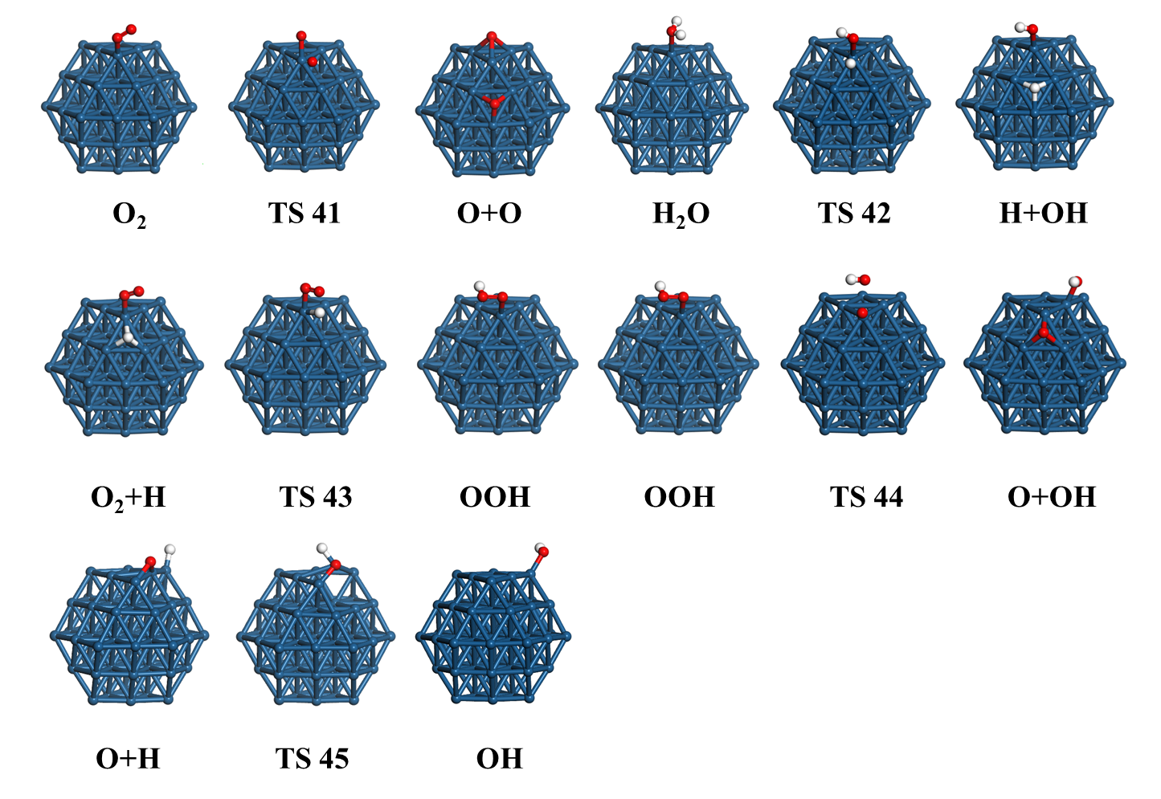
Fig. S8 Side views of the initial states, transition states, and final states involved in O₂ activation (R1-R5) over Pt₅₅ surface
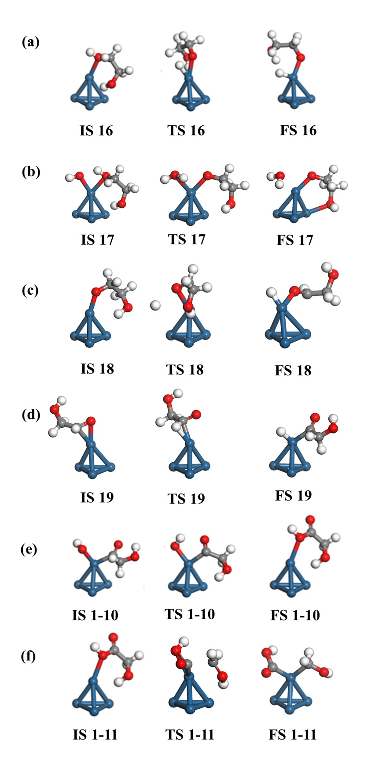
Fig. S9 Side views of the initial states, transition states, and final states involved in selective oxidation of EG to GA (R6-R7-11) over Pt₄ surface
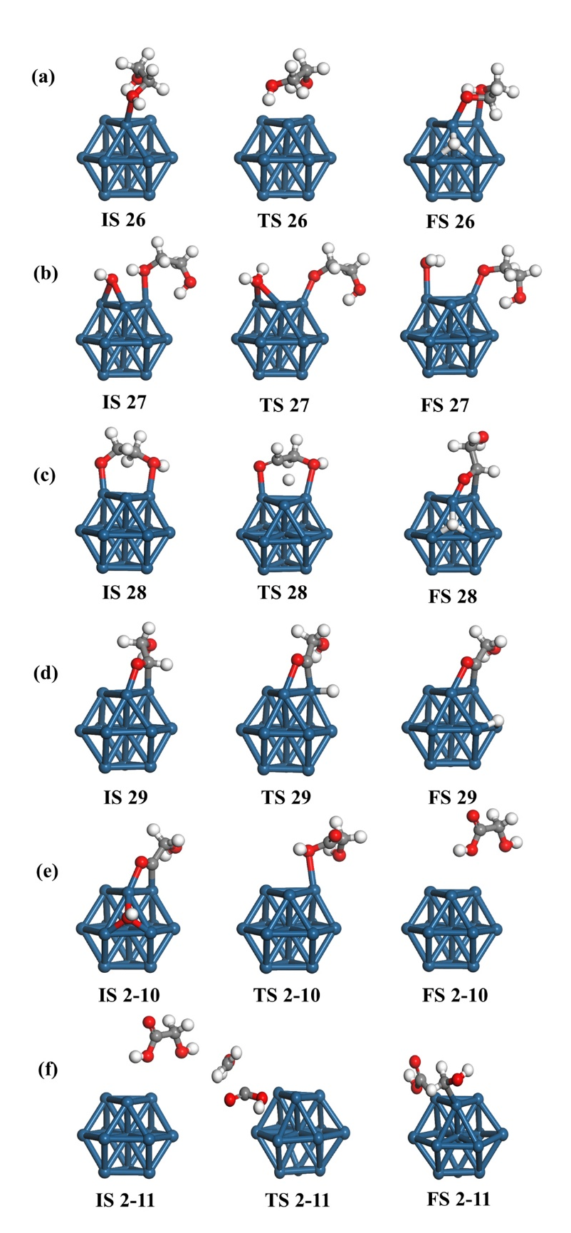
Fig. S10 Side views of the initial states, transition states, and final states involved in selective oxidation of EG to GA (R6-R11) over Pt₁₃ surface
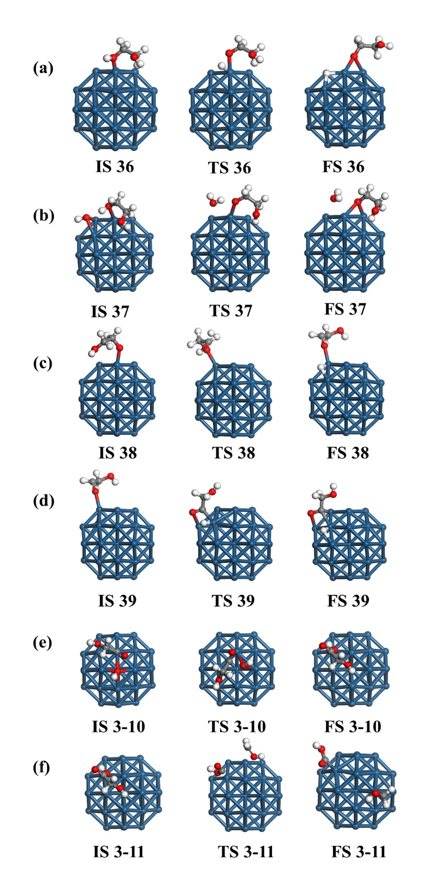
Fig. S11 Side views of the initial states, transition states, and final states involved in selective oxidation of EG to GA (R6-R11) over Pt₃₈ surface
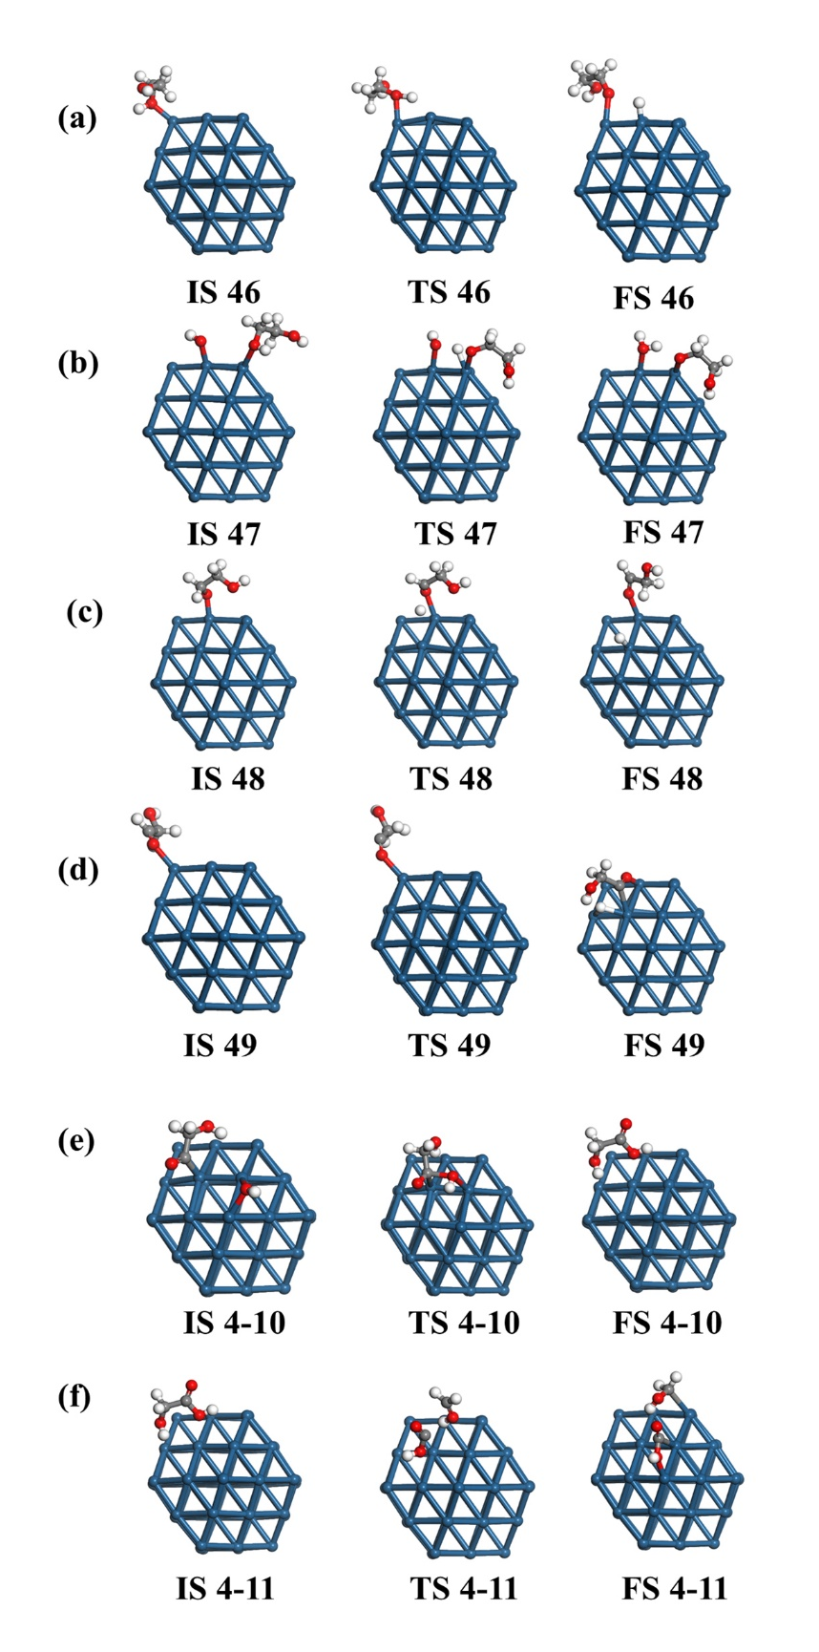
Fig. S12 Side views of the initial states, transition states, and final states involved in selective oxidation of EG to GA (R6-R11) over Pt₅₅ surface.
- Pt(111) slab model
Pt(111) surface was constructed using a p(4 × 4) slab containing four layers with 16 atoms per layer, which was companied with the vacuum thickness of 15 Å. The two bottom Pt (111) layers were fixed, while the other layers were fully relaxed. Furthermore, the surfaces of the Pt(111) with their possible adsorption sites are shown in Figure S13.
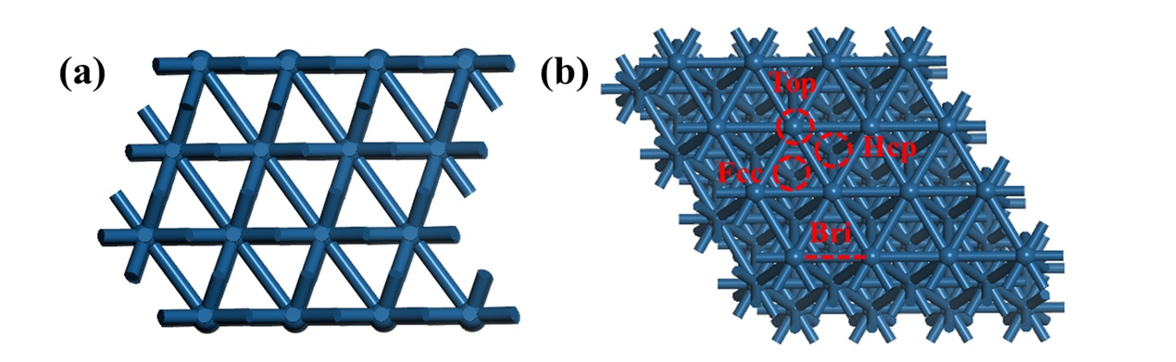
Fig. S13 (a) Top and (b) side views of the slab model of Pt(111)
The most stable adsorption configurations of the reactants, potential intermediates, and products on the Pt(111) surface are illustrated from Figure S14, with the associated adsorption sites and energies compiled in Table S1.
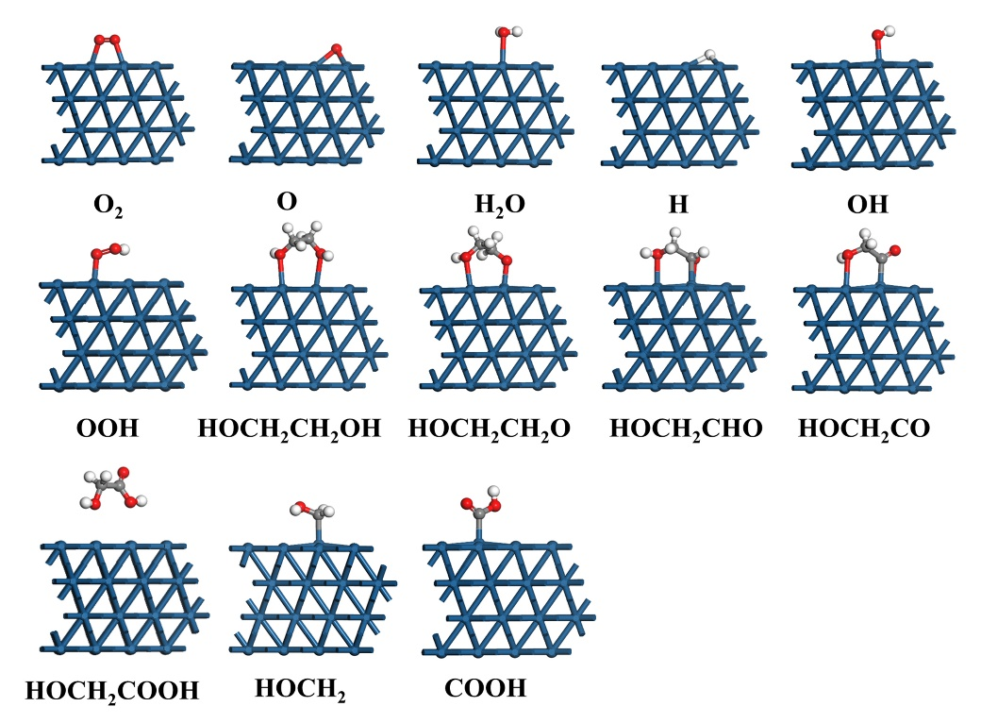
Fig. S14 Adsorbed configurations of all possible species involved in GA formation on Pt(111) surface. Color-coding: C, grey; Pt, blue; O, red; H, white.
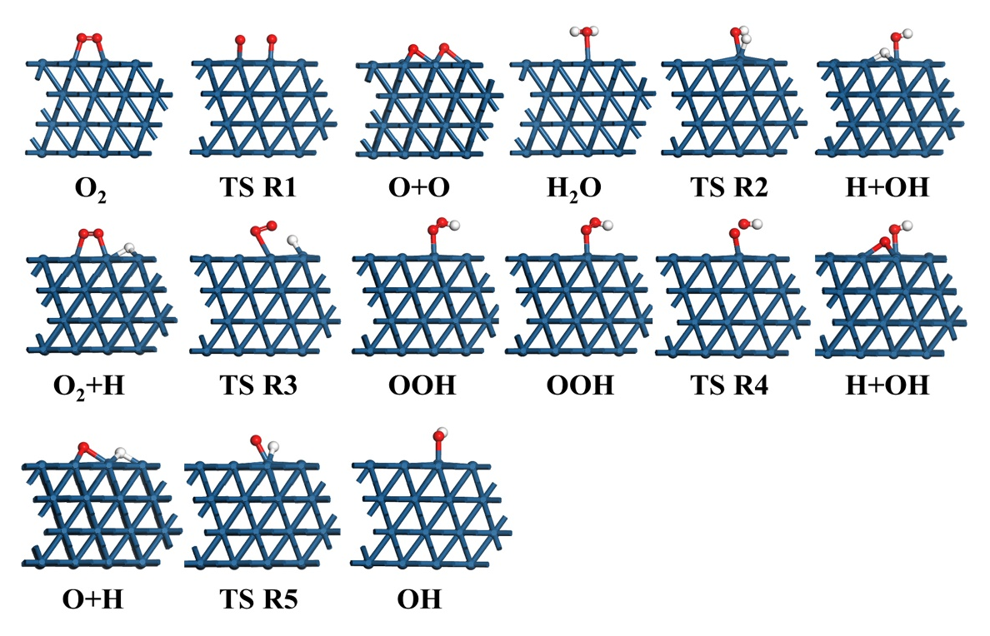
Fig. S15 Side views of the initial states, transition states, and final states involved in O₂ activation
(R1-R5) over Pt(111) surface
Table S2 Energy barrier E_{a} (kJ∙mol⁻¹) and reaction energies ∆H (kJ∙mol⁻¹) of GA formation on Pt(111) surface
Elementary step | Pt(111)
Elementary step | TS | E_{a} | ∆H
R1 | TS R1 | 129.9 | -14.9
R2 | TS R2 | 196.8 | -86.0
R3 | TS R3 | 125.3 | -20.6
R4 | TS R4 | 28.0 | -24.8
R5 | TS R5 | 142.9 | -79.5
R6 | TS R6 | 59.5 | 50.5
R7 | TS R7 | 63.1 | 52.9
R8 | TS R8 | 307.2 | 62.0
R9 | TS R9 | 56.3 | -27.3
R10 | TS R10 | 107.3 | -185.2
R11 | TS R11 | 262.9 | -22.9
On the Pt(111) surface (Figure S15), the O₂ molecule undergoes direct dissociation via the transition state TSR1, resulting in 129.9 kJ·mol⁻¹, and an exothermic energy of 14.9 kJ∙mol⁻¹. Then, the dissociated two O atoms are adsorbed on the Fcc sites. Meanwhile, O₂ and H react to produce OOH via the transition state TSR3, resulting in a reaction barrier of 125.3 kJ∙mol⁻¹ and an exothermic energy of 20.6 kJ∙mol⁻¹ on the Pt(111) surface. Subsequently, the formed OOH is adsorbed onto the Top site.
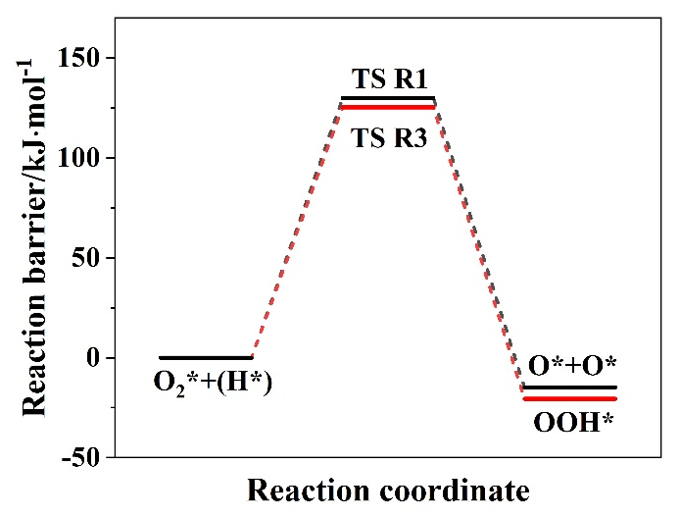
Fig. S16 The potential energy diagram of O₂ activation on the Pt(111) surface.
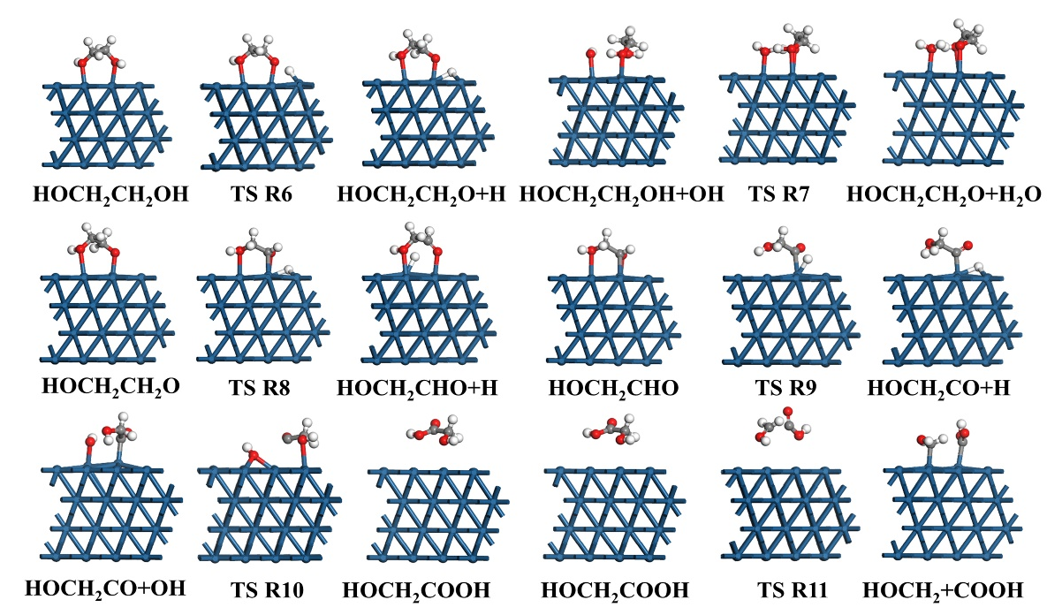
Fig. S17 Side views of the initial states, transition states, and final states involved in selective oxidation of EG to GA (R6-R11) over Pt(111) surface
Obviously, EG dehydrogenation to HOCH₂CH₂O via a transition state TSR6 and the activation energy of R6 on Pt(111) surface is 59.5 kJ∙mol⁻¹, which are significantly lower than that of R7 (63.1 kJ∙mol⁻¹), which indicates that HOCH₂CH₂O is more readily produced through the direct dehydrogenation of EG.
Subsequently, when HOCH₂CH₂O dehydrogenates to generate HOCH₂CHO, the optimized co-adsorption configuration of H and HOCH₂CHO, in conjunction with the most stable adsorption configuration of HOCH₂CH₂O, was chosen to investigate the transition state. On the Pt(111) surface, the dehydrogenation of HOCH₂CH₂O to form HOCH₂CHO occurs via the TSR8, with activation barrier and reaction energy of 307.2 and 62.0 kJ∙mol⁻¹, respectively. Then, the dissociated H atom and HOCH₂CHO are adsorbed on the Fcc and Top sites, respectively.
To study the dehydrogenation of HOCH₂CHO to HOCH₂CO, the optimized co-adsorption configuration of H and HOCH₂CO, along with the most stable adsorption configurations of HOCH₂CHO were selected for transition state search. On the Pt(111) surface, the dehydrogenation of HOCH₂CHO occurs through TSR9, where the C-H bond cleavage has an activation barrier of 56.3 kJ∙mol⁻¹ and is exothermic by 27.3 kJ∙mol⁻¹, which is followed by the adsorption of the dissociated H atom and HOCH₂CO on the Fcc and Top sites, respectively. It should be noted that the activation barrier for the HOCH₂CHO dehydrogenation is lower than its adsorption energy (60.3 kJ∙mol⁻¹), indicating that HOCH₂CHO favors dehydrogenation rather than desorption on the Pt(111) surface.
Starting from the HOCH₂CO intermediate, the reaction of HOCH₂CO with OH to form GA via the transition state TS10 requires activation barrier and reaction energies of 107.3 and -185.2 kJ∙mol⁻¹ on the Pt(111) surface, respectively. In addition, HOCH₂ and COOH are formed by the C-C cleavage of GA through TS11 with activation barrier and reaction energies of 262.9 and -229 kJ∙mol⁻¹, respectively, and then they are both adsorbed on the Top sites. Significantly, the activation barrier of C-C cleavage of GA is higher than its desorption energy (30.4 kJ∙mol⁻¹), suggesting that GA is more likely to desorb than to undergo oxidation on the Pt(111) surface.

