Electronic Supplementary Material
Zr-modified LiMn₂O₄-based film electrode with enhanced electrical conductivity and structural stability for electrochemical lithium extraction from brine lakes
Peng Li¹*, Yongzhen Ma²*, Wenbiao Ma¹, Yingjie Liu², Xiaowei An³, Jin Chang¹, Zheng Zhang ()², Xiaogang Hao ()⁴
¹College of Energy Science and Engineering, Taiyuan University of Science and Technology, Taiyuan 030024, China
² College of Chemical Engineering and Technology, Taiyuan University of Science and Technology, Taiyuan 030024, China
³College of Environmental Science and Engineering, Taiyuan University of Technology, Taiyuan 030024, China
⁴College of Chemistry and Chemical Engineering, Taiyuan University of Technology, Taiyuan 030024, China
E-mails: zhangzheng@tyust.edu.cn (Zhang Z); xghao@tyut.edu.cn (Hao X)
* These authors contributed equally to this work.
Materials and reagents
The chemicals and materials used in this study include Li₂CO₃, MnCO₃, C₆H₈O₇·H₂O, BiOCl, ZrO₂ and polyvinylidene fluoride (PVDF), polyacrylic acid (PAA), N-methylpyrrolidone (NMP), conductive carbon black, H₂SO₄ (98%), anhydrous ethanol, LiCl, MgCl₂, Na₂SO₄, graphite plate. All other reagents were obtained from Shanghai Aladdin Industrial Corporation (China). All reagents were analytically pure, except for specifically labeled substances, and solutions were prepared using deionized water.
Physical characterizations
Scanning electron microscope (SEM, JSM-7900F, JEOL, Japan)、Field emission transmission electron microscope (TEM, JEM-F200, JEOL, Japan) and X-ray diffractometer (XRD, Smartlab SE, Japan) were used to analyze the morphology, composition, and crystalline structure of the prepared material. The elemental contents of the material were tested by EDS (STEM, JEOL-2300, JEOL, Japan). Inductively coupled plasma (ICP-OES, Agilent 7800MS, USA). X-ray photoelectron spectroscopy (XPS, Thermo Scientific K-Alpha, USA) was used to further analyze the elemental composition and valence states of the material surface before and after doping. An atomic absorption spectrophotometer (TAS-990, China) was applied to detect the concentrations metal ions in solution. Water contact angle of the electroactive film coated electrode was examined by a contact angle goniometer (SL200B, USA).
Electrochemical characterizations
CV was performed within a potential range of 0.3-1.1 V in a 0.1 M LiCl solution. The obtained electrode was used as the working electrode, and Ag/AgCl/saturated MCl and Platinum foil were applied as the reference and counter electrodes, respectively. EIS was performed within a frequency range of 0.01 Hz to 0.1 MHz in a 0.1 M LiCl solution at 0.05V. GCD tests (LMO/LZMO) was performed within a frequency range of 0.3V to 1.1 V in a 0.1 M LiCl solution. GCD tests were performed at a current density of 0.1 A.g⁻¹. GCD tests (BiOCl) was performed within a potential range of -0.6-1.0 V in a 0.1 M LiCl solution. The obtained electrode was used as the working electrode, and Ag/AgCl/saturated MCl and Platinum foil were applied as the reference and counter electrodes, respectively. GCD tests were performed at a current density of 0.1 A.g⁻¹.
Electrochemically switched ion exchange system
The electrochemically switched ion exchange (ESIX) system has two main components: the feed solution (FS) and the recovery solution (RS). Working electrodes and counter electrodes were placed inside both chambers as counter electrodes.
(1) Parameter optimization
In this experimental section, the FS was filled with a 100 ppm Li⁺ solution, while the RS contained a 0.1 M Na₂SO₄ solution. After 20 cycles, the changes in Li⁺ concentration in both chambers were compared across different membrane electrodes and operating conditions. A potential of -1.0 V was applied to the membrane in step (i), and a potential of 1.0 V was applied in step (ii) to facilitate continuous ion transmission (noted as ±1.0 V). Due to measurement errors in the initial concentration of the solution, we normalized the data to allow for a more intuitive comparison of changes in Li⁺ concentration.
(2) Selectivity experiments
The FS contains a mixed solution of two different cations, the FS was replaced by a real brine, and the RS is filled with LiCl with a Li⁺ concentration of 100 mg. L⁻¹.
(3) Stability experiments
The obtained electrode was utilized as the working electrode, while an Ag/AgCl/saturated KCl electrode served as the reference electrode and platinum sheet was employed as the counter electrode. The FS contains a mixed solution of two different cations, the FS was replaced by a real brine, and the RS is filled with LiCl with a Li⁺ concentration of 100 mg. L⁻¹.
Detailed DFT calculation data and analysis procedures
Structural optimization, a crucial step in density functional theory (DFT) computations, involves minimizing system energy through atomic coordinate adjustments to identify the most stable ground state configuration of the material. In this investigation, geometric optimization was performed on pure-phase LiMn₂O₄, yielding lattice parameters of a=b=8.15 Å and c=8.70 Å. The computed results aligned with other reported values. Furthermore, between the two doped systems, the energy of the Mn⁴⁺ doped system was approximately 2.78 eV lower than that of the Mn³⁺ doped system, suggesting enhanced stability of the lattice structure at the Mn⁴⁺ site following Zr doping. Detailed lattice parameters are listed in Table S2.
The cyclic voltammetry (CV) curves were evaluated for materials with varying doping ratios in a 0.1 M LiCl solution at a scan rate of 0.5 mV/s. The electrochemical performance of the membrane materials was compared based on parameters such as peak current, peak area, and peak position to identify the most suitable doping ratio. Fig. S1 depicts the CV curves for all doped materials. Among different doping ratios, LZMO-x exhibits distinctive biphasic characteristics, suggesting a crystal structure and Li⁺ intercalation/deintercalation mechanism akin to LiMn₂O₄. For doping ratios below 0.03, both peak current and area exhibit an increment with doping, whereas they decline as the ratio exceeds this threshold. LZMO-0.03 displays the highest peak current and area, indicating remarkable symmetry, implying enhanced electrochemical intercalation capacity for Li⁺, improved lithium storage capability, and favorable reversible reaction behavior. Consequently, LZMO-0.03 is identified as the optimal doping ratio material.
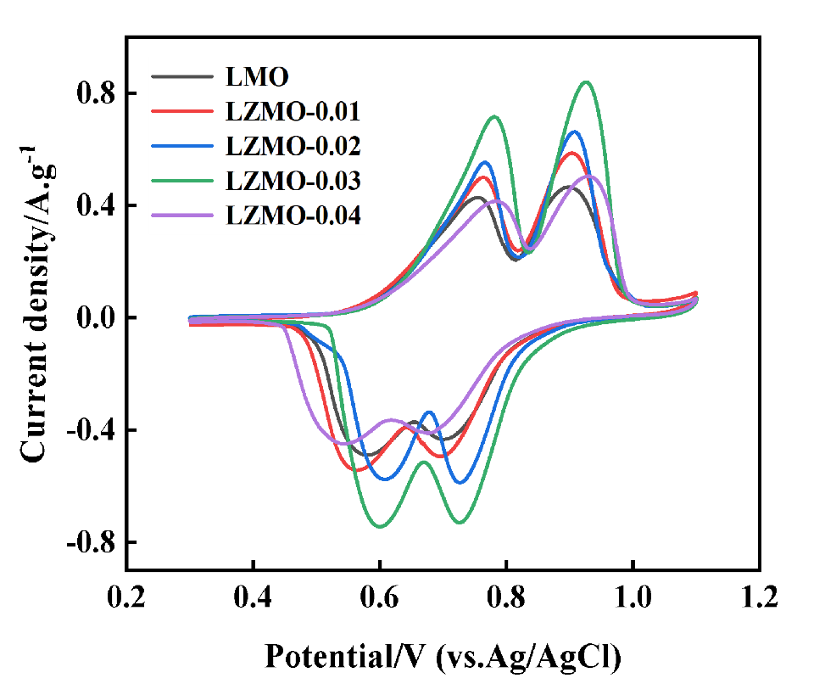
Fig. S1. CV curves of LZMO-x measured in 0.1 M LiCl solution at a scan rate of 0.5 mV.s⁻¹.
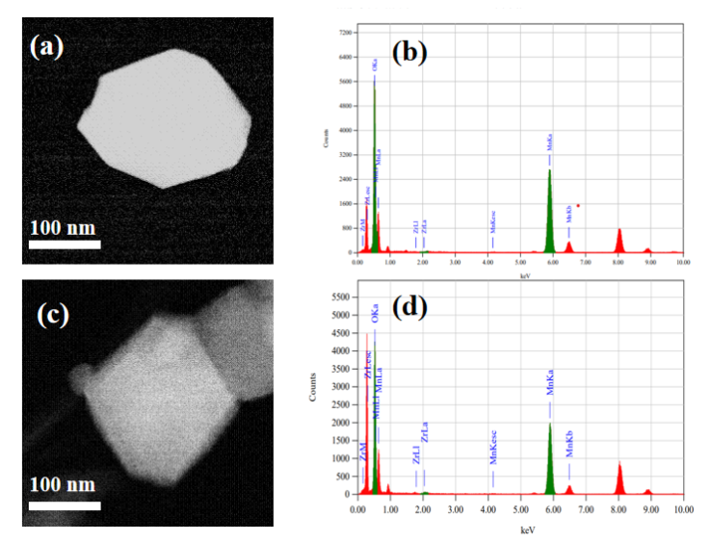
Fig. S2. EDS mappings of (a, b) LMO and (c, d) LZMO-0.03.
The fitted Zr 3d spectrum verifies the incorporation of tetravalent Zr⁴⁺ into the spinel framework. Substitution by high-valence Zr⁴⁺ raises the average Mn oxidation state, strengthens Mn-O linkage and restrains manganese leaching, thereby improving structural stability^{[1]}. The O 1s profile remains nearly unchanged after doping, demonstrating preservation of the intrinsic oxygen coordination environment of the pristine lattice.
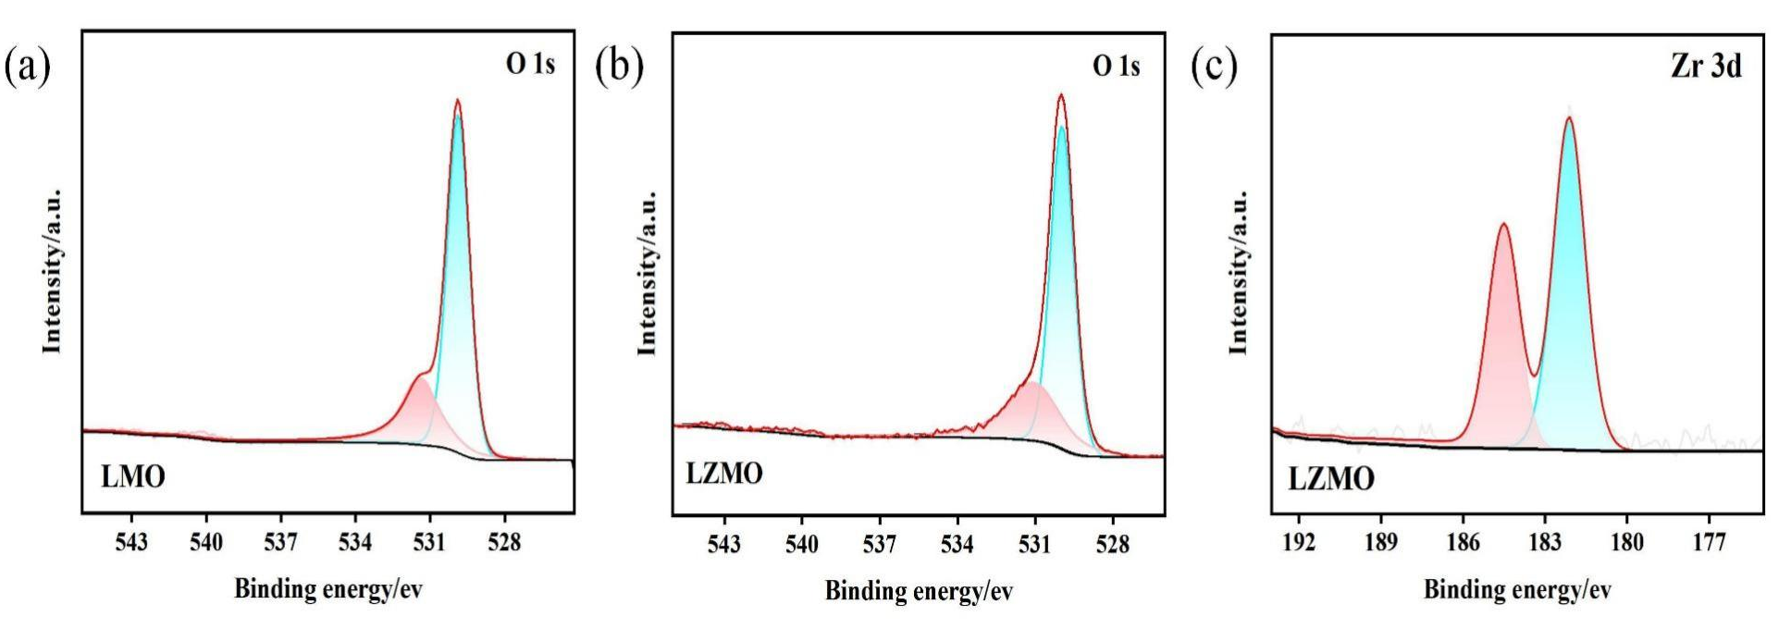
Fig. S3. High-resolution XPS O 1s spectra of (a) LMO and (b) Zr-doped LZMO; (c) Zr 3d XPS spectrum of LZMO.
High-resolution XPS analysis of the LZMO-0.03 membrane electrode reveals a direct correlation between Mn redox chemistry and Li⁺ intercalation/deintercalation via charge compensation. In the oxidized state, the near-disappearance of the Mn³⁺ peak alongside a marked increase in Mn⁴⁺ signal confirms the oxidation of Mn³⁺ to Mn⁴⁺, which coincides with a significant decrease in the Li 1s peak intensity, indicating Li⁺ extraction. Conversely, in the reduced state, the re-emergence of the Mn³⁺ peak signifies the reduction of Mn⁴⁺ back to Mn³⁺, a process accompanied by a pronounced increase in the Li 1s signal that confirms Li⁺ re-insertion into the electrode structure. The Li 1s/Mn 3p overlapping region exhibits distinct shifts during oxidation/reduction processes: the peak shift toward higher binding energy in the oxidation state (top) and lower binding energy in the reduction state (bottom) confirms the reversible Li⁺ intercalation/deintercalation behavior. For LZMO-0.03, the smaller peak shift amplitude implies that Zr modified reduces the lattice strain during Li⁺ migration, further contributing to cyclic stability.
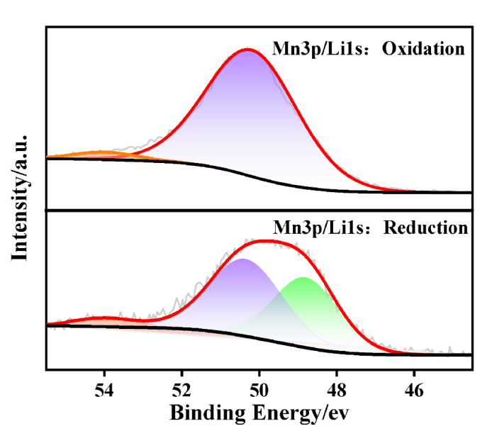
Fig. S4. High-resolution XPS spectrum of Mn 3p/Li 1s for LZMO-0.03.
Fig. S5 presented the total density of states (TDOS) for the LiMn₂O₄ and Zr-modified LMO systems. As shown in Fig. S5, the electronic density of states of the Zr- modified LMO system shifts predominantly toward lower energy levels compared with that of pristine LMO, which is attributed to the fact that Zr atoms with lower electronegativity substitute for partial Mn atoms and tend to donate electrons to Mn ions. Furthermore, the spin-down electronic states of Zr-modified LMO cross the Fermi level, endowing the doped system with metallic properties. This alteration facilitates the excitation and transition of electrons within the downward spin channel, thereby significantly enhancing the system's electronic conductivity. This optimization at the electronic structure level aligns closely with the observed reduction in charge transfer resistance (Rct) from electrochemical impedance spectroscopy (EIS) tests. The enhanced conductivity accelerates interfacial charge transfer kinetics, lowers the electron transport energy barrier at the electrode-electrolyte interface, and manifests as decreased charge transfer resistance.
Fig. S5. Density of states (DOS) calculation for LMO and LZMO.
As Fig. S6(a): BiOCl maintains symmetric charge-discharge profiles and reaction reversibility in both pure LiCl and real brine, with a slightly lower specific capacity in brine from elevated solution resistance induced by impurity ions. Specifically, we conducted GCD characterization after 20 intercalation-deintercalation cycles, with the corresponding curves shown in Fig. S6b. The results show that the BiOCl electrode undergoes capacity fading during prolonged cycling, with a capacity retention of approximately 86.7% after 20 cycles.
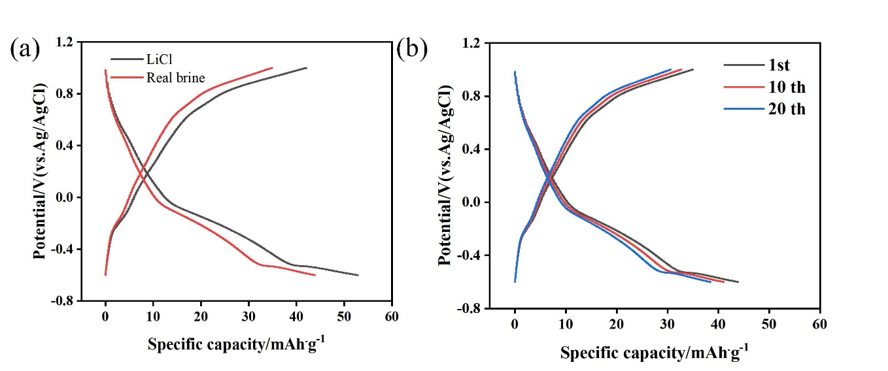
Fig. S6. GCD curves of the optimized BiOCl film electrode. (a)curves measured in pure LiCl solution and real salt lake brine; (b) curves recorded after 20 intercalation-deintercalation cycles
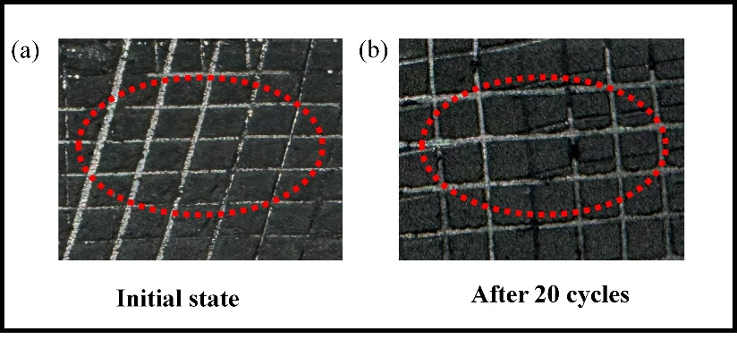
Fig. S7 Digital photographs of LZMO electrodes after the cross cut tape test

Fig. S8. SEM images of LZMO-0.03 cross-sectional SEM images of the film electrode.
An investigation was conducted to ascertain the impact of varying drive modes on the electrolytic lithium extraction performance of the ESIX separation device. This investigation led to the optimization of the device's lithium-ion extraction efficiency. Constant voltage drive has been identified as the predominant drive mode in the field of electrochemical lithium-ion capture research. Consequently, the voltage remains constant while the current gradually decreases over time, resulting in a progressively reduced lithium extraction rate. Conversely, adopting a constant-current drive mode facilitates expeditious and effective lithium capture by establishing an appropriate current value. However, during constant-current operation, the voltage gradually increases despite the constant current, and excessively high voltages can readily induce side reactions in the system. In light of these considerations, the present work proposes a coupled constant-current-constant-voltage drive strategy. The specific operation procedure is as follows: Initially, the system operates in constant-current mode, during which the voltage gradually increases over time. Upon attaining a voltage of 1 V, the constant-current phase is terminated (to circumvent side reactions), and the circuit transitions to constant-voltage drive mode. In constant voltage drive mode, the voltage value remains constant while the current value gradually decreases over time and approaches equilibrium at 120 minutes. When the constant current values are set at 0.5 mA, the current remains constant while the voltage continues to increase over time. The system's inability to attain a constant voltage phase within 120 minutes signifies that, in both instances, the current density remains comparatively low and the voltage growth rate is gradual. When utilizing 1.0 mA-1 V and 1.5 mA-1 V, respectively, the duration of the constant current phase undergoes a progressive reduction (from approximately 96 minutes to approximately 39 minutes), while the duration of the constant voltage phase undergoes a progressive increase (from approximately 24 minutes to approximately 81 minutes).
Fig. S9. The potential and current curves in constant current-constant voltage driving mode.
Table S1. Content of each element measured by EDS mappings.
Material | Element | Mass % | Atomic %
LMO | Zr
LMO | Mn | 50.66 | 23.02
LMO | O | 49.34 | 76.95
LZMO-0.03 | Zr | 0.04 | 0.12
LZMO-0.03 | Mn | 66.44 | 36.48
LZMO-0.03 | O | 33.52 | 63.40
Table S2. DFT calculations of lattice parameters of different models.
Bulk | a | b | c
LiMn₂O₄(Li₈Mn₁₆O₃₂) | 8.15 Å | 8.15 Å | 8.70 Å
Zr (III)-LiMn₂O₄(Zr₁Li₈Mn₁₅O₃₂) | 8.21 Å | 8.21 | 8.76 Å
Zr (IV)-LiMn₂O₄(Zr₁Li₈Mn₁₅O₃₂) | 8.21 Å | 8.19 Å | 8.75 Å
Table S3. Bader charge populations of Mn and O sites for bare LMO and LZMO obtained via DFT calculations.
Materials | Bader charge
Materials | Mn | O
LiMn₂O₄ | 1.727 | -1.108
Zr-LiMn₂O₄ | 1.751 | -1.122

Table S4. Content of each element measured by XPS.
Material | Name | Atomic %
LMO | Zr 3d
LMO | Li 1s | 20.53
LMO | Mn 2p | 20.69
LMO | O 1s | 58.78
LZMO-0.03 | Zr 3d | 0.53
LZMO-0.03 | Li 1s | 20.03
LZMO-0.03 | Mn 2p | 18.35
LZMO-0.03 | O 1s | 61.09
Table S5. Binding energies of LMO and LZMO-0.03 in XPS.
Material | Mn 2p_{1/2} | Mn 2p_{1/2} | Mn 2p_{3/2} | Mn 2p_{3/2}
LMO- Initial | 654.13 | 652.02 | 642.41 | 641.30
LMO-after | 654.24 | 652.88 | 642.38 | 641.05
LZMO-0.03-initial | 654.61 | 652.99 | 642.10 | 641.65
LZMO-0.03-after | 654.38 | 652.94 | 642.73 | 641.27

Table S6. Comparison of EIS Parameters of LMO and LZMO-0.03
Material | Rs(Ω) | Rct(Ω)
LMO | 24.76 | 43.25
LZMO-0.03 | 24.52 | 34.07
Table S7. The average diffusion coefficients for Li⁺ in LMO and LZMO-0.03.
D_{Li}⁺(cm²⋅s⁻¹) | Ox₁ | Ox₂ | Red₁ | Red₂ | Average
LMO | 22.92 × 10⁻¹¹ | 4.85 × 10⁻¹² | 1.16 × 10⁻¹² | 0.22× 10⁻¹² | 7.29×10⁻¹²
LZMO-0.03 | 7.50 × 10⁻¹¹ | 10.30 × 10⁻¹¹ | 8.03 × 10⁻¹¹ | 7.80 × 10⁻¹¹ | 8.41 × 10⁻¹¹
Table S8. The manganese loss ratio of LMO and LZMO-0.03.
Cycle number | LMO | LZMO-0.03
1 | 0.12 | 0.03
10 | 0.55 | 0.32
20 | 0.85 | 0.45
Table S9. Comparison of this work with modified-LMO materials in Simulated brine.
Working  electrode | Li⁺ Capacity  (mg⋅g⁻¹) | Feed  solution | Energy  consumption  (Wh$·$mol⁻¹) | Ref.
LMO | 15 mg/g | West Taijinar, | 7.42 Wh/mol | [2]
Cr-LMO | 21.8 mg | Jieze Chaka | 4.68 Wh/mol | [3]
Ce-LMO | 17.11 mg/g | simulated brine | 10.1 Wh/mol | [4]
In-LMO | 20.18 mg/g | simulated brine | 5.39 Wh/mol | [5]
CoV-LMO | 18.7 mg/g | simulated brine | 8.51 Wh/mol | [6]
NiCo-LMO | 12.91 mg/g | 30 mM LiCl | 3.97 Wh/mol | [7]
Al-LMO | 21.7 mg/g | simulated brine | 2.6 Wh/mol | [8]
LZMO | 22.16 mg/g | real brine | 3.61 Wh/mol | This  paper
References:
- Yan G, Wang M, Hill GT, Zou S, Liu C. Defining the challenges of Li extraction with olivine host: the roles of competitor and spectator ions, PNAS 119 (31) (2022)2200751119, https://doi.org/10.1073/pnas.2200751119
- Xu W, He L, Zhao Z. Lithium extraction from high Mg/Li brine via electrochemical intercalation/de-intercalation system using LiMn₂O₄ materials. Desalination, 2021, 503: 114935. https://doi.org/10.1016/j.desal.2021.114935
- Tian G, Gao J, Wang M, Wen X, Liu Y, Xiang J, Zhang L, Cheng P, Zhang J, Tang N. Structural stabilization of Cr-doped spinel LiMn₂O₄ for long-term lithium extraction from high Mg/Li brine. Journal of Materials Chemistry A, 2023, 11: 143361. https://doi.org/10.1039/D3TA01234A
- Luo G, Li X, Chen L, Zhang Y, Gu J, Chao Y, Zhu W, Liu Z, Xu C. Island-like CeO₂ decorated LiMn₂O₄: surface modification enhancing electrochemical lithium extraction and cycle performance. Chemical Engineering Journal, 2023, 455: 140928. https://doi.org/10.1016/j.cej.2022.140928
- Chen L, Fan L, Lan D, Gu J, Xiaojun C, Ji H, Chao Y, Wu P, Zhu W. In₂O₃ modification mitigates Jahn-Teller effect in LiMn₂O₄ enhancing lithium extraction efficiency and stability. Chemical Engineering Journal, 2025, 505: 159815. https://doi.org/10.1016/j.cej.2025.159815
- Mojtahedi B, Askari M, Dolati A, Shahcheraghi N, Ghorbanzadeh M. Enhanced Cycling Performance of LiMn₂O₄ Electrode Including Cobalt and Vanadium Codoping for Lithium Extraction from Brine. Energy & Fuels, 2024, 38: 19878–19889. https://doi.org/10.1021/acs.energyfuels.4c03409
- Wu Y, Shi P, Zhong Y, Cai R. Improved Performance of a Ni, Co-Doped LiMn₂O₄ Electrode for Lithium Extraction from Brine. Energy & Fuels, 2023, 37: 4083–4093. https://doi.org/10.1021/acs.energyfuels.2c04113
- Tan G, Wan S, Chen J, Yu H, Yu Y. Reduced Lattice Constant in Al-Doped LiMn₂O₄ Nanoparticles for Boosted Electrochemical Lithium Extraction. Advanced Materials, 2024, 36: 2310657. https://doi.org/10.1002/adma.202310657

