Electronic Supplementary Material

Effect of binder addition on combustion characteristics of cotton straw pellets and kinetic analysis
Yiwen Dai¹*, Bin Guan¹*, Xingxiang Wang¹, Jinli Zhang^{1,2}, Bin Dai¹, Jiangbing Li ()¹, Jichang Liu¹
1 School of Chemistry and Chemical Engineering/State Key Laboratory Incubation Base for Green Processing of Chemical Engineering, Shihezi University, Shihezi 832003, China
2 School of Chemical Engineering and Technology, Tianjin University, Tianjin 300350, China
* These authors contributed equally.
E-mail: ljbing@126.com

Fig.S1. Diagram of single column molding device
Fig. S2. Influence of Diameter of raw material on physical quality characteristics of biomass molding particles: (a) Forming density; (b) Compressive strength; (c) Hydrophobicity; (d) Energy density
Fig. S3. Influence of moisture content on physical quality characteristics of biomass forming particles: (a) Forming density; (b) Compressive strength; (c) Hydrophobicity ; (d) Energy density
Fig. S4. Influence of temperature on physical quality characteristics of biomass forming particles : (a) Forming density; (b) Compressive strength; (c) Hydrophobicity; (d) Energy density

Fig. S5. Influence of molding pressure on physical quality characteristics of biomass forming particles : (a)Forming density; (b) Compressive strength; (c) Hydrophobicity; (d) Energy density
Fig. S6. Influence of molding time on physical quality characteristics of biomass forming particles : (a)Forming density; (b) Compressive strength; (c) Hydrophobicity; (d) Energy density

Tab. S1 Level table of factors
Level | Factor
Level | A Temperature（℃） | B Moisture（%） | C Diameter（mm） | D Pressure  （kN）
1 | 120 | 5 | 0~0.5 | 6.5
2 | 140 | 10 | 0.5~1 | 7
3 | 160 | 15 | 1~1.5 | 7.5

Tab. S2 Orthogonal experiment design and results of L9（34）
Number | A | B | C | D | Experimental result
 |  |  |  |  | ρ  （g·cm⁻³） | Compressive strength（N·mm⁻¹） | Hydrophobicity（%） | Energy density (kJ·cm⁻³)
1 | 120 | 5 | 6.5 | 0~0.5 | 1.245 | 94.323 | 9.774 | 22.225
2 | 120 | 10 | 7 | 0.5~1 | 1.119 | 48.779 | 2.252 | 19.970
3 | 120 | 15 | 7.5 | 1~1.5 | 0.880 | 34.611 | 2.217 | 15.665
4 | 140 | 5 | 7 | 1~1.5 | 1.174 | 115.553 | 9.219 | 20.954
5 | 140 | 10 | 7.5 | 0~0.5 | 1.271 | 113.269 | 3.506 | 22.708
6 | 140 | 15 | 6.5 | 0.5~1 | 0.998 | 80.578 | 3.753 | 17.783
7 | 160 | 5 | 7.5 | 0.5~1 | 1.189 | 108.785 | 11.292 | 21.229
8 | 160 | 10 | 6.5 | 1~1.5 | 1.113 | 86.929 | 7.309 | 19.848
9 | 160 | 15 | 7 | 0~0.5 | 1.173 | 82.117 | 5.572 | 20.936

Tab. S3 Orthogonal experimental analysis of L9（34）
ρ |  |  | A | B | C | D
ρ | K1 |  | 3.244 | 3.608 | 3.355 | 3.689
ρ | K2 |  | 3.443 | 3.503 | 3.466 | 3.307
ρ | K3 |  | 3.475 | 3.051 | 3.341 | 3.167
ρ | Optimal decision |  | B₁D₁A₃C₂
Compressive strength |  |  | A | B | C | D
Compressive strength | K1 |  | 177.713 | 318.660 | 261.830 | 289.709
Compressive strength | K2 |  | 309.399 | 248.977 | 246.449 | 238.141
Compressive strength | K3 |  | 277.831 | 197.306 | 256.665 | 237.093
Compressive strength | Optimal decision |  | A2B1D1C3
Hydrophobicity |  |  | A | B | C | D
Hydrophobicity | K1 |  | 14.243 | 30.285 | 20.836 | 18.851
Hydrophobicity | K2 |  | 16.477 | 13.067 | 17.043 | 17.297
Hydrophobicity | K3 |  | 24.173 | 11.541 | 17.014 | 18.744
Hydrophobicity | Optimal decision |  | B1A3C2D1
Energy density |  |  | A | B | C | D
Energy density | K1 |  | 57.860 | 64.409 | 59.856 | 65.869
Energy density | K2 |  | 61.445 | 62.526 | 61.860 | 58.982
Energy density | K3 |  | 62.013 | 54.383 | 59.602 | 56.467
Energy density | Optimal decision |  | B1D1A3C2
Optimal decision |  | B₁A₃D₁C₂ (0–0.5mm, 5%(wt), 160℃, 7 kN, 60s)
Fig. S7. Effects of CG and PE addition on the physical properties of molded particles:
(a) Forming density; (b) Compressive strength; (c) Hydrophobicity; (d) Energy density
Fig. S8. (CG: PE=1:1) Effects of addition on physical properties of formed particles:
(a) Forming density; (b) Compressive strenghth; (c) Hydrophobicity;(d) Energy density
Fig. S9. Effects of adding different proportions of composite waste binder on the physical properties of formed particles: (a) Forming density; (b) Compressive strenghth; (c) Hydrophobicity;(d) Energy density
Fig. S10. Schematic diagram of ignition and burnout temperature
Fig. S11 The XRD of treated and untreated CS raw materials
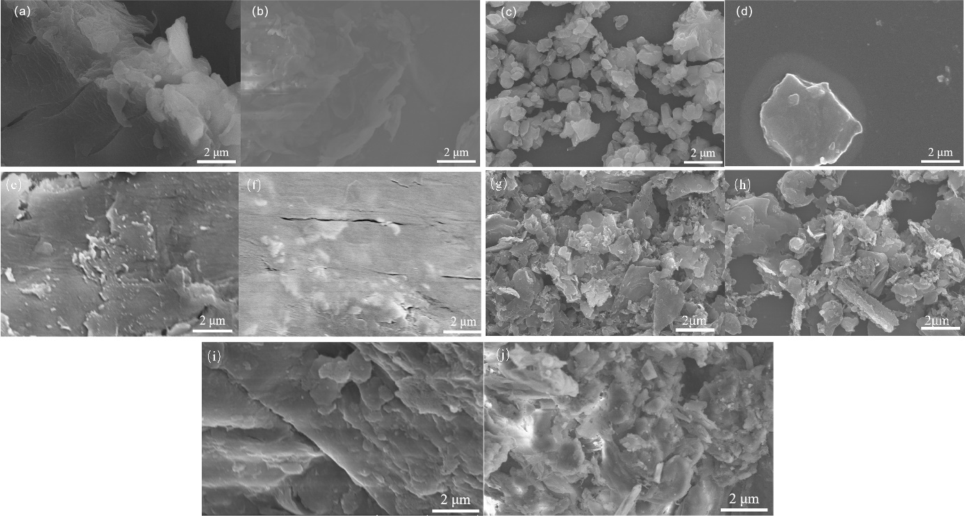
Fig. S12. SEM of sample: (a) CS powder; (b) CS pellet; (c) CG powder; (d) PE powder; (e) powder 12.5%CG; (f) powder 12.5%PE; (g) pellet 12.5%PE; (h) pellet 12.5%CG; (i) pellet 5%PE+5%CG; (j) pellet 12.5%PE+12.5%CG
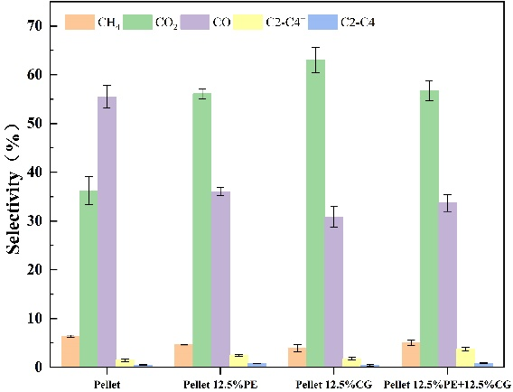
Fig. S13. Composition distribution of combustion gas phase products of CS pellets, 12.5%CG pellets, 12.5%PE pellets and 12.5%PE+12.5%CG pellets.

Tab. S4. Combustion characteristics of samples with different heating rates
Sample | β | T_{i} | T_{h} | (d_{m}/d_{t})_{max} | (d_{m}/d_{t})_{mean} | S_{N} | C
Sample | ℃·min⁻¹ | ℃ | ℃ | %·min⁻¹ | %·min⁻¹ | 10⁻⁷ | 10⁻⁶
PE | 10 | 230 | 528 | 12.85 | 0.196 | 0.90 | 242.91
CS | 10 | 185 | 465 | 11.83 | 0.61 | 4.53 | 345.65
CG | 10 | 560 | 750 | 1.003 | 0.11 | 0.0047 | 3.20
Powder | 30 | 232 | 470 | 29.52 | 2.52 | 25.19 | 548.45
Powder | 50 | 240 | 525 | 48.05 | 3.56 | 42.39 | 834.20
Powder | 70 | 243 | 618 | 53.14 | 4.37 | 51.32 | 899.93
Powder | 90 | 252 | 643 | 76.57 | 4.94 | 60.33 | 1205.75
Pellet | 30 | 240 | 480 | 32.63 | 2.50 | 24.42 | 566.49
Pellet | 50 | 247 | 571 | 48.67 | 3.54 | 49.69 | 797.75
Pellet | 70 | 251 | 638 | 57.05 | 4.33 | 55.79 | 905.54
Pellet | 90 | 253 | 807 | 60.12 | 4.94 | 62.86 | 939.24
Powder 12.5%PE | 30 | 235 | 455 | 28.23 | 2.51 | 28.22 | 511.54
Powder 12.5%PE | 50 | 243 | 453 | 46.31 | 3.49 | 60.42 | 784.26
Powder 12.5%PE | 70 | 245 | 534 | 51.94 | 4.29 | 69.52 | 865.31
Powder 12.5%PE | 90 | 251 | 588 | 62.09 | 4.8 | 80.45 | 985.54
Pellet 12.5%CG | 30 | 233 | 486 | 28.25 | 2.42 | 25.91 | 520.36
Pellet 12.5%CG | 50 | 245 | 529 | 46.54 | 3.39 | 49.69 | 775.34
Pellet 12.5%CG | 70 | 250 | 649 | 55.06 | 4.11 | 55.79 | 880.96
Pellet 12.5%CG | 90 | 255 | 714 | 62.23 | 4.69 | 62.86 | 957.02
Pellet 12.5% CG+12.5%PE | 30 | 235 | 463 | 26.31 | 2.49 | 25.62 | 476.41
Pellet 12.5% CG+12.5%PE | 50 | 246 | 551 | 39.93 | 3.54 | 42.39 | 659.83
Pellet 12.5% CG+12.5%PE | 70 | 250 | 650 | 48.15 | 4.33 | 51.32 | 770.40
Pellet 12.5% CG+12.5%PE | 90 | 250 | 711 | 56.48 | 4.9 | 62.28 | 903.68

Tab. S5. C-R kinetic parameters of fuel at different combustion rates
Sample | β(℃·min⁻¹) | T(℃) | Ea(kJ·mol⁻¹) | A(min⁻¹) | n | R²
Powder | 30 | 246.36~290.31 | 122.7121937 | 6.30894E+11 | 3 | 0.99834
Powder | 30 | 342.5~430.05 | 13.3534088 | 1.530115944 | 0.5 | 0.98963
Powder | 50 | 254.02~299.16 | 131.2638084 | 4.49527E+12 | 3 | 0.99863
Powder | 50 | 319.49~518.51 | 4.603371344 | 0.150453138 | 0.5 | 0.98152
Powder | 70 | 250.92~311.43 | 112.8453009 | 99314952036 | 3 | 0.99775
Powder | 70 | 350.55~580.44 | 8.231096034 | 0.86494346 | 1 | 0.93052
Powder | 90 | 260.07~310.23 | 121.3351906 | 5.2093E+11 | 3 | 0.99941
Powder | 90 | 370.47~600.17 | 7.86081525 | 0.947948058 | 1 | 0.91455
Pellet | 30 | 242.1~285.09 | 130.6158473 | 3.80243E+12 | 3 | 0.99845
Pellet | 30 | 307.4~472.16 | 7.091852725 | 0.232905716 | 0.5 | 0.99054
Pellet | 50 | 254.2~292.32 | 136.6164989 | 1.87485E+13 | 3 | 0.99834
Pellet | 50 | 326.15~550.16 | 8.759490143 | 0.818833219 | 1 | 0.9478
Pellet | 70 | 250.88~300.85 | 125.5357078 | 1.53052E+12 | 3 | 0.9987
Pellet | 70 | 340.14~600.73 | 5.736504944 | 0.388640631 | 1 | 0.91591
Pellet | 90 | 250.49~311.93 | 110.4053461 | 44220869072 | 3 | 0.99923
Pellet | 90 | 354.78~730.96 | 5.714871334 | 3.045563348 | 1 | 0.9191
Pellet 12.5% PE | 30 | 250.55~290.11 | 130.5360431 | 3.49226E+12 | 3 | 0.99793
Pellet 12.5% PE | 30 | 345.31~420.14 | 13.25965216 | 1.471596067 | 0.5 | 0.99134
Pellet 12.5% PE | 50 | 254.82~292.03 | 138.0161179 | 1.99693E+13 | 3 | 0.99929
Pellet 12.5% PE | 50 | 325.04~451.4 | 8.43150118 | 0.593583298 | 0.5 | 0.9772
Pellet 12.5% PE | 70 | 249.74~300.23 | 119.4215557 | 3.58516E+11 | 3 | 0.99858
Pellet 12.5% PE | 70 | 329.33~477.88 | 6.93717857 | 0.473593853 | 0.5 | 0.99088
Pellet 12.5% PE | 90 | 259.34~311.25 | 113.3225976 | 1.00353E+11 | 3 | 0.99505
Pellet 12.5% PE | 90 | 350.01~520.09 | 3.89766647 | 0.186188094 | 0.5 | 0.98422
Pellet 12.5%CG | 30 | 246.45~300.33 | 109.4889186 | 28720734750 | 3 | 0.99037
Pellet 12.5%CG | 30 | 315.81~461.22 | 6.960216498 | 0.219290575 | 0.5 | 0.9948
Pellet 12.5%CG | 50 | 246.42~292.44 | 129.8373008 | 4.35288E+12 | 3 | 0.99775
Pellet 12.5%CG | 50 | 319.61~493.68 | 3.800711927 | 0.107347488 | 0.5 | 0.99284
Pellet 12.5%CG | 70 | 260.02~301.91 | 128.7575306 | 3.06467E+12 | 3 | 0.99416
Pellet 12.5%CG | 70 | 350.21~578.93 | 7.32919531 | 0.660601437 | 1 | 0.93343
Pellet 12.5%CG | 90 | 260.95~311.7 | 119.48804 | 3.57185E+11 | 3 | 0.99622
Pellet 12.5%CG | 90 | 351.7~578.24 | 8.739936197 | 1.63996844 | 1.5 | 0.97064
Pellet 12.5%PE+12.5%CG | 30 | 245.91~290.33 | 113.441276 | 59661164252 | 3 | 0.99782
Pellet 12.5%PE+12.5%CG | 30 | 320.91~467.04 | 8.206015024 | 0.316820233 | 0.5 | 0.99332
Pellet 12.5%PE+12.5%CG | 50 | 254.15~299.22 | 115.5063934 | 1.07529E+11 | 3 | 0.99852
Pellet 12.5%PE+12.5%CG | 50 | 339.28~543.59 | 2.27993525 | 0.044763352 | 0.5 | 0.98244
Pellet 12.5%PE+12.5%CG | 70 | 250.68~310.55 | 103.7379441 | 8.19E+09 | 3 | 0.99847
Pellet 12.5%PE+12.5%CG | 70 | 350.66~620.68 | 13.90312824 | 5.255386486 | 1.5 | 0.91953
Pellet 12.5%PE+12.5%CG | 90 | 250.36~300.07 | 105.7225827 | 15483838309 | 3 | 0.99937
Pellet 12.5%PE+12.5%CG | 90 | 361.16~601.07 | 6.922035367 | 0.901598449 | 1.5 | 0.9788

.
Fig. S14. Dynamics of FWO and Starink without model: (a) (b) CS powder, (c) (d) CS pellet, (e) (f) 12.5%PE pellet, (g) (h) 12.5%CG pellet, (i) (j) 12.5%PE+12.5%CG pellet

Tab. S6. Dynamic parameters of FWO and Starink combustion without model method
Sample | α （%） | FWO |  | Starink
Sample | α （%） | Ea( kJ·mol⁻¹) | R² | Ea( kJ·mol⁻¹) | R²
Powder | 0.1 | 55.56146622 | 0.92915 | 126.3848937 | 0.92092
Powder | 0.2 | 60.54757433 | 0.97475 | 138.1251364 | 0.97179
Powder | 0.3 | 61.44085515 | 0.99768 | 140.1021239 | 0.99742
Powder | 0.4 | 59.9223647 | 0.99978 | 136.2886345 | 0.99975
Powder | 0.5 | 60.5277377 | 0.99907 | 137.5960787 | 0.99893
Powder | 0.6 | 58.67178736 | 0.97531 | 132.796125 | 0.97198
Powder | 0.7 | 33.50344424 | 0.96039 | 71.30690091 | 0.94945
Powder | 0.8 | 18.78063053 | 0.9784 | 35.0569663 | 0.96401
Powder | 0.9 | 13.84873728 | 0.97849 | 22.33406958 | 0.95282
Pellet | 0.1 | 68.82055755 | 0.99686 | 158.3594592 | 0.99652
Pellet | 0.2 | 67.96236624 | 0.97594 | 155.9999465 | 0.97343
Pellet | 0.3 | 58.87963736 | 0.94422 | 133.9196788 | 0.9375
Pellet | 0.4 | 52.72751445 | 0.91644 | 118.9165411 | 0.90529
Pellet | 0.5 | 49.63331551 | 0.9087 | 111.2733269 | 0.89546
Pellet | 0.6 | 34.87074951 | 0.88885 | 79.1490812 | 0.87155
Pellet | 0.7 | 26.84829272 | 0.87718 | 55.05115473 | 0.8364
Pellet | 0.8 | 14.26254055 | 0.91264 | 23.54219641 | 0.82186
Pellet | 0.9 | 10.52780008 | 0.92659 | 13.18543908 | 0.74565
Pellet 12.5% PE | 0.1 | 72.93788428 | 0.86321 | 168.2977416 | 0.85228
Pellet 12.5% PE | 0.2 | 87.66709945 | 0.93002 | 203.5836598 | 0.92488
Pellet 12.5% PE | 0.3 | 80.74079456 | 0.96481 | 186.7088987 | 0.96184
Pellet 12.5% PE | 0.4 | 72.53893873 | 0.99374 | 166.7620911 | 0.99313
Pellet 12.5% PE | 0.5 | 67.81149717 | 0.99278 | 155.172274 | 0.99201
Pellet 12.5% PE | 0.6 | 55.16117715 | 0.95206 | 124.2969921 | 0.94533
Pellet 12.5% PE | 0.7 | 45.92963399 | 0.93406 | 101.3940219 | 0.92205
Pellet 12.5% PE | 0.8 | 31.72241473 | 0.97626 | 66.50926649 | 0.96821
Pellet 12.5% PE | 0.9 | 24.25396118 | 0.94757 | 47.79999157 | 0.92164
Pellet 12.5% CG | 0.1 | 53.37896219 | 0.9889 | 121.0705438 | 0.98735
Pellet 12.5% CG | 0.2 | 60.03593141 | 0.96753 | 136.8880179 | 0.9637
Pellet 12.5% CG | 0.3 | 60.23192684 | 0.93645 | 137.2142162 | 0.92916
Pellet 12.5% CG | 0.4 | 60.2429911 | 0.91604 | 137.0758014 | 0.90637
Pellet 12.5% CG | 0.5 | 58.74291473 | 0.86993 | 133.2782989 | 0.8552
Pellet 12.5% CG | 0.6 | 55.72482209 | 0.80004 | 132.5646053 | 0.81637
Pellet 12.5% CG | 0.7 | 29.04296743 | 0.80356 | 60.39449634 | 0.80194
Pellet 12.5% CG | 0.8 | 18.01190165 | 0.90154 | 32.85541712 | 0.83694
Pellet 12.5% CG | 0.9 | 13.74283652 | 0.91573 | 21.45860215 | 0.81292
Pellet 12.5% PE+ 12.5% CG | 0.1 | 71.48411973 | 0.93771 | 164.7856834 | 0.93214
Pellet 12.5% PE+ 12.5% CG | 0.2 | 75.93740477 | 0.97986 | 175.2426693 | 0.97803
Pellet 12.5% PE+ 12.5% CG | 0.3 | 72.70924928 | 0.98885 | 167.2716 | 0.98778
Pellet 12.5% PE+ 12.5% CG | 0.4 | 71.85848683 | 0.9927 | 165.0403136 | 0.99195
Pellet 12.5% PE+ 12.5% CG | 0.5 | 66.00652144 | 0.98388 | 150.6766506 | 0.98197
Pellet 12.5% PE+ 12.5% CG | 0.6 | 58.88398403 | 0.9379 | 133.0654168 | 0.92953
Pellet 12.5% PE+ 12.5% CG | 0.7 | 35.23476361 | 0.97534 | 75.22103304 | 0.96825
Pellet 12.5% PE+ 12.5% CG | 0.8 | 17.89659627 | 0.98684 | 32.4102698 | 0.97474
Pellet 12.5% PE+ 12.5% CG | 0.9 | 12.72927141 | 0.99054 | 18.79194277 | 0.96848

