Electronic Supplementary Material
Economic and environmental comparison of mainstream and potential alternative routes: a study on one-step and two-step processes for methacrylonitrile production via isobutene ammoxidation
Mengzhen Zhu¹, Xinrui Song¹, Zhibo Zhang¹, Jiarong Lu¹, Xiaolin Zhu¹, Xin Zhou (⁾², Xiang Feng (⁾¹, Hao Yan¹, Guozhen Qi (⁾³
¹State Key Laboratory of Heavy Oil Processing, China University of Petroleum, Qingdao 266580, China
²College of Chemistry and Chemical Engineering, Ocean University of China, Qingdao 266100, China
³Shanghai Research Institute of Petrochemical Technology, Shanghai 201208, China
E-mails: xinzhou@ouc.edu.cn (Zhou X); xiangfeng@upc.edu.cn (Feng X); qigz.sshy@sinopec.com (Qi G)

This file contains: 21 pages, 7 sections, 17 tables and 2 figures.

Summary of figures and tables
Fig. S1. Main streams number in of One-Step process
Fig. S2. Main streams number in of Two-Step process
Table S1. Reaction settings for the one-step ammoxidation reactor.
Table S2. Reaction settings for the two-step oxidation reactor.
Table S3. Reaction settings for the two-step ammoxidation reactor.
Table S4. Partial steams details information in One-step Process
Table S5. Partial steams details information in Two-step Process
Table S6. Operating parameters of key columns in the One-step Process
Table S7. Operating parameters of key columns in the Two-step Process
Table S8. The specific module calculation formulas of TCI and the contents of TOC
Table S9. Reference of raw materials and product prices
Table S10. Equipment cost information in One-step Process and Two-step Process
Table S11. The Operating cost information in One-step Process and Two-step Process
Table S12. The unified converted value of energy consuming working medium
Table S13. The primary consumption factor of NED
Table S14. Indirect GHG emission factors
Table S15. Distribution of NED and GHG Across Process Units
Table S16. Heat recovery from three-stage heat exchangers in both processes
Table S17. Details of loss of butyl acetate
1. Thermodynamic Model Selection
1.1 Selection of the NRTL Model
In this study, the NRTL (Non-Random Two-Liquid) activity coefficient model was chosen as the primary thermodynamic method for process simulation in Aspen Plus. This section justifies the selection by discussing the model's suitability in relation to the characteristics of the process system.
In chemical process simulation, the selection of a property method should be based on the operating conditions and the intermolecular interaction characteristics of the system. The Peng–Robinson (PR) and Soave–Redlich–Kwong (SRK) equations of state are cubic models developed under the assumption of relatively weak intermolecular forces, making them primarily suitable for nonpolar or weakly polar systems. These models are typically applied in natural gas processing, light hydrocarbon separation, and petroleum refining. However, for strongly polar systems, associating systems containing hydrogen bonds (e.g., alcohols, water, acids, and nitriles), and systems exhibiting liquid–liquid equilibria at low pressures, cubic equations of state have inherent limitations in describing liquid-phase nonidealities. Their mixing rules and parameters cannot accurately capture the short-range interactions among strongly polar molecules—including hydrogen bonding and dipole–dipole interactions—resulting in significantly reduced predictive accuracy for vapor–liquid and liquid–liquid equilibria. The NRTL model is an activity coefficient model based on Scott's two-liquid theory and the local composition concept, specifically designed to address nonideal interactions among polar molecules. By incorporating binary interaction parameters and a non-randomness parameter (α), the NRTL model can simultaneously describe both vapor–liquid and liquid–liquid equilibria. It has demonstrated strong predictive performance for strongly polar, associating, and partially miscible systems across a wide pressure range, from low to medium-high pressures.
The primary components studied include methacrylonitrile (MAN), acetonitrile, hydrogen cyanide, and water. Among these, MAN is a strongly polar, unsaturated nitrile; acetonitrile is a strongly polar, associating solvent; hydrogen cyanide exhibits significant polarity; and water is a strongly polar, associating molecule. The coexistence of multiple strong polar components results in pronounced nonideality within the system. Specifically, MAN and water exhibit partial miscibility under distillation conditions, while acetonitrile and water form an azeotrope at atmospheric pressure, with an azeotropic point near 76°C and approximately 68% acetonitrile content. For systems exhibiting such complex nonideal behavior, activity coefficient models are thermodynamically superior to cubic equations of state.
1.2 Analogical Validation from Industrial Simulation of Acrylonitrile
The production processes of methacrylonitrile (MAN) and acrylonitrile (ACN) are highly homologous. Both involve ammoxidation of olefins—MAN from isobutene and ACN from propylene—with the products being mixtures of nitriles and water, and the downstream separation trains both comprising quenching, absorption, extractive distillation, and product purification units. Therefore, the thermodynamic model selection in industrial process simulation of acrylonitrile provides valuable analogical reference for this study.
Cao et al. conducted a full-process simulation of an acrylonitrile production plant and explicitly stated: “The mixed systems formed by organic compounds such as acrylonitrile, acetonitrile, and hydrogen cyanide with water exhibit strong polarity and high nonideality, with significant intermolecular forces (e.g., hydrogen bonding and dipole interactions) among components, leading to complex vapor–liquid equilibrium (VLE), vapor–liquid–liquid equilibrium (VLLE), and liquid–liquid equilibrium (LLE) behavior. The NRTL model, owing to its accurate description of polar systems and nonrandom mixing effects, is widely used for such complex phase equilibrium calculations.” In that study, the NRTL model was employed to establish the full-process simulation of acrylonitrile, and its reliability was validated against actual industrial data—the deviation between simulated and actual acrylonitrile yield was 0.3%, the deviation in absorber recovery was 0.7%, and deviations in key process parameters were all within 5%[1].Braga et al., in their techno-economic analysis of acrylonitrile production from crude glycerol, also used Aspen Plus for process simulation and selected NRTL as the thermodynamic model[2]. Their selection rationale directly cited the classical methodology of Carlson (1996)—the NRTL model is applicable to: non-electrolyte systems (or systems with very low electrolyte concentrations), systems containing polar molecules, low-pressure conditions (<1000 kPa), systems with liquid–liquid equilibria, and systems with a certain tendency toward polymerization (such as nitrile compounds).
In summary, the NRTL family of models has been successfully applied in the process simulation of industrial acrylonitrile production plants, with prediction deviations of less than 5% validated against actual operating data. This fact provides a reliable industrial analogical basis for the selection of the NRTL model in the methacrylonitrile process simulation of this study.

2. Reactor Modeling Details
In this study, all reactors in both the one-step and two-step processes are modeled using the RStoic module in Aspen Plus, which is a stoichiometric reactor based on specified conversions and product selectivities. The RStoic module performs material and energy balance calculations without requiring reaction kinetics data, making it particularly suitable for process design studies where reaction kinetics are not available but reliable experimental conversion data exist. This approach is widely adopted in chemical process simulation when the objective is to establish reliable mass and energy balances for downstream unit operations based on experimentally validated reaction data. The reactor feed compositions, operating temperatures, and pressures are set according to the experimental conditions reported in the patents (CN112121811A, CN116135308A) and literature. The product distributions at the reactor outlets, including yields of main products and by-products, are directly specified based on the experimental data provided in the patent examples. The conversion constraints are implemented through the RStoic module's conversion specifications, ensuring that the simulation results are consistent with the patent data. The details of each reactor's reaction settings are presented below.
2.1 One-Step Ammoxidation Reactor
The one-step isobutene ammoxidation reaction is operated at 410°C and atmospheric pressure. The reactions and their corresponding conversions are listed in Table S1.
Table S1. Reaction settings for the one-step ammoxidation reactor.
Reaction No. | Component basis | Conversion | Stoichiometric equation
1 | C₄H₈ | 0.8017 | C₄H₈+NH₃+1.5O₂→C₄H₅N+3H₂O
2 | C₄H₈ | 0.0674 | C₄H₈+2NH₃+2O₂→2ACN+4H₂O
3 | C₄H₈ | 0.0303 | C₄H₈+6O₂→4CO₂+4H₂O
4 | C₄H₈ | 0.0389 | C₄H₈+4O₂→4CO+4H₂O
5 | NH₃ | 0.0003 | NH₃+CO→HCN+H₂O
Operating conditions: Temperature 410°C, Pressure 1 atm, Valid phase: Vapor.
2.2 Two-Step Oxidation Reactor
The first step of the two-step process is the oxidation of isobutene to methacrolein (MAL), operated at 320°C and atmospheric pressure. The reactions and their corresponding conversions are listed in Table S2.
Table S2. Reaction settings for the two-step oxidation reactor.
Reaction No. | Component basis | Conversion | Stoichiometric equation
1 | C₄H₈ | 0.9410 | C₄H₈+O₂→C₄H₆O+H₂O
2 | C₄H₈ | 0.00015 | C₄H₈+6O₂→4CO₂+4H2O
3 | C₄H₈ | 0.0045 | C₄H₈+4O₂→4CO+4H₂O
4 | C₄H₈ | 0.012 | 2C₄H₈+O₂→4C₃H₄O+4H₂O
5 | C₄H₈ | 0.031 | C₄H₈+1.5O₂→C₄H₆O₂+H₂O
The second step of the two-step process is the liquid-phase ammoxidation of methacrolein to methacrylonitrile, operating at 10°C and 1 MPa, with butyl acetate as the solvent. The reactions and their corresponding conversions are listed in Table S3.
Table S3. Reaction settings for the two-step ammoxidation reactor.
Reaction No. | Component basis | Conversion | Stoichiometric equation
1 | MAL | 0.957 | C₄H₆O+NH₃+0.5O₂→C₄H₅N+2H₂O
2 | MAL | 0.01 | C₄H₆O+5O₂→4CO₂+3H₂O
3 | C₄H₈ | 0.031 | 2C₄H₈+3.5O₂+3NH₃→C₄H₅N +2C₂H₃N+7H₂O
4 | MAL | 0.001 | 2C₄H₆O +O₂→2C₄H₆O₂
Operating conditions: Temperature 10°C, Pressure 1 MPa, Valid phase: Vapor-Liquid.

3. Process simulation
Tables S4 and S5 respectively provide the information of the split strands in the One-Step process and the Two-Step process.
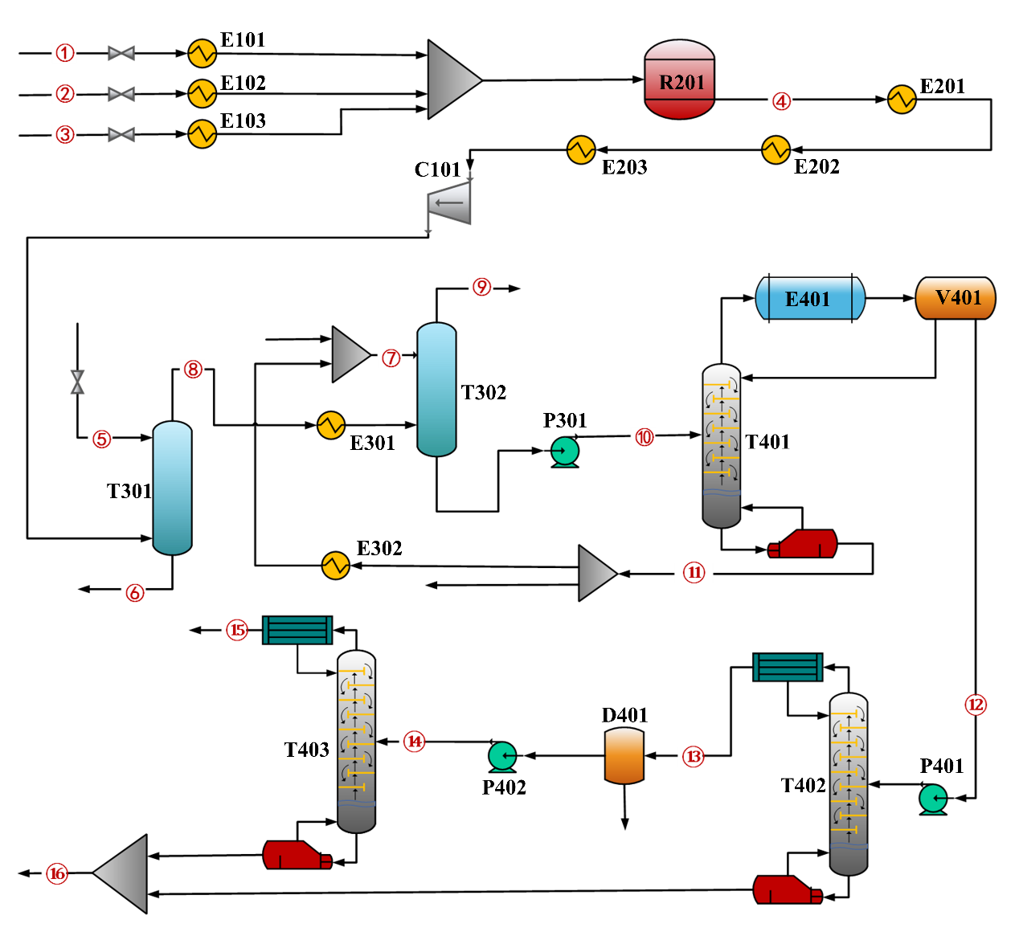
Fig. S1. Main streams number in of One-Step process

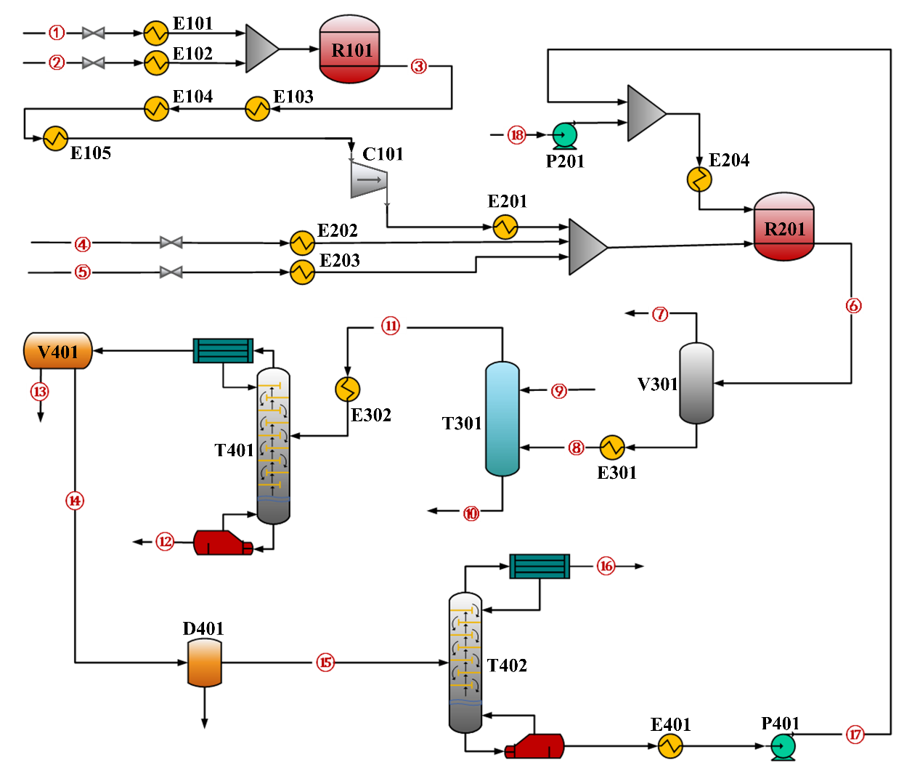
Fig. S2. Main streams number in of Two-Step process

The sequence numbers of the streams are shown in Fig. S1 and S2.
Table S4. Partial steams details information in One-step Process
Items | 1 | 2 | 3 | 4 | 5 | 6 | 7 | 8 | 9 | 10 | 11 | 12 | 13 | 14 | 15 | 16
Temperature, ℃ | 25 | 25 | 25 | 410 | 25 | 115.96 | 33.60 | 99.71 | 35.21 | 39.78 | 99.91 | 30.00 | 55.00 | 55.61 | 132.77 | 90.41
Stream Pressure, bar | 2 | 12.5 | 5 | 1.013 | 1.013 | 1.013 | 1.013 | 1.01 | 1.01 | 4.00 | 1.01 | 1.00 | 1.01 | 4.24 | 4.00 | 1.01
Flow rate, kg/h | 1000 | 366.53 | 1125.58 | 2492.11 | 1468.05 | 1017.59 | 8000 | 2934.52 | 467.21 | 10467.30 | 9451.45 | 1014.15 | 175.82 | 146.52 | 56.49 | 928.25
Component, %
NH₃ | 0.0000 | 1.0000 | 0.0000 | 0.0359 | 0.0000 | 0.0000 | 0.0000 | 0.0000 | 0.0000 | 0.0000 | 0.0000 | 0.0000 | 0.0000 | 0.0000 | 0.0000 | 0.0000
MAN | 0.0000 | 0.0000 | 0.0000 | 0.3981 | 0.0000 | 0.0461 | 0.0000 | 0.3221 | 0.0417 | 0.0884 | 0.0000 | 0.9125 | 0.5139 | 0.6167 | 0.0028 | 0.9962
ACN | 0.0000 | 0.0000 | 0.0000 | 0.0244 | 0.0000 | 0.0015 | 0.0000 | 0.0202 | 0.0000 | 0.0057 | 0.0000 | 0.0585 | 0.3194 | 0.3833 | 0.9972 | 0.0038
CO₂ | 0.0000 | 0.0000 | 0.0000 | 0.0292 | 0.0000 | 0.0000 | 0.0000 | 0.0248 | 0.1529 | 0.0001 | 0.0000 | 0.0001 | 0.0005 | 0.0000 | 0.0000 | 0.0000
CO | 0.0000 | 0.0000 | 0.0000 | 0.0191 | 0.0000 | 0.0000 | 0.0000 | 0.0162 | 0.1019 | 0.0000 | 0.0000 | 0.0000 | 0.0000 | 0.0000 | 0.0000 | 0.0000
C₄H₈ | 1.0000 | 0.0000 | 0.0000 | 0.0327 | 0.0000 | 0.0000 | 0.0000 | 0.0278 | 0.1738 | 0.0000 | 0.0000 | 0.0003 | 0.0015 | 0.0000 | 0.0000 | 0.0000
HCN | 0.0000 | 0.0000 | 0.0000 | 0.0001 | 0.0000 | 0.0000 | 0.0000 | 0.0000 | 0.0000 | 0.0000 | 0.0000 | 0.0002 | 0.0010 | 0.0000 | 0.0000 | 0.0000
H₂SO₄ | 0.0000 | 0.0000 | 0.0000 | 0.0000 | 0.0000 | 0.0000 | 0.0000 | 0.0000 | 0.0000 | 0.0000 | 0.0000 | 0.0000 | 0.0000 | 0.0000 | 0.0000 | 0.0000
H₂O | 0.0000 | 0.0000 | 0.0000 | 0.3665 | 0.65 | 0.3624 | 1.0000 | 0.5089 | 0.0285 | 0.9057 | 1.0000 | 0.0284 | 0.1637 | 0.0000 | 0.0000 | 0.0000
O₂ | 0.0000 | 0.0000 | 1.0000 | 0.0940 | 0.0000 | 0.0000 | 0.0000 | 0.0798 | 0.5012 | 0.0000 | 0.0000 | 0.0000 | 0.0000 | 0.0000 | 0.0000 | 0.0000
NH₄⁺ | 0.0000 | 0.0000 | 0.0000 | 0.0000 | 0.0000 | 0.0930 | 0.0000 | 0.0000 | 0.0000 | 0.0000 | 0.0000 | 0.0000 | 0.0000 | 0.0000 | 0.0000 | 0.0000
H⁺ | 0.0000 | 0.0000 | 0.0000 | 0.0000 | 0.0036 | 0.0002 | 0.0000 | 0.0000 | 0.0000 | 0.0000 | 0.0000 | 0.0000 | 0.0000 | 0.0000 | 0.0000 | 0.0000
OH⁻ | 0.0000 | 0.0000 | 0.0000 | 0.0000 | 0.0000 | 0.0000 | 0.0000 | 0.0000 | 0.0000 | 0.0000 | 0.0000 | 0.0000 | 0.0000 | 0.0000 | 0.0000 | 0.0000
HSO₄⁻ | 0.0000 | 0.0000 | 0.0000 | 0.0000 | 0.3413 | 0.4750 | 0.0000 | 0.0000 | 0.0000 | 0.0000 | 0.0000 | 0.0000 | 0.0000 | 0.0000 | 0.0000 | 0.0000
SO₄⁻ | 0.0000 | 0.0000 | 0.0000 | 0.0000 | 0.0051 | 0.0218 | 0.0000 | 0.0000 | 0.0000 | 0.0000 | 0.0000 | 0.0000 | 0.0000 | 0.0000 | 0.0000 | 0.0000

Table S5. Partial steams details information in Two-step Process
Items | 1 | 2 | 3 | 4 | 5 | 6 | 7 | 8 | 9 | 10 | 11 | 12 | 13 | 14 | 15 | 16 | 17 | 18
Temperature, ℃ | 25 | 25 | 320 | 25 | 25 | 10 | 20 | 180 | 25 | 106.01 | 99.61 | 99.63 | 60 | 60 | 59.7 | 72.29 | 25 | 25
Stream Pressure, bar | 1.013 | 150 | 1.013 | 150 | 120 | 10 | 1 | 1 | 1 | 1 | 1 | 1 | 1 | 1 | 1 | 1 | 1 | 1
Flow rate, kg/h | 1000 | 705.46 | 1705.46 | 649.27 | 428.43 | 7582.88 | 584.18 | 6998.7 | 1840.0 | 1952.8 | 6885.9 | 651.1 | 919.8 | 5314.9 | 5163.9 | 990.3 | 4173.6 | 634.7
Component, %
NH₃ | 0.0000 | 0.0000 | 0.0000 | 0.0000 | 1.0000 | 0.0204 | 0.0107 | 0.0213 | 0.0000 | 0.0000 | 0.0000 | 0.0000 | 0.0000 | 0.0000 | 0.0000 | 0.0000 | 0.0000 | 0.0000
MAN | 0.0000 | 0.0000 | 0.0000 | 0.0000 | 0.0000 | 0.1420 | 0.0344 | 0.1510 | 0.0000 | 0.0270 | 0.1459 | 0.0000 | 0.0066 | 0.1878 | 0.1933 | 0.9996 | 0.0020 | 0.0000
MAL | 0.0000 | 0.0000 | 0.6893 | 0.0000 | 0.0000 | 0.0050 | 0.0024 | 0.0052 | 0.0000 | 0.0005 | 0.0051 | 0.0000 | 0.0004 | 0.0066 | 0.0000 | 0.0000 | 0.0000 | 0.0000
MAA | 0.0000 | 0.0000 | 0.0279 | 0.0000 | 0.0000 | 0.0065 | 0.0000 | 0.0070 | 0.0000 | 0.0229 | 0.0006 | 0.0000 | 0.0001 | 0.0008 | 0.0000 | 0.0000 | 0.0000 | 0.0000
NBA | 0.0000 | 0.0000 | 0.0000 | 0.0000 | 0.0000 | 0.6330 | 0.0294 | 0.6834 | 0.0000 | 0.3141 | 0.6055 | 0.0000 | 0.0040 | 0.7838 | 0.8067 | 0.0000 | 0.9980 | 1.0000
CH₄ | 0.0000 | 0.0000 | 0.0020 | 0.0000 | 0.0000 | 0.0005 | 0.0057 | 0.0000 | 0.0000 | 0.0000 | 0.0000 | 0.0000 | 0.0000 | 0.0000 | 0.0000 | 0.0000 | 0.0000 | 0.0000
CO₂ | 0.0000 | 0.0000 | 0.0003 | 0.0000 | 0.0000 | 0.0040 | 0.0414 | 0.0008 | 0.0000 | 0.0000 | 0.0008 | 0.0000 | 0.0002 | 0.0011 | 0.0000 | 0.0000 | 0.0000 | 0.0000
ACN | 0.0000 | 0.0000 | 0.0000 | 0.0000 | 0.0000 | 0.0000 | 0.0000 | 0.0000 | 0.0000 | 0.0000 | 0.0000 | 0.0000 | 0.0000 | 0.0000 | 0.0001 | 0.0000 | 0.0000 | 0.0000
ACR | 0.0000 | 0.0000 | 0.0070 | 0.0000 | 0.0000 | 0.0016 | 0.0012 | 0.0016 | 0.0000 | 0.0000 | 0.0016 | 0.0000 | 0.0005 | 0.0020 | 0.0000 | 0.0000 | 0.0000 | 0.0000
AN | 0.0000 | 0.0000 | 0.0000 | 0.0000 | 0.0000 | 0.0000 | 0.0000 | 0.0000 | 0.0000 | 0.0000 | 0.0000 | 0.0000 | 0.0000 | 0.0000 | 0.0000 | 0.0000 | 0.0000 | 0.0000
CO | 0.0000 | 0.0000 | 0.0052 | 0.0000 | 0.0000 | 0.0012 | 0.0152 | 0.0000 | 0.0000 | 0.0000 | 0.0000 | 0.0000 | 0.0000 | 0.0000 | 0.0000 | 0.0000 | 0.0000 | 0.0000
C₄H₈ | 1.0000 | 0.0000 | 0.0067 | 0.0000 | 0.0000 | 0.0014 | 0.0153 | 0.0003 | 0.0000 | 0.0000 | 0.0003 | 0.0000 | 0.0000 | 0.0004 | 0.0000 | 0.0000 | 0.0000 | 0.0000
H₂SO₄ | 0.0000 | 0.0000 | 0.0000 | 0.0000 | 0.0000 | 0.0000 | 0.0000 | 0.0000 | 0.0000 | 0.0000 | 0.0000 | 0.0000 | 0.0000 | 0.0000 | 0.0000 | 0.0000 | 0.0000 | 0.0000
H₂O | 0.0000 | 0.0000 | 0.1865 | 0.0000 | 0.0000 | 0.1194 | 0.0119 | 0.1284 | 0.5800 | 0.1634 | 0.2393 | 1.0000 | 0.9854 | 0.0168 | 0.0000 | 0.0000 | 0.0000 | 0.0000
O₂ | 0.0000 | 1.0000 | 0.0751 | 1.0000 | 0.0000 | 0.0650 | 0.8324 | 0.0010 | 0.0000 | 0.0000 | 0.0009 | 0.0000 | 0.0028 | 0.0007 | 0.0000 | 0.0000 | 0.0000 | 0.0000
NH₄⁺ | 0.0000 | 0.0000 | 0.0000 | 0.0000 | 0.0000 | 0.0000 | 0.0000 | 0.0000 | 0.0000 | 0.0807 | 0.0000 | 0.0000 | 0.0000 | 0.0000 | 0.0000 | 0.0000 | 0.0000 | 0.0000
H⁺ | 0.0000 | 0.0000 | 0.0000 | 0.0000 | 0.0000 | 0.0000 | 0.0000 | 0.0000 | 0.0044 | 0.0000 | 0.0000 | 0.0000 | 0.0000 | 0.0000 | 0.0000 | 0.0000 | 0.0000 | 0.0000
OH⁻ | 0.0000 | 0.0000 | 0.0000 | 0.0000 | 0.0000 | 0.0000 | 0.0000 | 0.0000 | 0.0000 | 0.0000 | 0.0000 | 0.0000 | 0.0000 | 0.0000 | 0.0000 | 0.0000 | 0.0000 | 0.0000
HSO₄⁻ | 0.0000 | 0.0000 | 0.0000 | 0.0000 | 0.0000 | 0.0000 | 0.0000 | 0.0000 | 0.4123 | 0.3488 | 0.0000 | 0.0000 | 0.0000 | 0.0000 | 0.0000 | 0.0000 | 0.0000 | 0.0000
SO₄⁻ | 0.0000 | 0.0000 | 0.0000 | 0.0000 | 0.0000 | 0.0000 | 0.0000 | 0.0000 | 0.0033 | 0.0427 | 0.0000 | 0.0000 | 0.0000 | 0.0000 | 0.0000 | 0.0000 | 0.0000 | 0.0000

Operating parameters of key columns in the one-step process and two-step process are listed in Table S6 and Table S7.
Table S6. Operating parameters of key columns in the One-step Process
Columns | Number of stages | Feed Stage | Temperature/℃ | Pressure/Mpa | Reflux ratio
T301 | 10 | 1, 10 | [101.2, 116.0] | [0.10, 0.15] | -
T302 | 10 | 1, 10 | [34.4, 39.3] | [0.10, 0.15] | -
T401 | 10 | 1, 4 | [97.4, 100.0] | [0.10, 0.15] | 2.50
T402 | 36 | 13 | [76.7, 90.4] | [0.10, 0.25] | 12.12
T403 | 42 | 18 | [132.7, 147.0] | [0.40, 0.55] | 8.22

Table S7. Operating parameters of key columns in the Two-step Process
Columns | Number of stages | Feed Stage | Temperature/℃ | Pressure/Mpa | Reflux ratio
T301 | 10 | 1, 11 | [115.08, 102.24] | [0.10, 0.15] | -
T401 | 33 | 13 | [60.23, 99.63] | [0.10, 0.18] | 5.67
T402 | 28 | 11 | [83.31, 125.60] | [0.10, 0.21] | 6.89

4. Technological and economic analysis
The detailed calculating formulas of TCI and TOC are listed in Table S8.
Table S8. The specific module calculation formulas of TCI and the contents of TOC
Project | Formulas and values
Column shells cost ($)[3] | $$\frac{{CEPCI}_{2023}}{{CEPCI}_{2001}}×(C_{p}^{0}\left(2.25+1.82F_{M}F_{p}\right))$$  $$C_{p}^{0}={10}^{(3.497+0.4485\log_{10}\left(V\right)+0.1072{[\log_{10}\left(V\right)]}^{2}}$$  $$F_{p}=\frac{\frac{（P+1）D}{2[850-0.6(P+1)}+0.00315}{0.0063}$$  $$V=π×D^{2}×H$$  $$H=0.6096×\left(\frac{N_{T}}{0.75}-3\right)+6$$  Where V(m³) is the column diameter; H(m) is the column height; P(bar) is the column pressure; F_{M}=1. CEPCI is chemical engineering plant cost index [4]
Column trays cost ($) | $$\frac{{CEPCI}_{2023}}{{CEPCI}_{2001}}×(C_{p}^{0}N_{T}F_{BM}F_{q})$$  $$C_{p}^{0}={10}^{(2.995+0.4465\log_{10}\left(A\right)+0.3961{[\log_{10}\left(A\right)]}^{2}}$$  Where A(m²) is the tray area; N_{T} is the stage number; F_{q} is the quantity factor, when N_{T}≤20，F_{q}=0.4771+0.08516log₁₀N_{T}-0.3473[log₁₀N_{T}]², When N_{T}>20; F_{BM}=1
Heat exchanger area (m²) | $$A=(Q/(ΔT×U)$$  Where Q is the duty of the exchanger; U is the heat transfer coefficient; ΔT is the temperature difference.
Heat transfer coefficient (U) | Liquid – liquid:  Liquid – vapor:  Vapor – vaporizing liquid:  Condensing vapor – vaporizing liquid:  Vapor – vapor:  Liquid – condensing vapor: | U = 0.57 kW∙℃⁻¹∙m⁻²  U = 0.20 kW∙℃⁻¹∙m⁻²  U = 0.28 kW∙℃⁻¹∙m⁻²  U = 1.00 kW∙℃⁻¹∙m⁻²  U = 0.17 kW∙℃⁻¹∙m⁻²  U = 0.85 kW∙℃⁻¹∙m⁻²
Captial cost of heat exchanger ($) | $$\frac{{CEPCI}_{2023}}{{CEPCI}_{2001}}×(C_{p}^{0}\left(1.63+1.66F_{M}F_{p}\right))$$  $$C_{p}^{0}={10}^{(4.325-0.303\log_{10}\left(A\right)+0.1634{[\log_{10}\left(A\right)]}^{2}}$$  $$F_{p}={10}^{(0.03881-0.1127\log_{10}\left(P\right)+0.08183{[\log_{10}\left(P\right)]}^{2}}$$  Where the coefficient F_{M}=1, P(bar) is the pressure.
Capital cost of compressor ($) | $$\frac{{CEPCI}_{2023}}{{CEPCI}_{2001}}×2.6×{10}^{（2.29+1.36\log_{10}\left(P_{w}\right)-0.1027{[\log_{10}\left(P_{w}\right)]}^{2}）}$$  Where P_{w} represents the compressor power，kW·h.
Capital cost of pump ($) | $$F_{p}={10}^{(-0.3935+0.3957\log_{10}\left(P\right)-0.00226{[\log_{10}\left(P\right)]}^{2}}$$  $$\frac{{CEPCI}_{2023}}{{CEPCI}_{2001}}×{10}^{（3.389+0.0536\log_{10}\left(P_{w}\right)+0.1538{[\log_{10}\left(P_{w}\right)]}^{2}）}×(1.89+1.35F_{M}F_{p})$$  where P_{W} represents the compressor power, kW·h, P is the pressure，bar; F_{M}=1.
Capital cost of tank ($) | $$\frac{{CEPCI}_{2023}}{{CEPCI}_{2001}}×2.6×{10}^{（2.29+1.36\log_{10}\left(P_{w}\right)-0.1027{[\log_{10}\left(P_{w}\right)]}^{2}）}$$  $$F_{p}=\frac{\frac{（P+1）D}{2[850-0.6(P+1)}+0.00315}{0.0063}$$  where V(m³) is the column volume, P(bar) is the pressure; F_{M}=1.
Heating utilities[5, 6]: | LP steam (0.3MPa bar, 125℃):  MP steam (1.0 MPa, 175℃):  HP steam (3.5 MPa, 250℃)  Electricity:  Cooling water:  Refrigerant (-10℃): | 7.78 $·GJ⁻¹  8.18 $·GJ⁻¹  9.86 $·GJ⁻¹  0.04 $·kW·h  0.354 $·GJ⁻¹  6.6 $·GJ⁻¹
The prices of various raw materials and products are shown in table S9.
Table S9. Reference of raw materials and product prices
Feedstock/Product | Price, $/t | Reference
isobutene | 1100 | https://www.chemicalbook.com/priceindex_cb4763080.htm
ammonia | 230 | [2]
oxygen | 60 | https://material.oilchem.net/new_material/oxygen.shtml
sulfuric acid | 126 | [2]
butyl acetate | 680 | https://www.chemicalbook.com/PriceInfoall_CB6671615.htm
methacrylonitrile | 2200 | https://www.globalgrowthinsights.com/market-reports/methacrylonitrile-market-107500
ammonium sulfate | 125 | https://www.chemicalbook.com/PriceInfoall_CB9466357.htm

The equipment cost information in Owo-step Process and Two-step Process is listed in table S10. And the operating cost breakdown is listed in the table S11.
Table S10. Equipment cost information in One-step Process and Two-step Process
Items | One-Step Process |  | Two-Step Process
Items | quantity | Cost/$ | quantity | Cost/$
Tower | 5 | 2726301 | 3 | 2048424
Heat exchanger | 14 | 1820388 | 14 | 1905935
Compressor | 1 | 391429 | 1 | 225611
Pump | 3 | 65662 | 2 | 31799
tank | 2 | 35655 | 3 | 117230
reactor | 1 | 250114 | 2 | 889125
pipeline/valve | - | 3232760 | - | 3443962
Total |  | 8522311 |  | 8662087

Table S11. Operating cost information in One-step Process and Two-step Process
Items | One-Step Process, $/t MAN | Two-Step Process, $/t MAN
Utilities | 158.32 | 217.17
Raw Material Cost | 1408.86 | 1679.87
Payroll Costs | 94.34 | 88.49
Equipment Maintenance | 14.29 | 13.22
Equipment Depreciation | 35.73 | 33.06
Administrative Expenses | 35.68 | 42.38
Overhead Cost | 1.29 | 1.26
Selling Expenses | 35.68 | 42.38
Total | 1784.20 | 2117.83

5. Life cycle environmental assessment
The unified converted value of the energy-consuming working medium is listed in table S12.
Table S12. The unified converted value of energy consuming working medium [7]
Items | Energy conversion value | Unit
Standard oil | 1000 | kgEo/t
LP steam (0.3 MPa, 125 ℃) | 55 | kgEo/t
MP steam (1 MPa, 175 ℃) | 76 | kgEo/t
HP steam (3.5 MPa, 250 ℃) | 88 | kgEo/t
Cooling water | 0.06 | kgEo/t
Refrigerant(-10 ℃) | 0.018 | kgEo/MJ
Electricity | 0.22 | kgEo/kW·h
PFCF_{i} in Table S13 represent non-renewable energy consumption factor, unit is MJ/MJ; and LHV is the low calorific value, unit is MJ/t.
Table S13. The primary consumption factor of NED [8]
Items | LHV(MJ/t) | PFCF _{crude oil} | PFCF _{crude coal} | PFCF _{crude gas}
Standard oil | 41868 | 1.06 | 0.14 | 0.03
Crude oil | 41816 | 1.05 | 0.1 | 0.02
Fuel gas | 45998 | 1.06 | 0.14 | 0.03
Fuel oil | 41816 | 1.06 | 0.14 | 0.03
Electricity ª | 10.89 | 0.37 | 2.86 | 0.03
a: Unit is kw·h

GHG indirect emission factors are listed in table S13.
${IE}_{{CO}_{2}}=I_{{CO}_{2}}×LHV×EC$ (S1)
${IE}_{{CH}_{4}}=I_{{CH}_{4}}×LHV×EC$ (S2)
${IE}_{N_{2}O}=I_{N_{2}O}×LHV×EC$ (S3)
Where IE represents an indirect emission, unit is t CO₂; I is indirect emission factor, unit is tCO₂·MJ⁻¹; EC is process energy consumption quality, unit is t; LHV is the low calorific value, unit is MJ·t⁻¹. Emission data is calculated according to Formula S1-S3.
Table S14. Indirect GHG emission factors [8].
Items | LHV(MJ/t) | I_{CO2}(tCO₂MJ) | I_{N2O}(tCO₂MJ) | I_{CH4}(tCO₂MJ)
Standard oil | 41868 | 25.33×10⁻⁶ | 0.41×10⁻⁹ | 0.07×10⁻⁶
Crude oil | 41816 | 16×10⁻⁶ | 0.27×10⁻⁹ | 0.05×10⁻⁶
Fuel gas | 45998 | 25.33×10⁻⁶ | 0.41×10⁻⁹ | 0.07×10⁻⁶
Fuel oil | 41816 | 25.33×10⁻⁶ | 0.41×10⁻⁹ | 0.07×10⁻⁶
Electricity ª | 10.89 | 248.02×10⁻⁶ | 0.62×10⁻⁹ | 2.16×10⁻⁶
a: Unit is kw·h

Table S15 presents the distribution of NED and GHG emissions across the process units for both the one-step and two-step processes, after excluding the raw material acquisition and transportation unit.
Table S15. Distribution of NED and GHG Across Process Units.
Unit | NED (MJ/t MAN) |  |  | GHG (t CO₂-eq/t MAN)
Unit | One-Step Process | Two-Step Process |  | One-Step Process |  | Two-Step Process
Preheating + reaction combined unit | 11531 |  | 11690 |  | 0.791 |  | 0.566
Light‑component separation unit | 941 |  | 9951 |  | 0.026 |  | 0.226
Purification unit | 22450 |  | 22782 |  | 0.577 |  | 0.514
Total | 34922 |  | 44424 |  | 1.394 |  | 1.306

6. Heat Recovery from Exothermic Reactions
In both the one-step and two-step processes, heat recovery from the exothermic ammoxidation and oxidation reactions is implemented by installing three-stage series heat exchangers at the reactor outlet. The hot effluent gases are sequentially cooled through these exchangers, recovering heat at three temperature levels: high-pressure steam (250℃, 3.9 MPa), medium-pressure steam (175℃, 0.8 MPa), and low-pressure steam (125℃, 0.23 MPa). The recovered steam quantities for both processes are summarized in Table S13, expressed in kg of standard oil equivalent per tonne of MAN (kgEo/t MAN) to enable direct comparison with utility consumption.
Table S16. Heat recovery from three-stage heat exchangers in both processes
Equipment | Items | One-step process, kgEo / tMAN | Two-step process, kgEo / tMAN
first-stage heat exchanger | Regeneration of HP steam  (3.5 MPa, 250 ℃) | -16.56 | -10.38
second-stage heat exchanger | Regeneration of  MP steam (1 MPa, 175 ℃) | -11.65 | -7.14
third-stage heat exchanger | Regeneration of LP steam (0.3 MPa, 125 ℃) | -11.16 | -4.48
Total |  | 39.37 | 22
Note: Negative values indicate heat recovery (steam cogeneration), which reduces the demand for external utilities. Conversion factors: HP steam 88 kgEo/t, MP steam 76 kgEo/t, LP steam 55 kgEo/t.
In both the techno-economic analysis and the life cycle assessment, the steam generated from heat recovery is accounted for as negative utility consumption, the cogenerated steam reduces the demand for externally purchased steam, thereby lowering both total operating costs and environmental impacts. Consequently, the energy consumption and emission data presented in this study already reflect the actual benefits of heat recovery.

7. Solvent Loss Analysis for Butyl Acetate in the Two-Step Process
In the two-step process, butyl acetate (NBA) is used as the solvent for the liquid-phase ammoxidation reaction. The solvent is continuously recycled, but a certain amount of makeup NBA is required to compensate for inevitable losses. Based on the Aspen Plus material balance, the solvent losses are distributed across three main streams, as summarized in Table S17.
Table S17. Details of loss of butyl acetate
Equipment | Stream | flow rate of NBA kg/h
V301 | S7 | 17.1771
T301 | S10 | 613.5170
V401 | S13 | 3.6896
T402 | S16 | 0.0031
Total loss amount |  | 634.3868
Supplemented NBA |  | 634.3868

References
[1]. Cao, W., RESEARCH ON PROCESS SIMULATION AND OPTIMIZATION OF ACRYLONITRILE UNIT. Qilu Petrochemical Technology, 2025. 53(2): p. 93-97+102.
[2]. Braga, E.R., R.R. Braga and L.A. Magalhães Pontes, Technical and Economic Analysis for the Production of Acrylonitrile from Crude Glycerol. Chemical Engineering & Technology, 2021. 44(12): p. 2228-2235.
[3]. Turton, R., et al., Analysis, synthesis and design of chemical processes. 2008: Pearson.
[4]. Group, C.E., INFORMATION ON THE CEPCI. Chemical Engineering, 2023. 130(7): p. 43.
[5]. Liu, J., et al., Conceptual carbon-reduction process design and quantitative sustainable assessment for concentrating high purity ethylene from wasted refinery gas. Chinese Journal of Chemical Engineering, 2023. 57: p. 290-308.
[6]. Warren D. Seider, D.R.L.J., Product & Process design Principles—Synthesis, Analysis, and Evaluation. 2006: p. 649-650.
[7]. Standard for calculation of energy consumption in petrochemical engineering design., in GB/T 50441-2016.
[8]. Zhou, X., et al., Enhancing the Conversion of Polycyclic Aromatic Hydrocarbons from Naphthenic Heavy Oil: Novel Process Design, Comparative Techno-Economic Analysis, and Life Cycle Assessment. Industrial & Engineering Chemistry Research, 2020. 59(45): p. 20086-20101.

