Electronic Supplementary Material

Local hydrophobicity enhanced hydrogen evolution over NiCo₂O₄/CdS photocatalyst
Xuan Xiang?, Yuyin Mao?, Minghui Zhang?, Hanxiao Wang?, Xiangdong Xue?, Jian Tian ()?, Jian Liu ()?
1 School of Materials Science and Engineering, Shandong University of Science and Technology, Qingdao 266590, China
2 State Key Laboratory of Photoelectric Conversion and Utilization of Solar Energy, Qingdao New Energy Shandong Laboratory, Qingdao Institute of Bioenergy and Bioprocess Technology, Chinese Academy of Sciences, Qingdao 266101, China

E-mails: jiantian@sdust.edu.cn (Tian J); liujian@qibebt.ac.cn (Liu J)

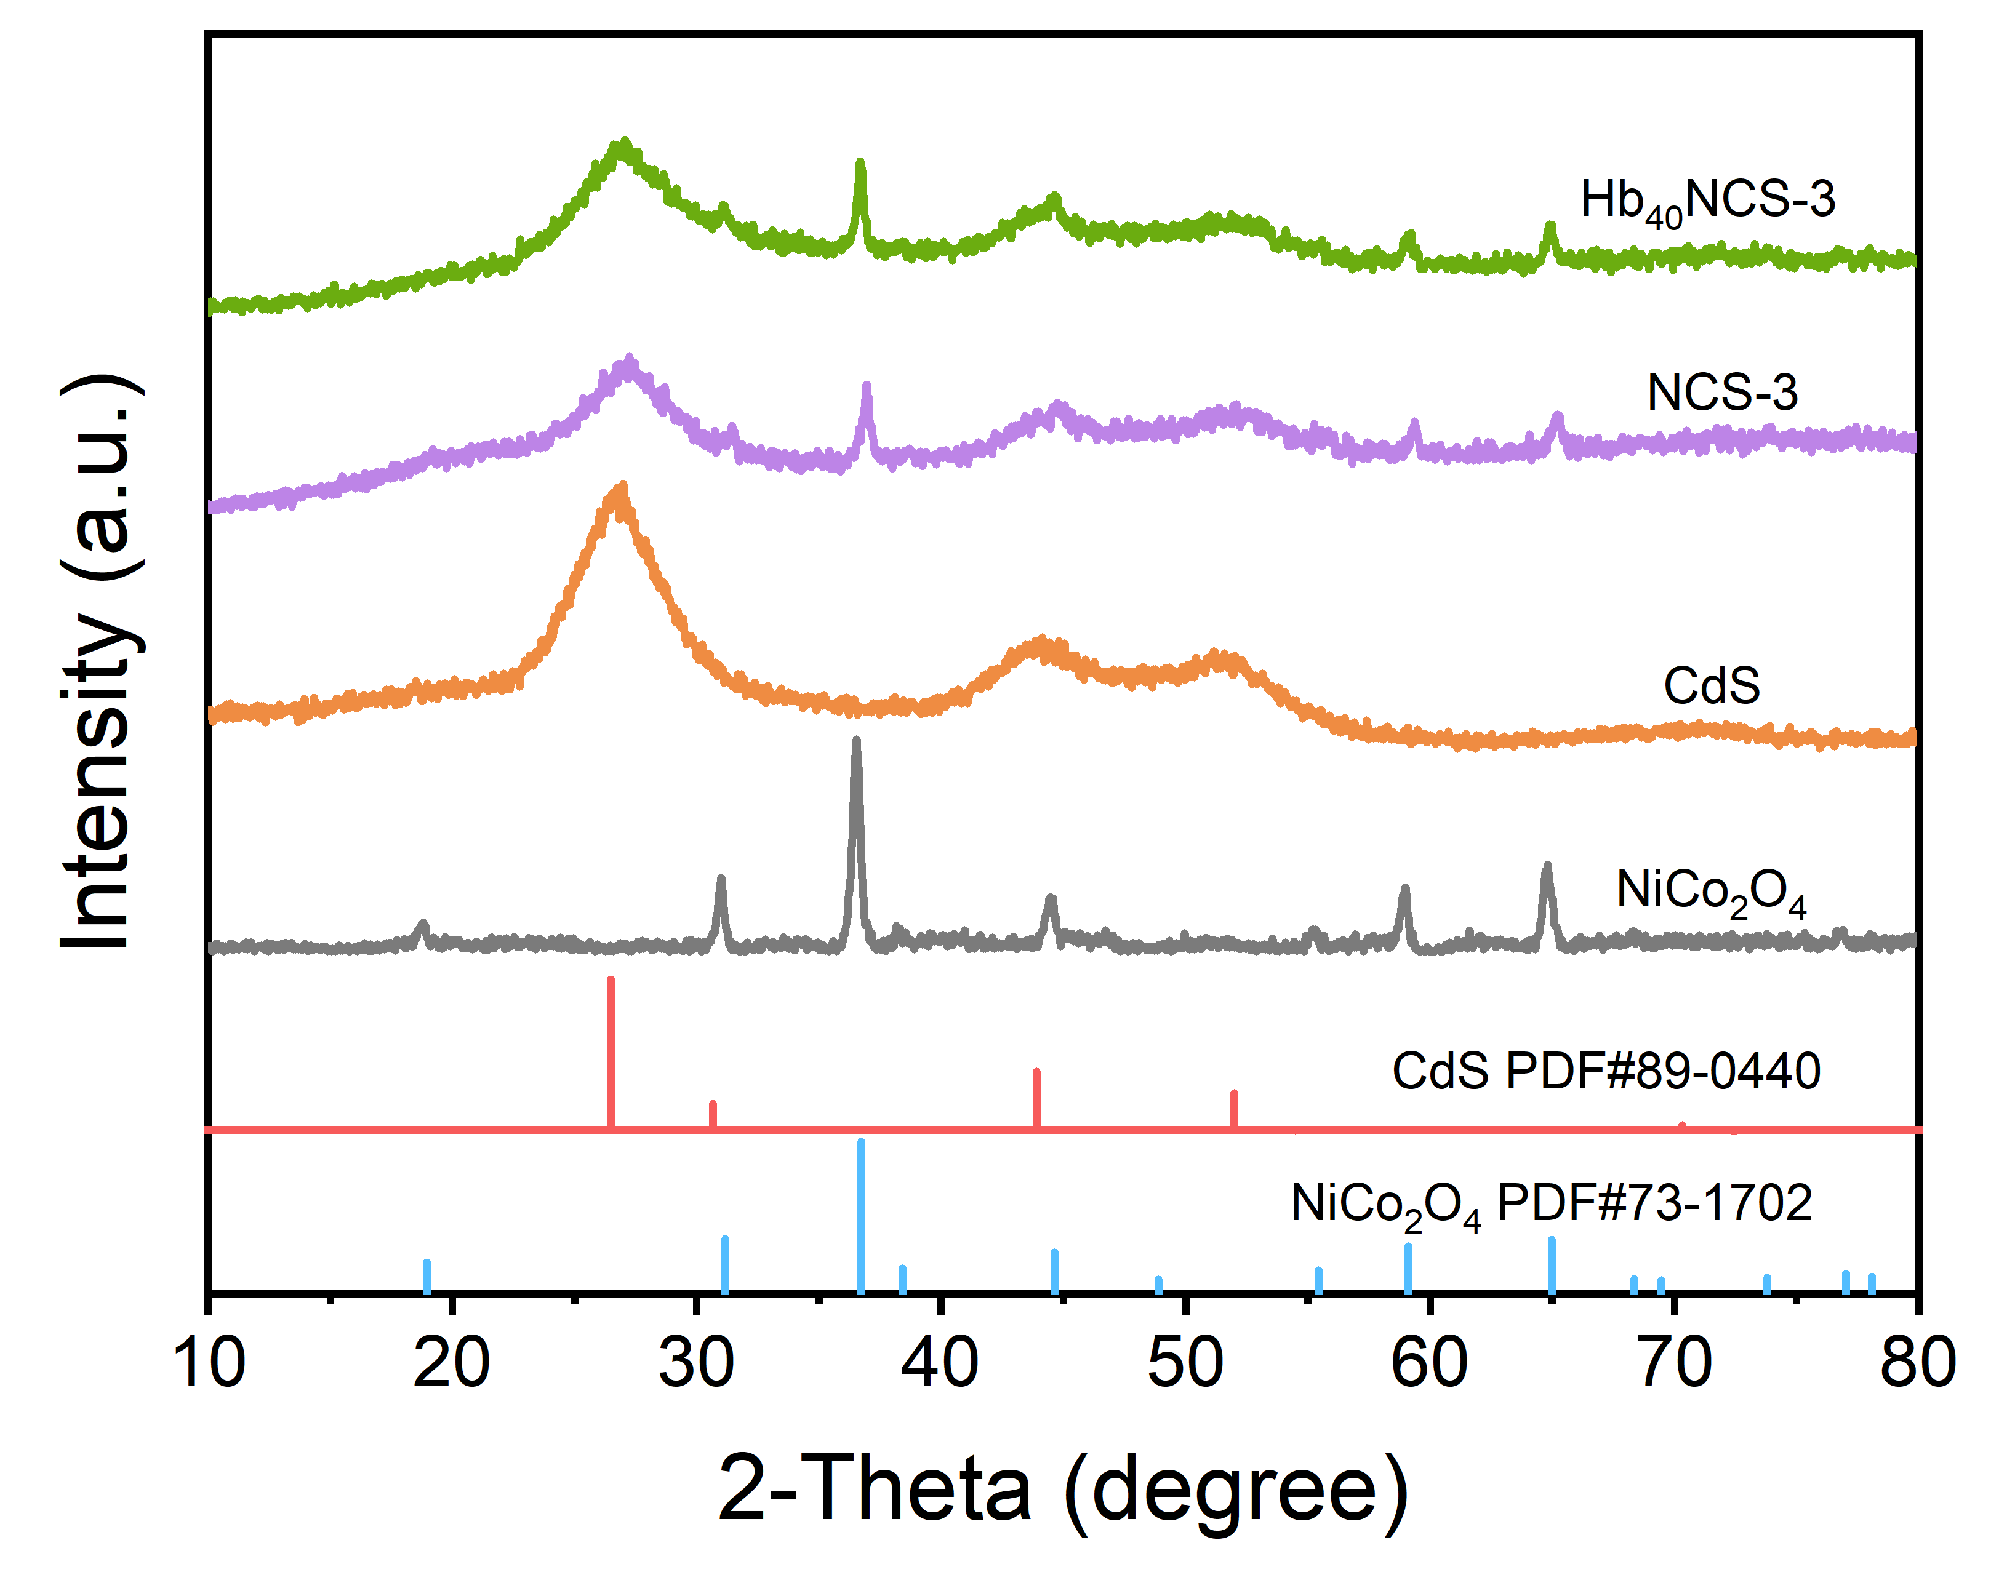
Figure S1 XRD patterns of the samples.

Sample | Theoretical doping (NiCo₂O₄) | Actual doping  (NiCo₂O₄)
NCS-1 | 7% | 4.0%
NCS-2 | 12.5% | 8.6%
NCS-3 | 22% | 20.4%
NCS-4 | 40% | 35.7%
Table S1 ICP-OES detection of NiCo₂O₄ doping results.
Sample | Theoretical doping (SiO₂) | Actual doping  (SiO₂)
Hb₁₀NCS-3 | 5% | 4.2%
Hb₂₀NCS-3 | 10% | 5.9%
Hb₄₀NCS-3 | 18% | 11.9%
Hb₈₀NCS-3 | 33% | 32.5%
Hl₄₀NCS-3 | 20% | 16.2%
Table S2 ICP-OES detection of SiO₂ doping results.

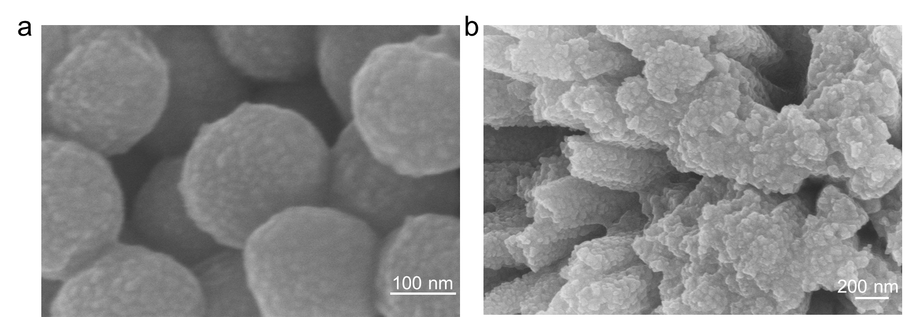 Figure S2 SEM image of (a) CdS and (b) NiCo₂O₄.

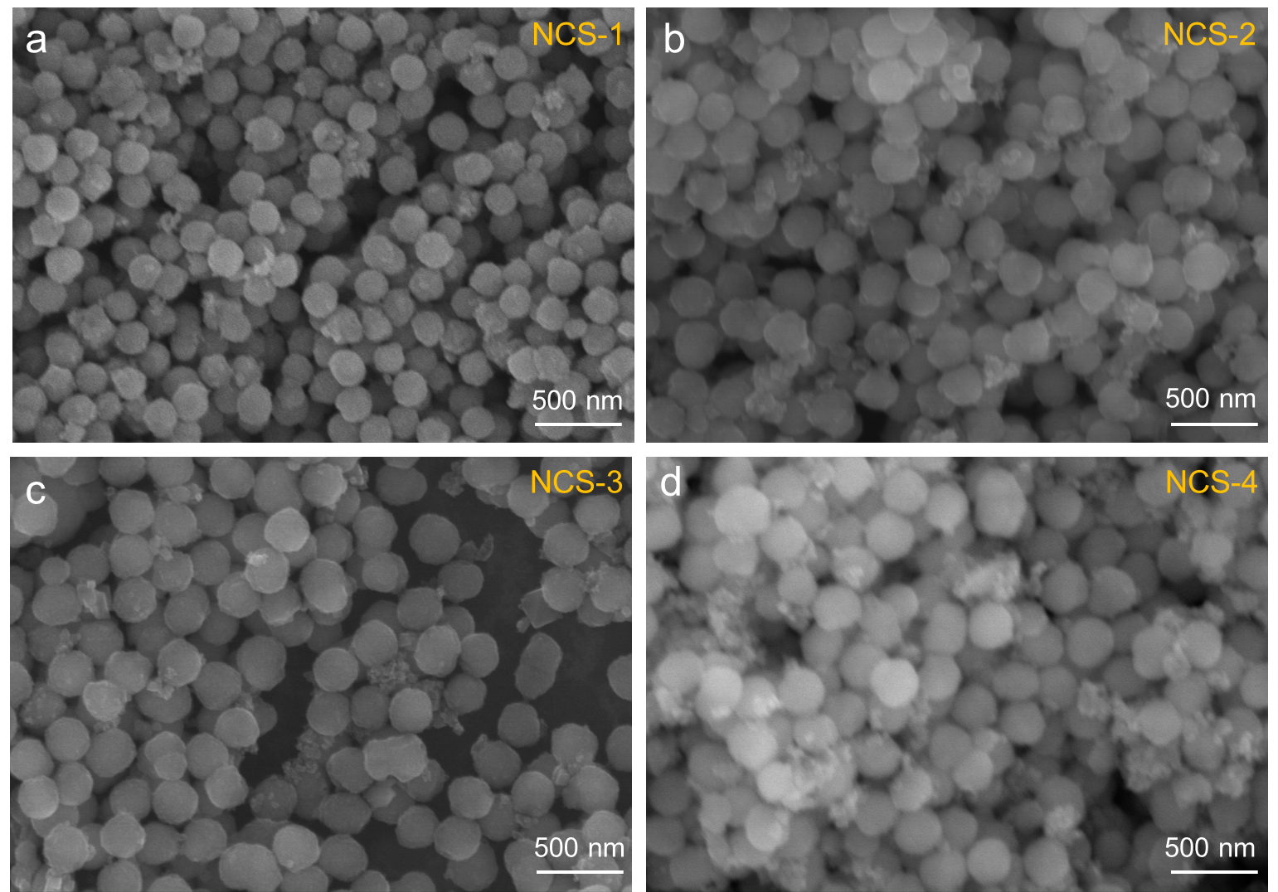
Figure S3 SEM images of the NCS series.

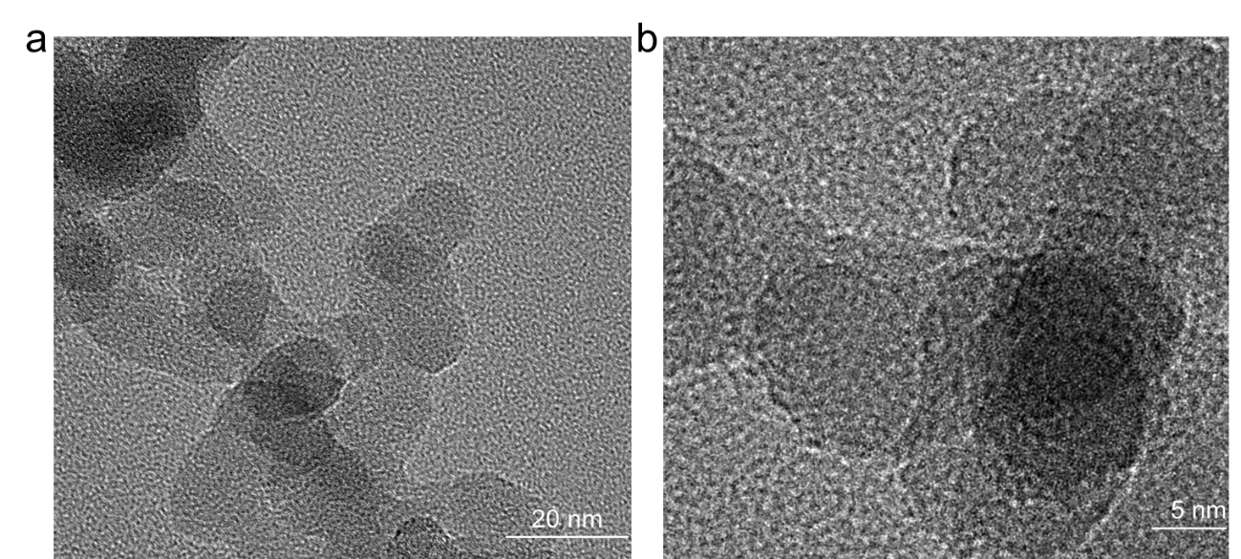
Figure S4 TEM images of Hydrophobic SiO₂.

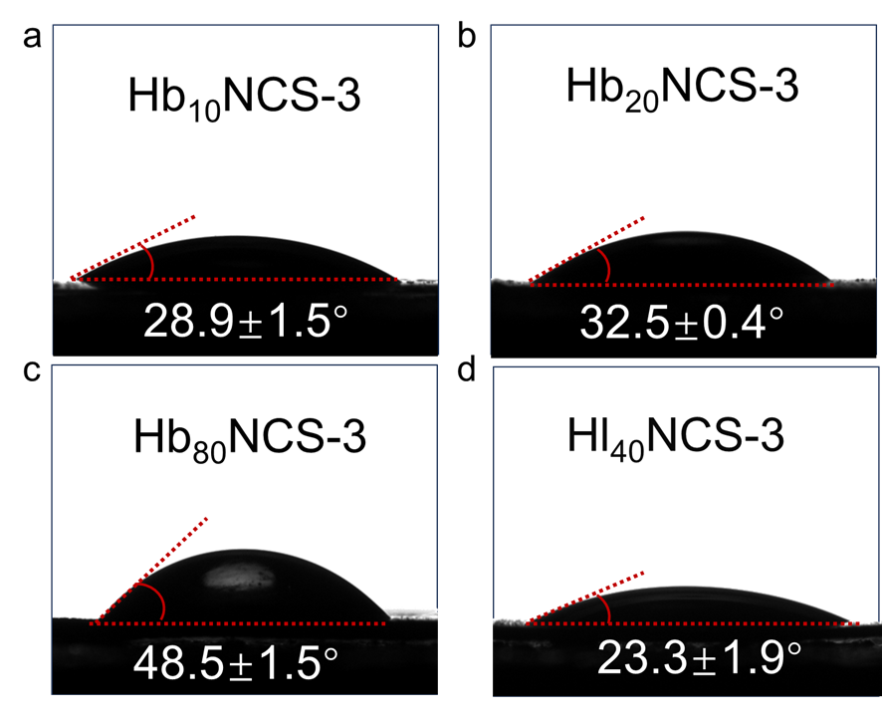
Figure S5 Water contact angles of different samples.
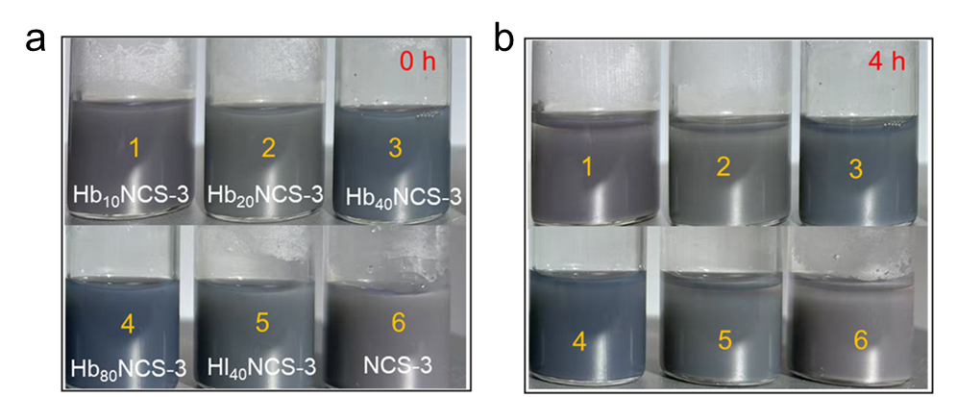
Figure S6 The dispersion of the samples at 0 hours and 4 hours.

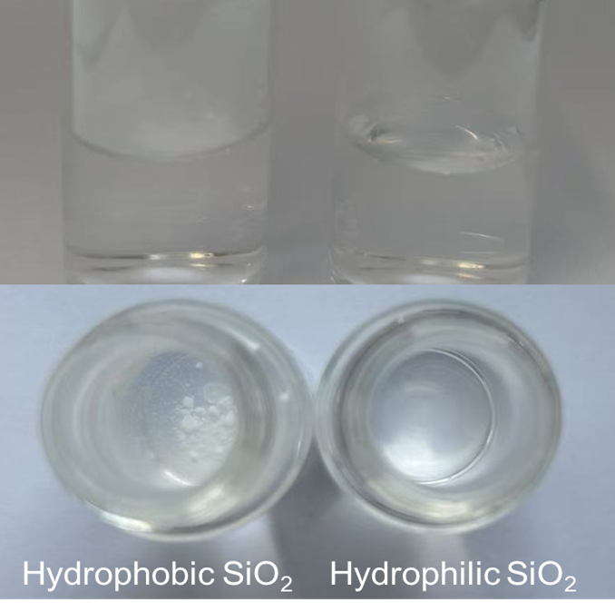
Figure S7 The dispersion of the Hydrophobic SiO₂ and Hydrophilic SiO₂.

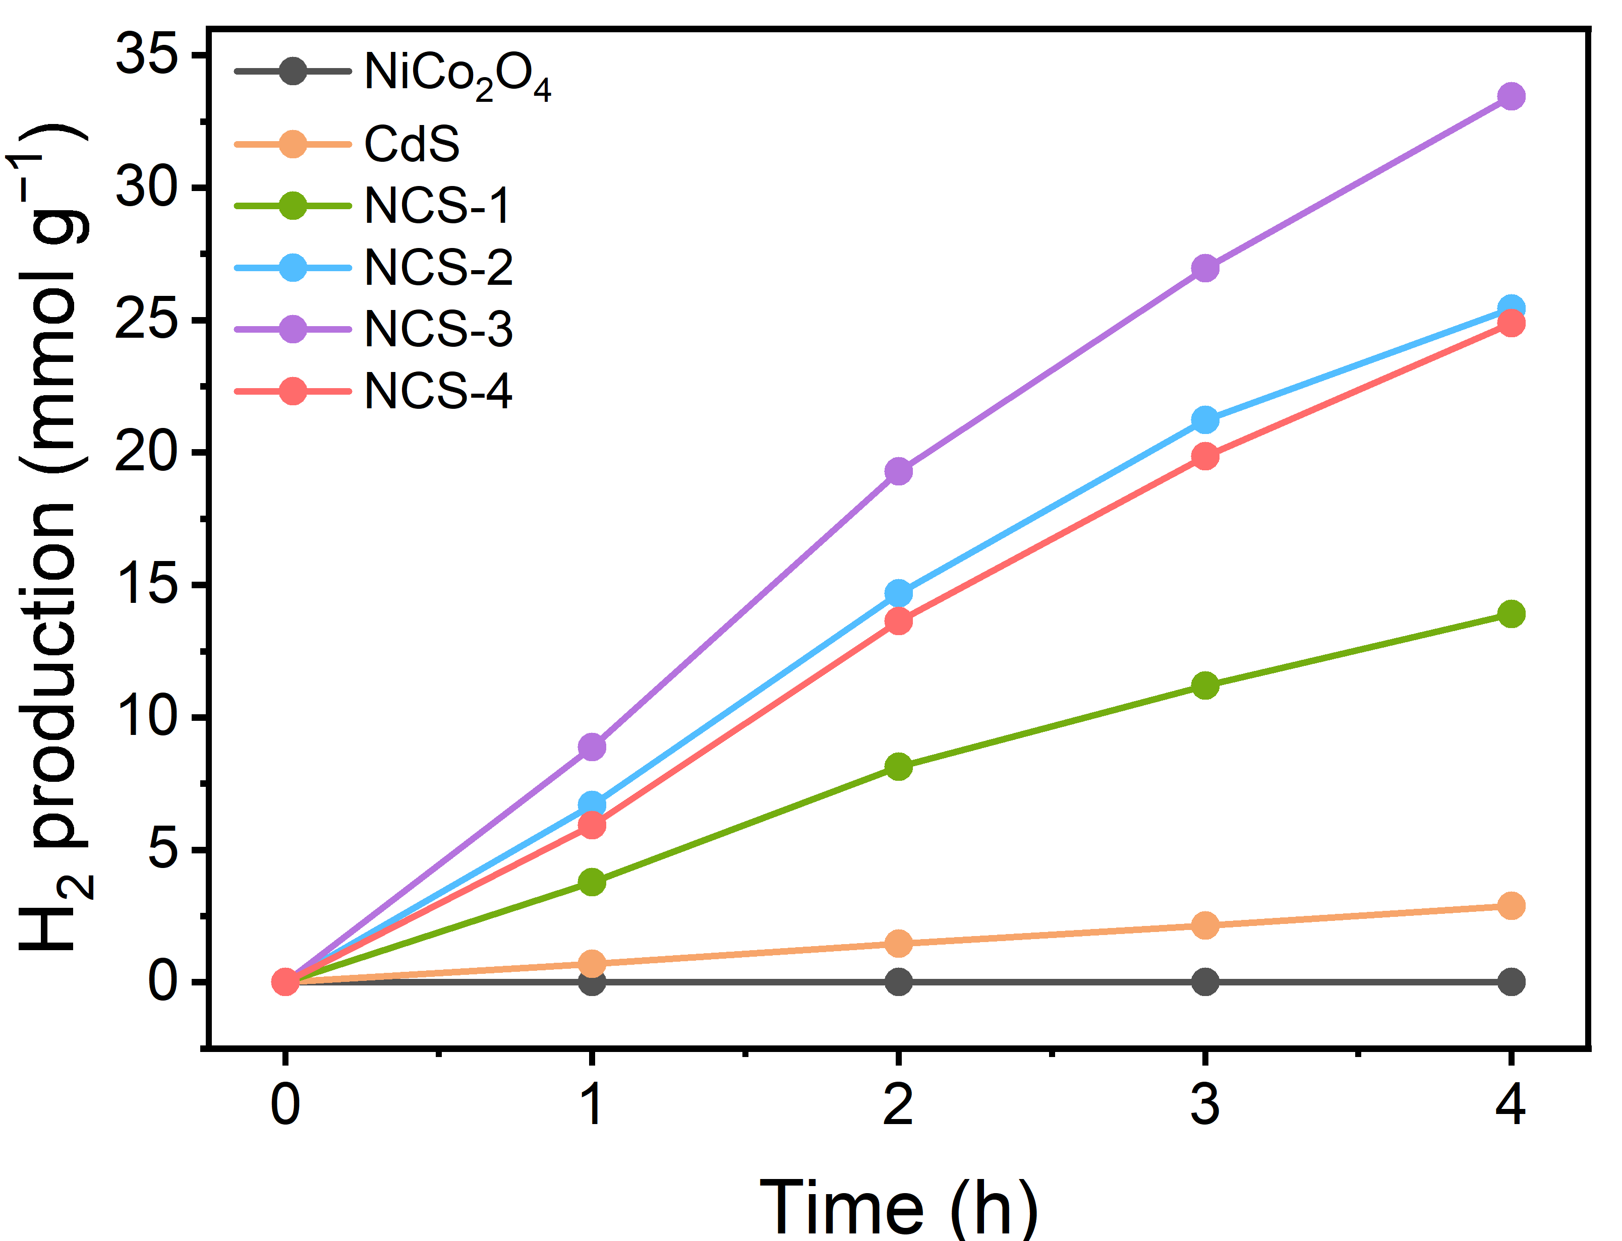
Figure S8 Photocatalytic activities of CdS, NiCo₂O₄ and different proportions.
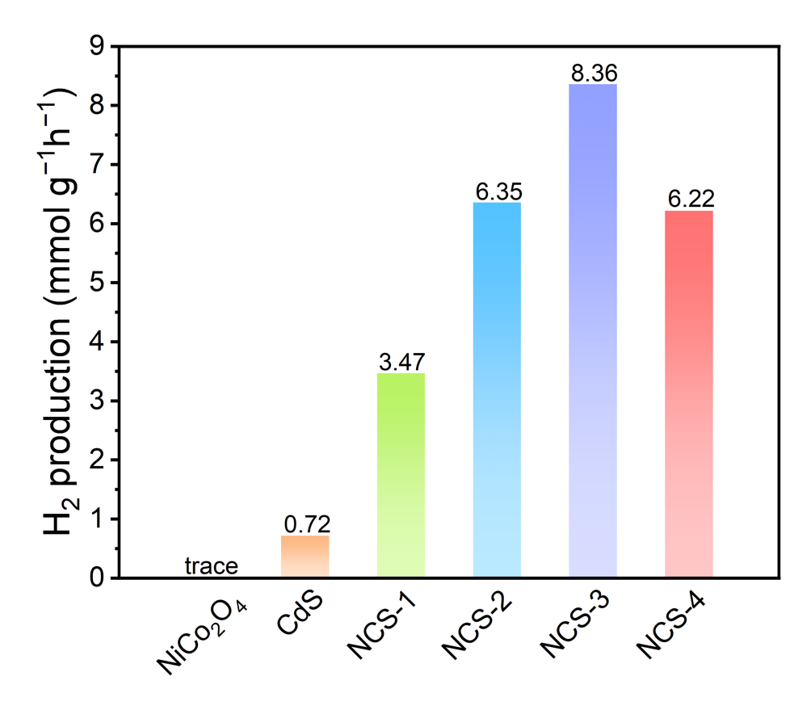
Figure S9 Comparison of hydrogen production under different ratios.

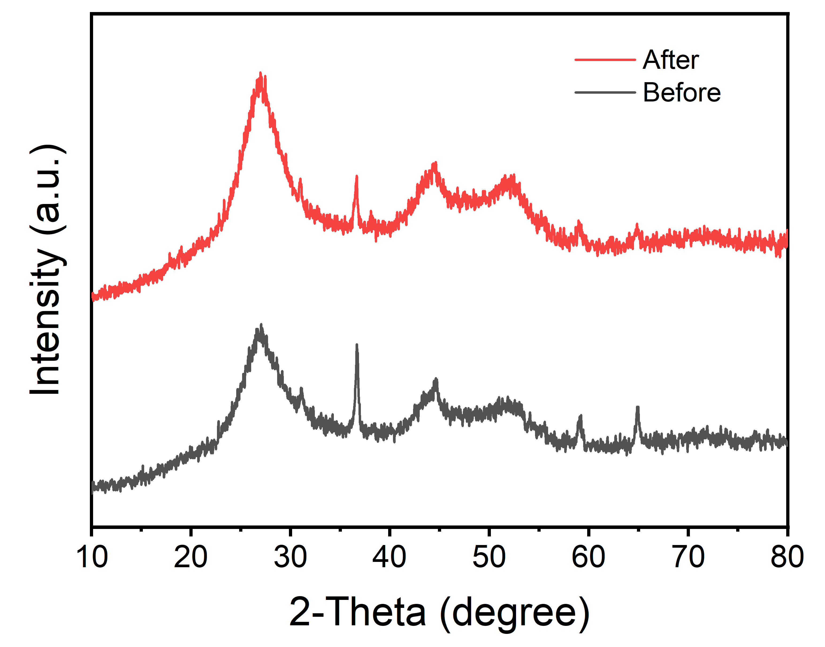
Figure S10 XRD diagram before and after hydrogen production of Hb₄₀NCS-3.
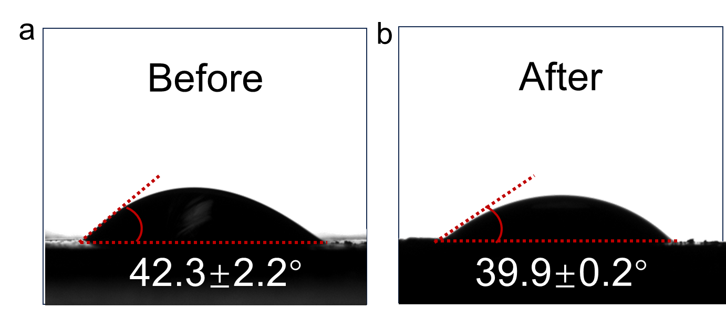
Figure S11 Water contact angles diagram before and after hydrogen production of Hb₄₀NCS-3.

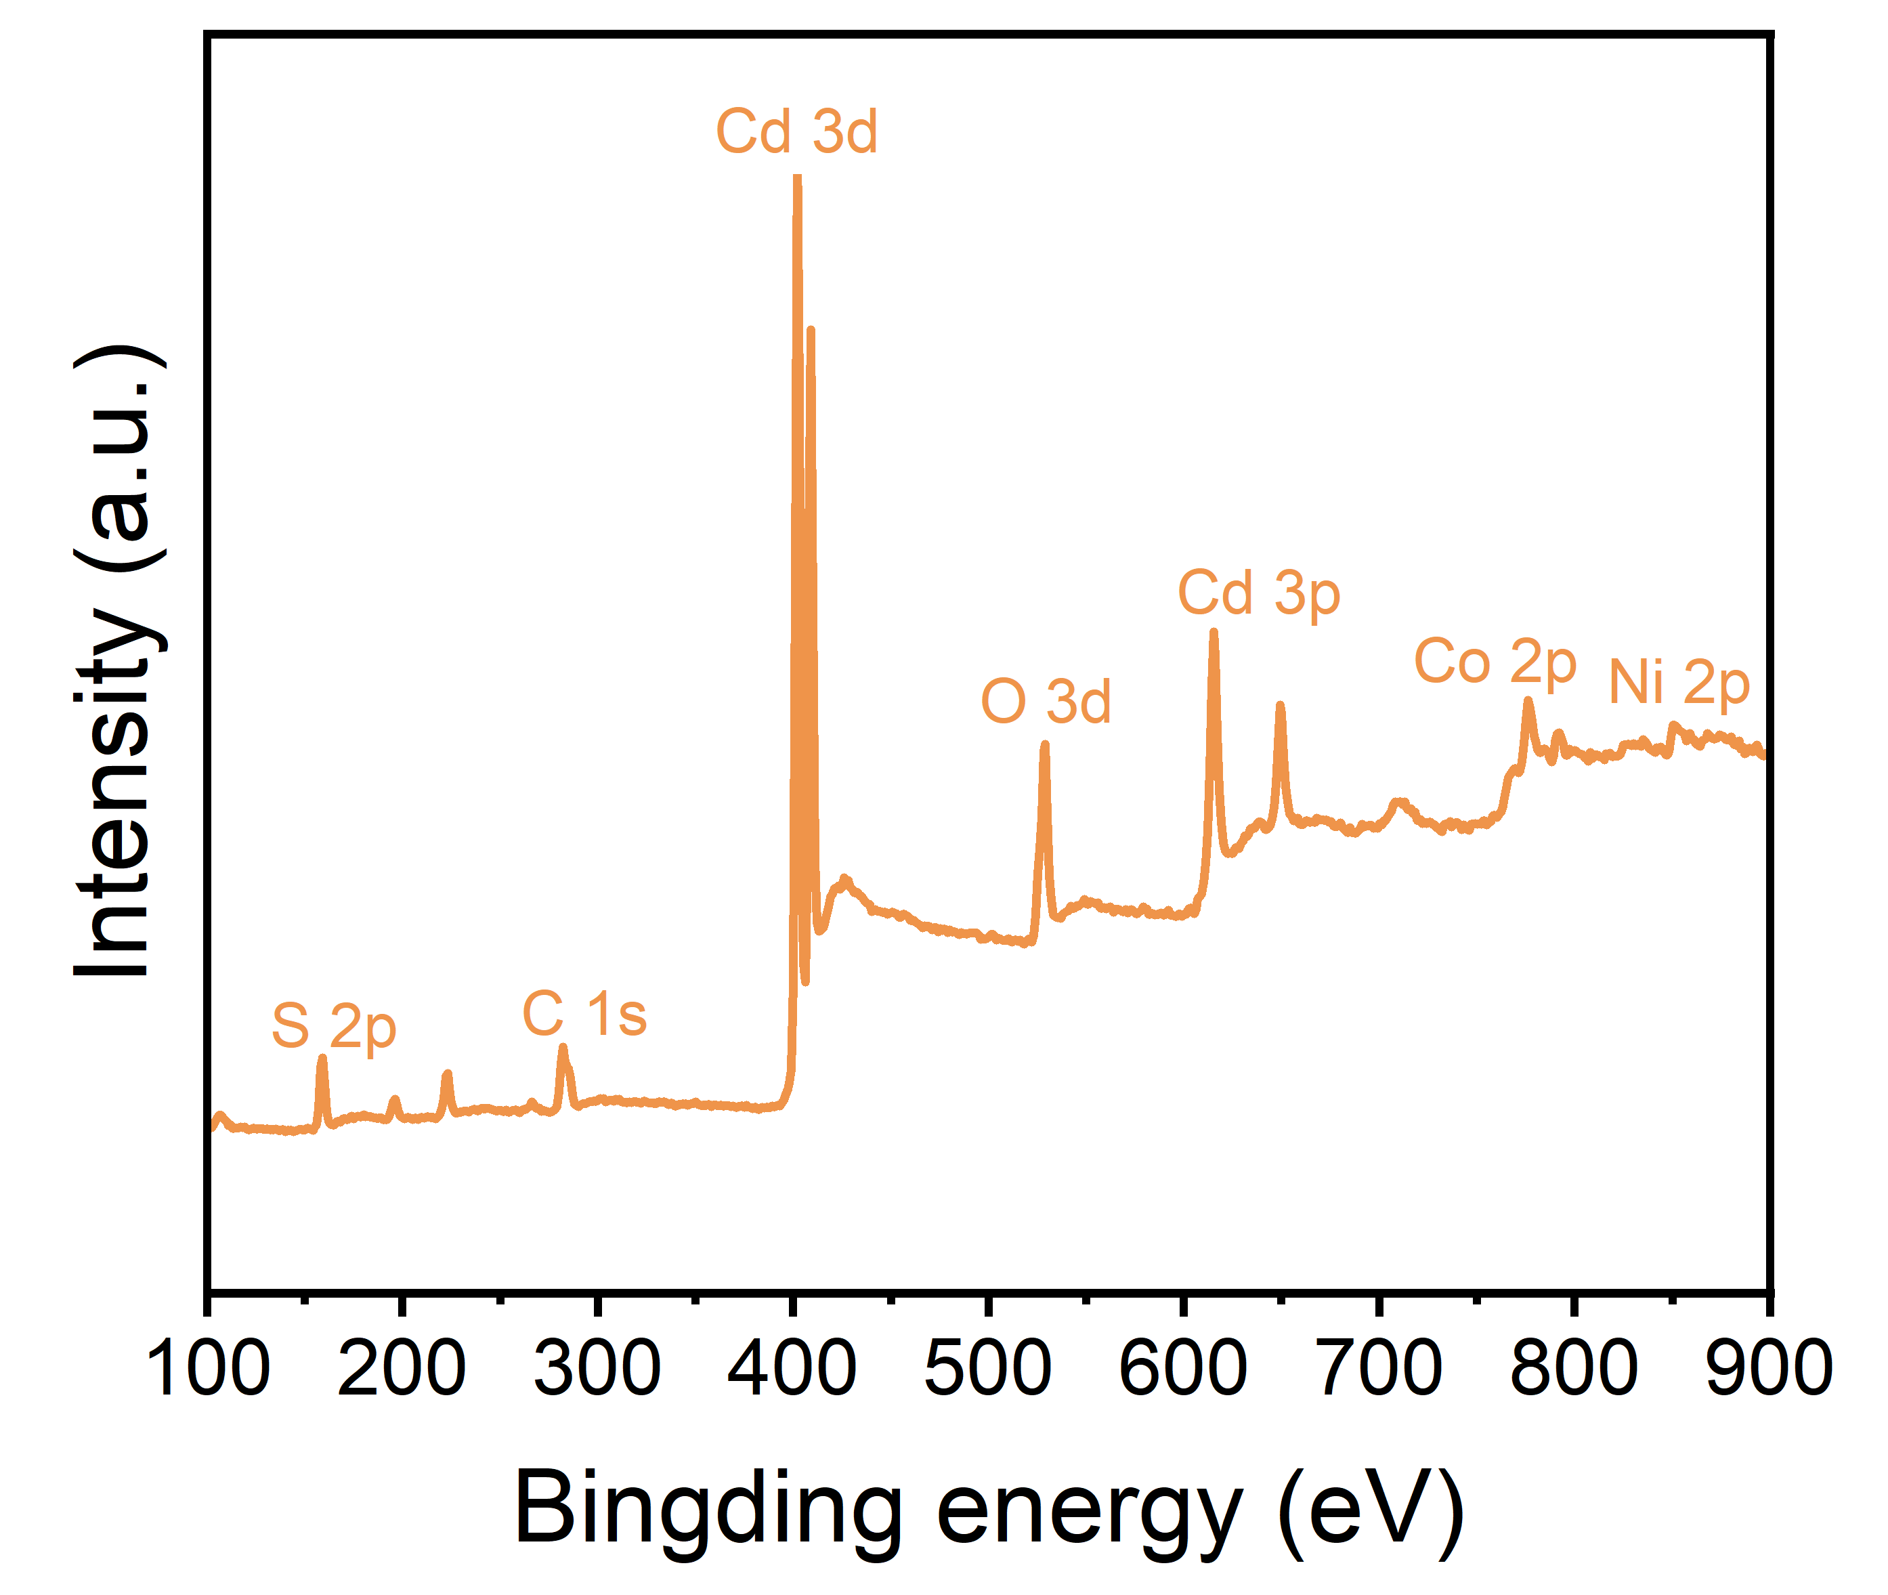
Figure S12 XPS survey scan spectra.

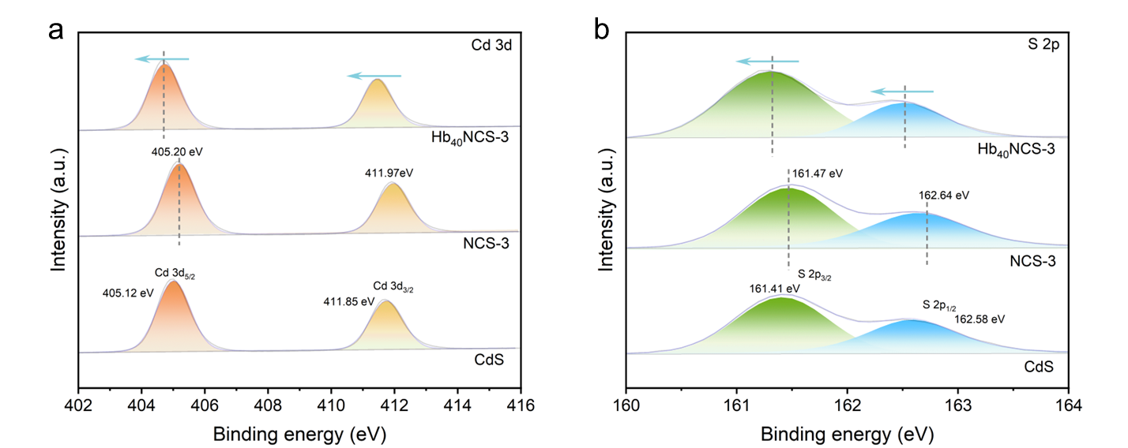
Figure S13 XPS spectra of Cd 3d and S 2p.

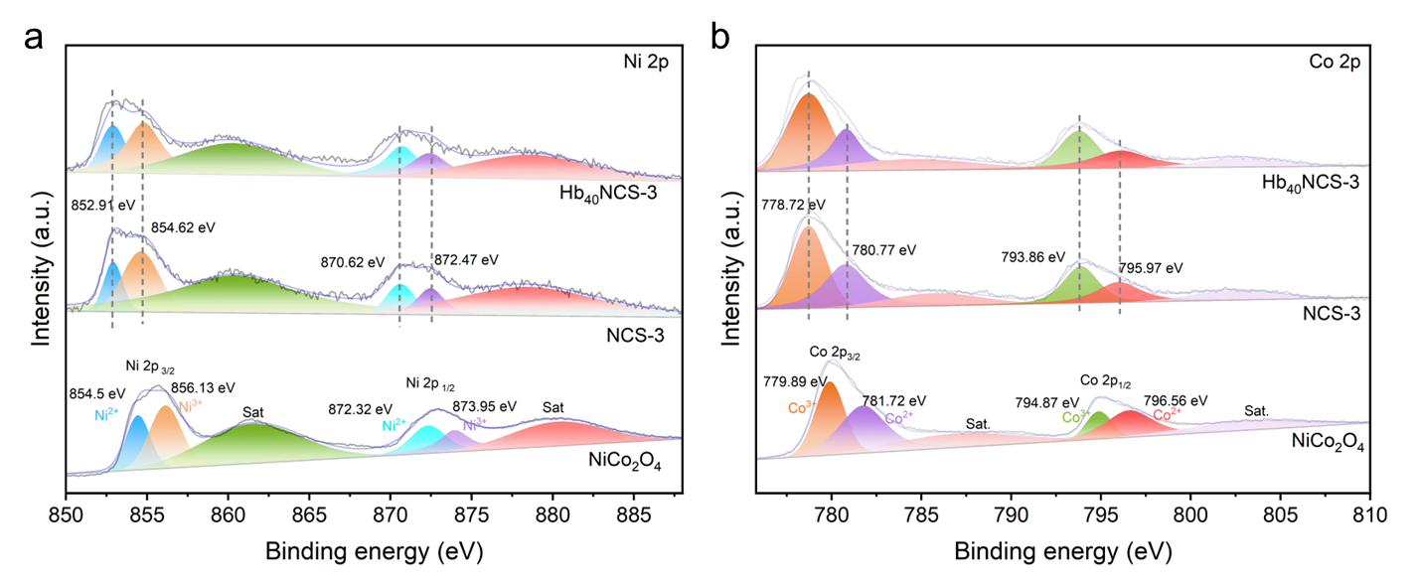
Figure S14 XPS spectra of Ni 2p and Co 2p.

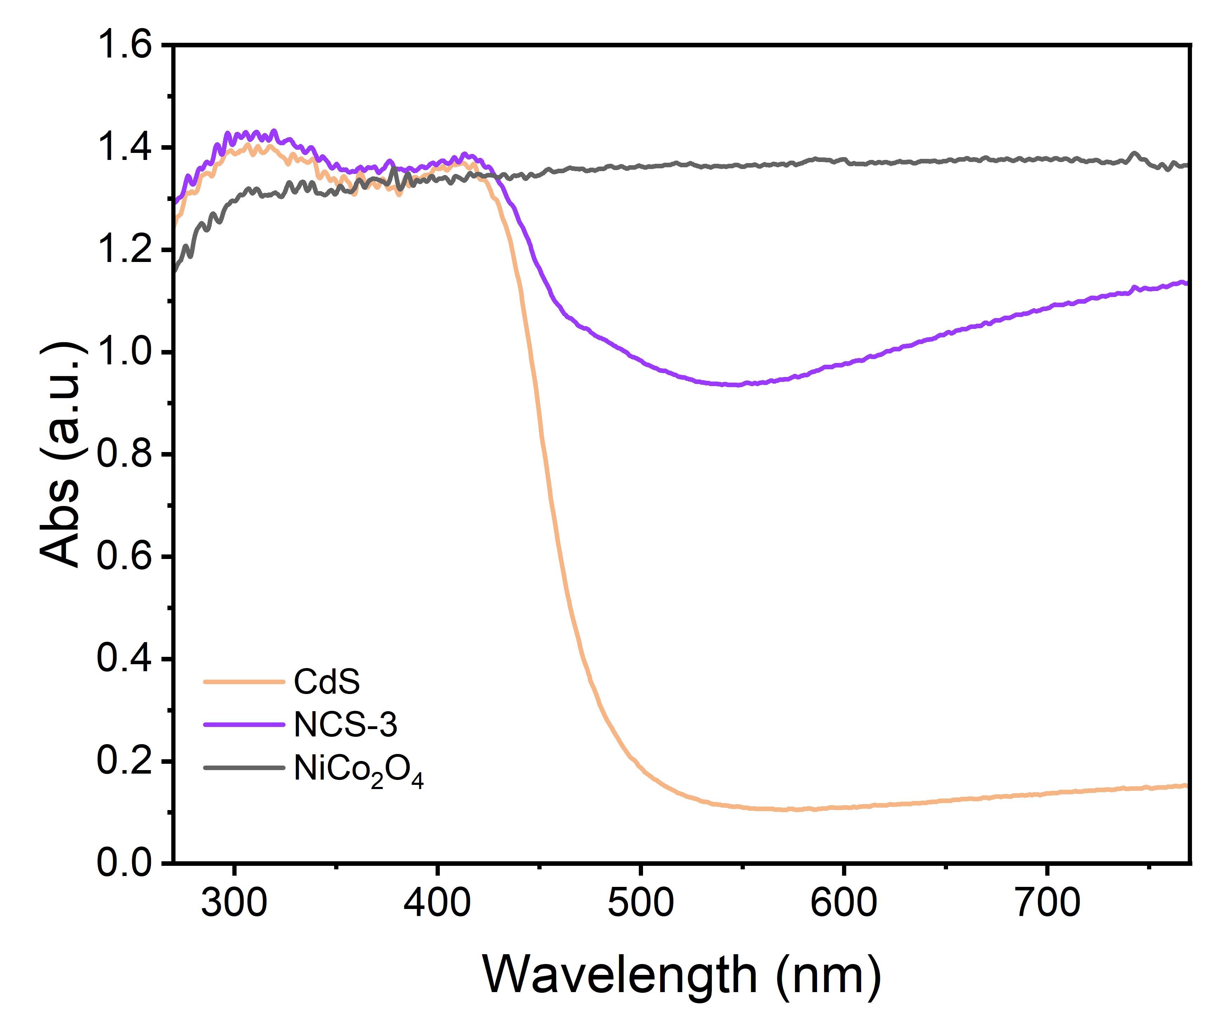
Figure S15 UV–vis absorption spectra of the samples.

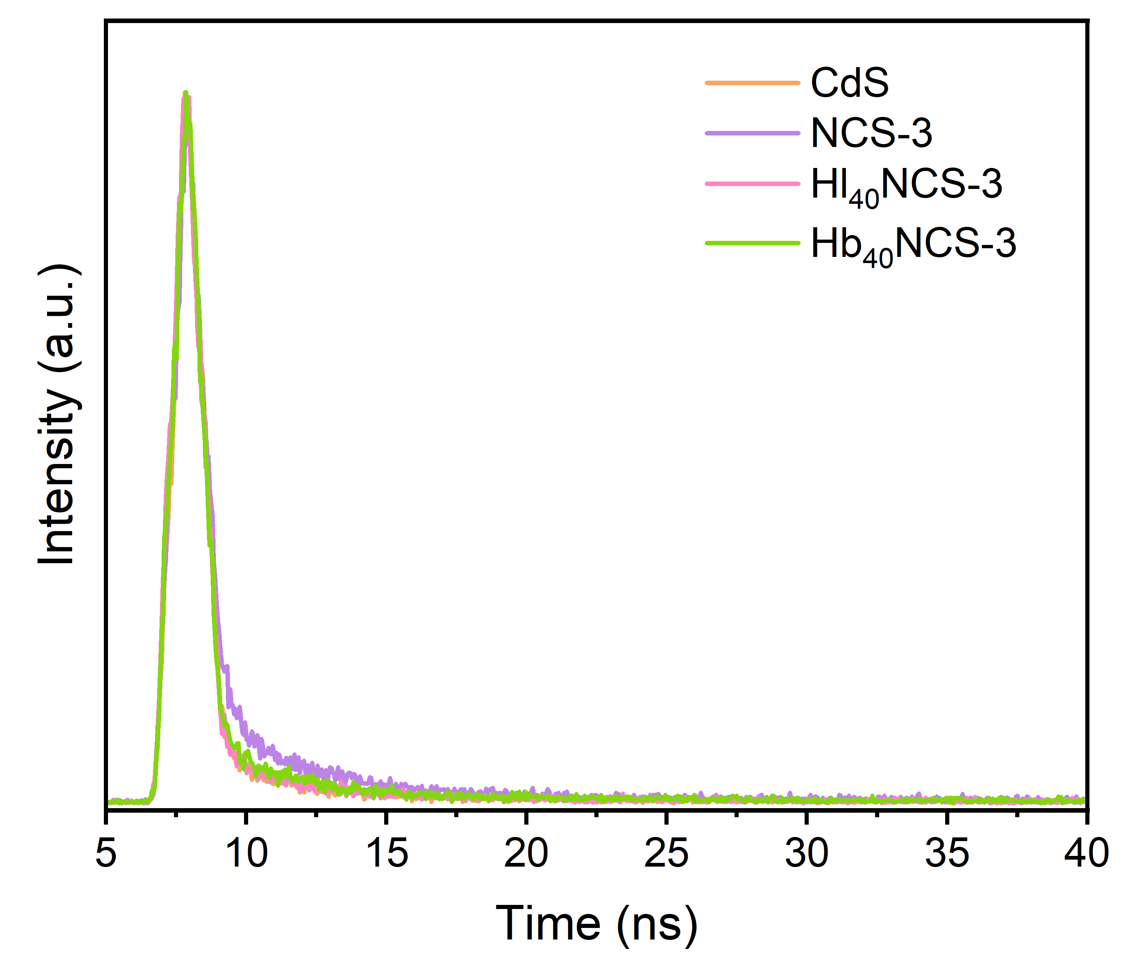
Figure S16 CdS, NCS-3, Hl₄₀NCS-3 and Hb₄₀NCS-3 of TRPL.

Table S3 Secondary fitting attenuation parameters for the average life time of CdS, NCS-3, Hl₄₀NCS-3 and Hb₄₀NCS-3.
Sample | τ1 (ns) | τ2 (ns) | τ3 (ns) | τ_{ave} (ns)
CdS | 0.57 | 4.22 | 31.85 | 23.55
NCS-3 | 0.64 | 3.91 | 18.70 | 13.21
Hl₄₀NCS-3 | 0.53 | 4.09 | 24.12 | 16.24
Hb₄₀NCS-3 | 0.53 | 3.61 | 19.14 | 14.13

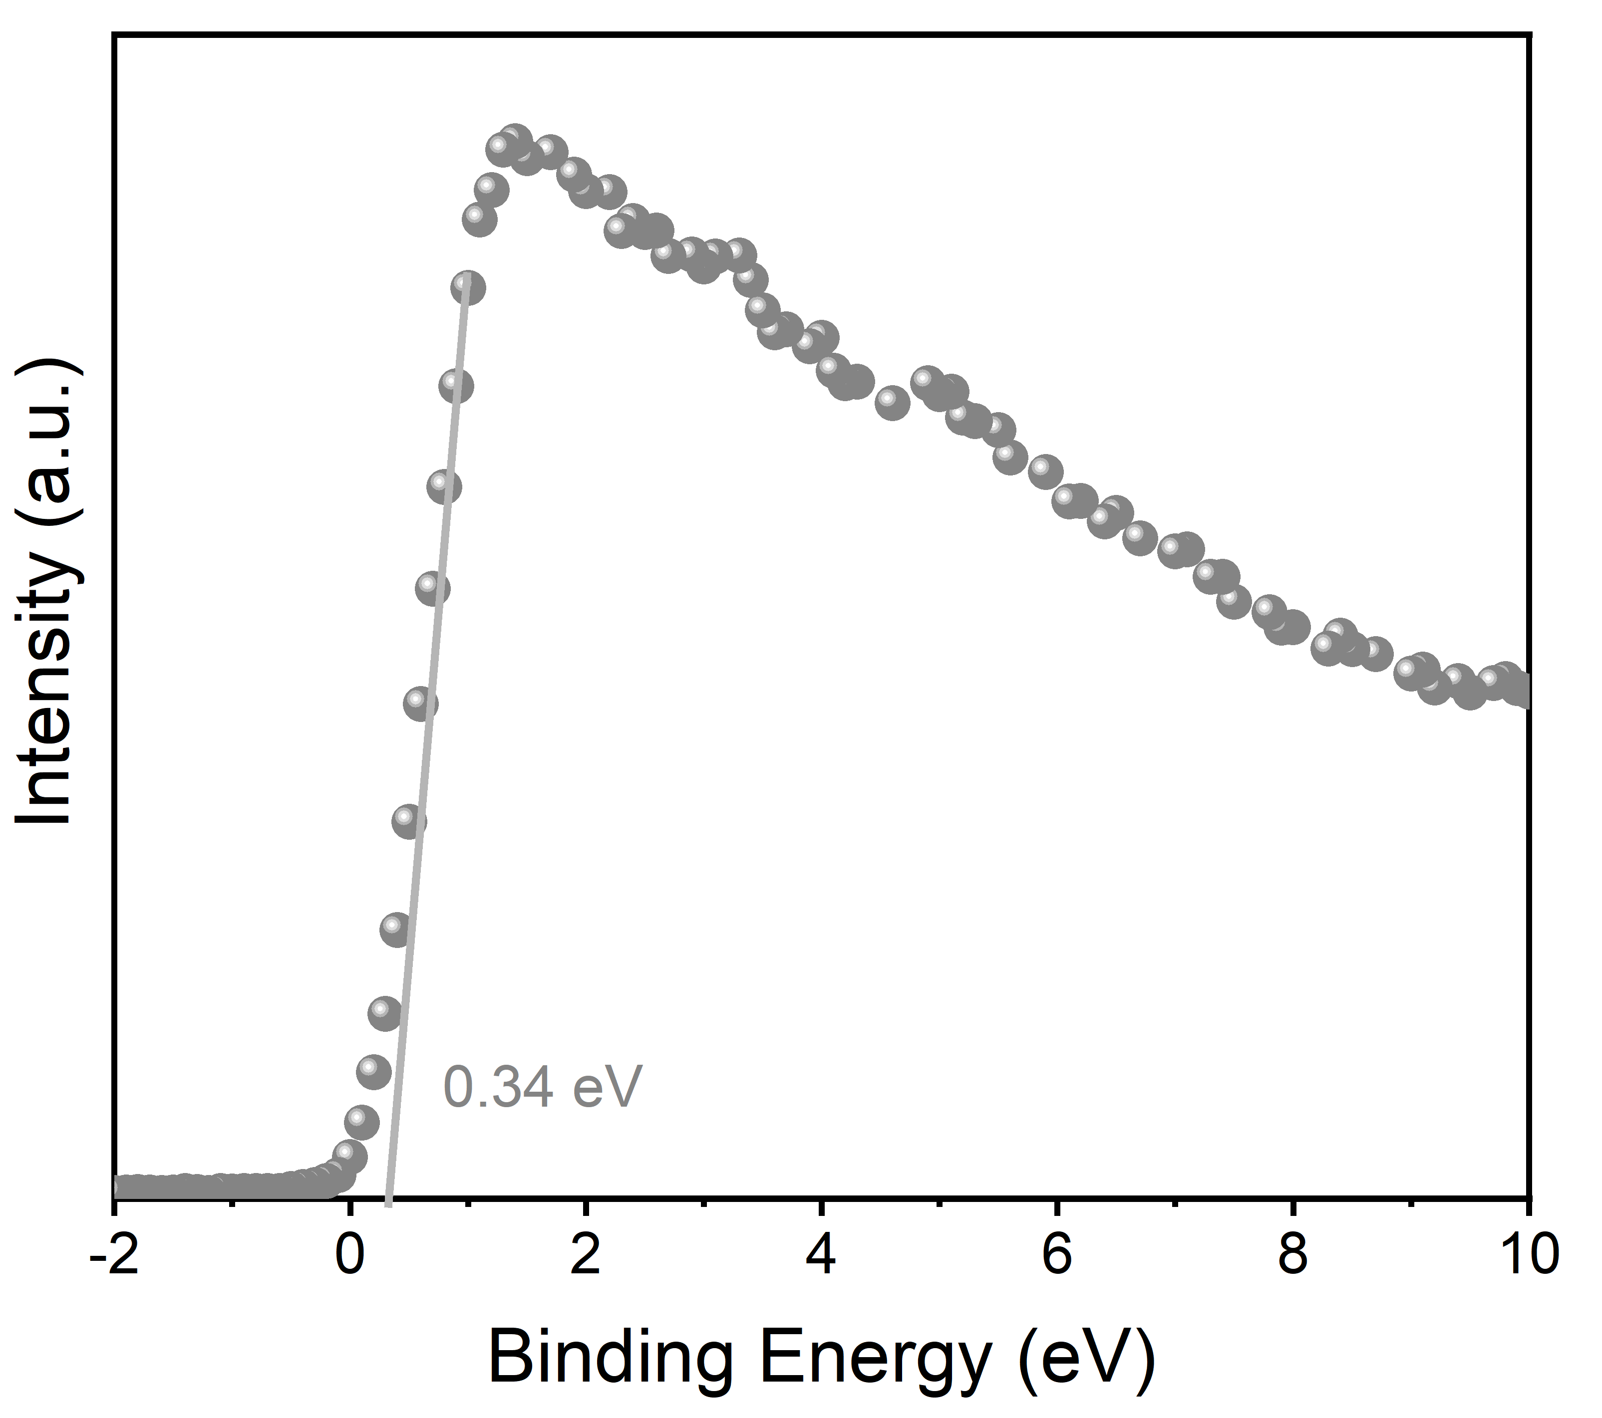
Figure S17 XPS valence band spectra of NiCo₂O₄.
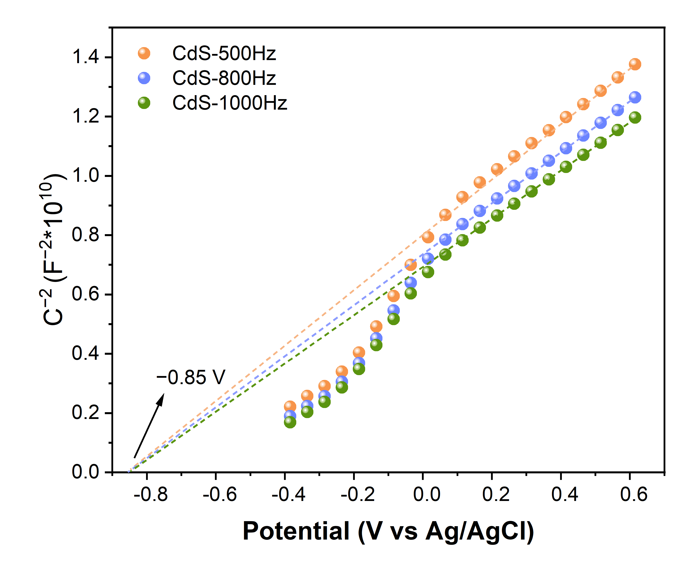
Figure S18 Mott-Schottky curve of the CdS.

