Electronic Supplementary Material
Sustainable hybrid supercapacitors based on CoFe₂O₄-C composite
M. Federico Ponce ()^{1,2,3}, Arminda Mamaní^{5,6}, Pamela B. Ramos^{3,1}, Florencia Jerez^{1,2,3}, Gerardo G. Acosta^{3,1,2}, Julia E. Tasca^{4,1,2}, Marcela A. Bavio^{1,2,3}
1 Centro de Investigaciones en Física e Ingeniería del Centro de la Provincia de Buenos Aires (CIFICEN), UNCPBA-CICPBA-CONICET, Olavarría B7400JWI, Argentina
2 Consejo Nacional de Investigaciones Científicas y Técnicas (CONICET), CCT Tandil, Paraje Arroyo Seco (Campus Universitario), Tandil B7000, Argentina
3 Universidad Nacional del Centro de la Provincia de Buenos Aires (UNCPBA), Facultad de Ingeniería, INTELYMEC, Olavarría B7400JWI, Argentina
4 Universidad Nacional del Centro de la Provincia de Buenos Aires (UNCPBA), Facultad de Ingeniería, INMAT, Olavarría B7400JWI, Argentina
5 Instituto de Ingeniería Química, Universidad Nacional de San Juan (UNSJ), San Juan J5400ARL, Argentina
6 Consejo Nacional de Investigaciones Científicas y Técnicas (CONICET), CCT San Juan, San Juan J5400ARL, Argentina
E-mail: federicoponcee@gmail.com
The capacitive and diffusive contributions to the current response in cyclic voltammetry were deconvoluted by applying the v-v^{1/2} model with a correction. The v-v^{1/2} model is based on a linear regression which often has limitations, as it does not always fit the experimental data and the error can be high. Therefore, Pervez and Iqbal proposed a corrected model based on a quadratic regression, whose equation is as follows:
$$I\left(v,V\right)=β_{1}v+β_{2}v^{1/2}+β_{3}v^{3/2}$$
Where $β_{1}v$ is the capacitive+pseudocapacitive current and $β_{2}v^{1/2}+β_{3}v^{3/2}$ is the diffusive current, being $β_{1}$, $β_{2}$ and $β_{3}$ the regression parameters. Dividing the above equation by $v^{1/2}$ gives the following:
$$\frac{I\left(v,V\right)}{v^{1/2}}=β_{1}v^{1/2}+β_{2}+β_{3}v$$
Where $\frac{I\left(v,V\right)}{v^{1/2}}$ is a quadratic function of $v^{1/2}$.
The fits at different potentials are shown in Fig. SI-1.
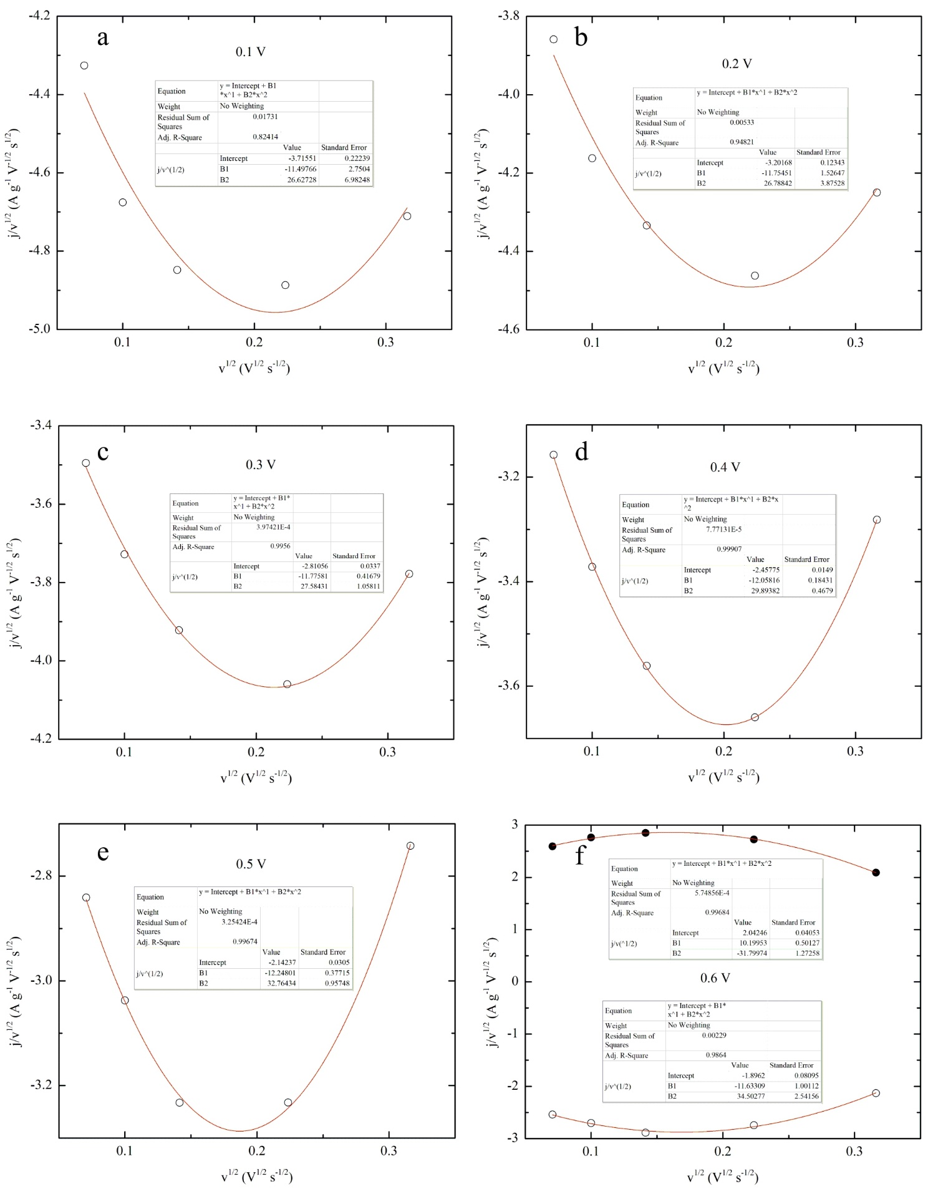

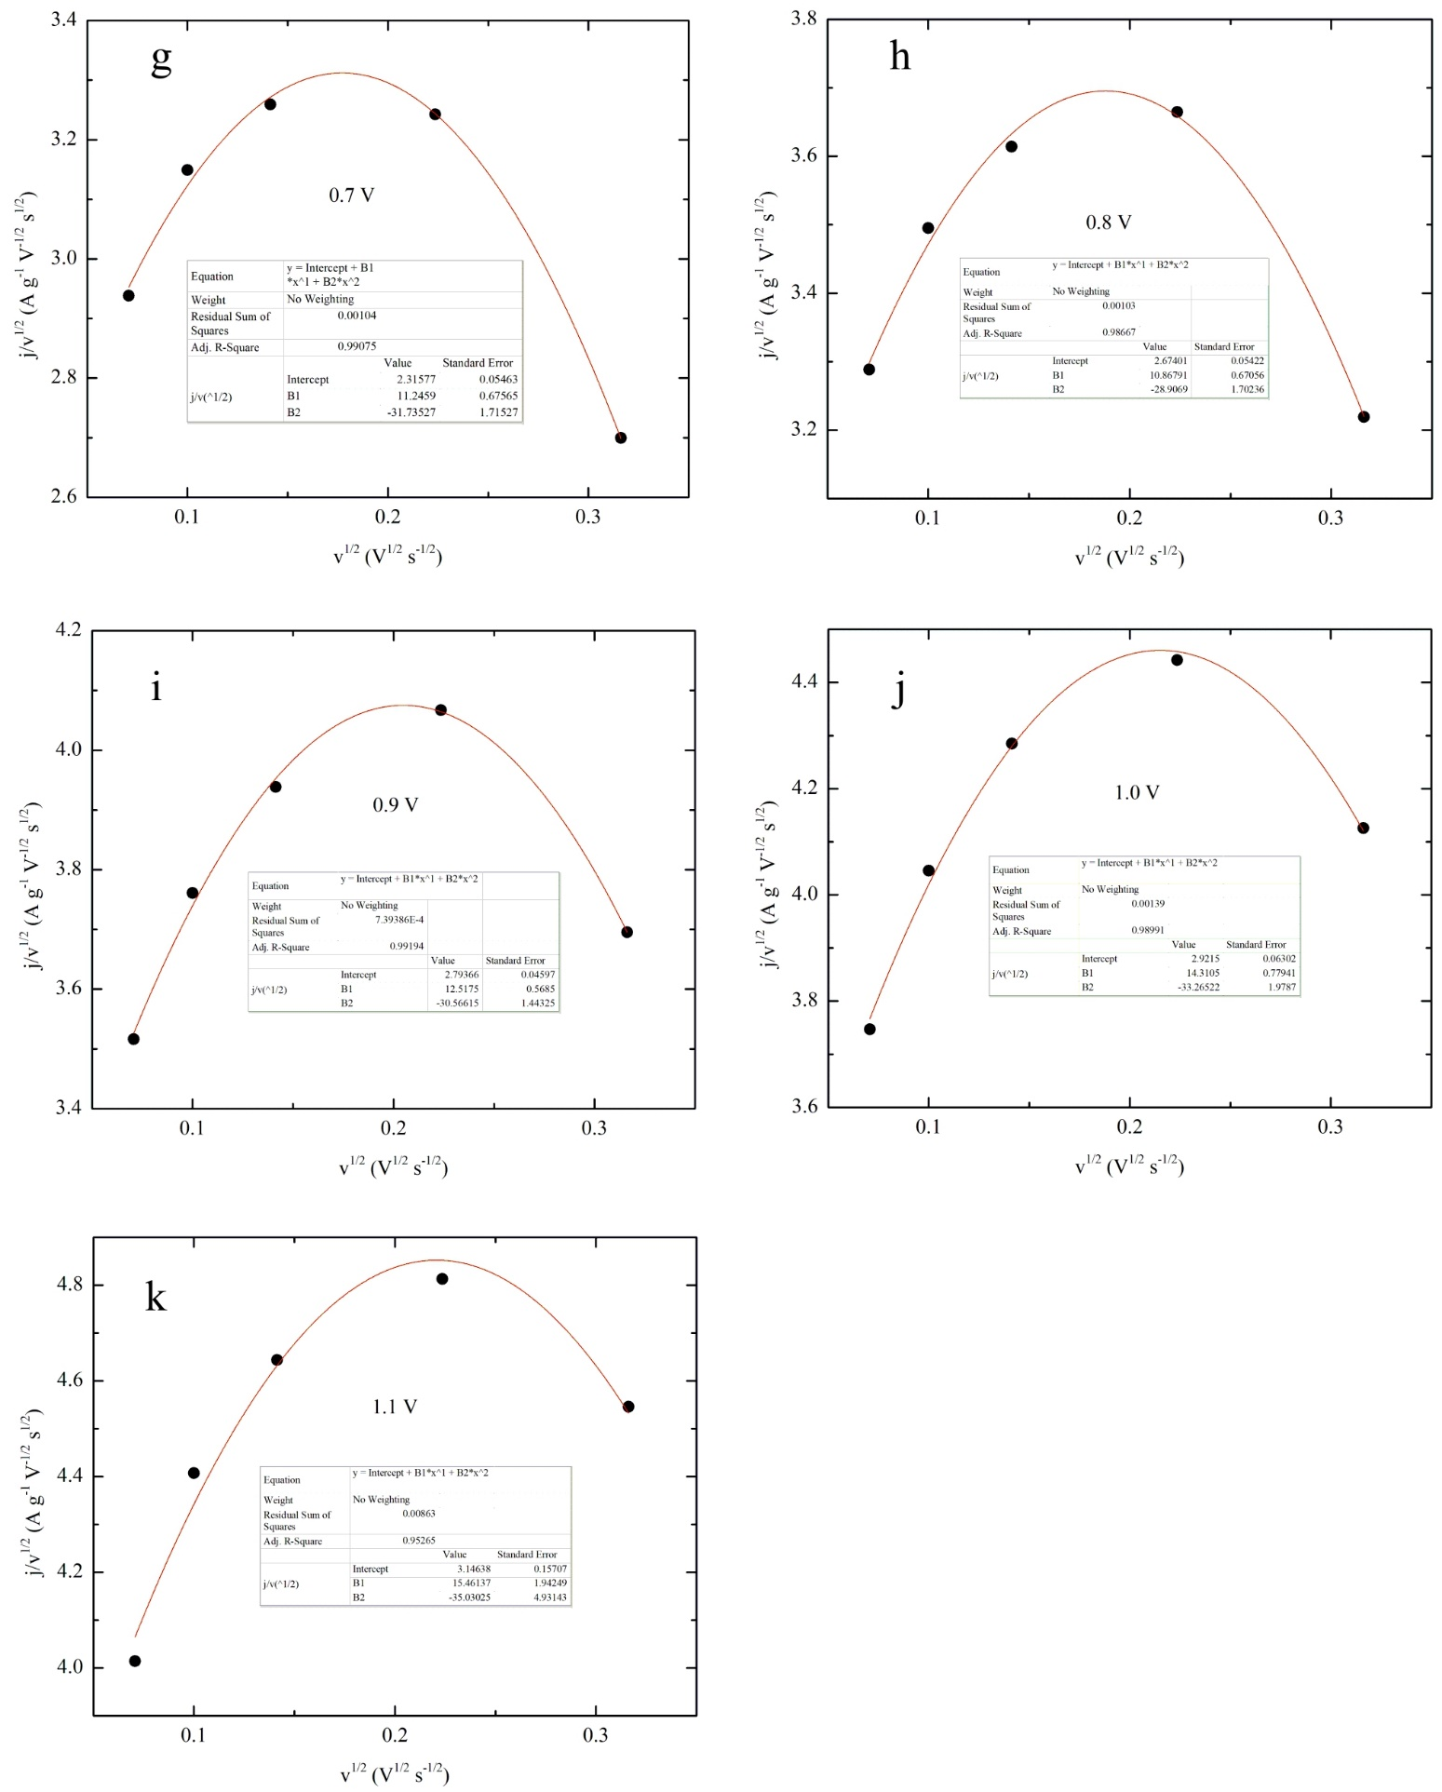
Fig. SI-1. Fits of cyclic voltammetry data with the corrected v-v^{1/2} model, at different potentials.

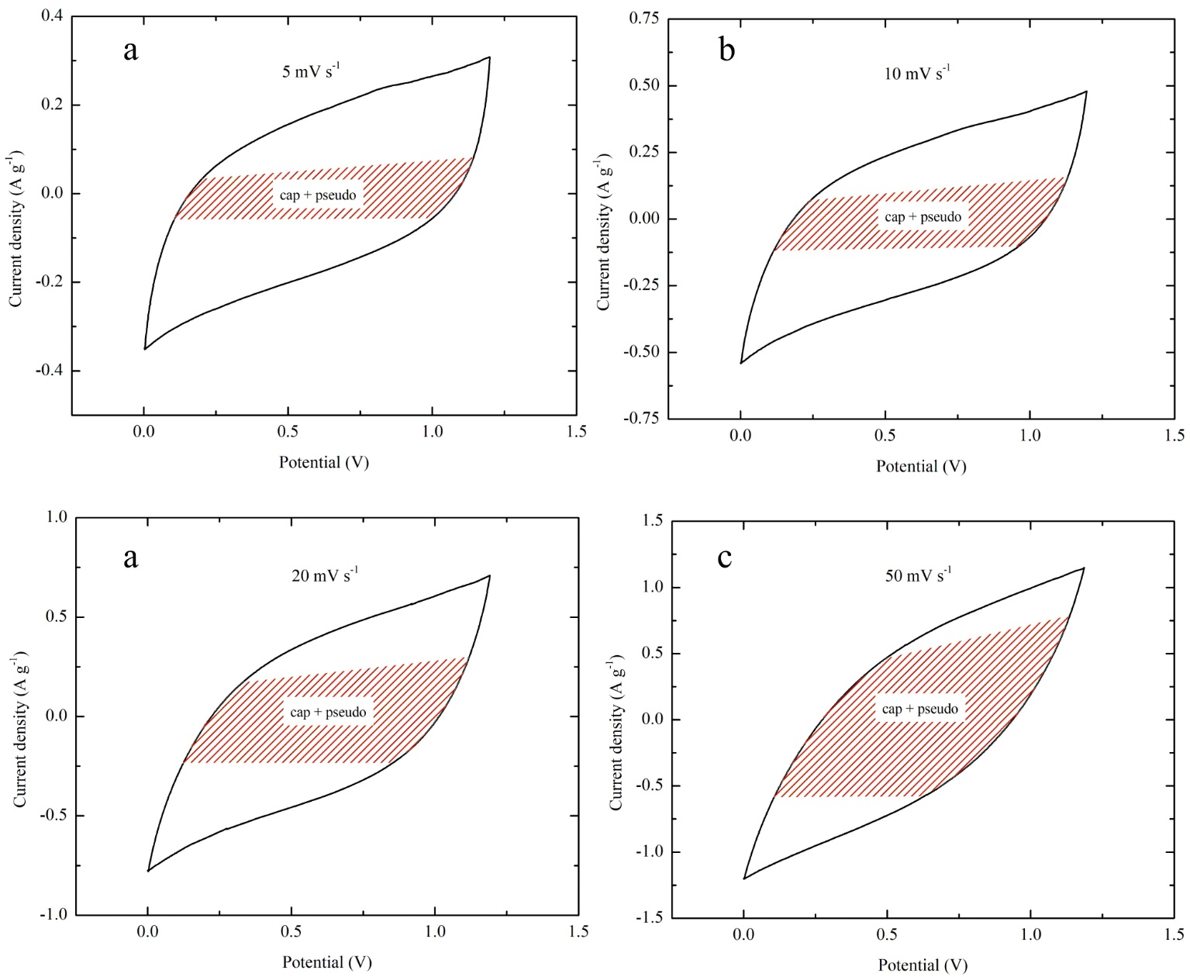
Fig. SI-2. Capacitive-pseudocapacitive contribution to the current response, at different scan rates.

Pervez S, Iqbal M Z. Capacitive and Diffusive Contributions in Supercapacitors and Batteries: A Critique of b-Value and the ν–ν1/2 Model. Small, 2023, 19(48): 2305059. https://doi.org/https://doi.org/10.1002/smll.202305059

