Electronic Supplementary Material

Critical role of CoO modification on Pt/Al₂O₃ for efficient H18-DBT dehydrogenation in LOHC systems
Ligang Zhang^{1,2}, Rudong Liu^{1,2}, Chang Xu^{1,2}, Chuanze Feng², Sicong Qiu^{1,2}, Nian Lei^{1,2}, Kuo Liu ()², Tao Zhang^{1,3}
1 School of Chemical Sciences, University of Chinese Academy of Sciences, Beijing 101408, China
2 State Key Laboratory of Mesoscience and Engineering, Beijing Key Laboratory of Ionic Liquids Clean Process, Institute of Process Engineering, Chinese Academy of Sciences, Innovation Academy for Green Manufacture, Chinese Academy of Sciences, Beijing 100190, China
3 CAS Key Laboratory of Science and Technology on Applied Catalysis, Dalian Institute of Chemical Physics, Chinese Academy of Sciences, Dalian 116023, China
E-mail: kuoliu@ipe.ac.cn

Supplementary References
Text SM Characterization
Nitrogen adsorption-desorption measurements were performed at -196 °C using a
Quantachrome Autosorb-iQ instrument. The specific surface areas (S_{BET}) were calculated from the N₂ adsorption isotherm with BET equation, and the pore size distribution was obtained using desorption branch of the isotherms and BJH method. Prior to the physisorption measurements, the sample was firstly pretreated under vacuum at 200 °C for 8 hours.
Power X-ray diffraction (XRD) patterns were recorded on a Rigaku SmartLab diffractometer equipped with a Cu Kα radiation source (λ = 0.15432 nm). The X-ray patterns of reduced samples were collected in the 2θ range from 10° to 90°.
Raman spectra were measured with a laser micro-confocal Raman spectrometer (InVia Reflex, Renishaw) to investigate the surface structure of catalysts, and a laser at 532 nm was used as the excitation light. The patterns of reduced samples were collected in the 200-800 cm⁻¹ regions.
Spherical aberration-corrected transmission electron microscopy (AC-TEM) images were obtained on a JEOL ARM200F Transmission Electron Microscope equipped with energy disperse spectroscopy (EDS) microanalysis system. In addition, EDS mapping and line scan over 1Pt/1CoO_{x}/Al₂O₃ were conducted on an FEI Spectra 300 transmission electron microscope equipped with Super X EDS microanalysis system. The samples were prepared via ultrasonically dispersing the reduced powers into ethanol solvent and deposited on a holey C/Cu TEM grid.
H₂ temperature-programmed reduction (H₂-TPR) was conducted on a Micromeritics AutoChem II 2920 chemisorber. In H₂-TPR measurement, the samples were pretreated in Ar at 150 °C for 1 h to remove adsorbed water, and then cooled to 50 °C. Afterwards, the samples were heated from 50 °C to 750 °C at a ramping rate of 10 °C/min in a flowing gas of 10 vol.% H₂/Ar while a cold trap (a mixture of isopropanol and liquid nitrogen) was placed to remove generated water. The amount of H₂ consumption was monitored by a thermal conductivity detector (TCD).
Diffuse reflectance infrared Fourier transform spectra (DRIFTS) were collected with a Bruker INVENIO spectrometer equipped with a mercury cadmium telluride (MCT) detector at a resolution of 4 cm⁻¹ using 128 scans. The sample was put into a sample cell, reduced at 300 °C under a stream of pure H₂ for 1 h, and purged by Ar flow for 30 min at 300 °C. After being cooled down to 50 °C in Ar atmosphere, background spectrum was recorded. Then, 10% CO/Ar was introduced into the sample cell for 30 min. Pure N₂ was subsequently introduced to the cell to remove the physically adsorbed CO, until the spectra of chemisorbed CO species were stable.
X-ray photoelectron spectra (XPS) of reduced samples were obtained on a Shimadzu AXIS Supra+ X-ray photoelectron spectrometer equipped with monochromated Al Kα anode. All binding energies were calibrated by referencing them to the energy of the C1s peak at 284.8 eV. During quasi-in-situ experiment, the samples were placed in the pretreatment chamber for vacuum pumping. Subsequently, pure hydrogen (30 mL/min) was introduced into the chamber, and the temperature was raised to 300 °C and kept for one hour. After cooling down to room temperature, the sample was purged with Ar (30 mL/min) for 30 minutes, followed by a vacuum treatment, and then, the chamber was finally transferred to the testing station for quasi-in-situ XPS experiment with the samples protected from exposure to air.
¹H NMR spectra were collected on a Bruker AVANCE III spectrometer (700 MHz) at room temperature to analyze the composition of liquid organic hydrogen carrier (LOHC), and chemical shift values were referenced to dichloromethane-d2(CD₂Cl₂) as internal standard at 5.35 ppm for ¹H NMR.
The H₂ pulse chemisorption measurement was conducted on a Micromeritics AutoChem III 2930 chemisorption analyzer. The calcined sample was pre-reduced at 300 °C in the H₂ gas for 1 h, and then purged by Ar for 1 h at 300 °C. After being cooled down to 50 °C, pulses of 10% H₂/Ar were introduced into the reactor until saturation for H₂ chemisorption. The consumed H₂ was detected with a TCD and the H₂ uptake was calculated by calibration with the standard sample.
The actual Pt loadings were analyzed by inductively coupled plasma spectroscopy (ICP-AES) on an ICP-OES 5110 instrument (Agilent).
Theoretical calculations
Methods
All calculations were performed using the plane-wave-based periodic DFT method implemented in the Vienna ab initio simulation package (VASP),^{[1,2]} where the ionic cores are described by the projector augmented wave (PAW) method. ^{[3,4]} To achieve accurate energies with errors of less than 1 meV per atom, the cut-off energy for plane wave expansion was set to 450 eV, and the convergence criteria for force was below 0.03 eV/Å with the iterative convergence of energy of 10⁻⁴ eV. Since the semi-local and mixed exchange-correlation generalized functions do not correctly describe the van der Waals interactions induced by the dynamical correlations between the fluctuating charge distributions, we adopt the DFT-D3 method with the Becke-Johnson damping function for the dispersion correction of the system ^{[5]}.
The adsorption energy (E_{ads}) was calculated by subtracting the energies of gas-phase species and the clean surface from the total energy of the adsorbed species (X), E_{ads} = E(X/slab) – [E(X) + E(slab)], where E(X/slab) is the total energy of the slab with one X molecule, E(slab) is the total energy of the bare slab and E(X) is the total energy of a free X molecule in gas phase. Therefore, the more negative the E_{ads} the stronger the adsorption.
Models
The models used in our theoretical calculations were based on the experimental characterization results (TEM). The (100) surface of Al₂O₃ (Fig. S9a) was cleaved from the bulk γ-Al₂O₃ crystal (a = 5.587 Å, b = 8.413 Å, c = 8.068 Å) from the database of the Materials Project. A 2-layer-thick and (2×3) periodic supercell surface model was constructed, with the bottom layer fixed and the remaining atoms fully relaxed during structural optimization. In addition, Pt and Co cluster were located on Al₂O₃ with a Pt/Co mass ratio of 1:0.5 (Fig. S9b), according the experimental results (Fig. 8), to represent the 1Pt/yCo/Al₂O₃ catalyst in the present study for the investigation of electronic effect.
For Hydrogen desorption calculation, the most stable Pt(111) surface (Fig. S12) was built which cleaved from the bulk face-centered cubic Pt (a = b = c = 3.924 Å) from the database of the Materials Studio. A four layers periodic (4 × 4) supercell surface model was constructed with the Pt bottom two layers fixed and the remaining atoms fully relaxed during optimization. For all the models in the present study, the Brillouin zone was sampled with a Gamma-centered (2 × 1 × 1) k-point mesh, and a 15 Å vacuum was introduced between the repeated slabs along the z-direction.

Table S1. Surface cobalt chemical states determined by XPS.
Catalysts | Co³⁺ (%) | Co²⁺ (%) | Co⁰ (%)
1Pt/1Co/Al₂O₃ after reduction ª | 0 | 95.4 | 4.6
1Pt/10Co/Al₂O₃ after reduction ª | 17.8 | 77.2 | 5.0
1Pt/1Co/Al₂O₃ before reduction ^{b} | 58.4 | 41.6 | 0
1Pt/10Co/Al₂O₃ before reduction ^{b} | 65.7 | 34.3 | 0
- The cobalt states were quantitatively analyzed via quasi-in situ H₂-reduced Co 2p XPS spectral deconvolution (Fig. 4).
- The cobalt states were quantitatively analyzed via Co 2p XPS spectral deconvolution (Fig. 4).

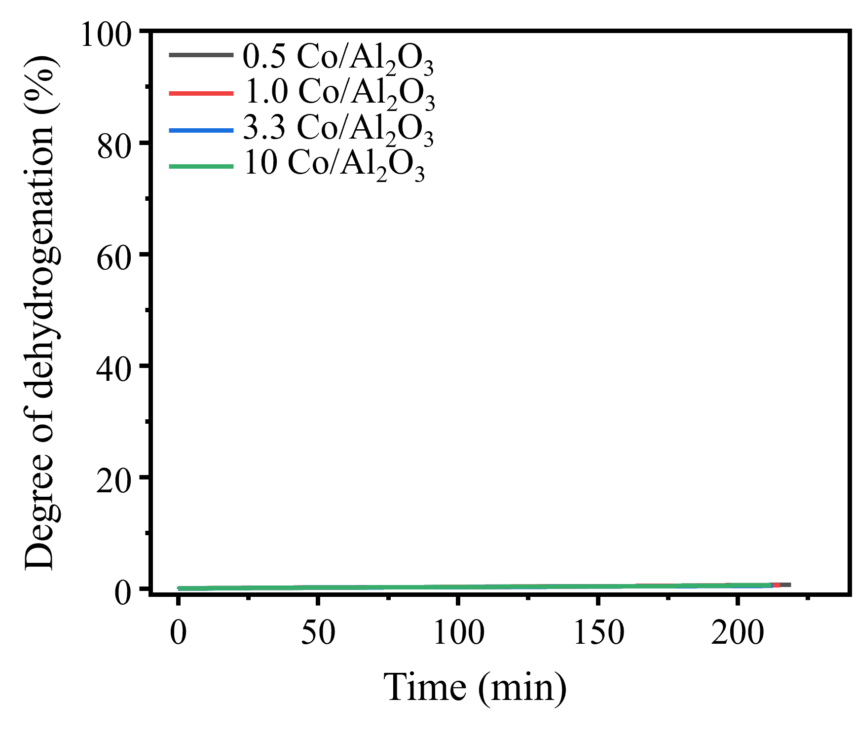
Fig. S1. Degree of dehydrogenation over yCo/Al₂O₃ (y = 0.5, 1, 3.3 and 10 wt%). Reaction conditions: a stainless steel batch reactor, 300 °C, 0.1 MPa, 1200 rpm, 0.05 mol% Pt to substrate.

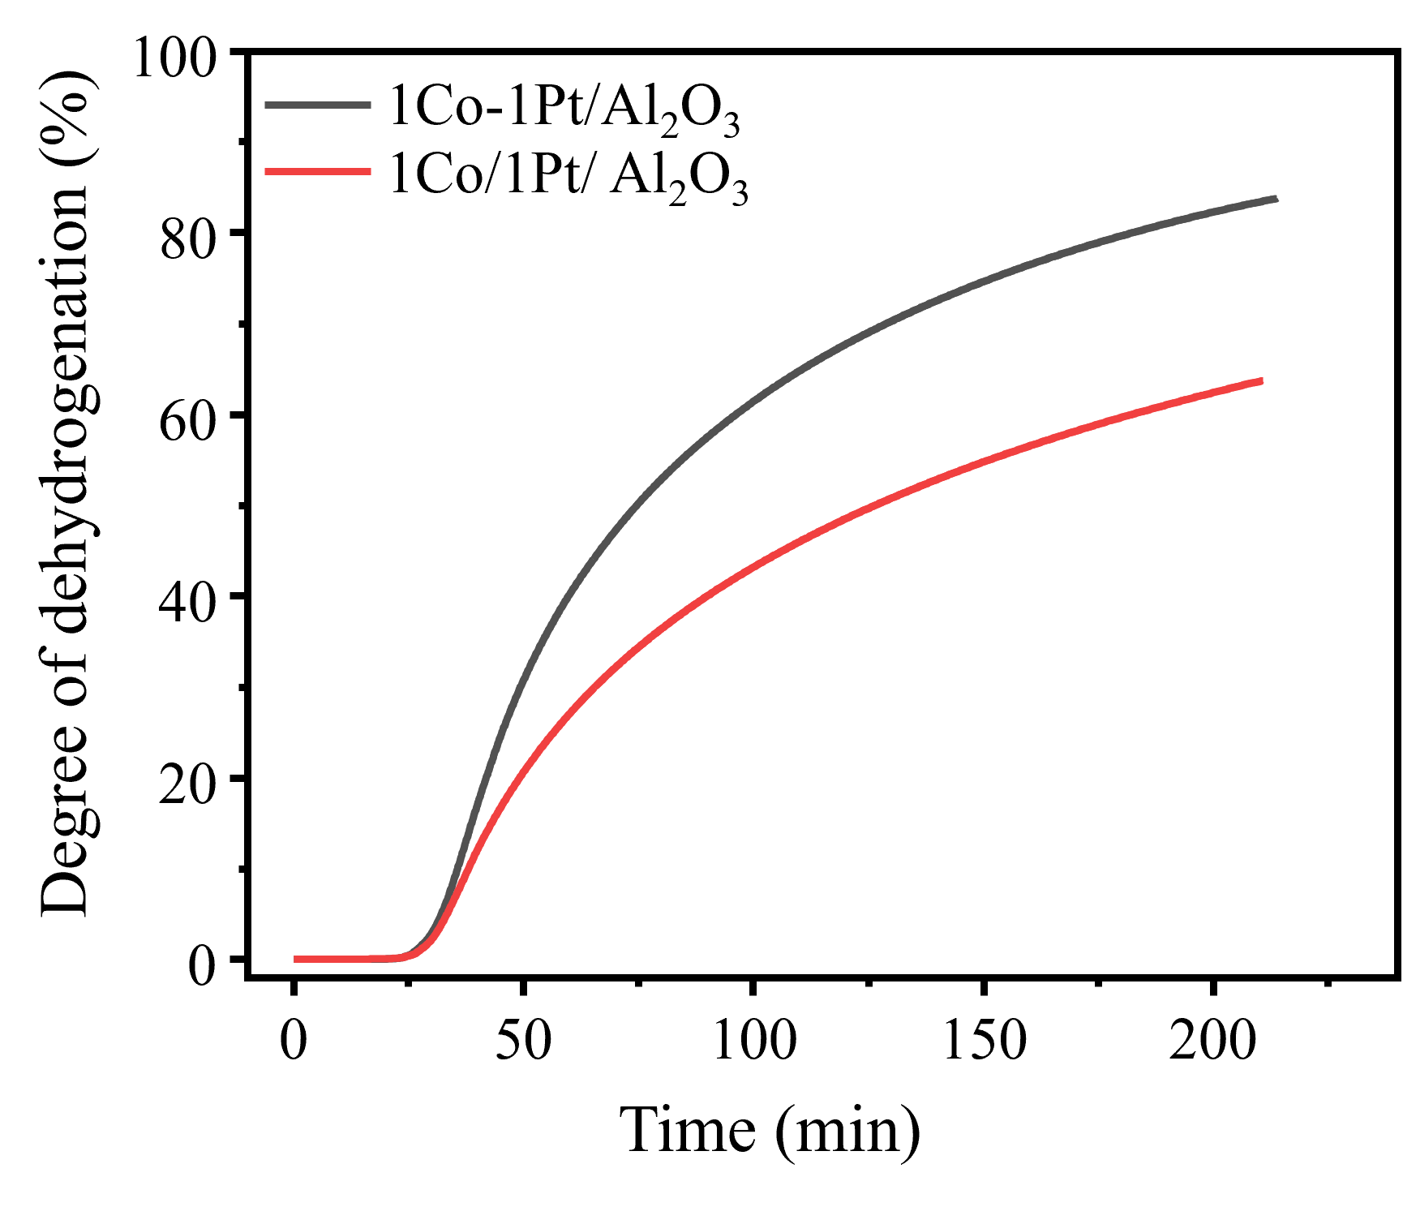
Fig. S2. Degree of dehydrogenation on 1Pt-1Co/Al₂O₃ and 1Co/1Pt/Al₂O₃. Reaction conditions: a stainless steel batch reactor, 300 °C, 0.1 MPa, 1200 rpm, 0.05 mol% Pt to substrate.

Fig. S3. The corresponding energy disperse spectroscopy (EDS) mapping results of (a) 1Pt/Al₂O₃, (b) 1Pt/0.5Co/Al₂O₃, (c) 1Pt/1Co/Al₂O₃, and (d) 1Pt/10Co/Al₂O₃.

Fig. S4. HAADF-STEM image of 1Pt/1Co/Al₂O₃. No discernible lattice fringes were obtained from the TEM analysis.

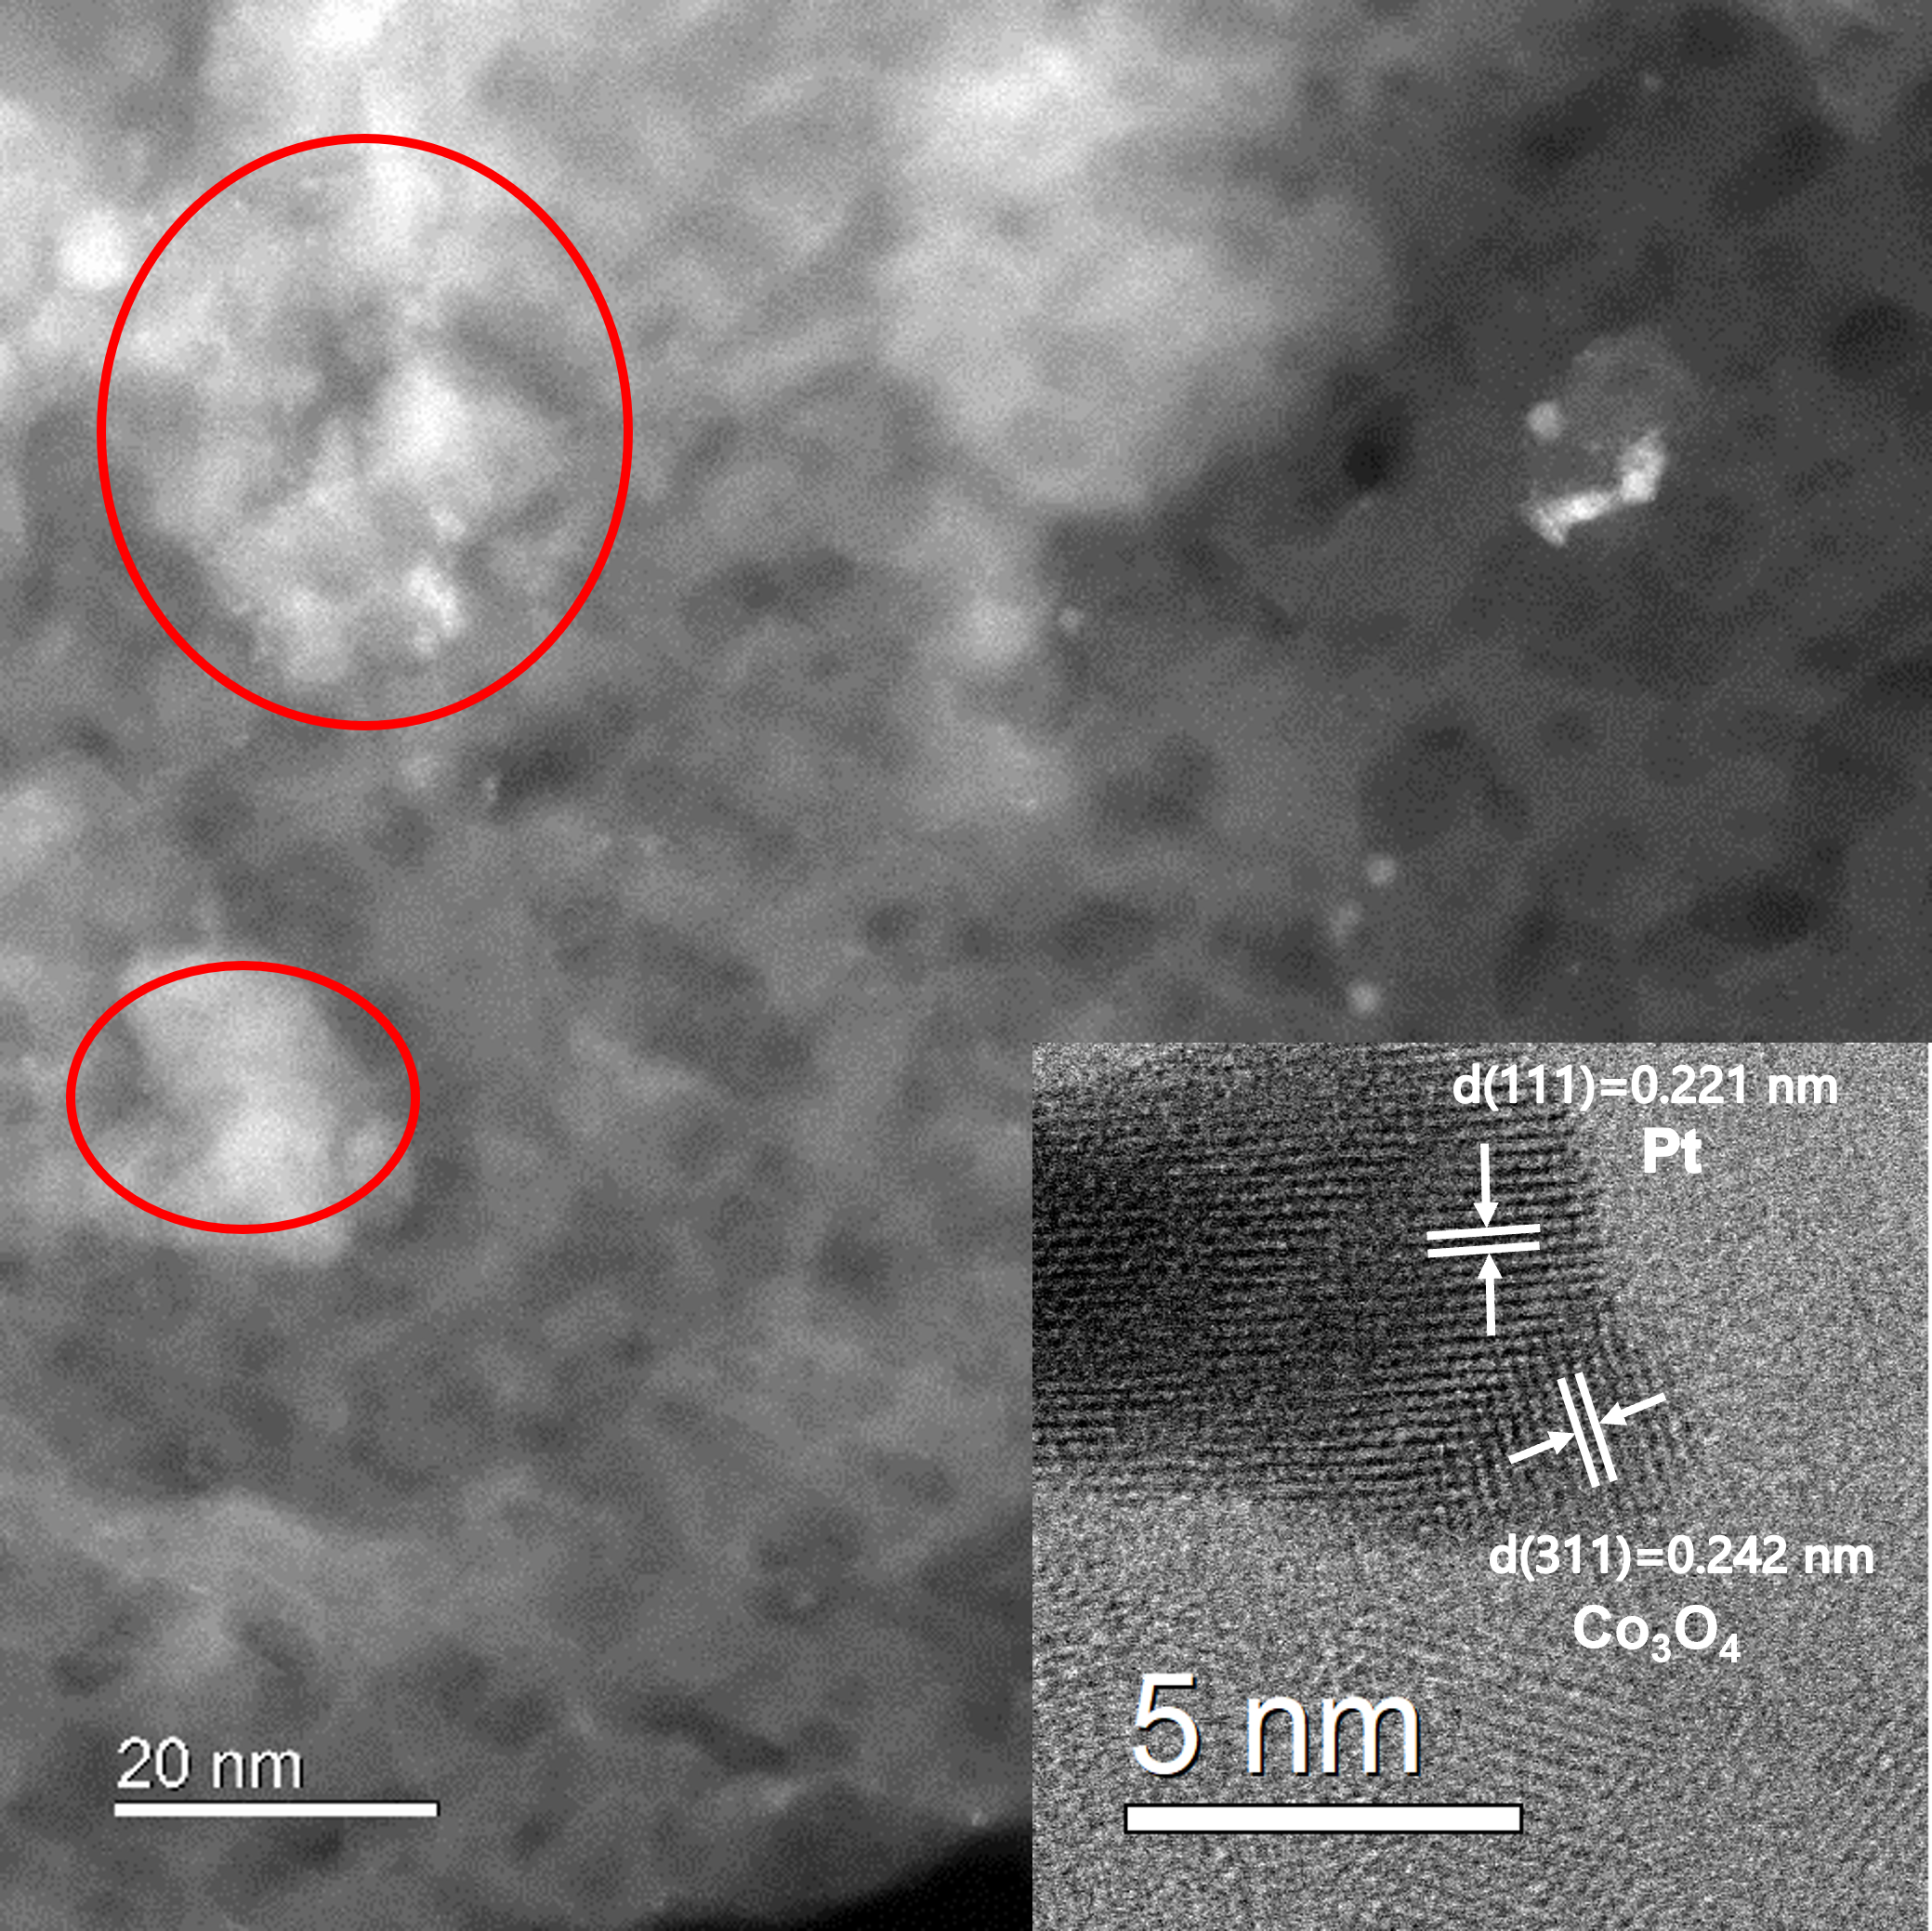
Fig. S5. HAADF-STEM image of 1Pt/10Co/Al₂O₃ (inset shows the image of well-defined lattice fringe (d = 0.221 nm) of Pt (111) plane).

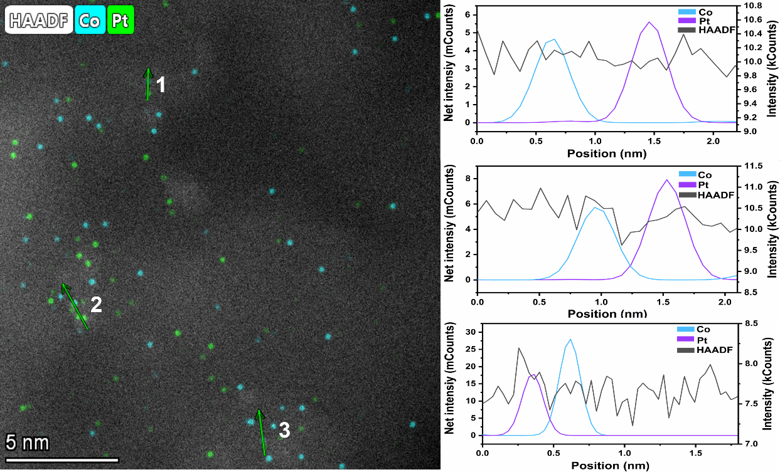
Fig. S6. The EDS line scan results of 1Pt/1Co/Al₂O_{3.}
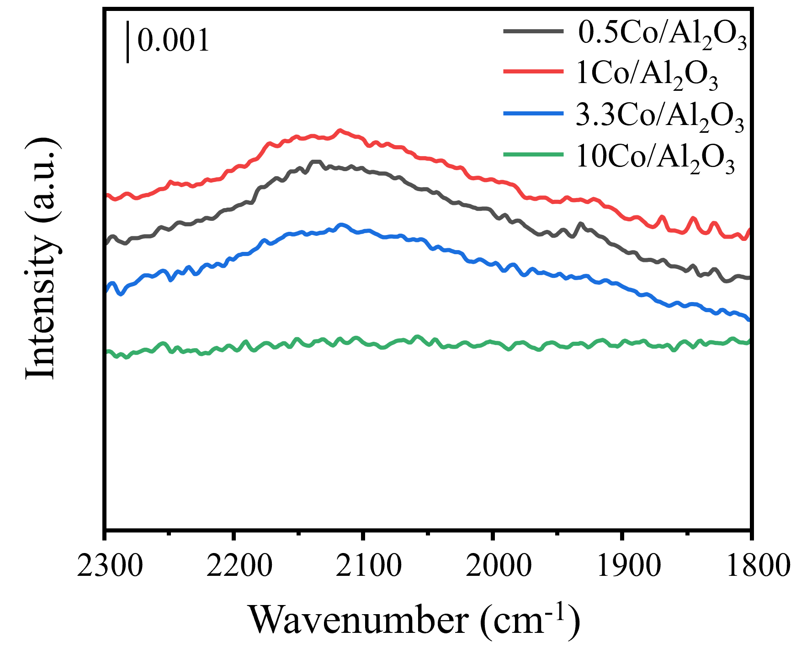
Figure. S7. In situ DRIFT spectra of CO adsorption for the yCo/Al₂O₃ (y = 0.5, 1, 3.3 and 10 wt %) catalysts.

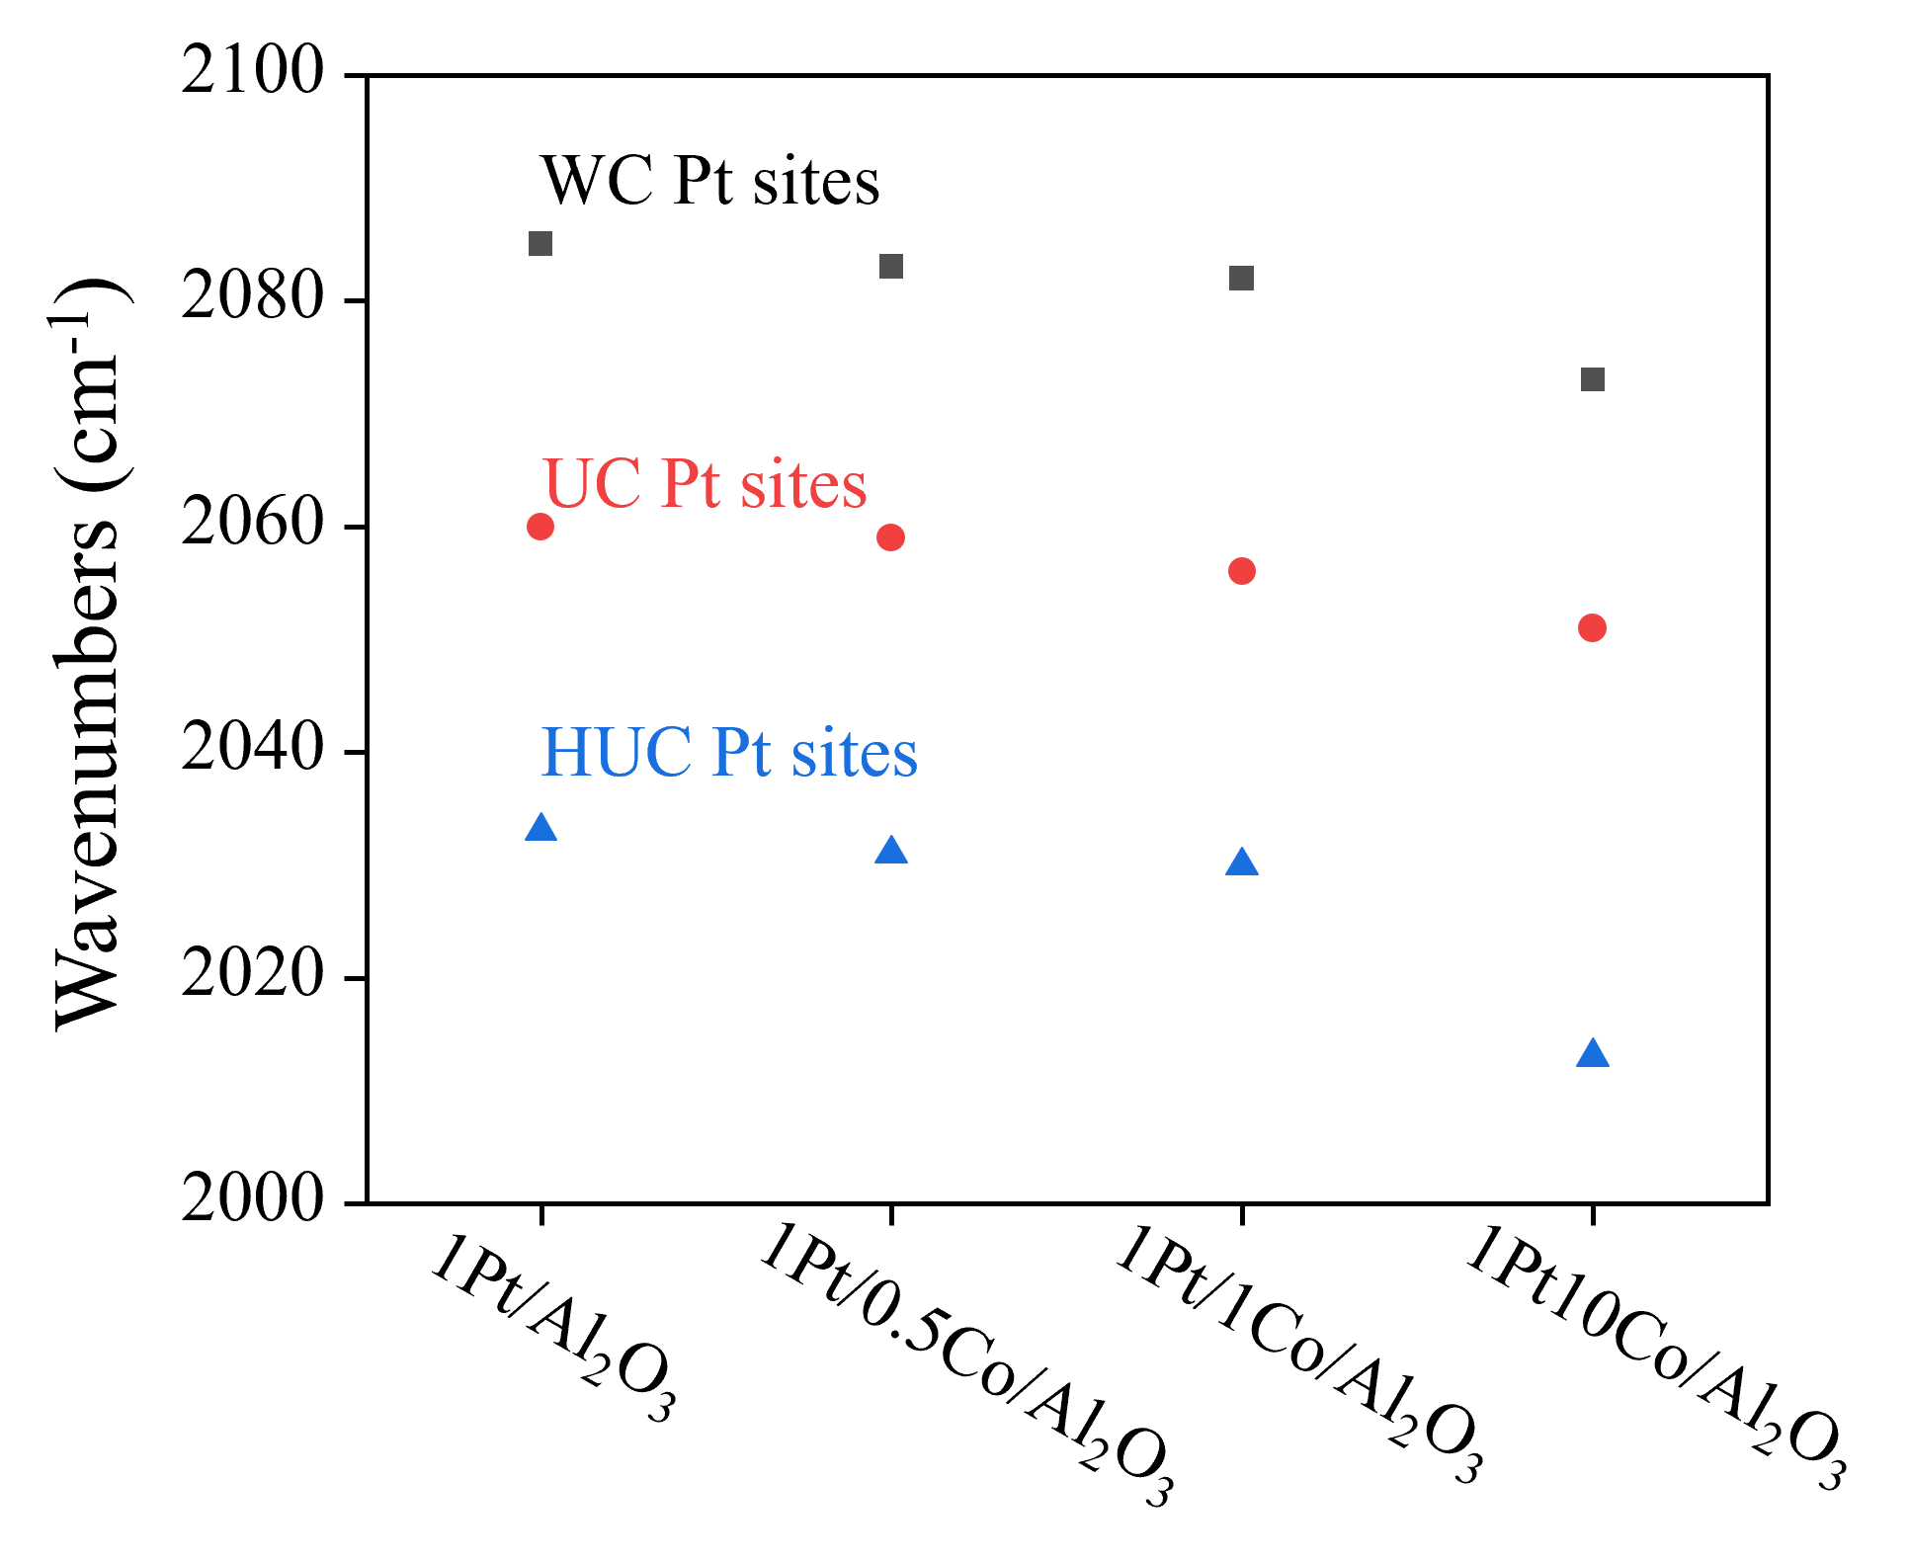
Fig. S8. Vibrational frequency of linear CO adsorbed on 1Pt/yCo/Al₂O₃.

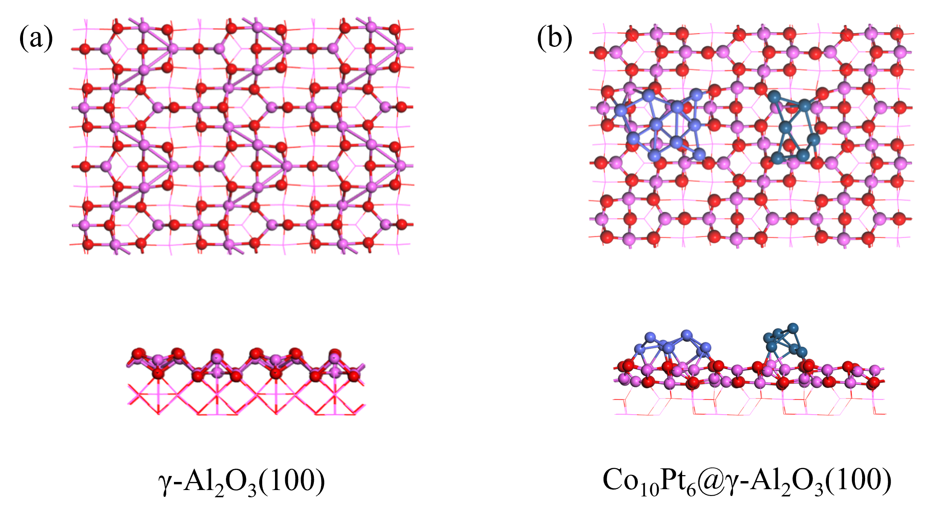
Fig. S9. Top (above) and side (below) views of the (a) γ-Al₂O₃(100) and (b) Co₁₀Pt₆@γ-Al₂O₃(100) surfaces (O: red, Al: pink, Pt: cyan, Co: light blue).

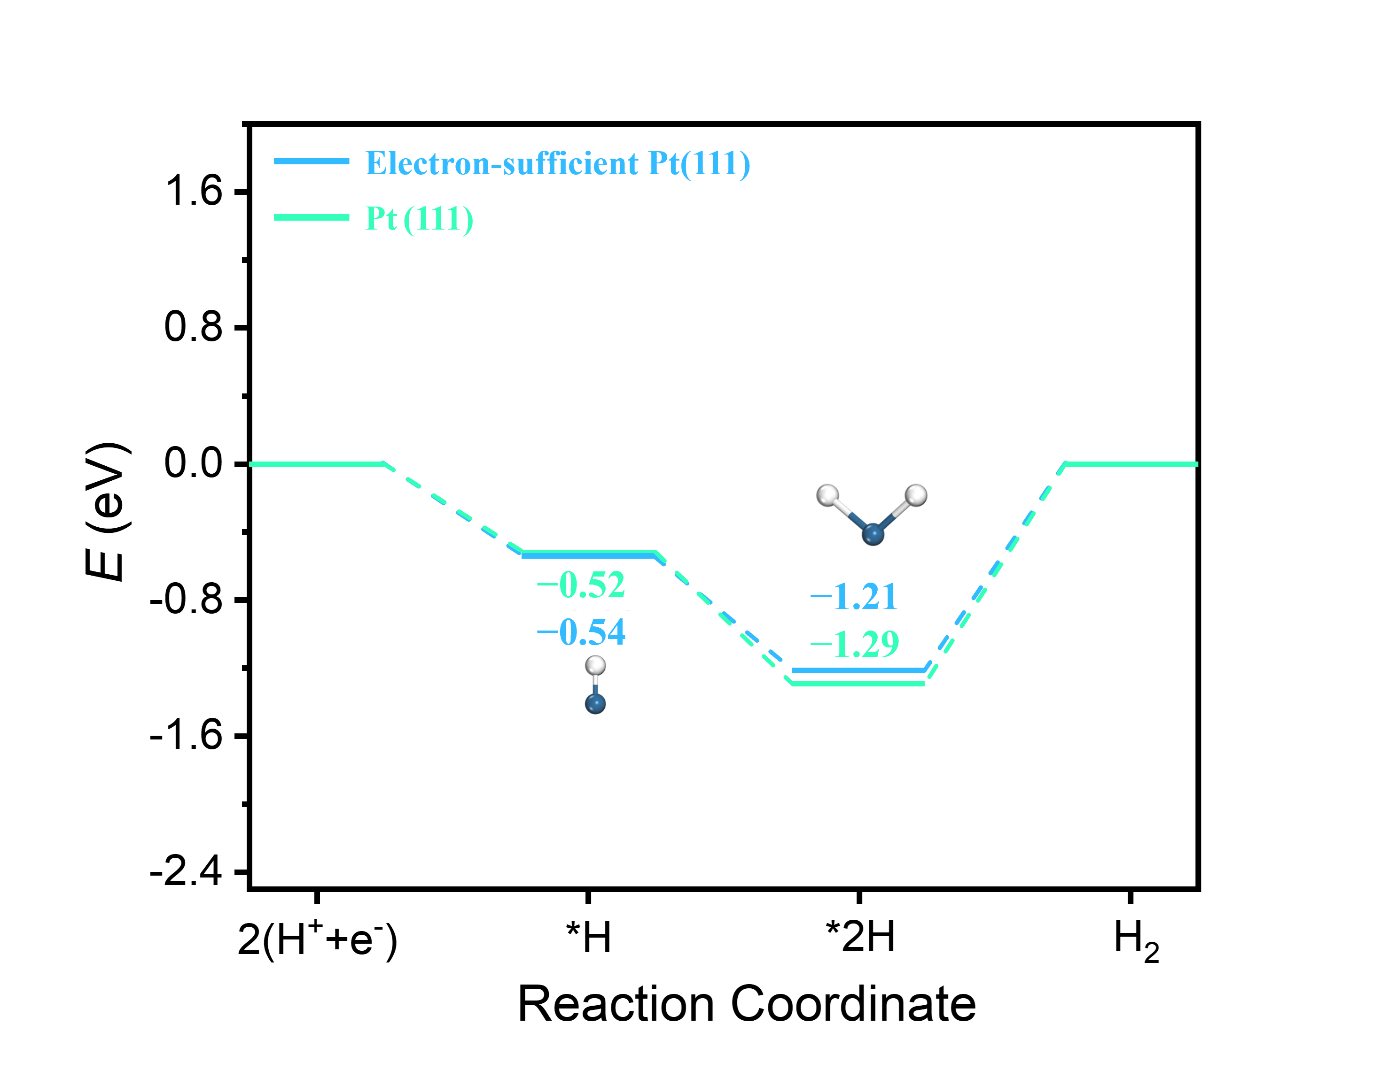
Fig. S10. Hydrogen species adsorption on both the pure and electron-sufficient Pt(111) surface.
Fig. S11. Correlation between H₂ uptake and degree of hydrogenation over 1Pt/yCo/Al₂O₃ (y = 0, 0.5, 1, 3.3, and 10 wt%).

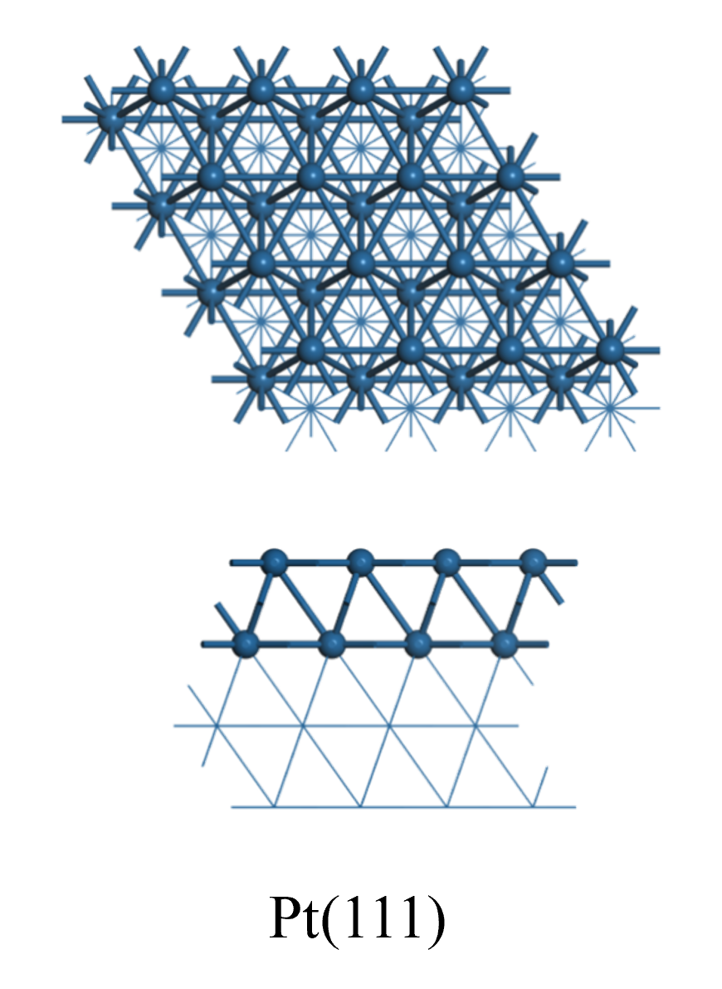
Fig. S12. Top (above) and side (bottom) views of the Pt(111) surface.

Supplementary References
[S1] G. Kresse; J. Furthmüller, Phys. Rev. B 54 (1996) 11169.
[S2] G. Kresse; J. Furthmüller, Comput. Mater. Sci. 6 (1996) 15–50.
[S3] G. Kresse; D. Joubert, Phys. Rev. B 59 (1999) 1758.
[S4] P.E. Blöchl, Phys. Rev. B 50 (1994) 17953.
[S5] S. Grimme; S. Ehrlich; L. Goerigk, J. Comput. Chem. 32 (2011) 1456–1465.

