Electronic Supplementary Material

Degradation of methylene blue by a continuous microfluidic plasma process
Hongyu Huang¹, Mei Ji¹, Hongfei Zhu¹, Rabin Duwal², Jie Shen¹, Sirui Li³, Volker Hessel², Liangliang Lin ()¹
1 Key Laboratory of Synthetic and Biological Colloids, Ministry of Education, School of Chemical and Material Engineering, Jiangnan University, Wuxi 214122, China
2 School of Chemical Engineering, Adelaide University, South Australia, Australia
3 Sustainable Process Engineering, Department of chemical engineering and chemistry, Eindhoven University of Technology, Eindhoven, the Netherlands

E-mail: linliangliang@jiangnan.edu.cn
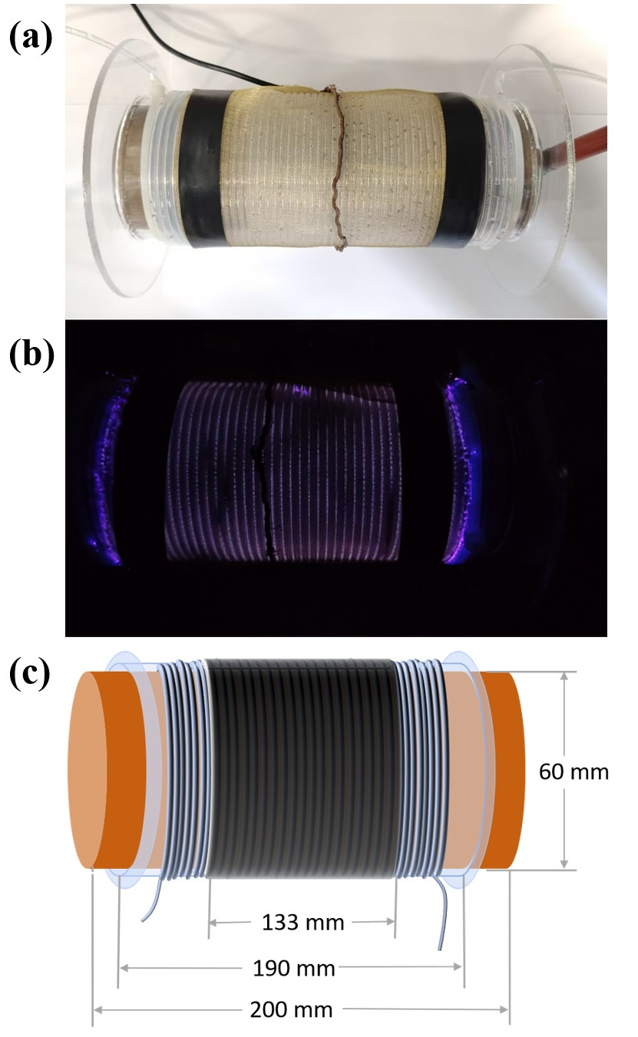
Fig. S1. (a) Photograph of the microfluidic plasma reactor. (b) Image of the plasma discharge during the degradation of methylene blue. (c) Schematic diagram detailing the key dimensions of the reactor.
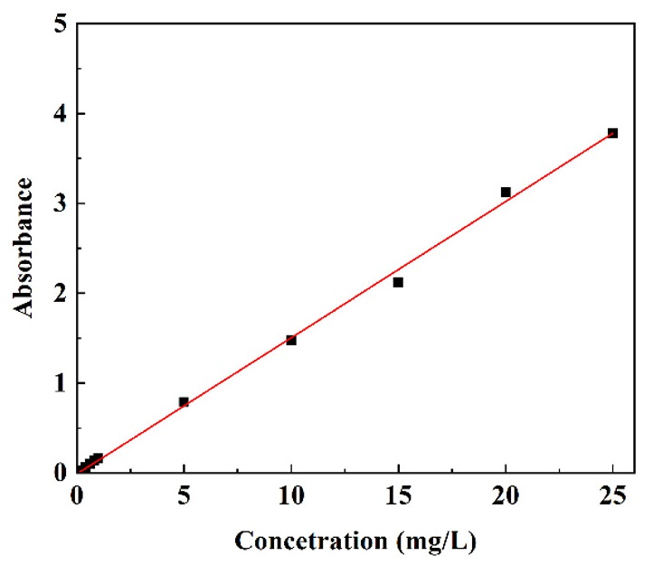
Fig. S2. Calibration curve of between MB concentration and absorbance at a wavelength of 663 nm.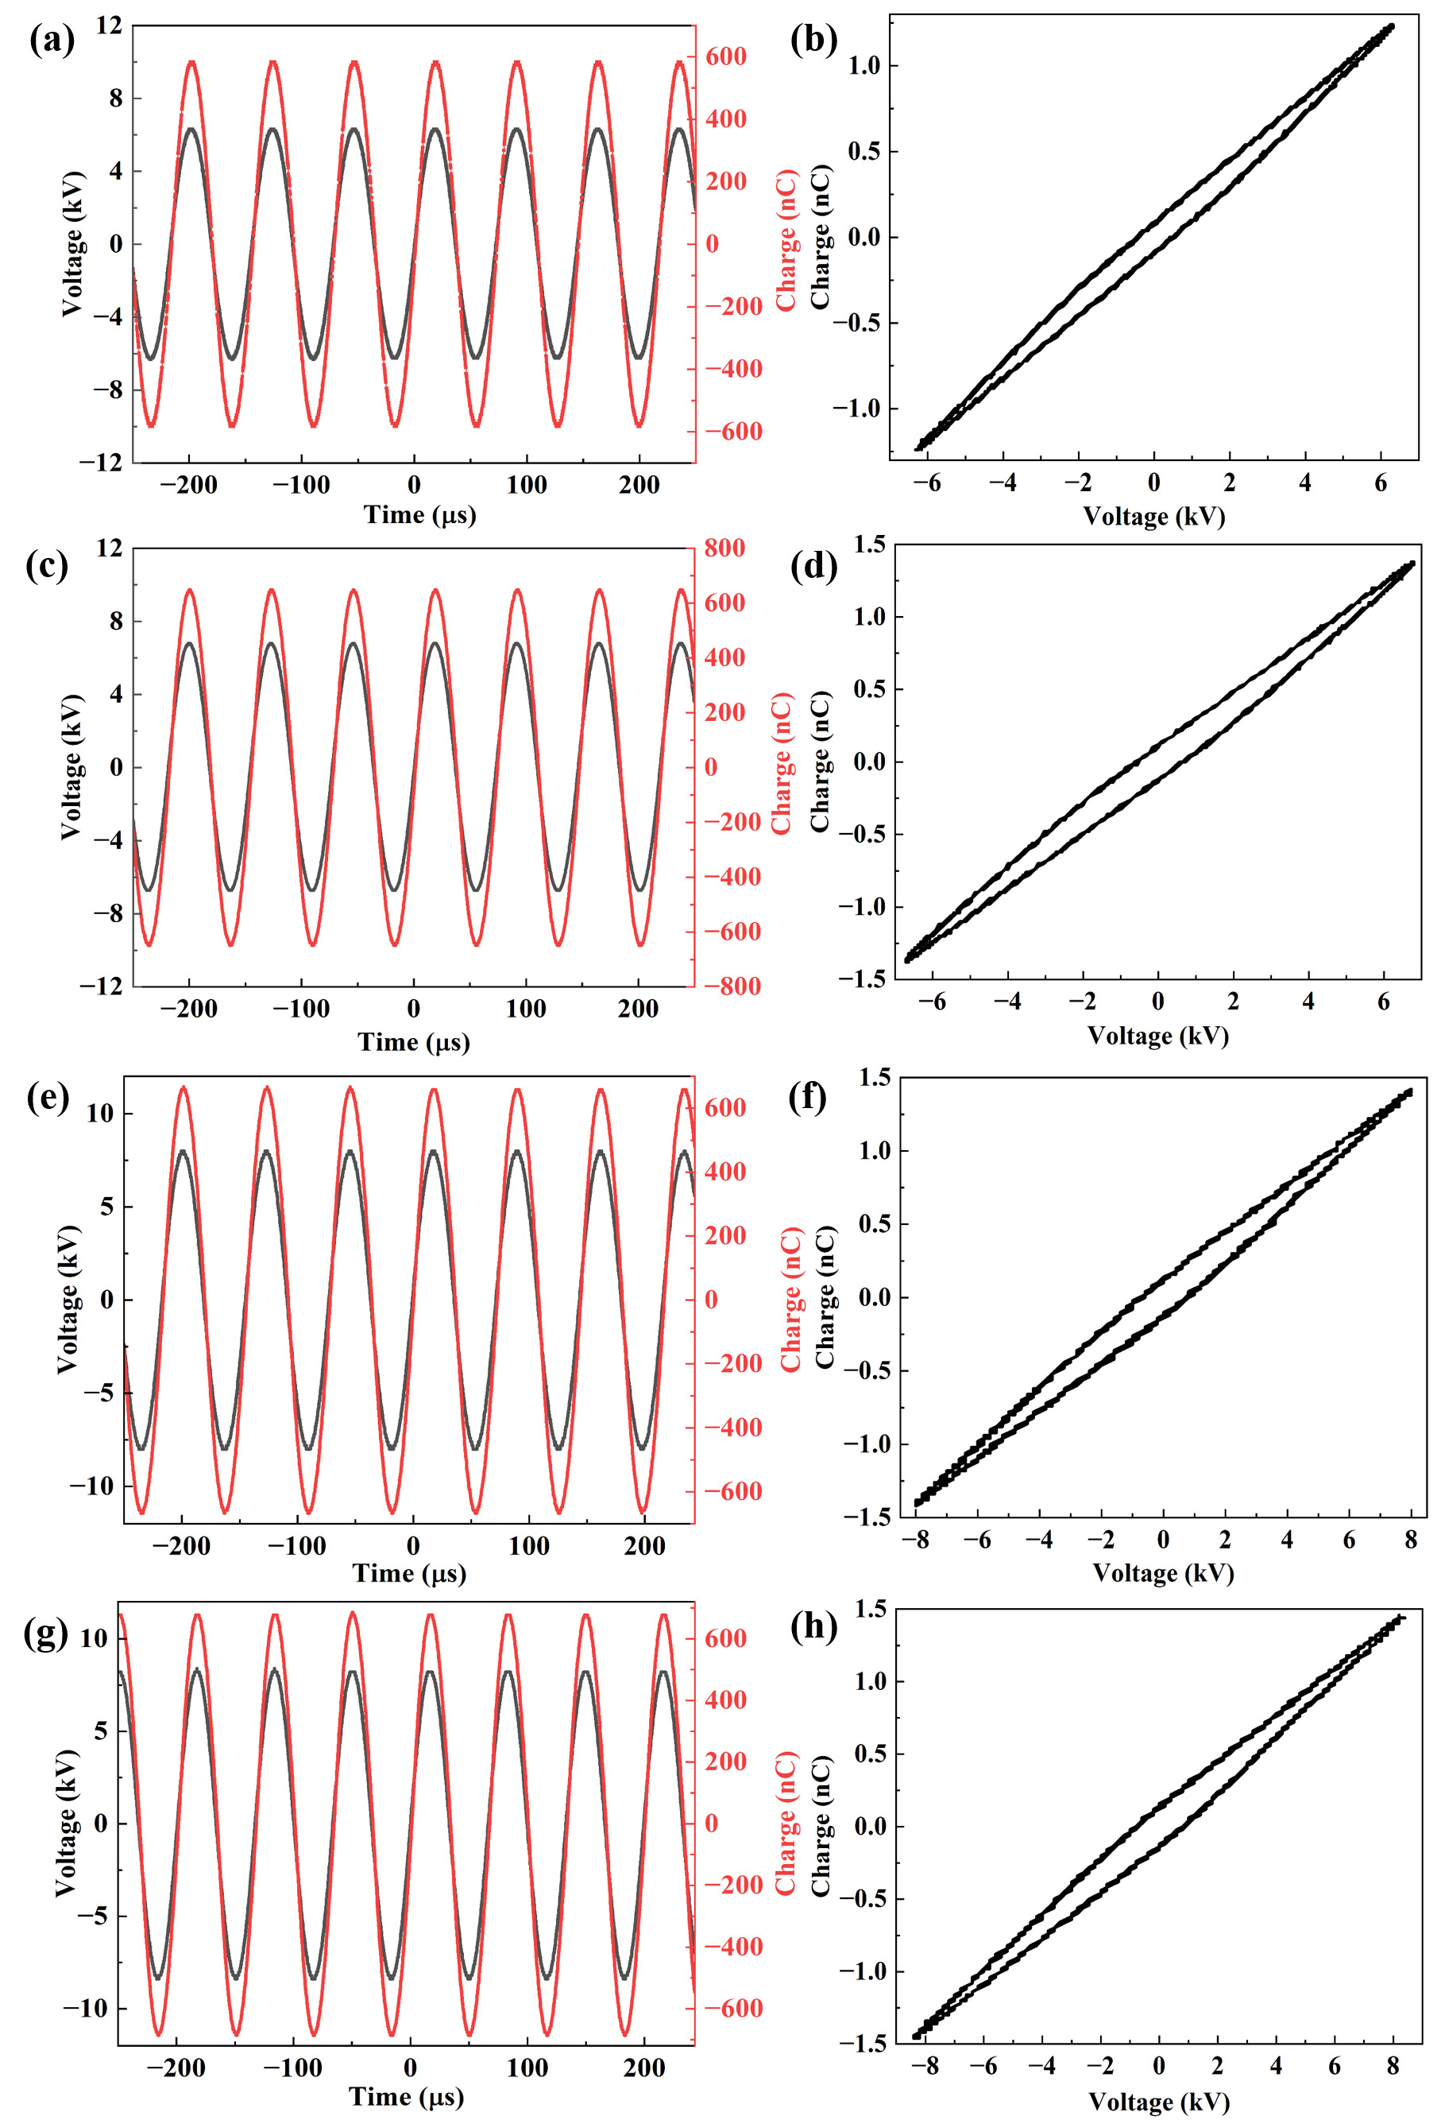
Fig. S3. V-Q diagrams and Lissajous figures during the plasma degradation process at different plasma powers: (a, b) 5.6 W; (c, d) 13.1 W; (e, f) 14.5 W; (g, h) 17.3 W.
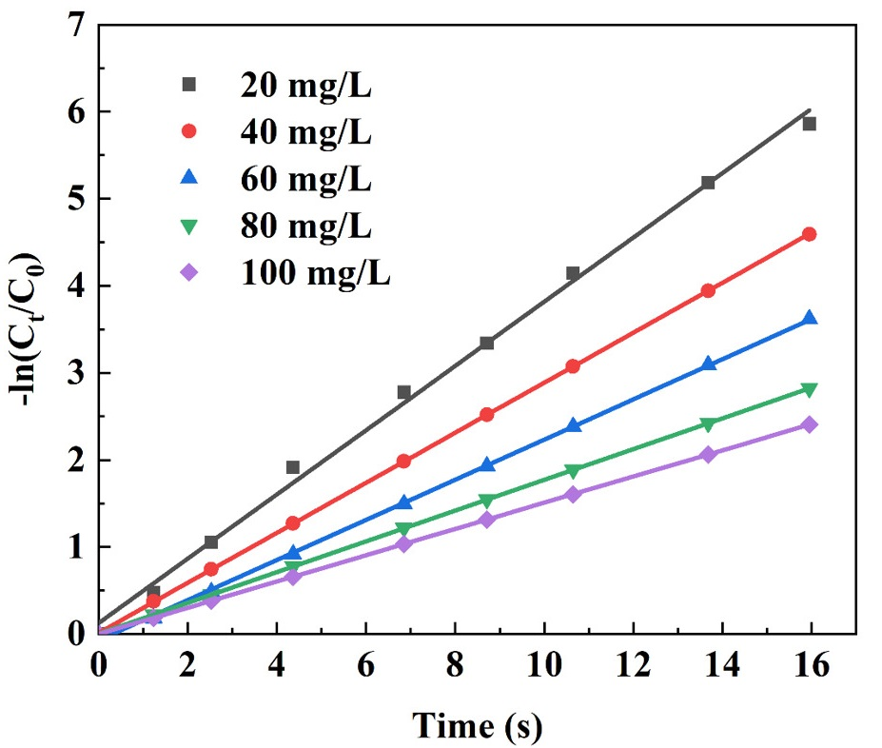
Fig. S4. Degradation kinetics of MB at various initial concentrations under constant plasma power (5.6 W) and a residence time of up to 15.95 s.
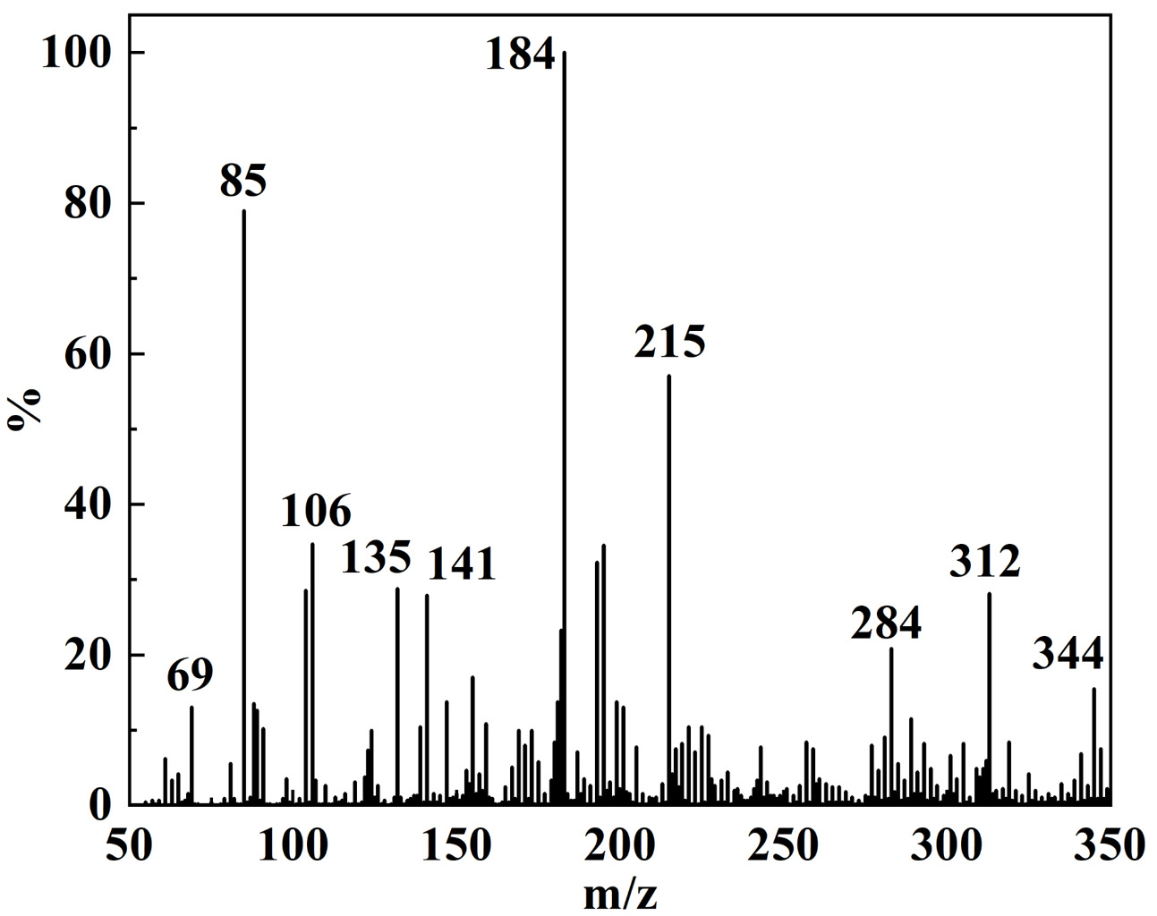
Fig. S5. Mass spectrum of the plasma-assisted MB degradation intermediates.
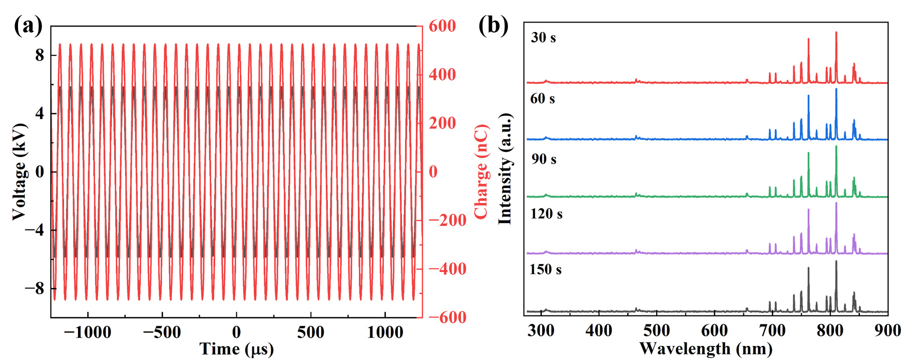
Fig. S6. (a) Representative V-Q diagrams during a typical degradation process; (b) OES spectra recorded at 30-second intervals during a standard degradation run.

Tab. S1. The rate constants and correlation coefficients obtained from the linear fitting of the different models.
Model | Rate constant, k | R² value
Pseudo-zero-order | k₀=0.892 | 0.5621
Pseudo-first-order | k₁=0.369 | 0.9969
Pseudo-second-order | k₂=0.901 | 0.7321

Tab. S2. Rate constant and correlation coefficient of MB degradation at different initial MB concentrations.
Initial MB concentrations (mg/L) | Rate constant, k (s⁻¹) | R² value
20 | 0.369 | 0.9969
40 | 0.287 | 0.9985
60 | 0.231 | 0.9975
80 | 0.177 | 0.9978
100 | 0.151 | 0.9987

Tab. S3. Tentative identification of plasma-assisted MB degradation compounds from the mass spectrum.
m/z | 344 | 312 | 284 | 215 | 184
Structure
m/z | 141 | 135 | 106 | 85 | 69
Structure

