Electronic Supplementary Material
Granulation mechanism and CO₂ capture performance of alkaline metal salt-promoted MgO sorbents

Jinbo Song^{1,2}, Jieying Jing ()^{1,2}, Jinpeng Zhang^{1,2}, Yufeng Xu^{1,2}, Wen-Ying Li ()^{1,2}
1 State Key Laboratory of Clean and Efficient Coal Utilization, Taiyuan University of Technology, Taiyuan 030024, China
2 College of Chemistry and Chemical Engineering, Taiyuan University of Technology, Taiyuan 030024, China

E-mails: jingjieying@tyut.edu.cn (Jing J); ying@tyut.edu.cn (Li W-Y)

Table S1 Response variables and their coded and actual values for optimization.
Independent variables | Unit | Symbol coded | Coded levels
Independent variables | Unit | Symbol coded | −1 | 0 | 1
sesbania powder | wt% | SP | 1 | 3 | 5
pseudoboehmite | wt% | PB | 1 | 2 | 3
nitric acid | wt% | NA | 10 | 15 | 20
microcrystalline cellulose | wt% | MC | 1 | 5 | 10

Table S2 Box-behnken experimental design and response results
STD | SP | PB | NA | MC | Initial CO₂ capture capacity / mmol/g
1 | -1 | 0 | 1 | 0 | 9.76
2 | 0 | 0 | 0 | 0 | 8.62
3 | 0 | 1 | 0 | -1 | 8.70
4 | 0 | 0 | 0 | 0 | 8.90
5 | -1 | 0 | 0 | 1 | 11.46
6 | 0 | 0 | 0 | 0 | 9.34
7 | 0 | 1 | 1 | 0 | 8.47
8 | 0 | 0 | 0 | 0 | 9.47
9 | 1 | 0 | 1 | 0 | 8.74
10 | -1 | 0 | 0 | -1 | 10.98
11 | 0 | 0 | -1 | 1 | 11.29
12 | -1 | 0 | -1 | 0 | 10.98
13 | 0 | 1 | -1 | 0 | 9.01
14 | 1 | 1 | 0 | 0 | 8.09
15 | 0 | -1 | -1 | 0 | 10.82
16 | 0 | -1 | 0 | -1 | 8.65
17 | 0 | 0 | 1 | 1 | 8.47
18 | 1 | 0 | -1 | 0 | 10.23
19 | 1 | 0 | 0 | 1 | 8.99
20 | 0 | 0 | 0 | 0 | 9.22
21 | 0 | -1 | 0 | 1 | 10.10
22 | 0 | 1 | 0 | 1 | 8.18
23 | 1 | -1 | 0 | 0 | 9.68
24 | 0 | 0 | -1 | -1 | 10.62
25 | 0 | 0 | 1 | -1 | 9.82
26 | -1 | 1 | 0 | 0 | 9.38
27 | -1 | -1 | 0 | 0 | 10.68
28 | 0 | -1 | 1 | 0 | 8.06
29 | 1 | 0 | 0 | -1 | 9.93
To ensure the accuracy of the test results, the initial CO₂ capture capacity of each sorbent pellet (STD) needs to be averaged after 5 measurements.

Table S3 ANOVA results of the RSM–BBD model of responses.
Source | Sum of squares | Degree of freedom | Mean  square | F  value | P-value  prob > F
Model | 26.540 | 14 | 1.896 | 12.574 | <0.0001
SP | 5.147 | 1 | 5.147 | 34.142 | <0.0001
PB | 3.559 | 1 | 3.559 | 23.607 | 0.0003
NA | 8.318 | 1 | 8.318 | 55.169 | <0.0001
MC | 0.003 | 1 | 0.003 | 0.023 | 0.8829
SP×PB | 0.020 | 1 | 0.020 | 0.135 | 0.7185
SP×NA | 0.018 | 1 | 0.018 | 0.118 | 0.7365
SP×MC | 0.580 | 1 | 0.580 | 3.849 | 0.0700
PB×NA | 1.227 | 1 | 1.227 | 8.140 | 0.0128
PB×MC | 0.938 | 1 | 0.938 | 6.219 | 0.0258
NA×MC | 1.058 | 1 | 1.058 | 7.018 | 0.0191
SP² | 2.991 | 1 | 2.991 | 19.841 | 0.0005
PB² | 1.348 | 1 | 1.348 | 8.939 | 0.0097
NA² | 0.792 | 1 | 0.792 | 5.255 | 0.0379
MC² | 1.418 | 1 | 1.418 | 9.404 | 0.0084
Residual | 2.111 | 14 | 0.151
Lack of fit | 1.631 | 10 | 0.163 | 1.360 | 0.4116
Pure error | 0.480 | 4 | 0.120
Cor total | 28.650 | 28
Note: P< 0.05 means significant difference; P< 0.01 means highly significant difference. SP×PB, SP×NA, SP×MC, PB×NA, PB×MC, and NA×MC represent the interactions between sesbania powder and pseudoboehmite, sesbania powder and nitric acid, sesbania powder and microcrystalline cellulose, pseudoboehmite and nitric acid, pseudoboehmite and microcrystalline cellulose, and nitric acid and microcrystalline cellulose, respectively. SP², PB², NA², and MC² represent the secondary terms for sesbania powder, pseudoboehmite, nitric acid, and microcrystalline cellulose, respectively.

Fig. S1 Initial CO₂ capture capacity: (a) normal probability plot of the residuals, (b) distribution of the residuals versus the predicted values, and (c) distribution of the predicted values versus the actual values.
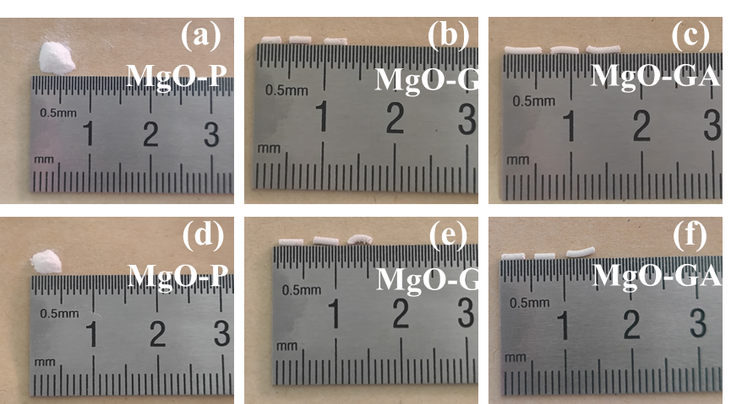
Fig. S2 Particle images before and after TGA cycling experiments: (a)-(c) before carbonation, (d)-(f) after carbonation.
Fig. S3 Plot of CO₂ capture capacity of samples over time.

