Electronic Supplementary Material

Long-range electron-rich optimization of Cl doped LaCoO₃ catalyst for efficient electrocatalytic water oxidation
Fei Jiang¹*, Jiaye Li¹*, Yingying Liu¹, Kun Hu¹, Yan Lin ()², Chao Feng ()³, Yuan Pan ()¹
1 State Key Laboratory of Heavy Oil Processing, China University of Petroleum (East China), Qingdao 266580, China
2 Shandong Key Laboratory of Integrated Multi-Energy Systems for High Efficiency and Intelligent Operation, College of Energy Storage Technology, Shandong University of Science and Technology, Qingdao 266590, China
3 College of Chemical and Biological Engineering, Shandong University of Science and Technology, Qingdao 266590, China

E-mails: linyan09@sdust.edu.cn (Lin Y); fengchao@sdust.edu.cn (Feng C); panyuan@upc.edu.cn (Pan Y)
*These authors contributed equally to the work.

Keywords: Electrocatalysts, Perovskite oxides, Single site, Oxygen evolution reaction

Electrochemical test
All of the electrochemical measurements were collected by using a standard three-electrode system. The three-electrode system was placed in 1 M KOH electrolyte (room temperature condition) and connected to the electrochemical workstation to evaluate the OER activity of the catalysts. The reference electrode was a mercury/mercury oxide (Hg/HgO: 0.098 V vs. RHE) electrode and the working electrode was a platinum sheet electrode, which was prepared as the working electrode. The same test conditions were required to be maintained for the different catalysts during the OER activity test. conditions. The working electrode was prepared by dispersing 5 mg of catalyst in 0.5 mL of ethanol solution with 10 μL of phenol, and the mixture was ultrasonicated for more than 1 h to form a homogeneous ink-like slurry, and 10 μL of this ink-like slurry was uniformly coated on a glassy carbon electrode, which was dried naturally in the air.
The potential used in this work was the reversible hydrogen electrode (RHE) according to the Nernst equation E (RHE) = E (SCE) + 0.243 V + 0.059 pH correction. Before data collection, the working electrode was subjected to activation: 20 cycles in the range 0-1.0 V vs Hg/HgO at a scan rate of 0.001 V/s. Linear swept surface polarization curves (LSVs) were obtained by scanning at a rate of 0.01 V/s in the range 0-1.0 V vs Hg/HgO.
The Tafel slope describes the mathematical relationship between the logarithm of the current density and the overpotential, and the rate of reaction can be described by obtaining the slope from the estimation of these two sets of data. A smaller Tafel slope reflects a gradual increase in the growth rate of the current density as the voltage increases, implying a more rapid charge transfer rate and reaction kinetics. The Tafel slope is calculated as follows:
η = a + b log | j |
where η is the overpotential; a is the Tafel constant; b is the Tafel slope; and j is the current density.
Electrochemical impedance spectroscopy was calibrated to the potential by determining R_{ct} and the solution internal resistance (R_{s}). EIS was performed in a 1.0 M KOH electrolyte at an overpotential of 300 mV between 100 KHz and 0.01 Hz.
CV cycles were performed in the potential range between 1.5 and 1.6 V (relative to RHE) with a scan rate of 20-100 mV s⁻¹, and the current density at 1.55 V was plotted versus scan rate, with the slope of the curve corresponding to C_{dl}.
The durability test was performed using the 1000 CVs with a scan rate of 20 mV s⁻¹. Then the LSV curve was recorded.
J_{specific} is the ratio of current density normalized to the geometric area of the electrode to ESCA at 1.55 V (vs. RHE):
J_{specific}=J/ESCA
ESCA=C_{dl}/C_{s}
J is the current density normalized to the geometric area of the electrode. Cs represents the capacitance value for a flat electrode surface, which is equal to 0.04 mF cm⁻².
Characterization
XRD was measured with a Bruker D8 model instrument equipped with a Cu Kα source. XPS was measured with a Thermo Fisher Scientific, “Escalab 250Xi instrument. Cryogenic nitrogen adsorption-desorption analysis of the samples was recorded using a Micro-meiritics ASAP2010 automated adsorption instrument. SEM (HITACHI, S-4800), TEM (JEM-2100UHR) and HRTEM (JEM-2100UHR) were used to study the morphology and structure of the catalysts. Inductively coupled plasma mass spectrometry (ICP-MS) analysis using Agilent 7700 for determination of elemental content in samples. The X-ray absorption fine structure (XAFS) of Co/Ni/Ce K-edge were performed on BL14W1/BL11B station in Shanghai Synchrotron Radiation Facility. The data were measured by using a Lytle detector in fluorescence mode.
DFT calculations
All calculations were performed using DFT technique using the Vienna ab initio simulation package (VASP). Spin-polarized calculations were performed using the generalized gradient approximation (GGA) combined with the Perdew–Burke–Ernzerhof (PBE) method to determine the exchange and correlation energies. The projector-augmented wave (PAW) method was used to represent the core–valence electron interactions. Copper 3d, 4s; nickel 3d, 4s; lanthanum 4d, 5s, cerium 4d, 5s and oxygen 2p, 2s electrons were considered valence electrons, and the typical plane-wave cutoff energy was 400 eV for basis-set expansion. For geometry optimization calculations, forces were converged below 0.03 eV/Å. The SCF convergence energy was 1 × 10^{–4} eV. A 3 × 3 × 1 k-point mesh was used to perform all the calculations. In the calculation of alkaline OER, five-layer slab model surfaces of LaCoO₃ (211) were built to calculate the adsorption energies and Gibbs free energies. Two p (3×3) unit cell expansions were used to model the surface include a La and a Co atom on surface. A vacuum of 15 Å was used to simulate the surface under periodic boundary conditions.
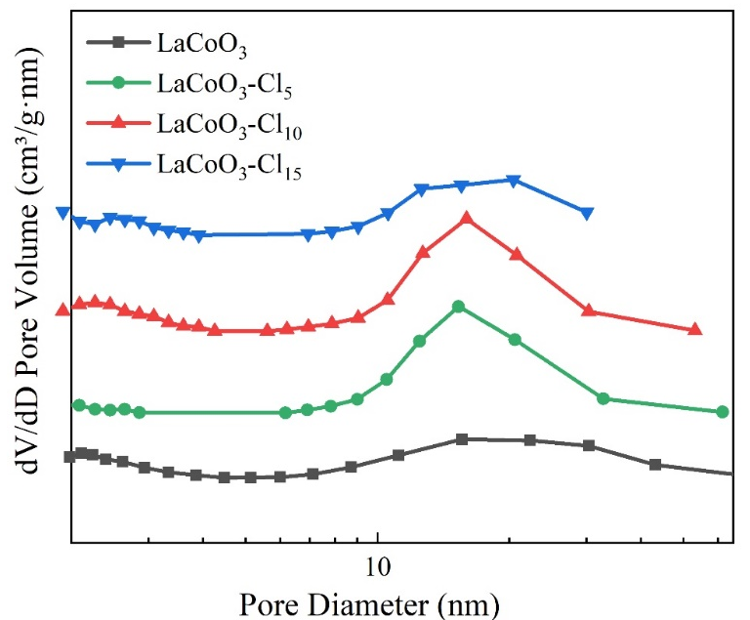
Fig. S1 pore size distribution of LaCoO₃-Cl_{δ} catalysts.

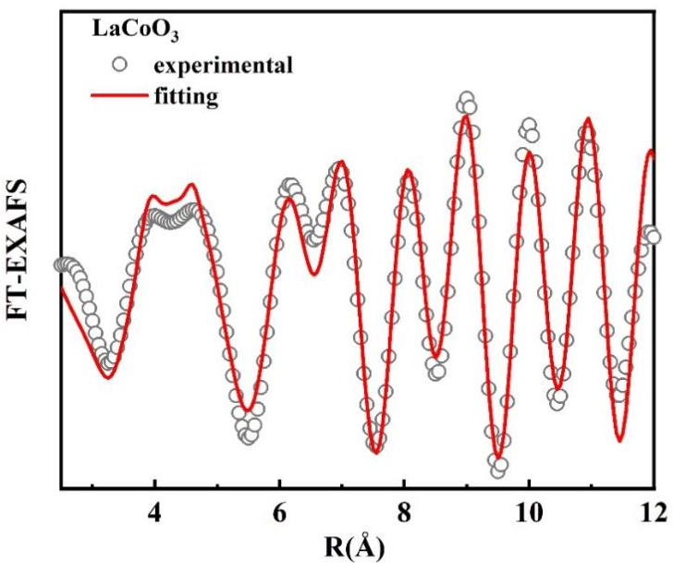
Fig. S2 k space of LaCoO₃

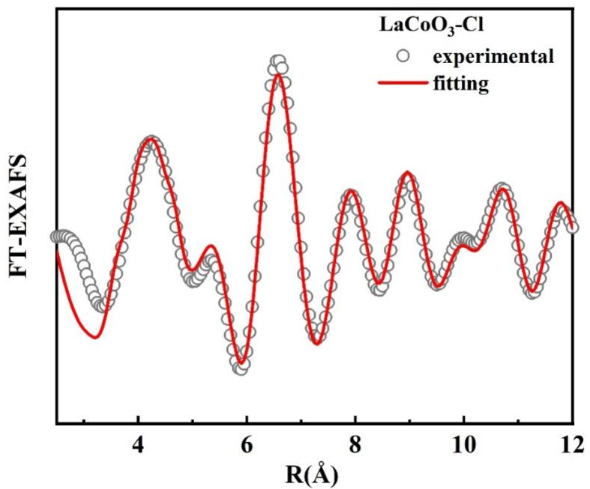
Fig. S3 k space of LaCoO₃-Cl₁₀

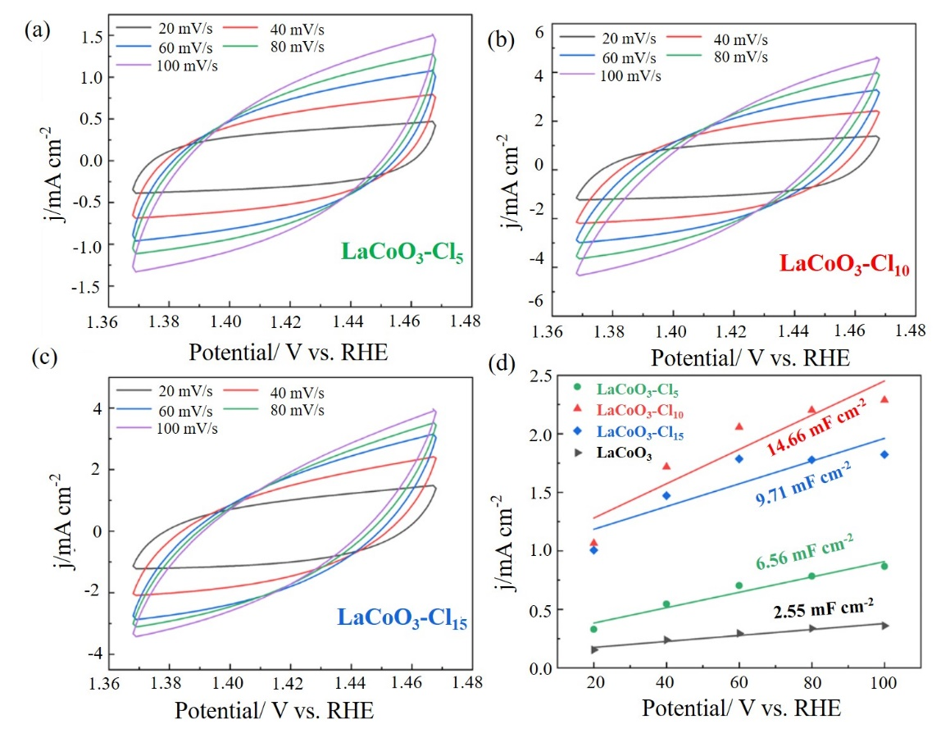
Fig. S4 Cyclic voltammograms running at various scan rates and double-layer capacitance measured by cyclic voltammetry: (a) LaCoO₃-Cl₅; (b) LaCoO₃-Cl₁₀; (c) LaCoO₃-Cl₁₅ and (d) C_{dl}

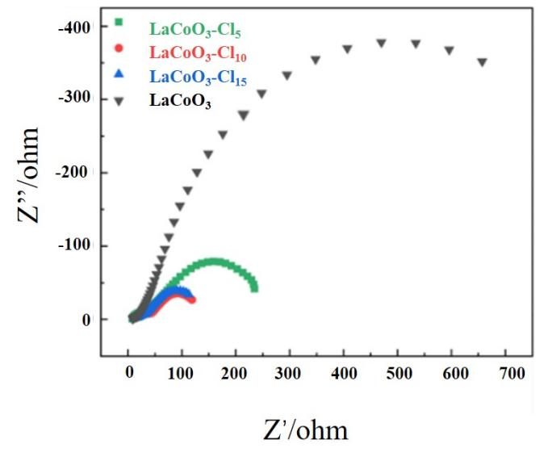
Fig. S5 EIS curve of the catalysts in 1.0 M KOH (380 mV)

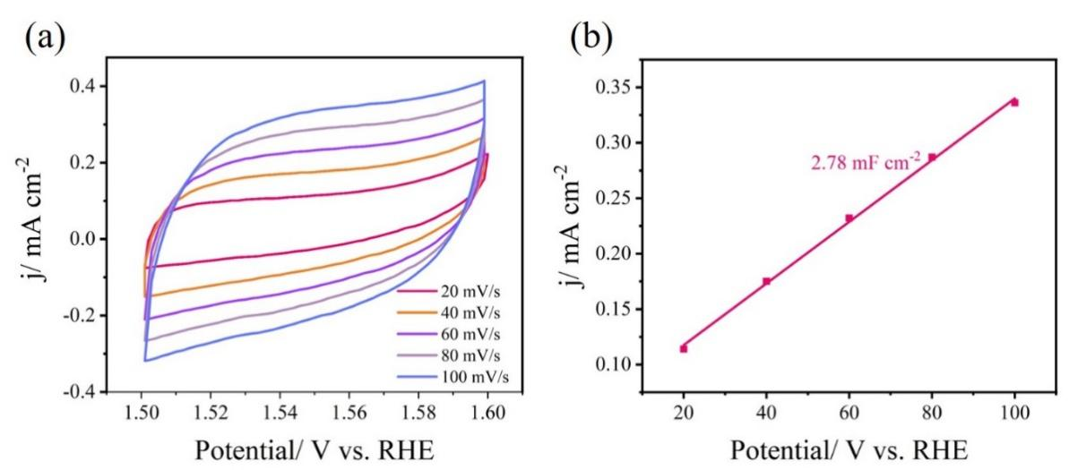
Fig. S6 Cyclic voltammograms running at various scan rates and double-layer capacitance measured by cyclic voltammetry of Co₃O₄
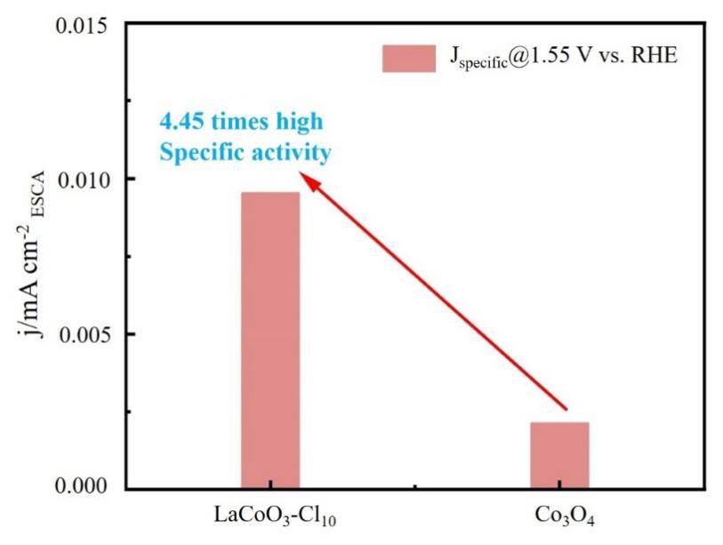
Fig. S7 ECSA normalized current density information for LaCoO₃-Cl₁₀ and Co₃O₄
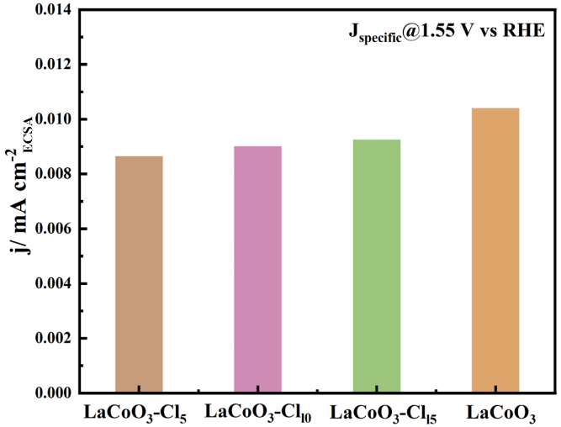
Figure S8 J_{specific} of LaCoO₃-Cl and LaCoO₃

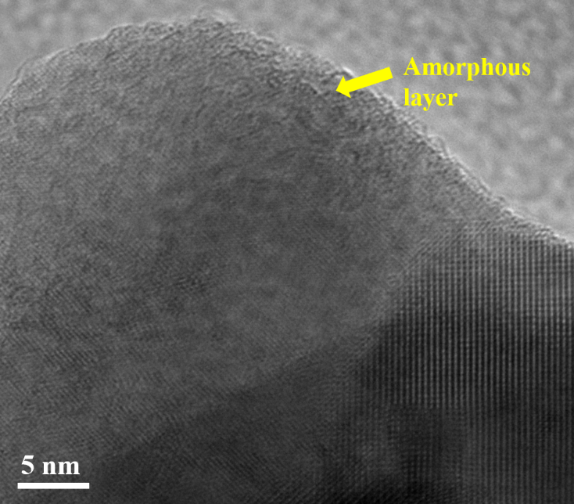
Fig. S9 TEM image of LaCoO₃-Cl₁₀-After 1000 CVs

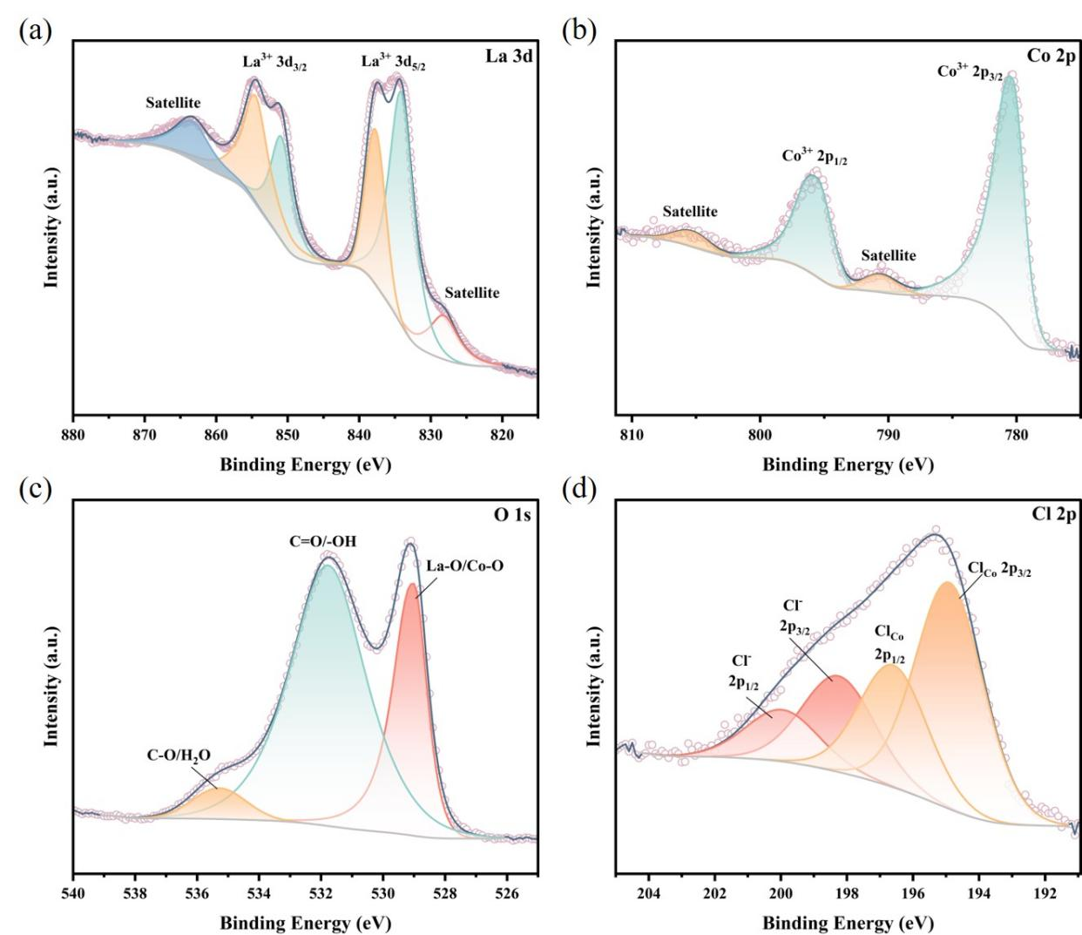
Fig. S10 XPS analysis of LaCoO₃-Cl₁₀-After 1000 CVs. (a) La 3d; (b) Co 2p; (c) O 2p; (d) Cl 2p

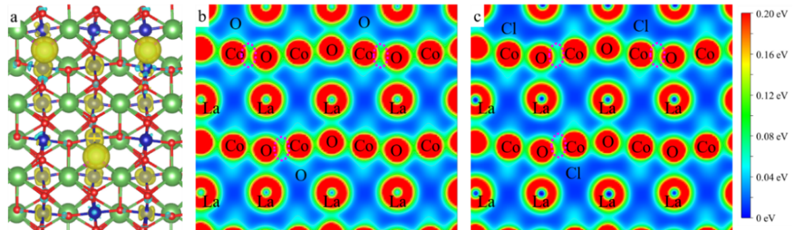
Fig. S11 Charge density difference plot for (a) LaCoO₃-Cl. The isosurface value is 0.03 e·Bohr-3. Yellow is positive and blue is negative. Electron location function maps of (b) LaCoO₃ and (c) LaCoO₃-Cl
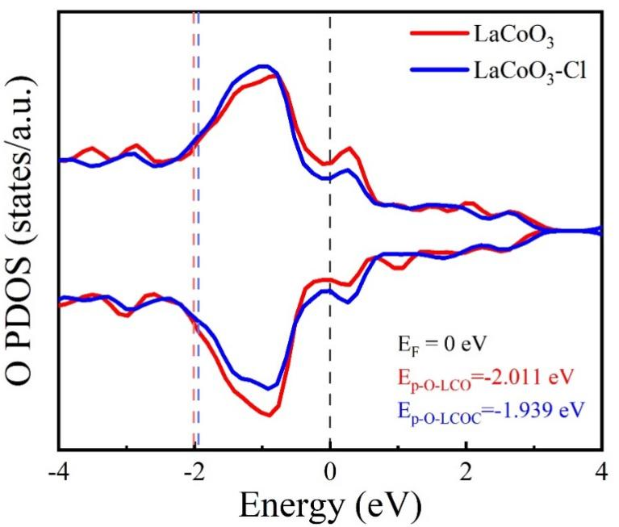
Fig. S12 O PDOS of LaCoO₃ and LaCoO₃-Cl

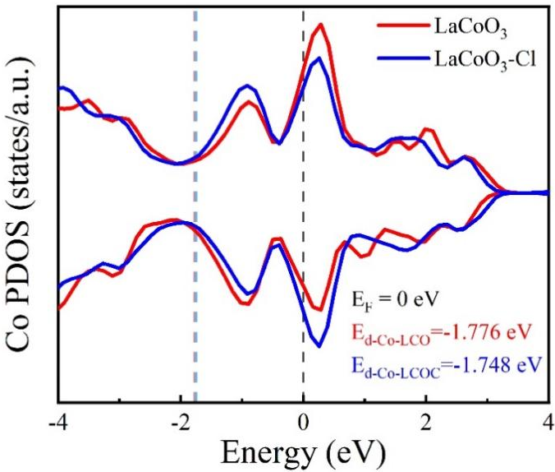
Fig. S13 Co PDOS of LaCoO₃ and LaCoO₃-Cl

Table S1 The lattice strain of LaCoO₃ and LaCoO₃-Cl_{δ}
Catalysts | 2theta | theta | β | βcos（theta） |  | 4sin（theta） |  | ɛ
LaCoO₃ | 23.22 | 0.203 | 0.305 | 0.298 | 0.805 |  | 0.088±0.110
LaCoO₃ | 33.06 | 0.289 | 0.535 | 0.513 | 1.138
LaCoO₃ | 58.98 | 0.514 | 0.606 | 0.527 | 1.969
LaCoO₃ | 53.42 | 0.467 | 0.430 | 0.384 | 1.798
LaCoO₃ | 47.50 | 0.414 | 0.385 | 0.352 | 1.611
LaCoO₃-Cl₅ | 23.21 | 0.203 | 0.278 | 0.272 | 0.805 |  | 0.020±0.331
LaCoO₃-Cl₅ | 33.05 | 0.289 | 0.546 | 0.524 | 1.138
LaCoO₃-Cl₅ | 47.49 | 0.414 | 0.344 | 0.315 | 1.611
LaCoO₃-Cl₁₀ | 33.05 | 0.289 | 0.565 | 0.541 | 1.138 |  | 0.084±0.253
LaCoO₃-Cl₁₀ | 58.97 | 0.515 | 0.402 | 0.350 | 1.969
LaCoO₃-Cl₁₀ | 58.97 | 0.515 | 0.681 | 0.593 | 1.969
LaCoO₃-Cl₁₅ | 33.08 | 0.289 | 0.544 | 0.522 | 1.139 |  | 0.013±0.223
LaCoO₃-Cl₁₅ | 40.70 | 0.355 | 0.413 | 0.387 | 1.391
LaCoO₃-Cl₁₅ | 47.50 | 0.415 | 0.315 | 0.288 | 1.611
LaCoO₃-Cl₁₅ | 58.97 | 0.515 | 0.590 | 0.513 | 1.969

Table S2 Pore structure analysis results of LaCoO₃ and LaCoO₃-Cl_{δ} catalysts
Catalysts | S_{BET}/(m²·g⁻¹) | V_{P}/(cm³·g⁻¹) | D_{P}/(nm)
LaCoO₃ | 11.17 | 0.07 | 24.99
LaCoO₃₋Cl₅ | 11.32 | 0.04 | 18.69
LaCoO₃₋Cl₁₀ | 12.46 | 0.05 | 17.17
LaCoO₃₋Cl₁₅ | 8.58 | 0.04 | 16.83

Table S3 Structural parameters extracted from the Co K-edge EXAFS fitting.
Co K-edge | path | CN | R | dE | DW
LaCoO₃ | Co-O | 5.6(2) | 1.93(1) | -1.4(4) | 0.0061(6)
LaCoO₃ | Co-La | 7.7(3) | 3.28(1) | 3.0(6) | 0.0074(5)
LaCoO₃ | Co-Co | 5.3(3) | 3.94(3) | -3.2(6) | 0.0088(6)
LaCoO₃-Cl | Co-O | 5.1(2) | 1.93(2) | -0.3(5) | 0.0101(5)
LaCoO₃-Cl | Co-La | 3.4(3) | 3.25(2) | -9.9(8) | 0.0063(7)
LaCoO₃-Cl | Co-Co | 2.7(3) | 3.85(4) | -3.9(7) | 0.0060(8)
LaCoO₃-Cl | Co-Cl | 5.7(4) | 2.78(3) | -8.4(6) | 0.0046(8)

Table S4 Elemental content analysis of different catalysts (Mass%)
Catalysts | Cl
LaCoO₃-Cl₁₀ | 0.03
LaCoO₃₋Cl₁₀-After 1000 CVs | 0.02

Table S5 Comparative table of OER catalysts
Catalysts | Overpotential/mV | Tafel scope/mV dec⁻¹ | Ref.
La_{0.6}Sr_{0.4}CoO₃-_{δ} | 397 | 74 | 1
La_{0.2}Sr_{0.8}FeO₃-x | 370 | / | 2
BaCo_{0.7}Fe_{0.2}Sn_{0.1}O₃-x | 450 | 69 | 3
PSCFO-T | 480 | 82.4 | 4
LNFO | 390 | 132.3 | 5
Ca0.87%-LaCoO₃ | 396 | 73 | 6
3DIO-LaCoO₃-x | 424 | 67 | 7
LCM-5 | 475 | 125 | 8
LaCoO₃₋Cl₁₀ | 380 | 112.5 | This Work
Table S6 O p-band center and UHB-LHB of Co
Catalysts | O p-band center |  | UHB(Co) | LHB(Co)
LaCoO₃ |  | -1.95 | 1.16 | -3.22
LaCoO₃-Cl |  | -1.98 | 1.19 | -3.11

Table S7 Bader charge calculation
Sample | Electron | Average  Bader Charge | Average  State Value
LaCoO₃ | La | 8.88 | 4.24
LaCoO₃ | Co | 7.56 | 2.83
LaCoO₃-Cl | La | 8.88 | 4.23
LaCoO₃-Cl | Co | 7.60 | 2.80

Reference
- Jung S, Kim Y,Yang D, Kim Y,Kim K,Choe G, Lee J, Ihm, K, Choi S, Son J, Kim Y. Low-temperature exsolution of cobalt from perovskite nanoparticles via bead milling for enhanced electrocatalytic oxygen evolution reaction. Advanced Functional Materials, 2025, 2506227.
- Xu X, Su C, Zhou W, Zhu Y, Chen Y, Shao Z. Co-doping strategy for developing perovskite oxides as highly efficient electrocatalysts for oxygen evolution reaction. Advanced Science, 2016, 3: 1500187.
- She S,Yu J,Tang W, Zhu Y, Chen Y, Sunarso J, Zhou W, Shao Z. Systematic study of oxygen evolution activity and stability on La_{1–x}Sr_{x}FeO_{3−δ} perovskite electrocatalysts in alkaline media. ACS Appilied Materials & Interfaces, 2018, 10: 11715-11721.
- Bai J, Shang J, Mei J, Qi D, Liao T, Sun Z. Triphenylphosphine-assisted exsolution engineering on ruddlesden–popper perovskites for promoting oxygen evolution. Energy & Environmential Materials, 2024, 7: e12668.
- Zhang J, Ye Y, Wei B, Hu F, Sui L, Xiao H, Gui L, Sun J, He B, Zhao L. Unveiling anion induced surface reconstruction of perovskite oxide for efficient water oxidation. Applied Catalysis B: Environmental, 2023, 330: 122661.
- Bai F, Schulwitz J, Priamushko T, Hagemann U, Kostka A, Heidelmann M, Cherevko S, Muhler M, Li T. Correlating atomic-scale structural and compositional details of Ca-doped LaCoO₃ perovskite nanoparticles with activity and stability towards the oxygen evolution reaction. Journal of Catalysis, 2024, 438: 115697.
- Wang Y, Shen X, Arandiyan H, Yin Y, Sun F, Chen X, Garbrecht M, Han L, Andersson G, Zhao C. Tuning the surface energy density of non-stoichiometric LaCoO₃ perovskite for enhanced water oxidation. Journal of Power Sources, 2020, 478: 228748.
- Zhou H, Zhao W, Yan J, Zheng Y. Bifunctional catalytic activity of LaCoO₃ perovskite air electrode for rechargeable Zn–air batteries boosted by molybdenum doping. Journal of Power Sources 2024, 597: 234104.

