Electronic Supplementary Material

Improving the performance of paper-based separator for lithium-ion batteries application by cellulose fiber acetylation and metal-organic framework coating
Wei Wang ()¹, Xiangli Long¹, Liping Pang¹, Dawei Shen², Qing Wang³
1 Guangxi Key Laboratory of Natural Polymer Chemistry and Physics, College of Chemistry and Materials Science, Nanning Normal University, Nanning 530001, China
2 Huzhou Yongxing Lithium Battery Technology Co., LTD., Huzhou 313000, China
3 College of Food Science and Engineering, Xinyang Agriculture and Forestry University, Xinyang 464000, China
E-mail: wwei027@sina.com

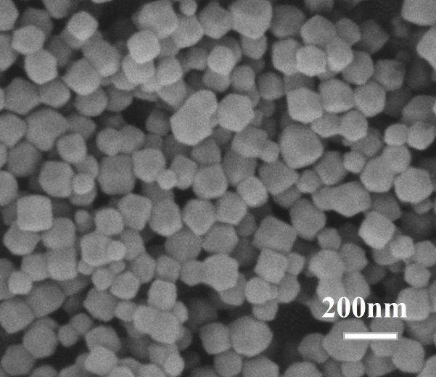
Fig. S1. TEM image of ZIF-8 nanoparticles.
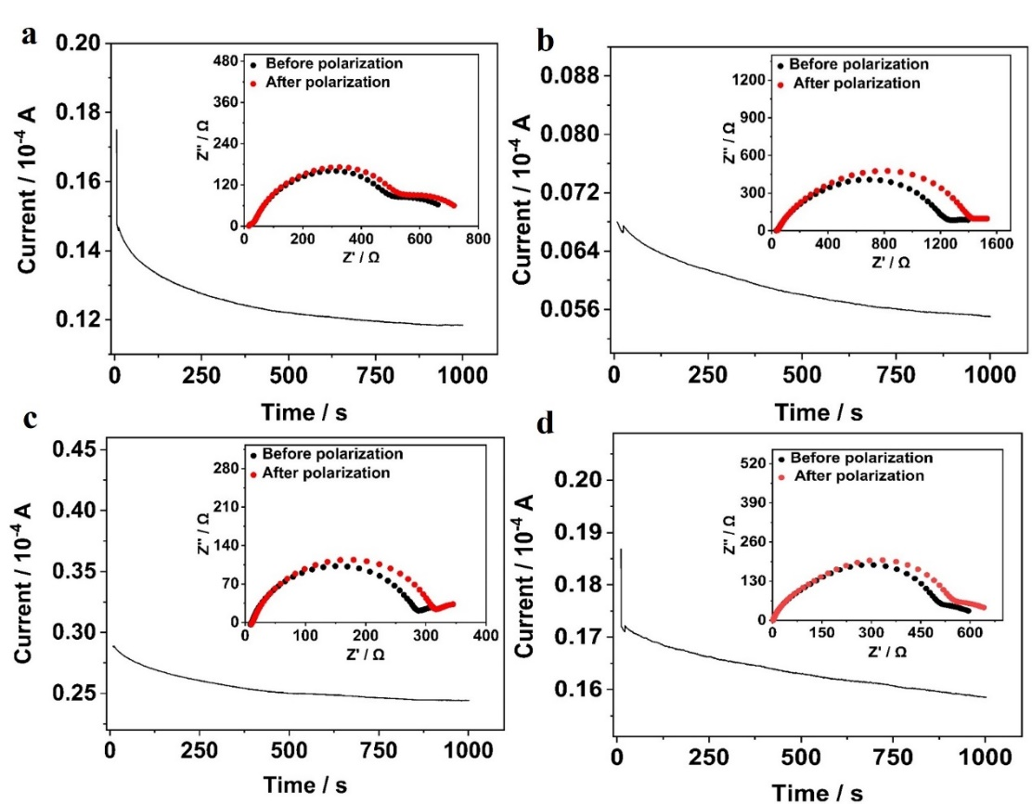
Fig. S2. The current-time curves of DC polarization and Nyquist plots before and after polarization in the Li/GPE/Li cell assembled by CP, ACP, ZIF-8@ACP and Celgard separators.

