Electronic Supplementary Material
Synergetic catalysis between ZnZrO_{x} and silanol nest-enriched silicalite-1 in CO₂ hydrogenation coupled with toluene alkylation
Yuhang Guo, Weichao Qin, Ruiwen Cao, Linfeng Zhang, Tingjun Fu (), Zhong Li
State Key Laboratory of Clean and Efficient Coal Utilization, College of Chemistry and Chemical Engineering, Taiyuan University of Technology, Taiyuan 030024, China

E-mail: futingjun@tyut.edu.cn

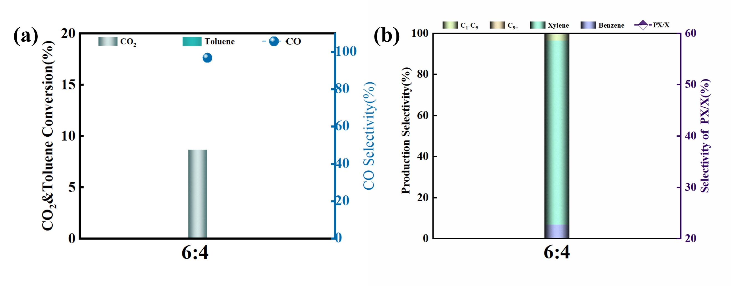
Fig. S1 Catalytic performance of ZZO:AS-1 at a mass ratio of 6:4. Reaction conditions: 350 °C, 3.0 MPa, GHSV of mixture gas (CO₂/H₂/N₂) = 4800mL g⁻¹ h⁻¹, WHSV of toluene = 0.8 h⁻¹.

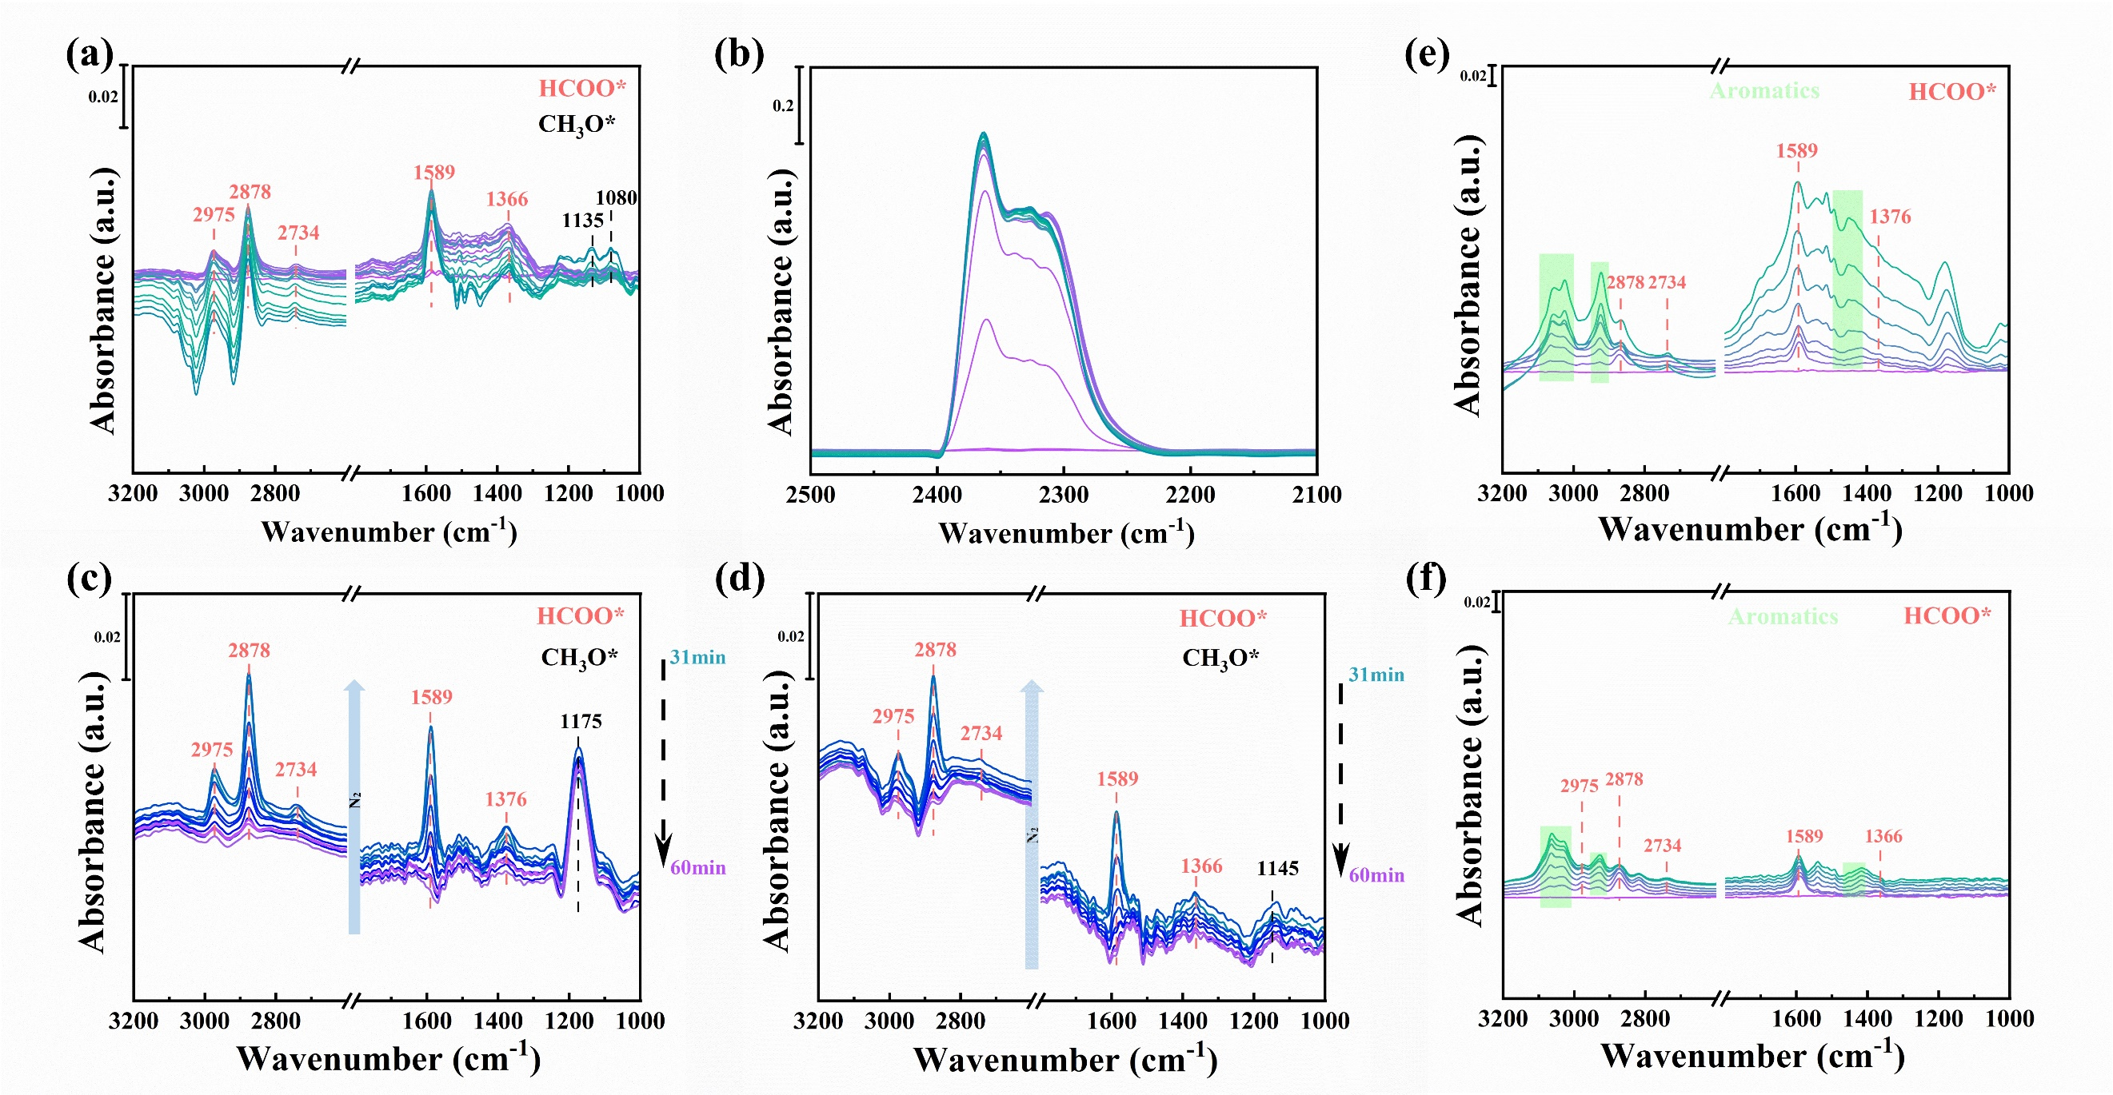
Fig. S2 In situ DRIFTS spectra at 350 °C. (a, b) ZnZrO_{x} catalyst under a CO₂/H₂ stream for 30 min: (a) 3200-1000 cm⁻¹ range and (b) 2500-2100 cm⁻¹ range. (c, d) Spectra after switching to a toluene/N₂ stream for 30 min over (c) ZZO&ZSM-5 and (d) ZZO&AS-1. (e, f) Control spectra under a toluene/N₂ stream for 30 min over (e) ZZO&ZSM-5 and (f) ZZO&AS-1.
Fig. S3 (a) Photographs after being dissolved in 20% HF and extracted by CH₂Cl₂: ①ZZO&ZSM-5 catalyst, ②ZZO&AS-1 catalyst. (b) GC-MS chromatograms of the organic species extracted by CH₂Cl₂. (c) ZZO&Z5 catalysts and (d) ZZO&AS-1 catalysts after in situ experiment.

Fig. S4 TEM images of (a) the parent AS-1 and the AHFS-treated samples for (b) 8 h and (c) 16 h.

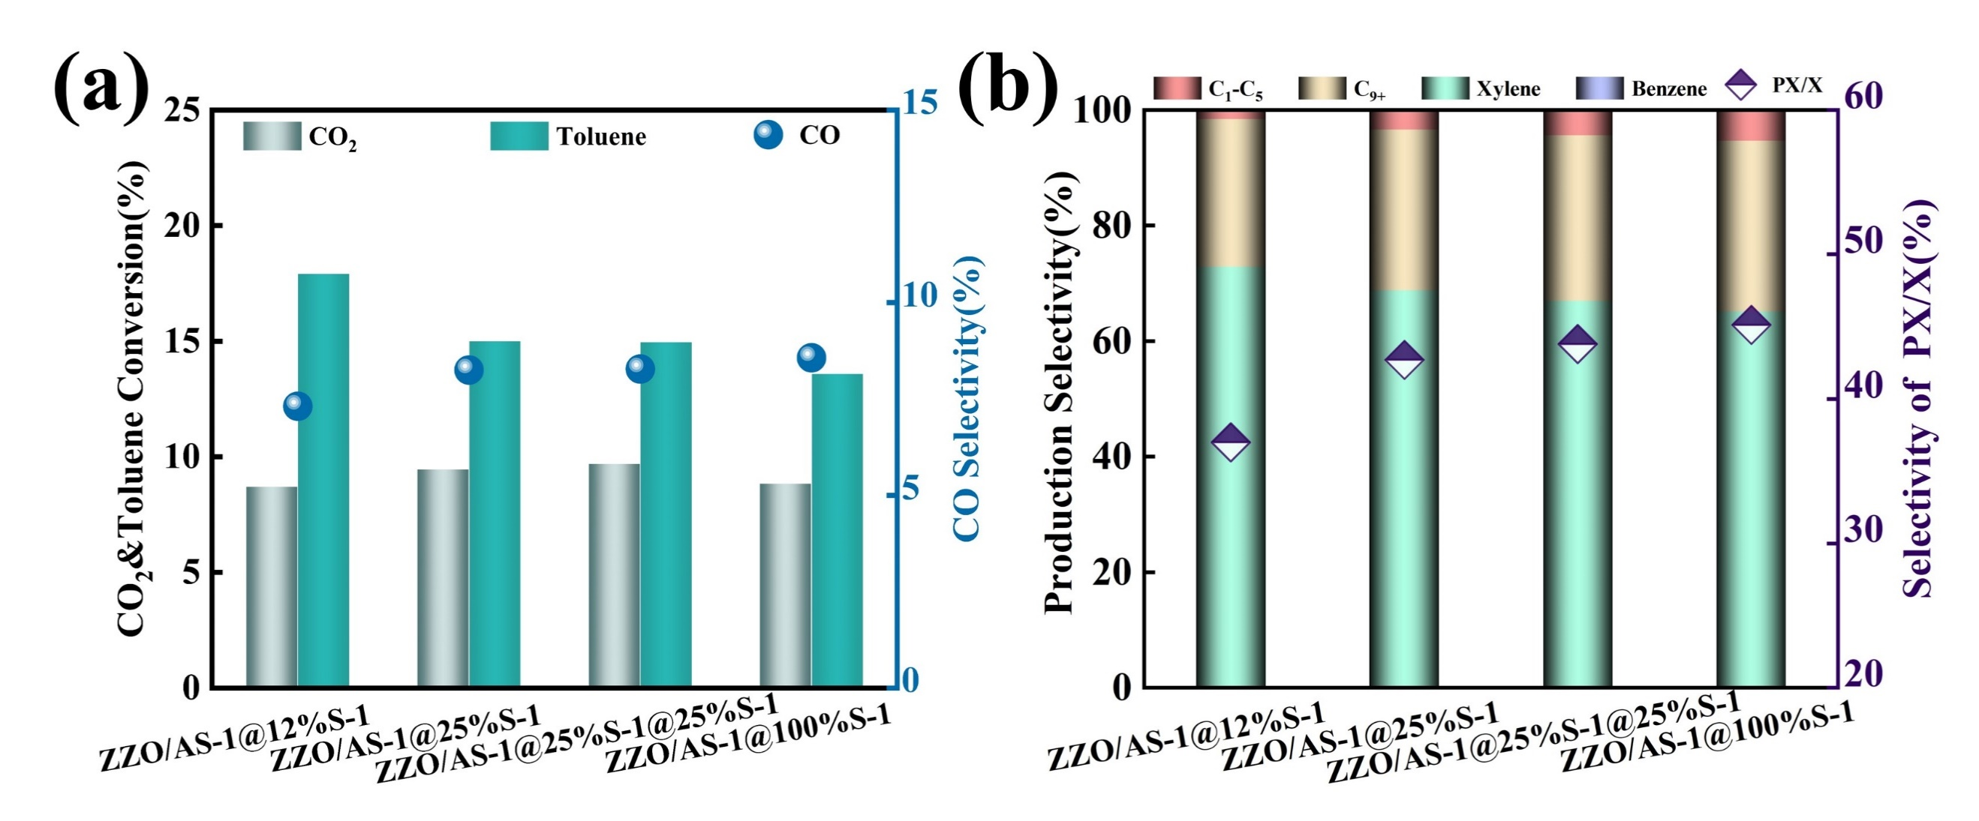
Fig. S5 (a-b) Influence of different silicon coating on the catalytic performance of AS-1. The ZZO loading ratio is fixed at 1:2. Reaction conditions: 350 °C, 3.0 Mpa. GHSV of mixture gas (CO₂/H₂/N₂) = 8000 mL g⁻¹ h⁻¹, WHSV of toluene = 1.3 h⁻¹.

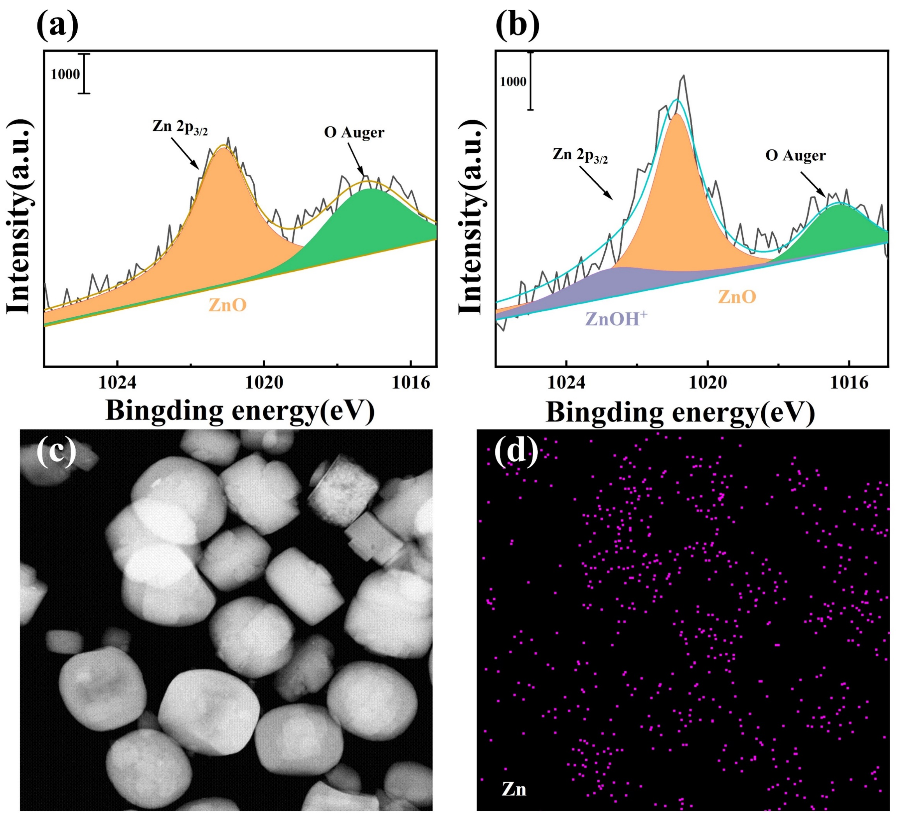
Fig. S6 XPS patterns of (a) AS-1 in ZZO&AS-1 20-40 PM catalyst, denoted as fresh-AS-1, (b) AS-1 in ZZO&AS-1 20-40 PM catalyst after stability evaluation, denoted as used-AS-1 (c-d) STEM and EDS elemental mapping of Spent-ZZO&AS-1 PM catalyst.
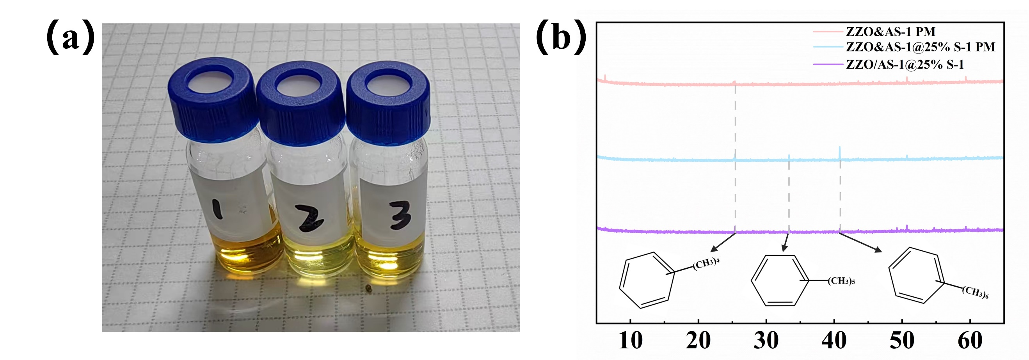
Fig. S7 (a) Photographs after being dissolved in 20% HF and extracted by CH₂Cl₂: ①spent-ZZO&AS-1 PM catalyst, ②spent-ZZO&AS-1@25%S-1 PM catalyst, ③spent-ZZO/AS-1@25%S-1 catalyst. (b) GC-MS chromatograms of the organic species extracted by CH₂Cl₂.
Table S1. Textural properties of ZSM-5 and AS-1 catalysts.
Sample | Surface area / (m²·g⁻¹) |  |  | Pore volume / (cm³·g⁻¹)
Sample | S_{BET} ª | S_{mic} ^{b} | S_{ext} ^{c} | V_{total} ^{d} | V_{mic} ^{e} | V_{meso}^{f}
ZSM-5 | 390 | 378 | 12 | 0.22 | 0.16 | 0.07
AS-1 | 397 | 388 | 9 | 0.21 | 0.19 | 0.02
ª Surface area, determined by BET model.
^{b} Surface area of micropores, determined by t-plot method.
^{c} Surface area of mesopores, determined by S_{BET}-S_{micro}.
^{d} Total pore volume, estimated from the adsorbed amount at P/P₀=0.99.
^{e} Micropores volume, determined by t-plot method.
^{f} Mesopores volume, determined by V_{total}-V_{micro}.

Table S2. Acidic properties of ZSM-5 and AS-1.
Sample | NH₃-TPD (μmmol·g⁻¹)
Sample | Total
ZSM-5 | 443
AS-1 | 38

Table S3. The assignments of peaks in in situ DRIFTS.
Peaks (cm⁻¹) | Assignment | Species
2200-2400 | v(C=O) | CO₂
1376 | v_{s}(OCO) | HCOO*
1589 | v_{as}(OCO) | HCOO*
2734 | δ(CH)+ v_{as}(OCO) | HCOO*
2878 | v(CH) | HCOO*
2975 | v(CH) | HCOO*
1175 | v(C-O) | CH₃O*
1145 | v(C-O) | CH₃O*
1400-1500 | v(C-C) | The C-H and C-C vibration of aromatic compounds
3000-3100 | v(C-H) | The C-H and C-C vibration of aromatic compounds

Table S4. Textural properties of samples with defect-repairing treatment at different times
Sample | Surface area / (m²·g⁻¹) |  |  | Pore volume / (cm³·g⁻¹)
Sample | S_{BET} ª | S_{mic} ^{b} | S_{ext} ^{c} | V_{total} ^{d} | V_{mic} ^{e} | V_{meso}^{f}
AS-1 | 397 | 388 | 9 | 0.21 | 0.19 | 0.02
4F-AS-1 | 318 | 241 | 77 | 0.21 | 0.12 | 0.09
8F-AS-1 | 307 | 241 | 66 | 0.21 | 0.13 | 0.08
16F-AS-1 | 309 | 249 | 60 | 0.21 | 0.13 | 0.08
ª Surface area, determined by BET model.
^{b} Surface area of micropores, determined by t-plot method.
^{c} Surface area of mesopores, determined by S_{BET}-S_{micro}.
^{d} Total pore volume, estimated from the adsorbed amount at P/P₀=0.99.
^{e} Micropores volume, determined by t-plot method.
^{f} Mesopores volume, determined by V_{total}-V_{micro}.

Table S5. Acidic properties of with different time points of defect-repairing treatment.
Sample | NH₃-TPD (μmmol·g⁻¹)
Sample | Total
AS-1 | 38
4F-AS-1 | 29
8F-AS-1 | 22
16F-AS-1 | 12

Table S6. Comparison of Data Related to Two Types of Catalysts
catalysts | STY_{PX} | r_{xylene} | r_{MeOH1} | r_{MeOH2}
catalysts | mg g-1 cat h⁻¹ | mol g-1 cat h⁻¹ | mol_{MeOH} g-1 cat h⁻¹ | mol_{MeOH} g-1 cat h⁻¹
ZZO (20-40) & AS-1@25%S-1(80-100) | 34.23 | 3.69×10⁻³ | 0.002015 | 0.000943
ZZO/AS-1@25%S-1 (1:3) | 42.33 | 4.2×10⁻³ | 0.004114 | 0.002057

Table S7. Summary of catalysts and their performances for CO₂ hydrogenation to aromatics
Catalysts | T  (°C) | Press. (MPa) | CO₂ Conv. (%) | Toluene Conv.  (%) | Selectivity of Xylene (%) | PX Selectivity (PX/X) (%) | Ref
ZnZrOx /4SZ5 | 360 | 3 | - | - | Xyl 92.4 | 70.8 | Sci. Adv. 2020; 6 : eaba5433
ZnCeZrOx /MCM-22 | 330 | 3 | 7.7 | 23.6 | Xyl 92.4 | 62~67 | Chin. J. Catal. 73 (2025) 174–185
ZnZrO / HZSM-5 (ZZO/Z5-SG) | 400 | 0.5 | 10.5 | 24.7 | Xyl 86.5 | - | Angew. Chem. Int. Ed. 2023, e202309377
ZnZrOx / C-Z5-SiO₂ | 450 | 0.5 | 5-6 | 19.2 | Xyl 91.1 | 90.1 | Appl. Catal. B: Environ. Energy 359 (2024) 124523
ZZO&4Si/MCM-22 | 280-400 | 3 | 4.2 | 10.3 | Xyl 91.0 | 70.4 | Nat. Commun. (2026) 17:967

Table S8. Acidic properties of AS-1 and AS-1@25%S-1.
Sample | NH₃-TPD (μmmol·g⁻¹)
Sample | Total
AS-1 | 38
AS-1@25%S-1 | 21

