Electronic Supplementary Material
Material failure risk mitigation and regulation strategies for thermochemical heat storage reactors
Hui Wu¹, Chengcheng Wang^{1,3}, Hui Yang¹, Quanchi Dong¹, Tianyu Guo³, Shaowu Yin¹, Lige Tong ()¹, Li Wang¹, Yulong Ding²
1 School of Energy and Environmental Engineering, University of Science and Technology Beijing, Beijing 100083, China
2 School of Chemical Engineering & Birmingham Centre for Energy Storage, University of Birmingham, Birmingham B15 2TT, UK
3 The China ENFI Engineering Co., Ltd, Beijing 100038, China

Email: tonglige@me.ustb.edu.cn

1. Fig. S1
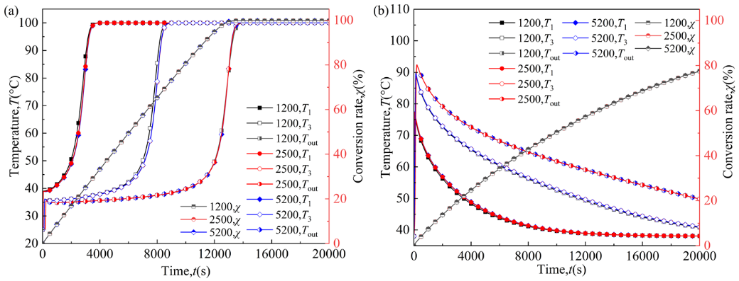
Fig. S1 Grid independence verification: (a) charging process, and (b) discharging process.
2. Fig. S2
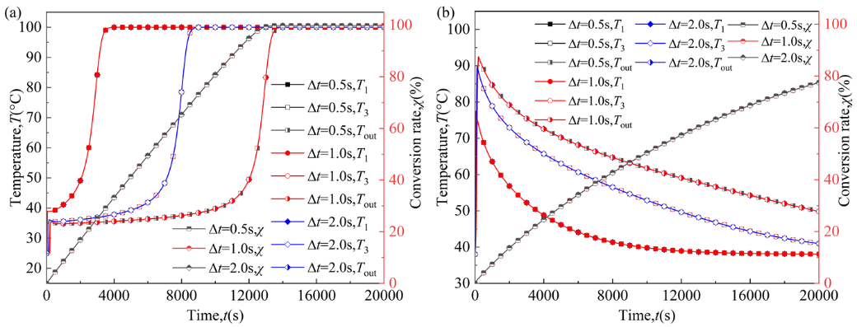
Fig. S2 Time step independence verification: (a) charging process, and (b) discharging process.
3. Fig. S3
Fig. S3 The variations of parameters with bed depth during the charging process when DL = 80%: (a) Temperature distribution, and (b) moisture saturation.
4. Fig. S4
Discharging condition: T_{ini,reactor} = -2 °C
Inlet air: 38 °C (RH = 80%) and -2 °C (RH = 80%); u = 0.428 m·s⁻¹
Fig. S4 The variations of outlet temperature and TCMs conversion rate during the discharging process when T_{in} = -2 °C and T_{in} =38 °C.

5. Fig. S5
Fig. S5 Temporal evolution of maximum moisture saturation (Š_{max}) throughout discharge under different initial reactor temperature (T_{ini,reactor} = -2 °C to 28 °C).
6. Fig. S6
Charging mode: isotropic charging
Reactor state: DL = 80%
Inlet air: T = 120 °C, moisture content = 1.0% (38 °C, RH = 80%), u = 0.428 m·s⁻¹
Fig. S6 The distribution of moisture saturation under DL = 80% and isotropic charging mode.
7. Fig. S7
Charging mode: reverse charging
Reactor state: DL = 80%
Inlet air: T = 120 °C, moisture content = 1.0%, u = 0.428 m·s⁻¹
Fig. S7 The distribution of moisture saturation under DL = 80% and reverse charging mode.
8. Fig. S8
Charging mode: reverse charging
Reactor state: DL = 80%
Inlet air: T = 100 °C, moisture content = 1.0%, u = 0.428 m·s⁻¹
Fig. S8 The distribution of moisture saturation under inlet air temperature T = 100 °C.
9. Fig. S9
Charging mode: reverse charging
Reactor state: DL = 80%
Inlet air: T = 120 °C, moisture content = 2.0%, u = 0.428 m·s⁻¹
Fig. S8 The distribution of moisture saturation when the moisture content of inlet air is 2.0%.
10. Fig. S10
Charging mode: reverse charging
Reactor state: DL = 80%
Inlet air: T = 120 °C, moisture content = 1.0%, u = 0.214 m·s⁻¹
Fig. S10 The distribution of moisture saturation when the inlet air velocity u = 0.214 m·s⁻¹.
11. Fig. S11
Charging mode: reverse charging
Reactor state: DL = 80%
Inlet air: T = 26.85 °C to 120 °C in 600 s, moisture content = 1.0%, u = 0.428 m·s⁻¹
Fig. S11 The distribution of moisture saturation when the inlet air temperature increases from 26.85 °C to 120 °C in 600 s.
12. Fig. S12
Charging mode: reverse charging
Reactor state: DL = 80%
Inlet air: T = 26.85 °C to 120 °C in 900 s, moisture content = 1.0%, u = 0.428 m·s⁻¹
Fig. S12 The distribution of moisture saturation when the inlet air temperature increases from 26.85 °C to 120 °C in 900 s.
13. Fig. S13
Charging mode: reverse charging
Reactor state: DL = 80%
Inlet air: T = 26.85 °C to 120 °C in 600 s, moisture content = 2.0%, u = 0.428 m·s⁻¹
Fig. S13 The distribution of moisture saturation when the inlet air temperature increases from 26.85 °C to 120 °C in 600 s and moisture content is 2.0%.
14. Fig. S14
Charging mode: reverse charging
Reactor state: DL = 80%
Inlet air: T = 26.85 °C to 120 °C in 900 s, moisture content = 1.0%, u = 2.140 to 0.428 m·s⁻¹ in 900 s
Fig. S14 The distribution of moisture saturation when the inlet air temperature increases from 26.85 °C to 120 °C in 900 s and inlet air velocity decrease from 2.140 m·s⁻¹ to 0.428 m·s⁻¹.
15. Fig. S15
Charging mode: reverse charging
Reactor state: DL = 80%
Inlet air: T = 26.85 °C to 120 °C in 900 s, moisture content = 1.0%, u = 1.284 to 0.428 m·s⁻¹ in 900 s
Fig. S15 The distribution of moisture saturation when the inlet air temperature increases from 26.85 °C to 120 °C in 900 s and inlet air velocity decrease from 1.284 m·s⁻¹ to 0.428 m·s⁻¹.

