Support Information
Minute-level interfacial polymerization of covalent organic framework membranes for high-flux nanofiltration
Junjie Liuª, Bingqian Kangª, Xinyi Zhaoª, Yingzhou Lu^{a,}*, Hongwei Fan^{a,}*
ªState Key Laboratory of Chemical Resource Engineering, College of Chemical Engineering, Beijing University of Chemical Technology, Beijing 100029, P. R. China
*Corresponding author E-mail address: lyz0321@163.com; fanhongwei@mail.buct.edu.cn.

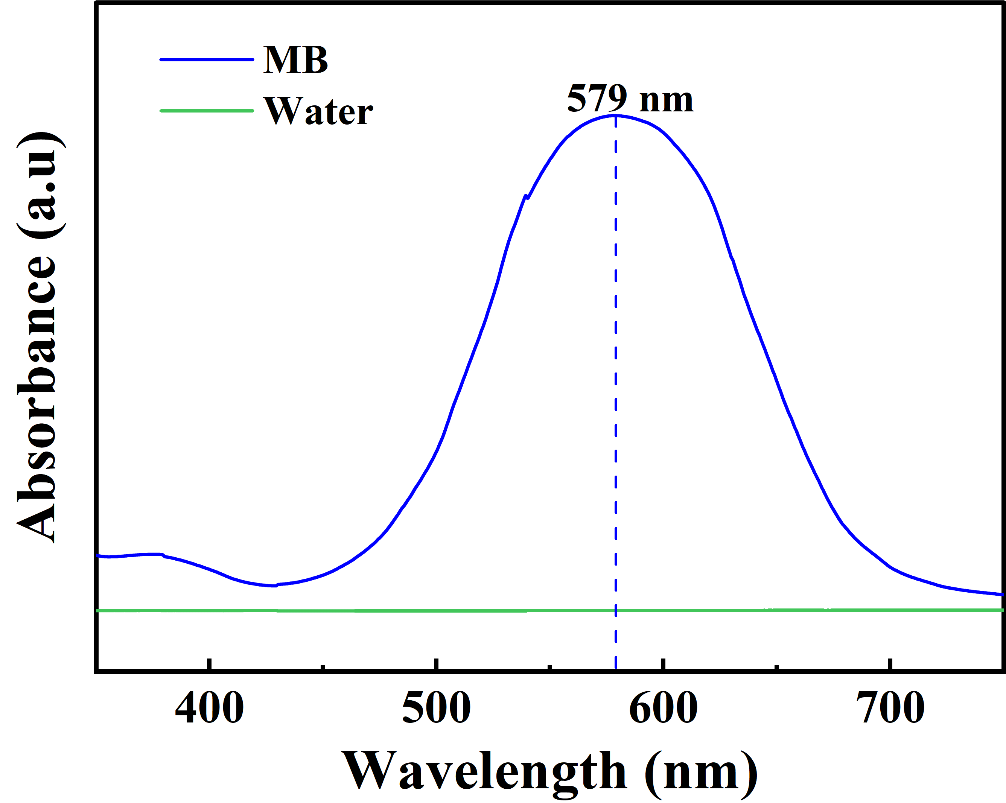
Fig. S1 UV absorption spectrum of MB (0.1 g L⁻¹).

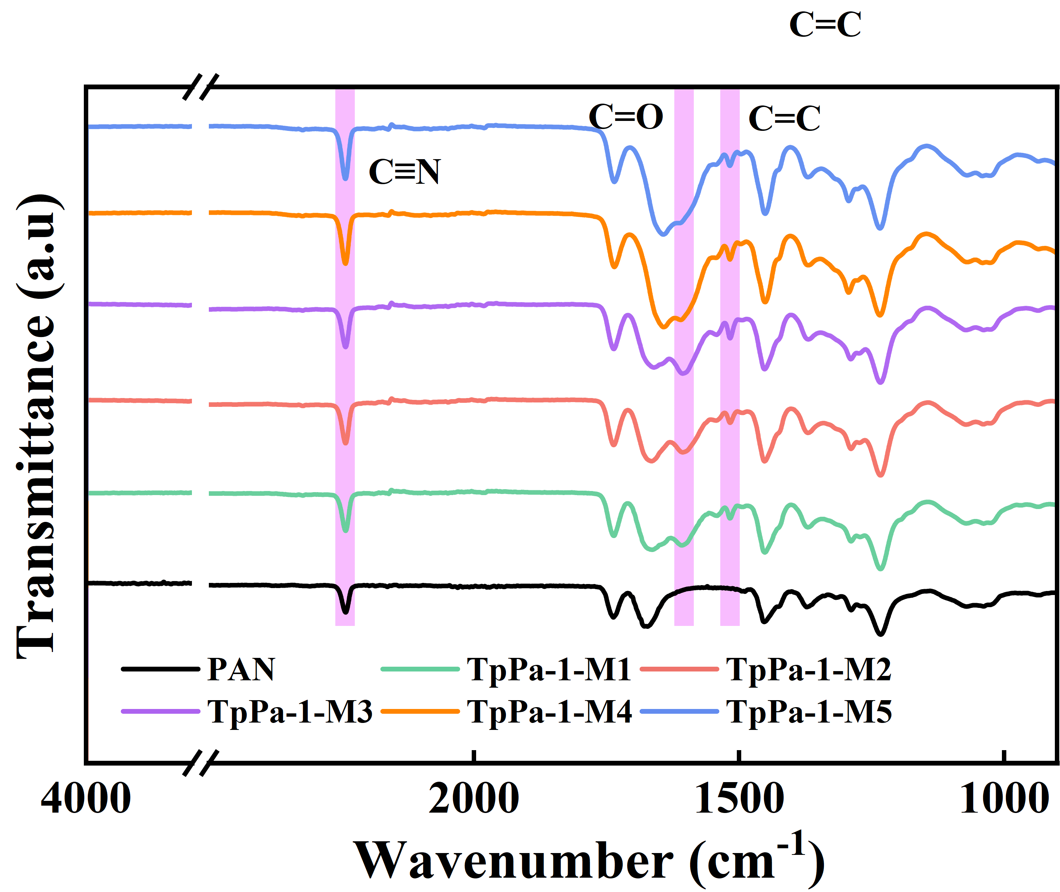
Fig. S2 FTIR spectra of PAN substrate and TpPa-1-MX.

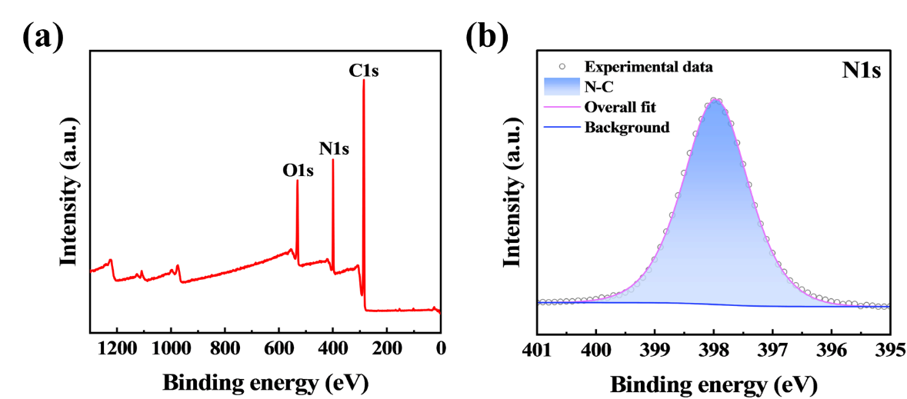
Fig. S3 (a) Survey spectrum of TpPa-1-M2 membrane XPS. (b) High-resolution XPS spectrum of N1s.

Table S1 Surface elemental composition of the TpPa-1-M2 membrane.
Element | TpPa-1-M2 (at%)
C | 73.30%
N | 14.48%
O | 12.22%

Table S2 Detailed C1s spectrum results for the TpPa-1-M2 membrane.
Species | TpPa-1-M2 (at%) | Energy (Ev)
C-C | 48.55% | 283.19
C-O/C-N | 43.68% | 284.82
C=O | 7.77% | 286.71

Table S3 Detailed O1s spectrum results for the TpPa-1-M2 membrane.
Species | TpPa-1-M2 (at%) | Energy (Ev)
O=C | 50.43% | 529.38
O-N | 40.01% | 531.19
O-H | 9.56% | 533.67

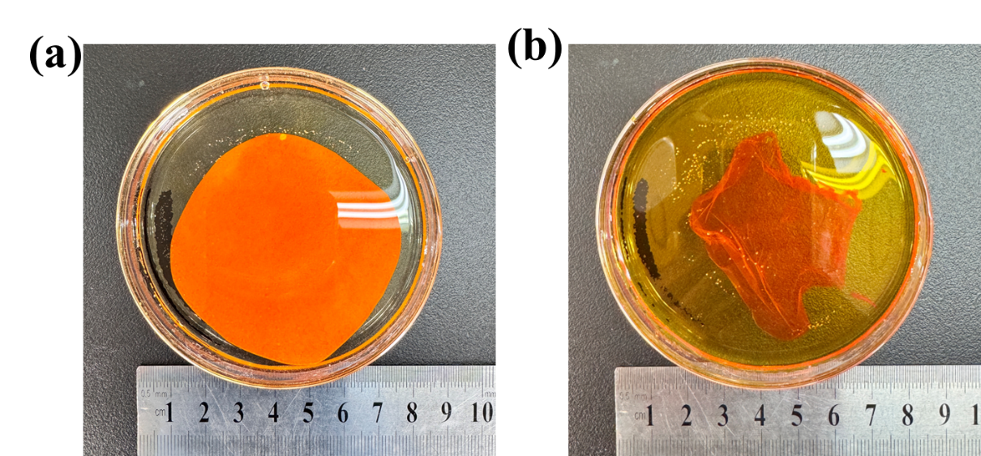
Fig. S4 Digital photographs of TpPa-1-M2 in DMF: (a) before stripping, (b) after stripping.

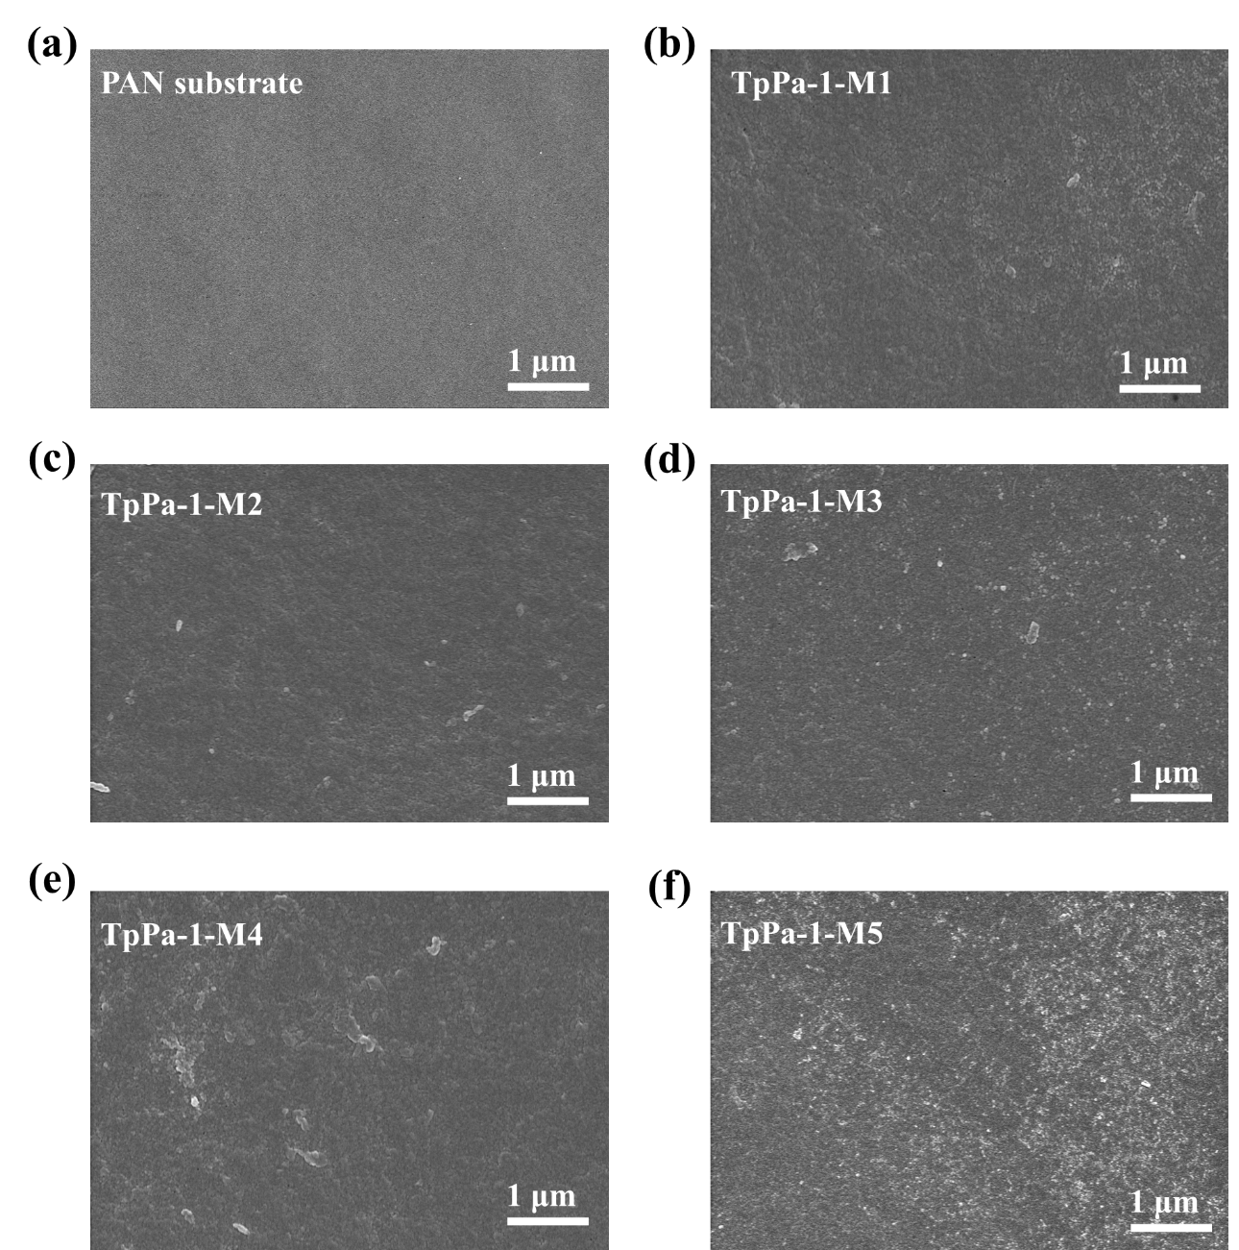
Fig. S5 (a) SEM image of PAN substrate surface. (b-f) SEM images of TpPa-1-MX membrane surface.

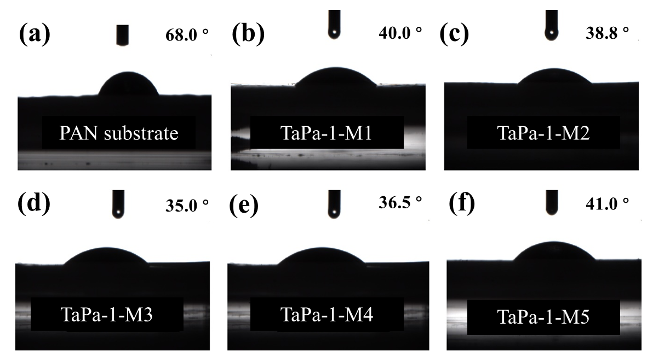
Fig. S6 (a) PAN substrate water contact angle. (b-f) Water contact angles of TpPa-1 membranes prepared under different conditions.
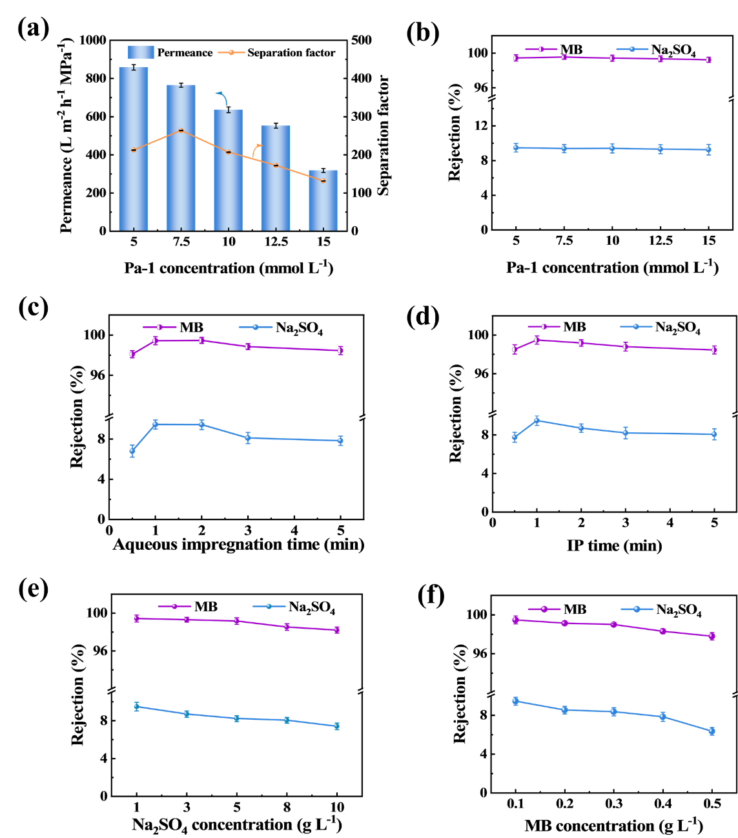
Fig. S7 (a) Effect of Pa-1 concentration on membrane performance. (b-f) Effect of Pa-1 concentration, aqueous phase impregnation time, IP time, Na₂SO₄ concentration, and MB concentration on Na₂SO₄ and MB rejection.
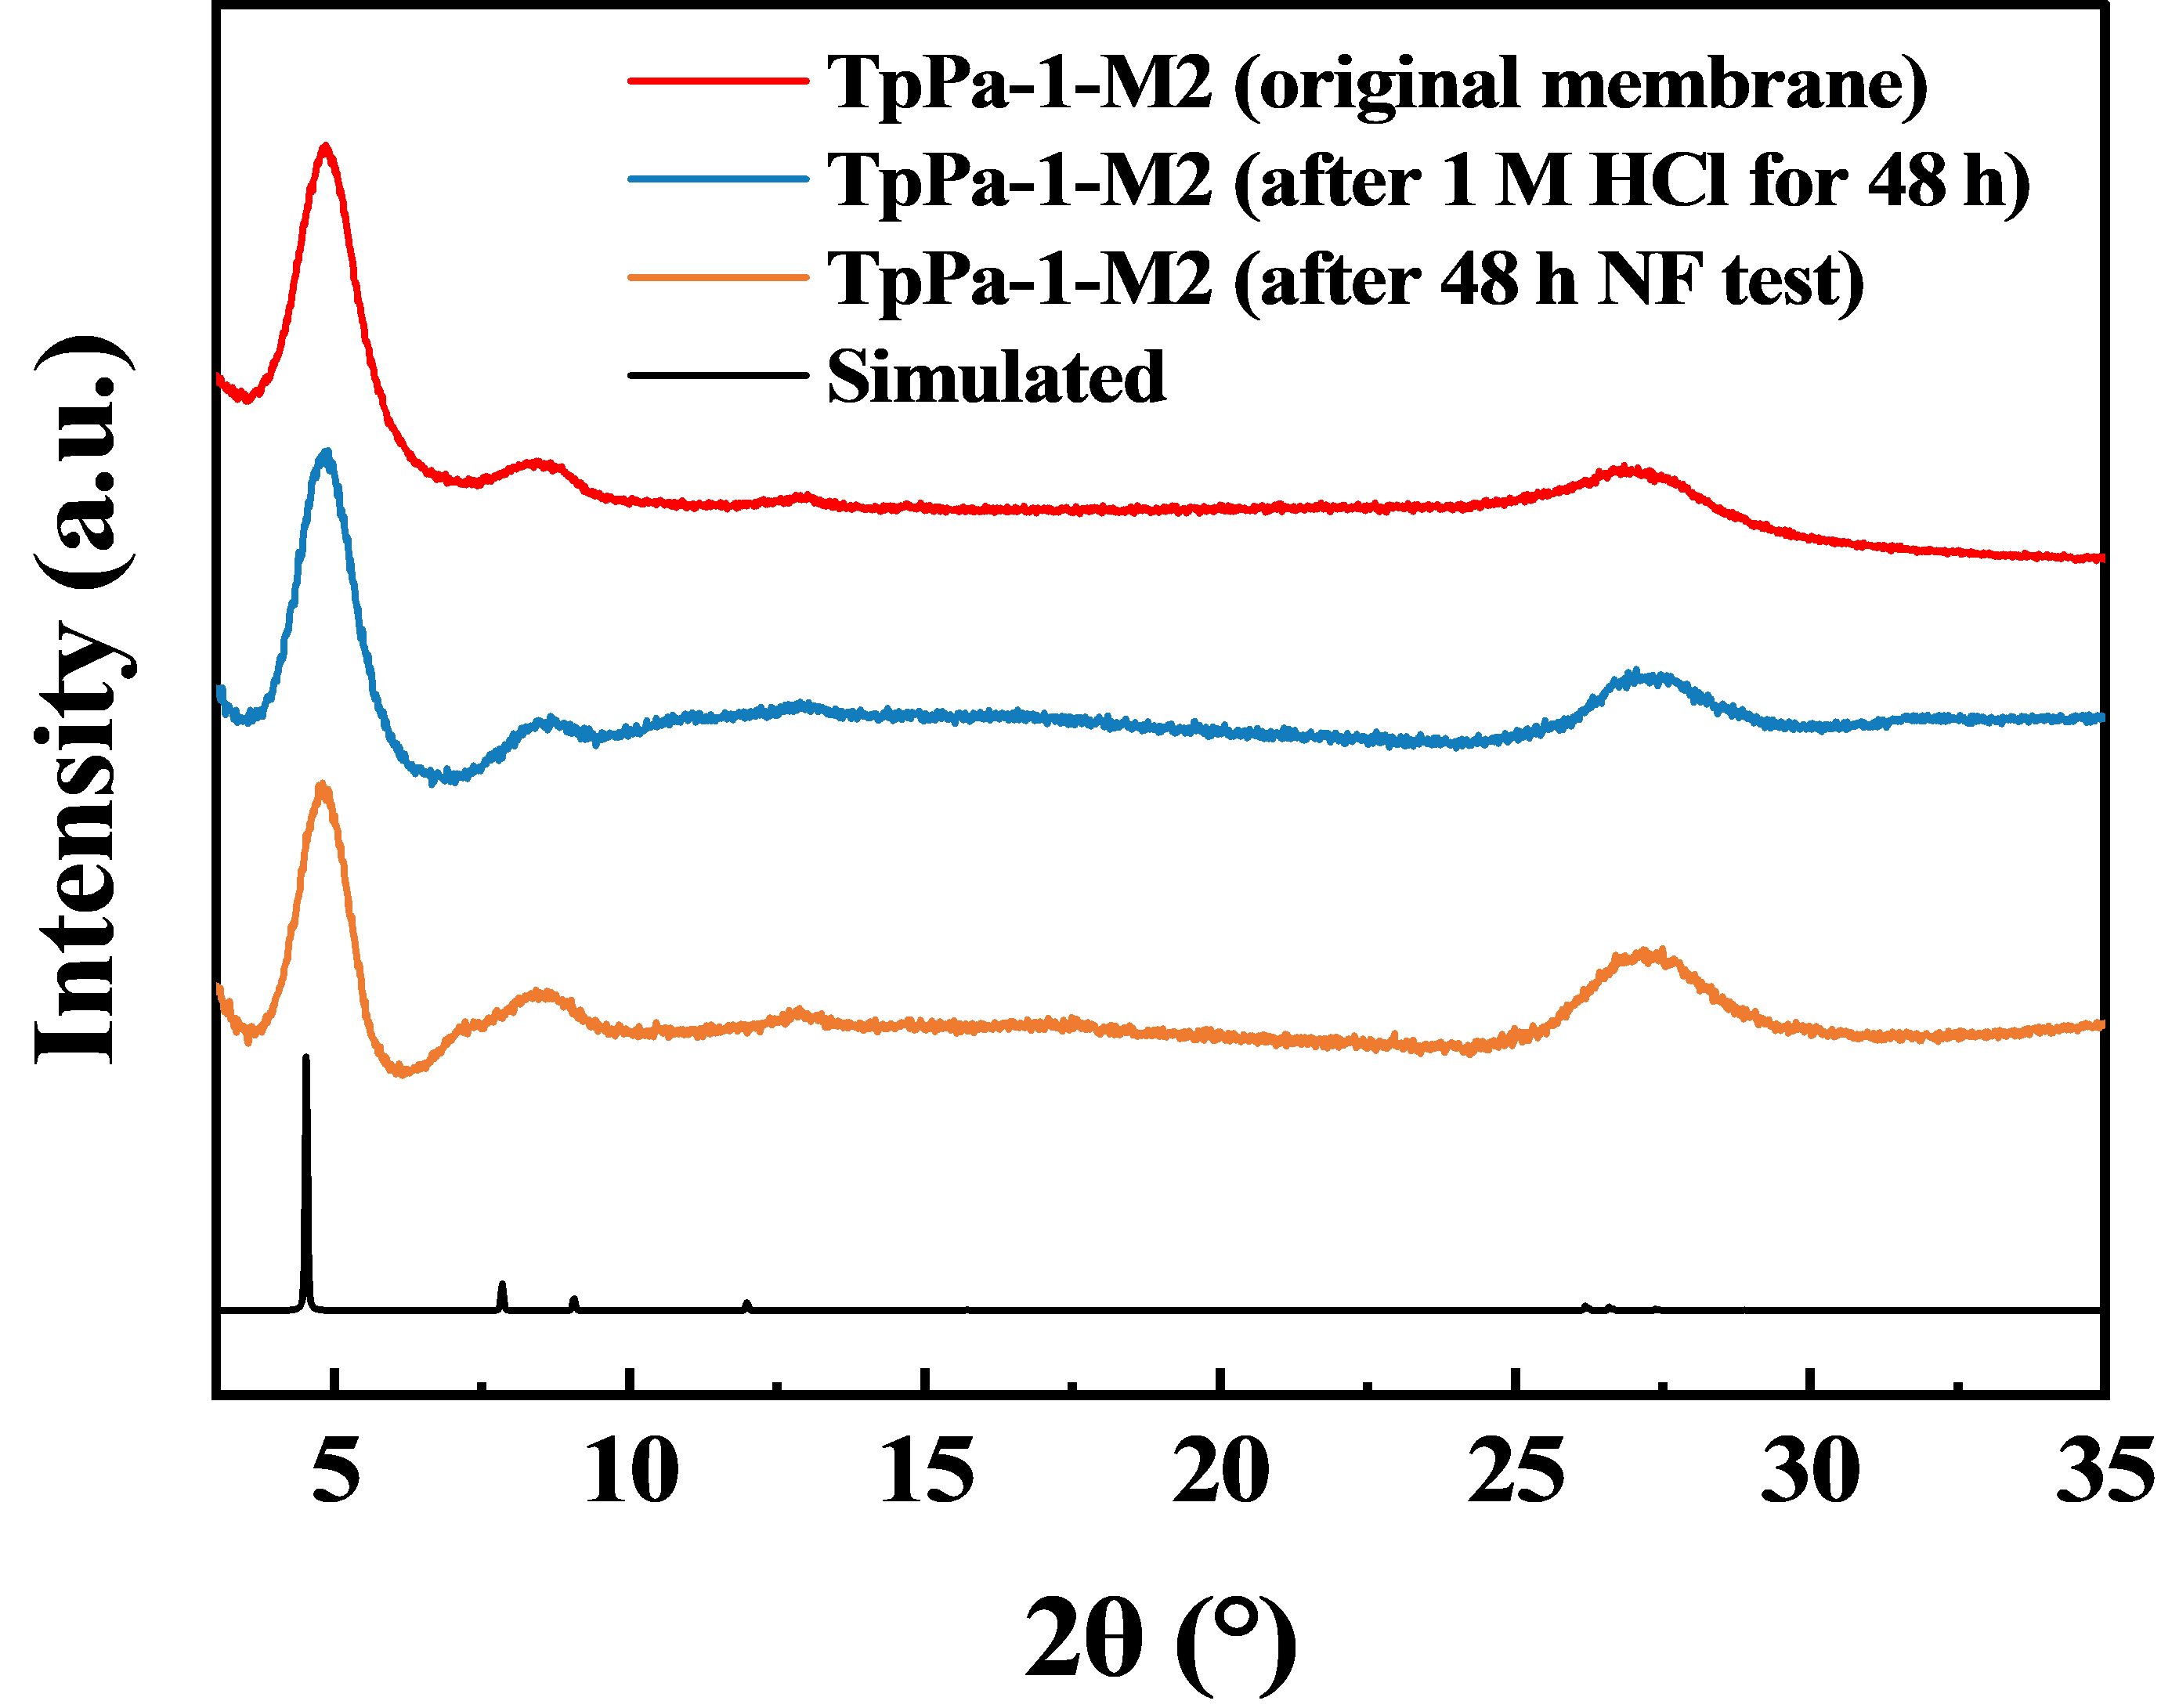
Fig. S8 XRD comparison of TpPa-1-M2 membrane before and after acid treatment and stability testing.
The acid-resistance test was performed by immersing the membrane in a 1 M HCl solution for 48 hours. For the stability evaluation, a membrane sample was subjected to a continuous 48-hour test before collecting XRD data. All XRD samples were treated with DMF before measurement to ensure consistent sample preparation.
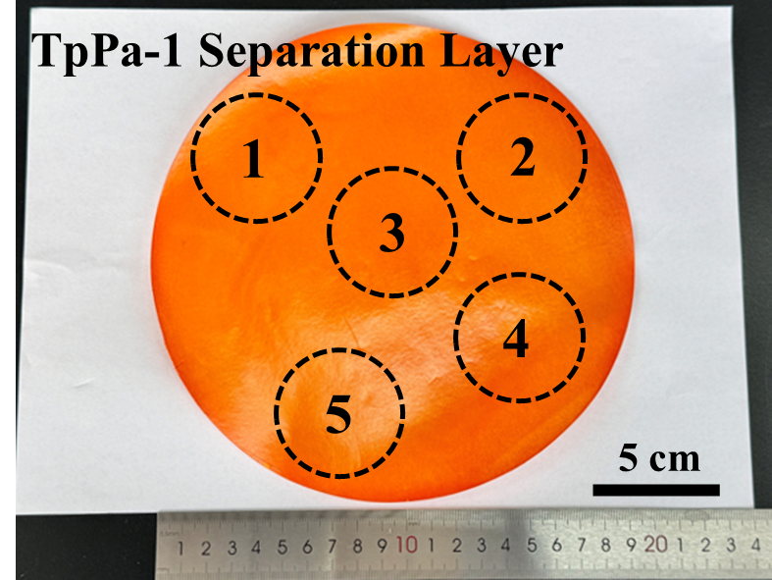
Fig. S9 Electron micrographs of the separation layer of an 18 cm diameter TpPa-1 amplified membrane.
Table S4 Dye desalting performance of five regions on large membranes.
 | Permeance  (L·m⁻²·h⁻¹·MPa⁻¹) | Rejection of Na₂SO₄ (%) | Rejection of  MB (%) | Separation factor
1 | 360.83 | 10.37 | 99.25 | 118.8
2 | 344.91 | 8.02 | 99.11 | 103.3
3 | 334.29 | 7.32 | 99.27 | 126.5
4 | 318.38 | 16.74 | 99.19 | 102.3
5 | 382.05 | 13.32 | 99.10 | 96.6

Table S5 Comparison of water flux and dye desalination separation factor for different nanofiltration membranes.
Membrane | Permeance  （L m⁻² h⁻¹ MPa⁻¹） | Salt rejection（%） | Dye rejection（%） | Separation factor | Ref.
3,5-DABA/TMC | 246.2 | 13.6 | 99.5 | 172.8 | [1]
SMA-PEI/PES | 236.0 | 2.5 | 99.4 | 162.5 | [2]
CFGO/PA | 110.0 | 25.0 | 95.1 | 16.3 | [3]
LNFM4-COF-366 | 650.0 | / | / | 27.1 | [4]
PA-DEA-PQ | 420.4 | 10.7 | 98.9 | 81.2 | [5]
EIP M120 | 47.0 | 4.7 | 99.8 | 435.1 | [6]
PEA-TMC | 166.0 | 16.4 | 95.4 | 16.8 | [7]
TpPa-12/PAN | 210.0 | 19.5 | 99.8 | 402.5 | [8]
TAIP (M4) | 71.6.0 | 2.6 | 97.5 | 38.5 | [9]
GN-PA/PAN | 365.0 | 5.6 | 96.9 | 30.2 | [10]
PES-CNT-PA | 170.0 | 25.9 | 99.4 | 123.5 | [11]
TiO₂COOH/CaAlg | 141.0 | 7.5 | 98.4 | 57.8 | [12]
PrGO75/250 | 1130.0 | 0.4 | 98.3 | 59.0 | [13]
TMC-β-CD/PES | 1039.0 | 10.6 | 99.0 | 89.4 | [14]
TMC-DAT/HPAN | 951.0 | 5.8 | 99.1 | 104.7 | [15]
TMC-ME/PES | 532.3.0 | 5.6 | 99.6 | 236.0 | [16]
CMCS-OA-NaAlg | 126.0 | 7.0 | 99.5 | 186.0 | [17]
TbPa-SO₃H | 360.0 | 1.2 | 96.0 | 24.7 | [18]
TpPa COFs | 1050.0 | 6.0 | 98.5 | 62.7 | [19]
IP-TpPa-1-M2 | 865.0 | 9.4 | 99.6 | 212.0 | This work

References
- Wu B, Li S, Ullah N, Duan Q, Wang M, Yu N, Gong G, Hu Y. Highly hydrophilic loose nanofiltration membrane based on a novel diaminobenzamide monomer for efficient dye/salt separation. Separation and Purification Technology, 2025, 360: 131005
- Jin J, Du X, Yu J, Qin S, He M, Zhang K, Chen G. High performance nanofiltration membrane based on SMA-PEI cross-linked coating for dye/salt separation. Journal of Membrane Science, 2020, 611: 118307
- Zhang H, Li B, Pan J, Qi Y, Shen J, Gao C, Van der Bruggen B. Carboxyl-functionalized graphene oxide polyamide nanofiltration membrane for desalination of dye solutions containing monovalent salt. Journal of Membrane Science, 2017, 539: 128–137
- Chen M, Song Q, Li Z, Bai W, Xu M, Li X, Li W, Nan H, Wang J, Zhang Y, Wang Y. COFs functionalized self-cleaning loose nanofiltration membranes for efficient dye/salt separation. Desalination, 2025, 593: 118206
- Yi B, Liu L, He H, Yu S, Wu D, Gao C. Enhancing loose nanofiltration membrane performance with strategic diethanolamine and polyquaternium-10 modifications for efficient dye desalination. Desalination, 2025, 601: 118586
- Kang Y, Jang J, Kim S, Lim J, Lee Y, Kim IS. PIP/TMC interfacial polymerization with electrospray: novel loose nanofiltration membrane for dye wastewater treatment. ACS Applied Materials & Interfaces, 2020, 12 (32): 36148–36158
- Mi Y, Wang N, Qi Q, Yu B, Peng X, Cao Z. A loose polyamide nanofiltration membrane prepared by polyether amine interfacial polymerization for dye desalination. Separation and Purification Technology, 2020, 248: 117079
- Zhang T, Li P, Ding S, Wang X. High permeability composite nanofiltration membrane assisted by introducing TpPa covalent organic frameworks interlayer with nanorods for desalination and NaCl/dye separation. Separation and Purification Technology, 2021, 270: 118802
- Li Q, Liao Z, Fang X, Xie J, Ni L, Wang D, Qi J, Sun X, Wang L, Li J. Tannic acid assisted interfacial polymerization based loose thin-film composite NF membrane for dye/salt separation. Desalination, 2020, 479: 114343
- Zhang H, Zhang T, Ding S, Wang X. Development of loose thin film nanofibrous composite nanofiltration membrane with modified g-C3N4 nanosheets barrier layer for efficient separation of salt/dye mixtures. Separation and Purification Technology, 2023, 306: 122661
- Gong G, Wang P, Zhou Z, Hu Y. New insights into the role of an interlayer for the fabrication of highly selective and permeable thin-film composite nanofiltration membrane. ACS Applied Materials & Interfaces, 2019, 11 (7): 7349–7356
- Wang X, Qin W, Wang L, Zhao K, Wang H, Liu H, Wei J. Desalination of dye utilizing carboxylated TiO₂/calcium alginate hydrogel nanofiltration membrane with high salt permeation. Separation and Purification Technology, 2020, 253: 117475
- Deng E, Chen K, Quigley A, Yuan M, Zhu L, Kralles Z, Freeman B, Dai N, Lin H. In situ oxidation of reduced graphene oxide membranes by peracetic acid for dye desalination. Journal of Membrane Science, 2024, 707: 122991
- Liu L, Yu L, Borjigin B, Liu Q, Zhao C, Hou D. Fabrication of thin-film composite nanofiltration membranes with improved performance using β-cyclodextrin as monomer for efficient separation of dye/salt mixtures. Applied Surface Science, 2021, 539: 148284
- Feng X, Liu D, Ye H, Peng D, Wang J, Han S, Zhang Y. High-flux polyamide membrane with improved chlorine resistance for efficient dye/salt separation based on a new N-rich amine monomer. Separation and Purification Technology, 2021, 278: 119533
- Jin P, Zhu J, Yuan S, Zhang G, Volodine A, Tian M, Wang J, Luis P, Van der Bruggen B. Erythritol-based polyester loose nanofiltration membrane with fast water transport for efficient dye/salt separation. Chemical Engineering Journal, 2021, 406: 126796
- Xie W, Zhao K, Xu L, Gao N, Zhao H, Gong Z, Yu L, Jiang J. Oxalic acid cross-linked sodium alginate and carboxymethyl chitosan hydrogel membrane for separation of dye/NaCl at high NaCl concentration. Chinese Chemical Letters, 2022, 33 (4): 1951–1955
- Miao Q, Chen G, Chen D, Sun P, Pang J, Cao N, Wang Y, Chen C. Development of high crystalline and robust ionic COFs nanofiltration membranes for dyes/salts separation via facile microwave technique. Chemical Engineering Journal, 2025, 519: 164883
- Zhou C, Li H, Wang L, Fu T, Liu G, Shen X, Zhao H. High-flux and stability nanofiltration membranes prepared with β-cyclodextrin and in-situ co-polymerized of TpPa COFs for dye desalination. Journal of Environmental Chemical Engineering, 2025, 13 (2): 116096

