Electronic Supplementary Material
Nanocrystalline low-silica X zeolite as an efficient ion-exchanger enabling fast radioactive strontium capture
Hyungmin Jeon¹, Susung Lee¹, Jeong-Chul Kim², Minkee Choi ()¹
1 Department of Chemical and Biomolecular Engineering (BK21 Four), Korea Advanced Institute of Science and Technology (KAIST), Daejeon 34141, Republic of Korea
2 Center for Nanomaterials and Chemical Reactions, Institute for Basic Science (IBS), Daejeon 34141, Republic of Korea

E-mail: mkchoi@kaist.ac.kr

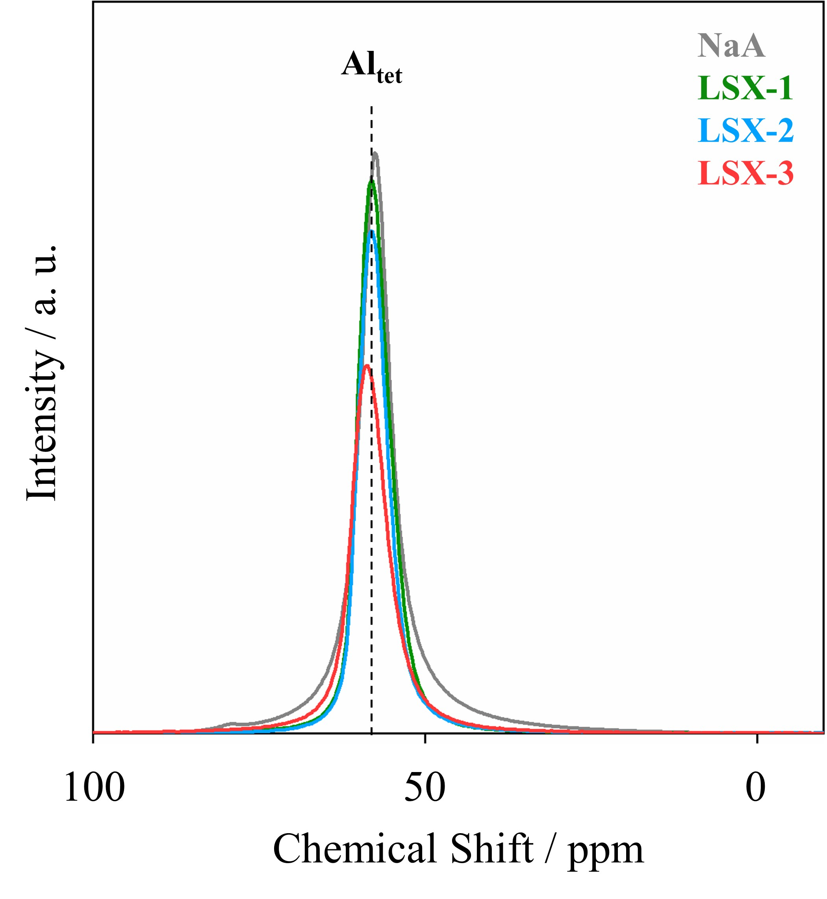
Fig. S1. ²⁷Al MAS NMR spectra of the zeolites.
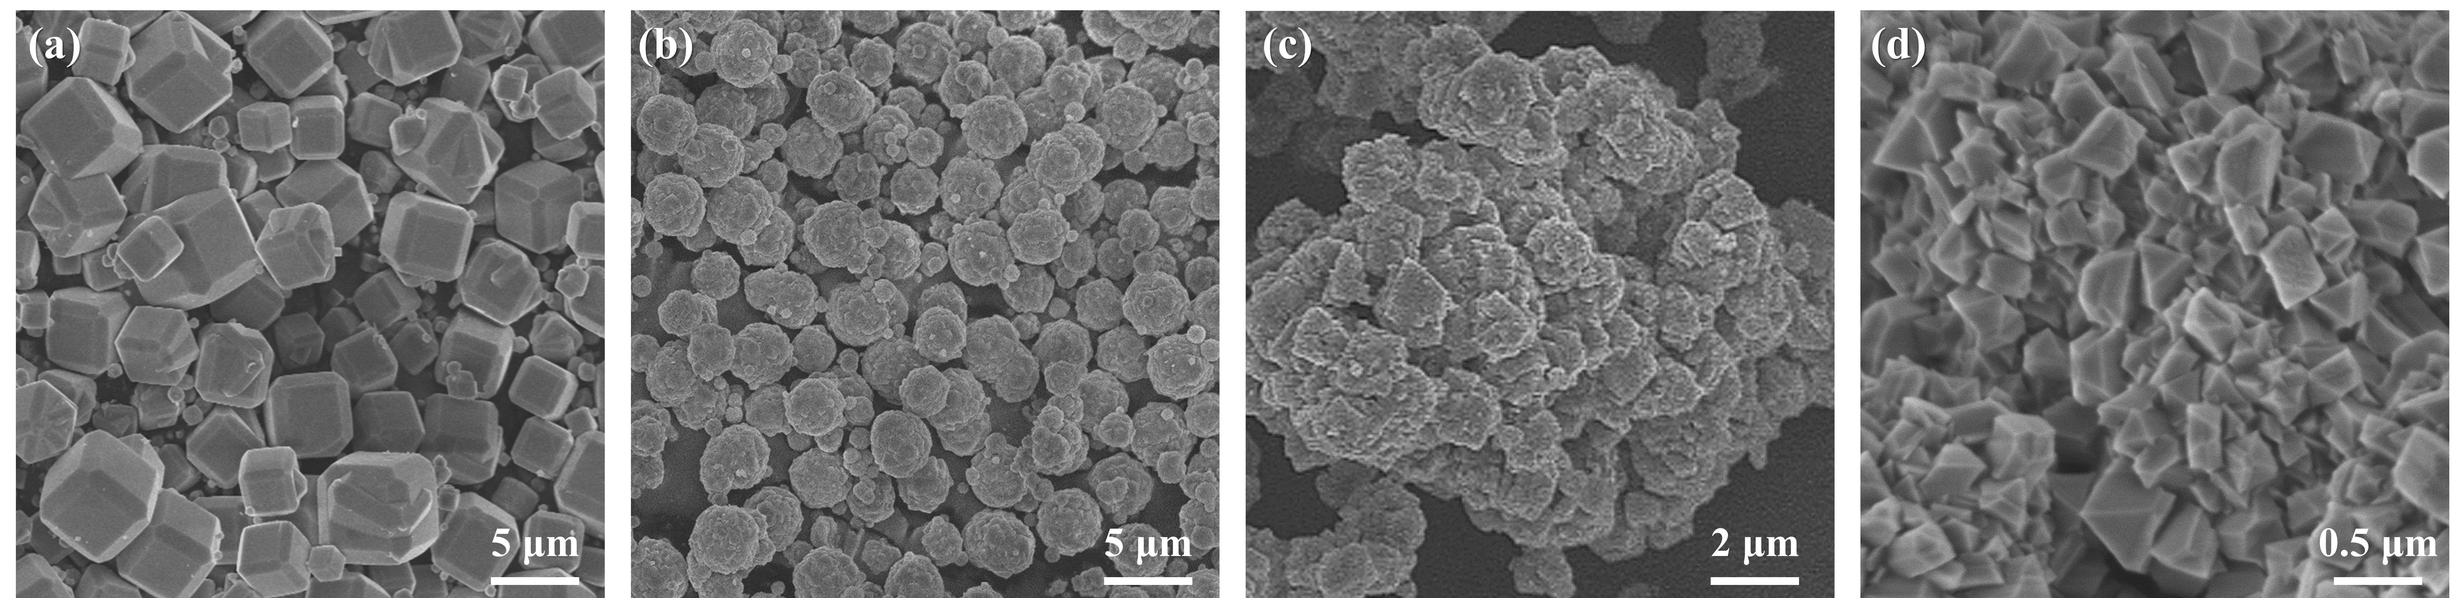
Fig. S2. Low-magnification SEM images of (a) NaA, (b) LSX-1, (c) LSX-2, and (d) LSX-3.
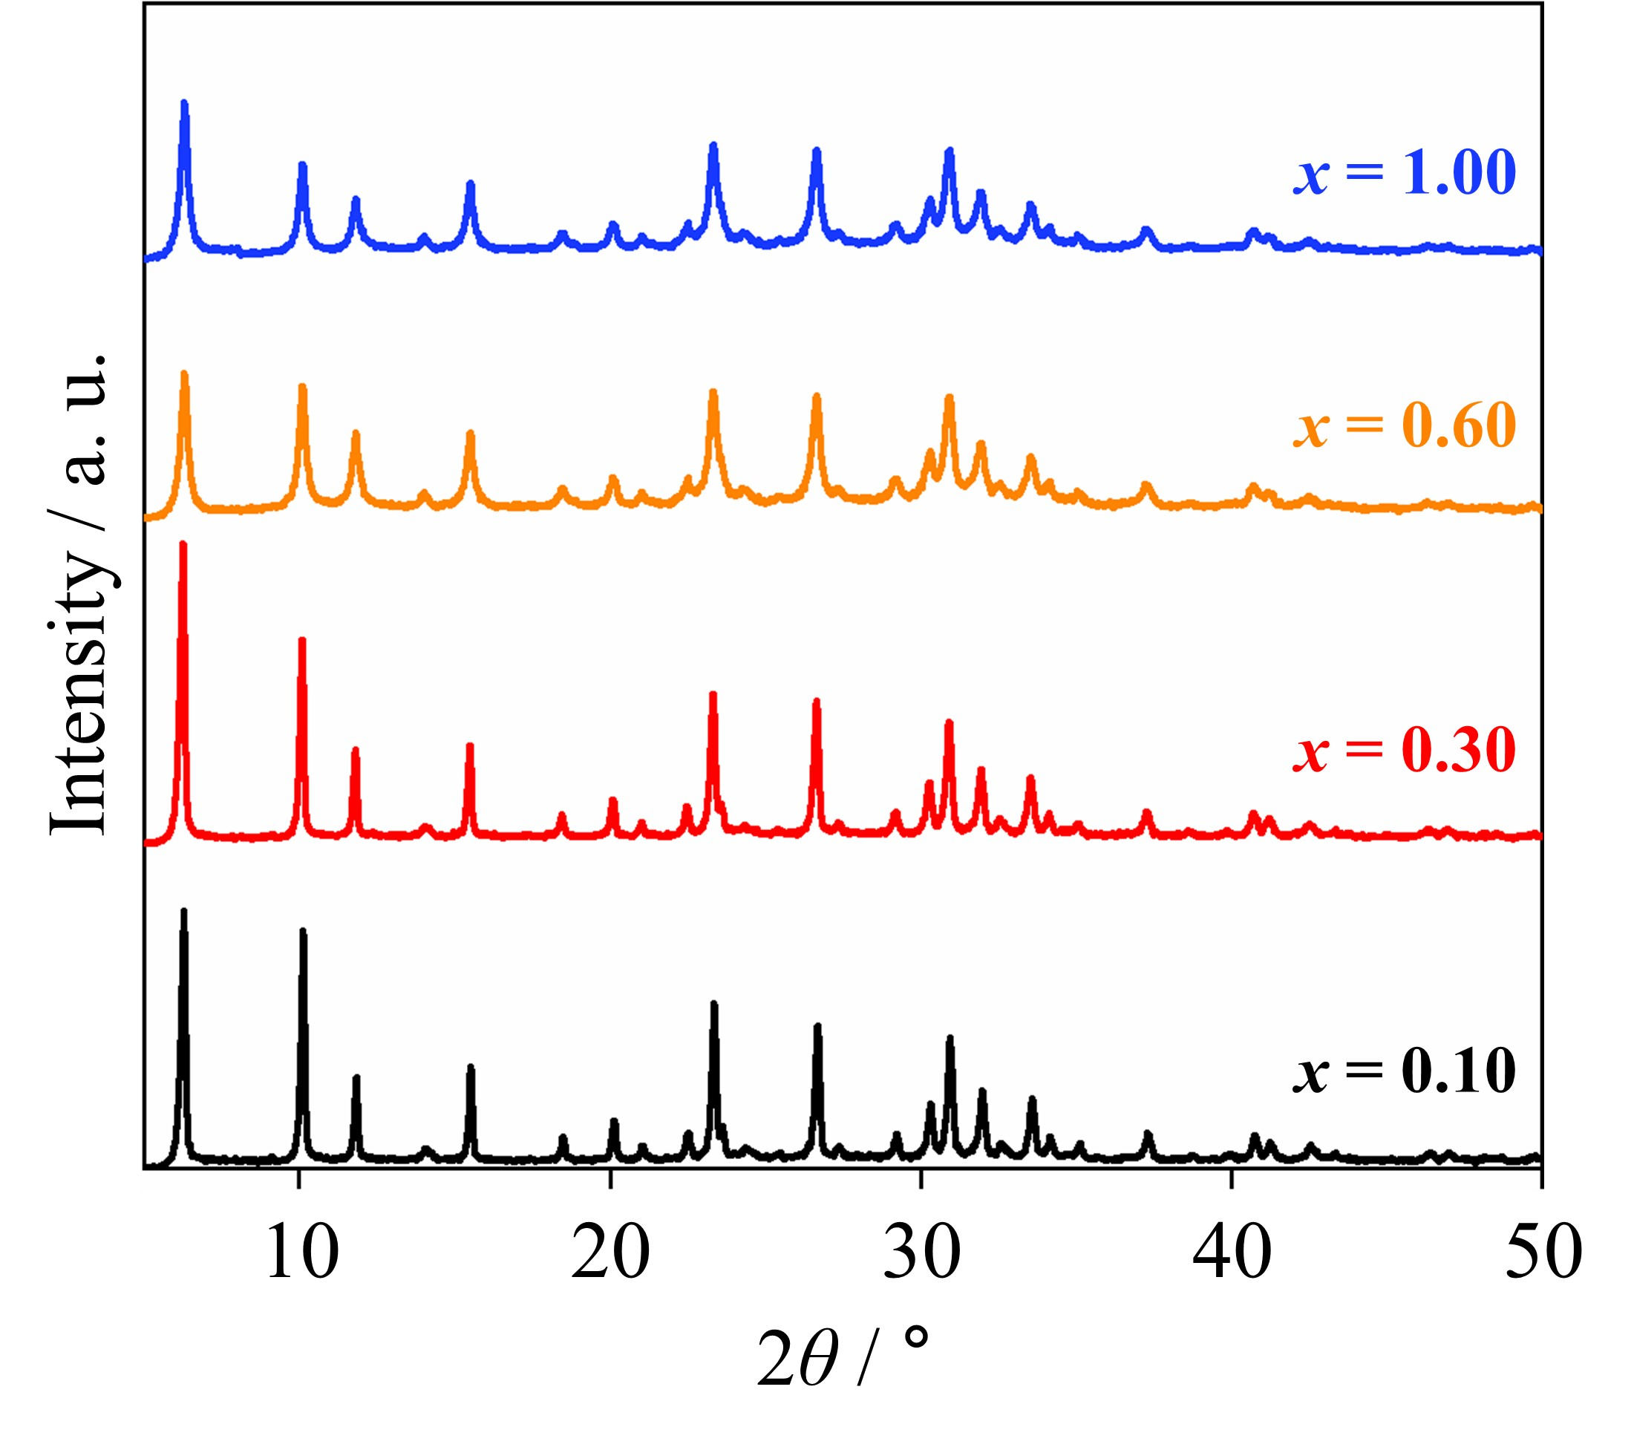
Fig. S3. X-ray diffraction patterns of the LSX zeolites synthesized by adding varying amounts of methyl cellulose. The synthesis gel compositions are 5.50 Na₂O: 1.65 K₂O: 1.00 Al₂O₃: 2.20 SiO₂: 61 H₂O: x methyl cellulose, where x is 0.10, 0.30, 0.60, and 1.00.
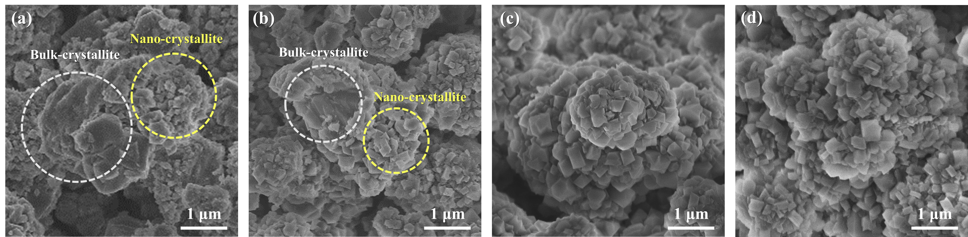
Fig. S4. SEM images of LSX zeolites synthesized by adding varying amounts of methyl cellulose. The synthesis gel compositions are 5.50 Na₂O: 1.65 K₂O: 1.00 Al₂O₃: 2.20 SiO₂: 61 H₂O: x methyl cellulose, where x is (a) 0.10, (b) 0.30, (c) 0.60, and (d) 1.00.

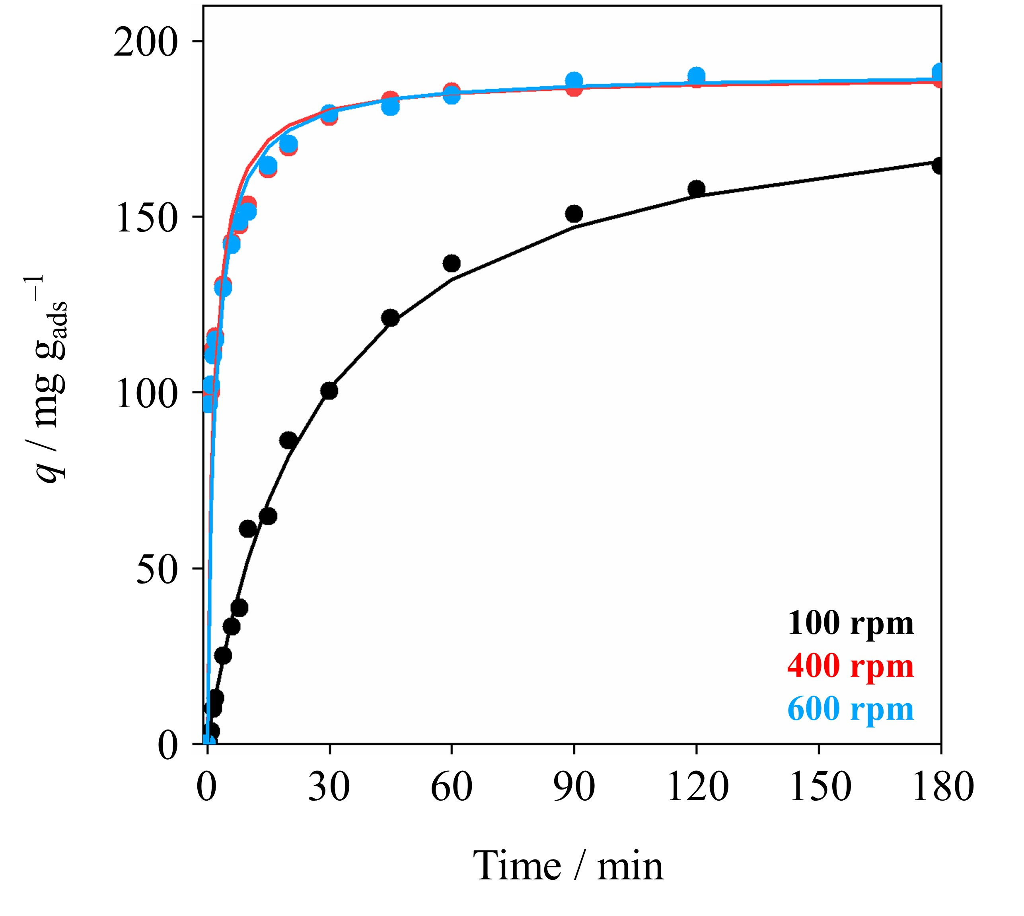
Fig. S5. Sr²⁺-exchange kinetics of LSX-3 zeolite in a 100 mg L^{–1} of Sr²⁺ solution under three different stirring rates. Above 400 rpm, the exchange kinetics did not increase further.
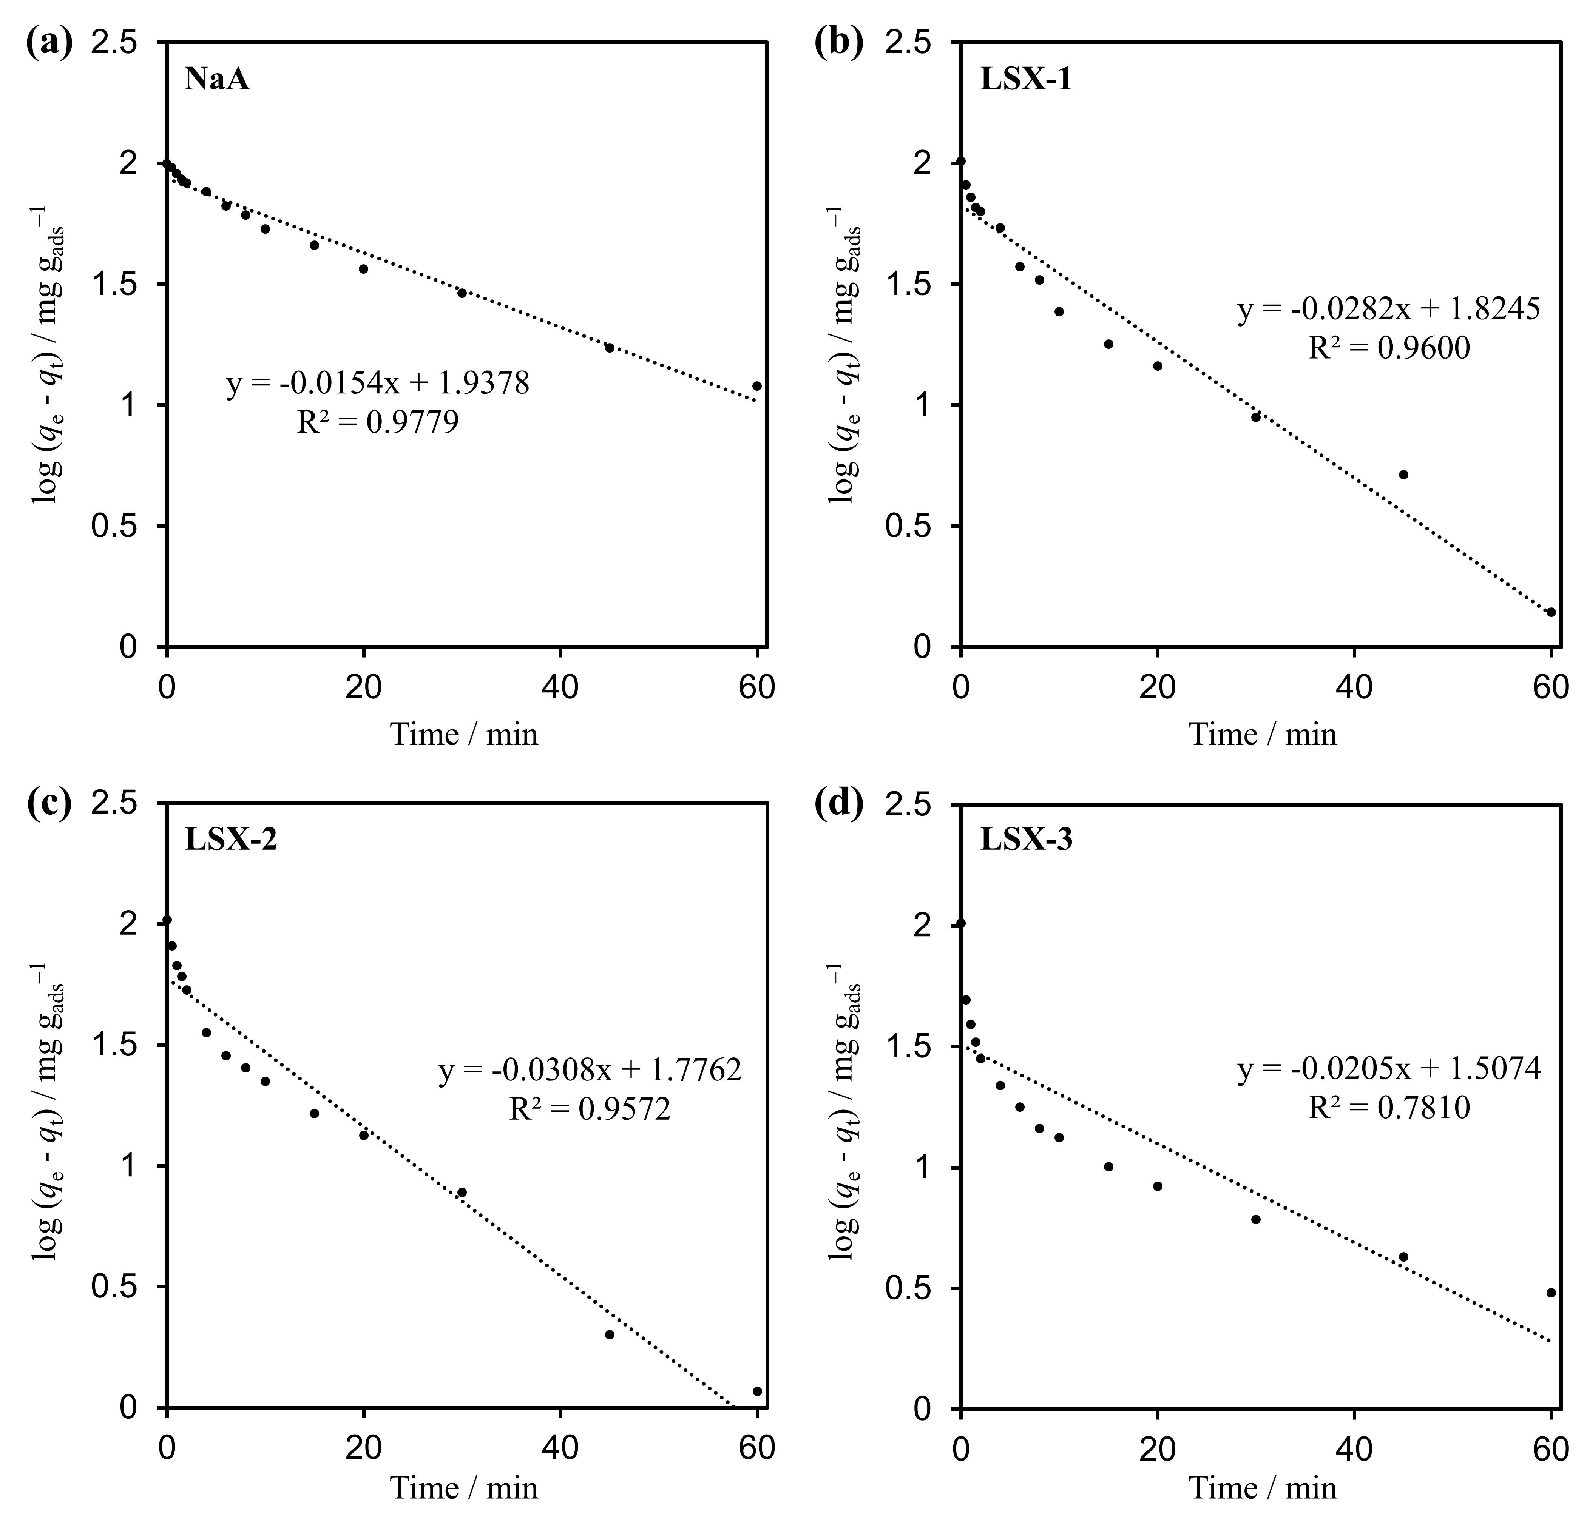
Fig. S6. Fitting of the Sr²⁺-exchange kinetics of the adsorbents using the pseudo-first order kinetic model. (a) NaA, (b) LSX-1, (c) LSX-2, and (d) LSX-3.
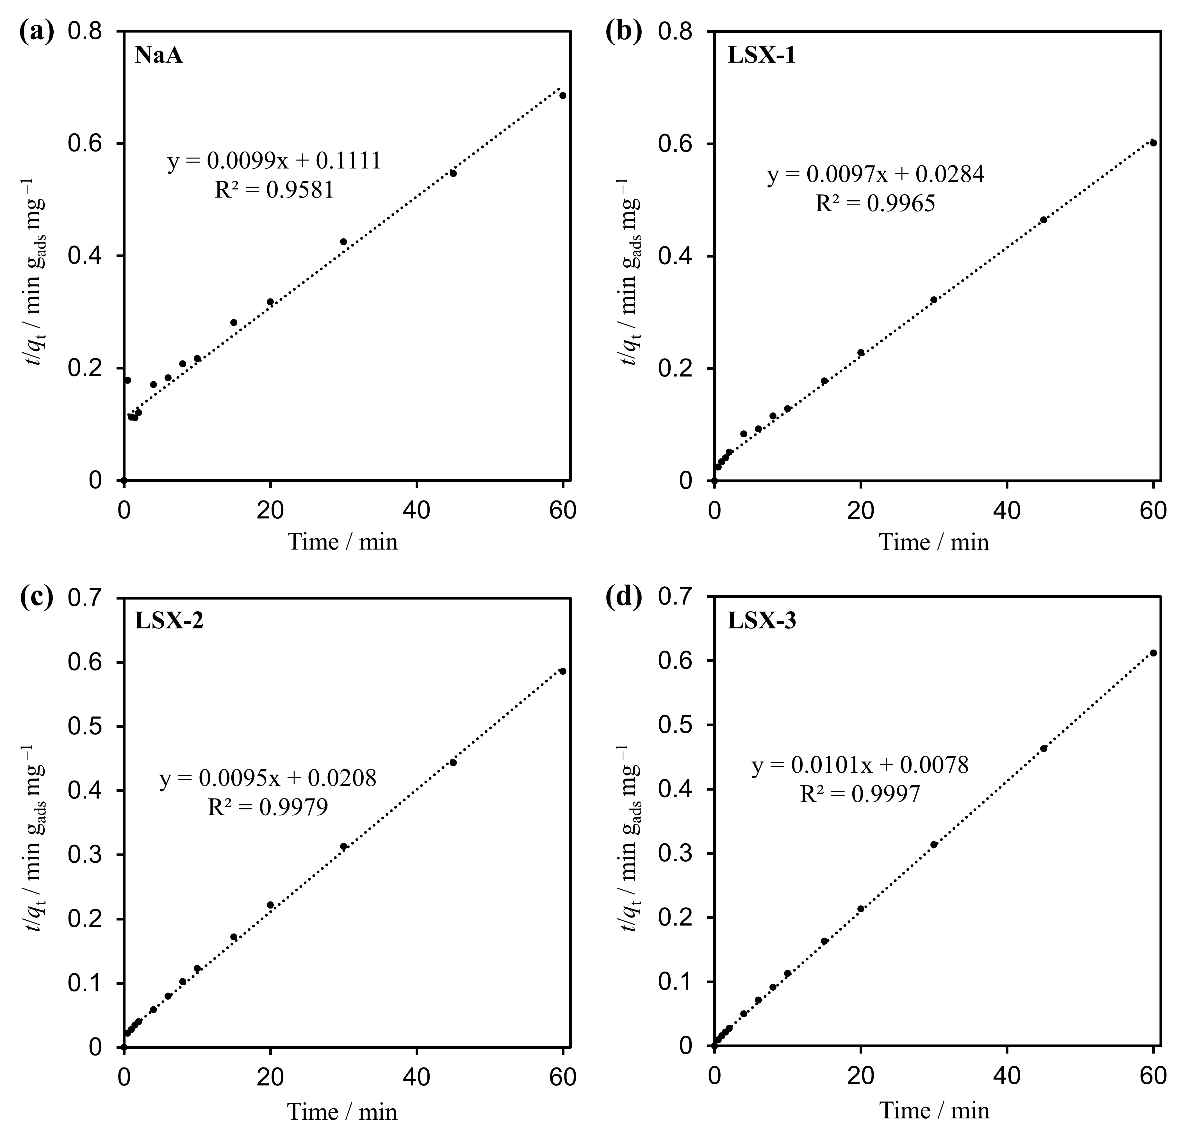
Fig. S7. Fitting of the Sr²⁺-exchange kinetics of the adsorbents using the pseudo-second order kinetic model. (a) NaA, (b) LSX-1, (c) LSX-2, and (d) LSX-3.
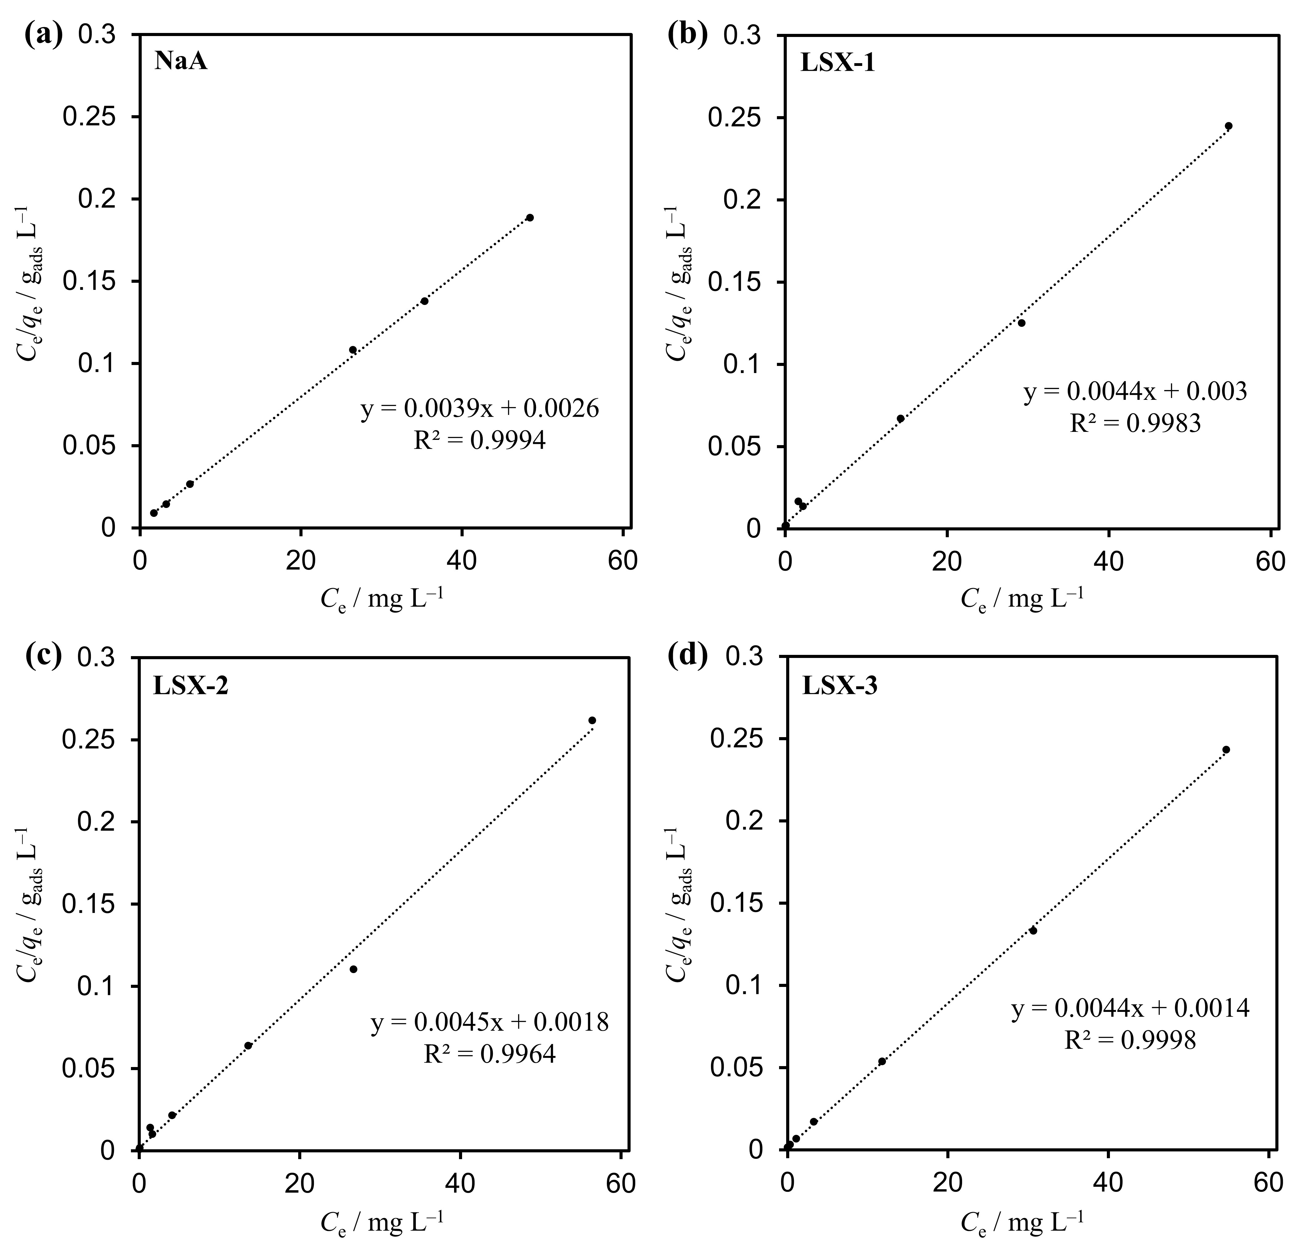
Fig. S8. Isotherm fittings using the Langmuir model. (a) NaA, (b) LSX-1, (c) LSX-2, and (d) LSX-3.
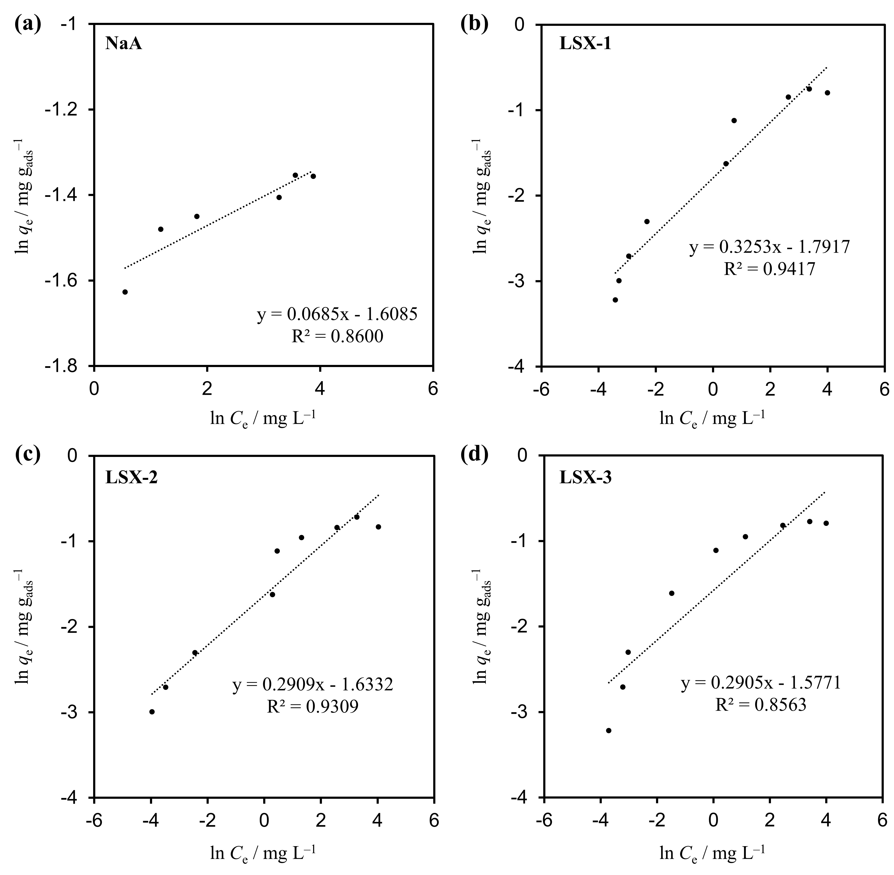
Fig. S9. Isotherm fittings using the Freundlich model. (a) NaA, (b) LSX-1, (c) LSX-2, and (d) LSX-3.
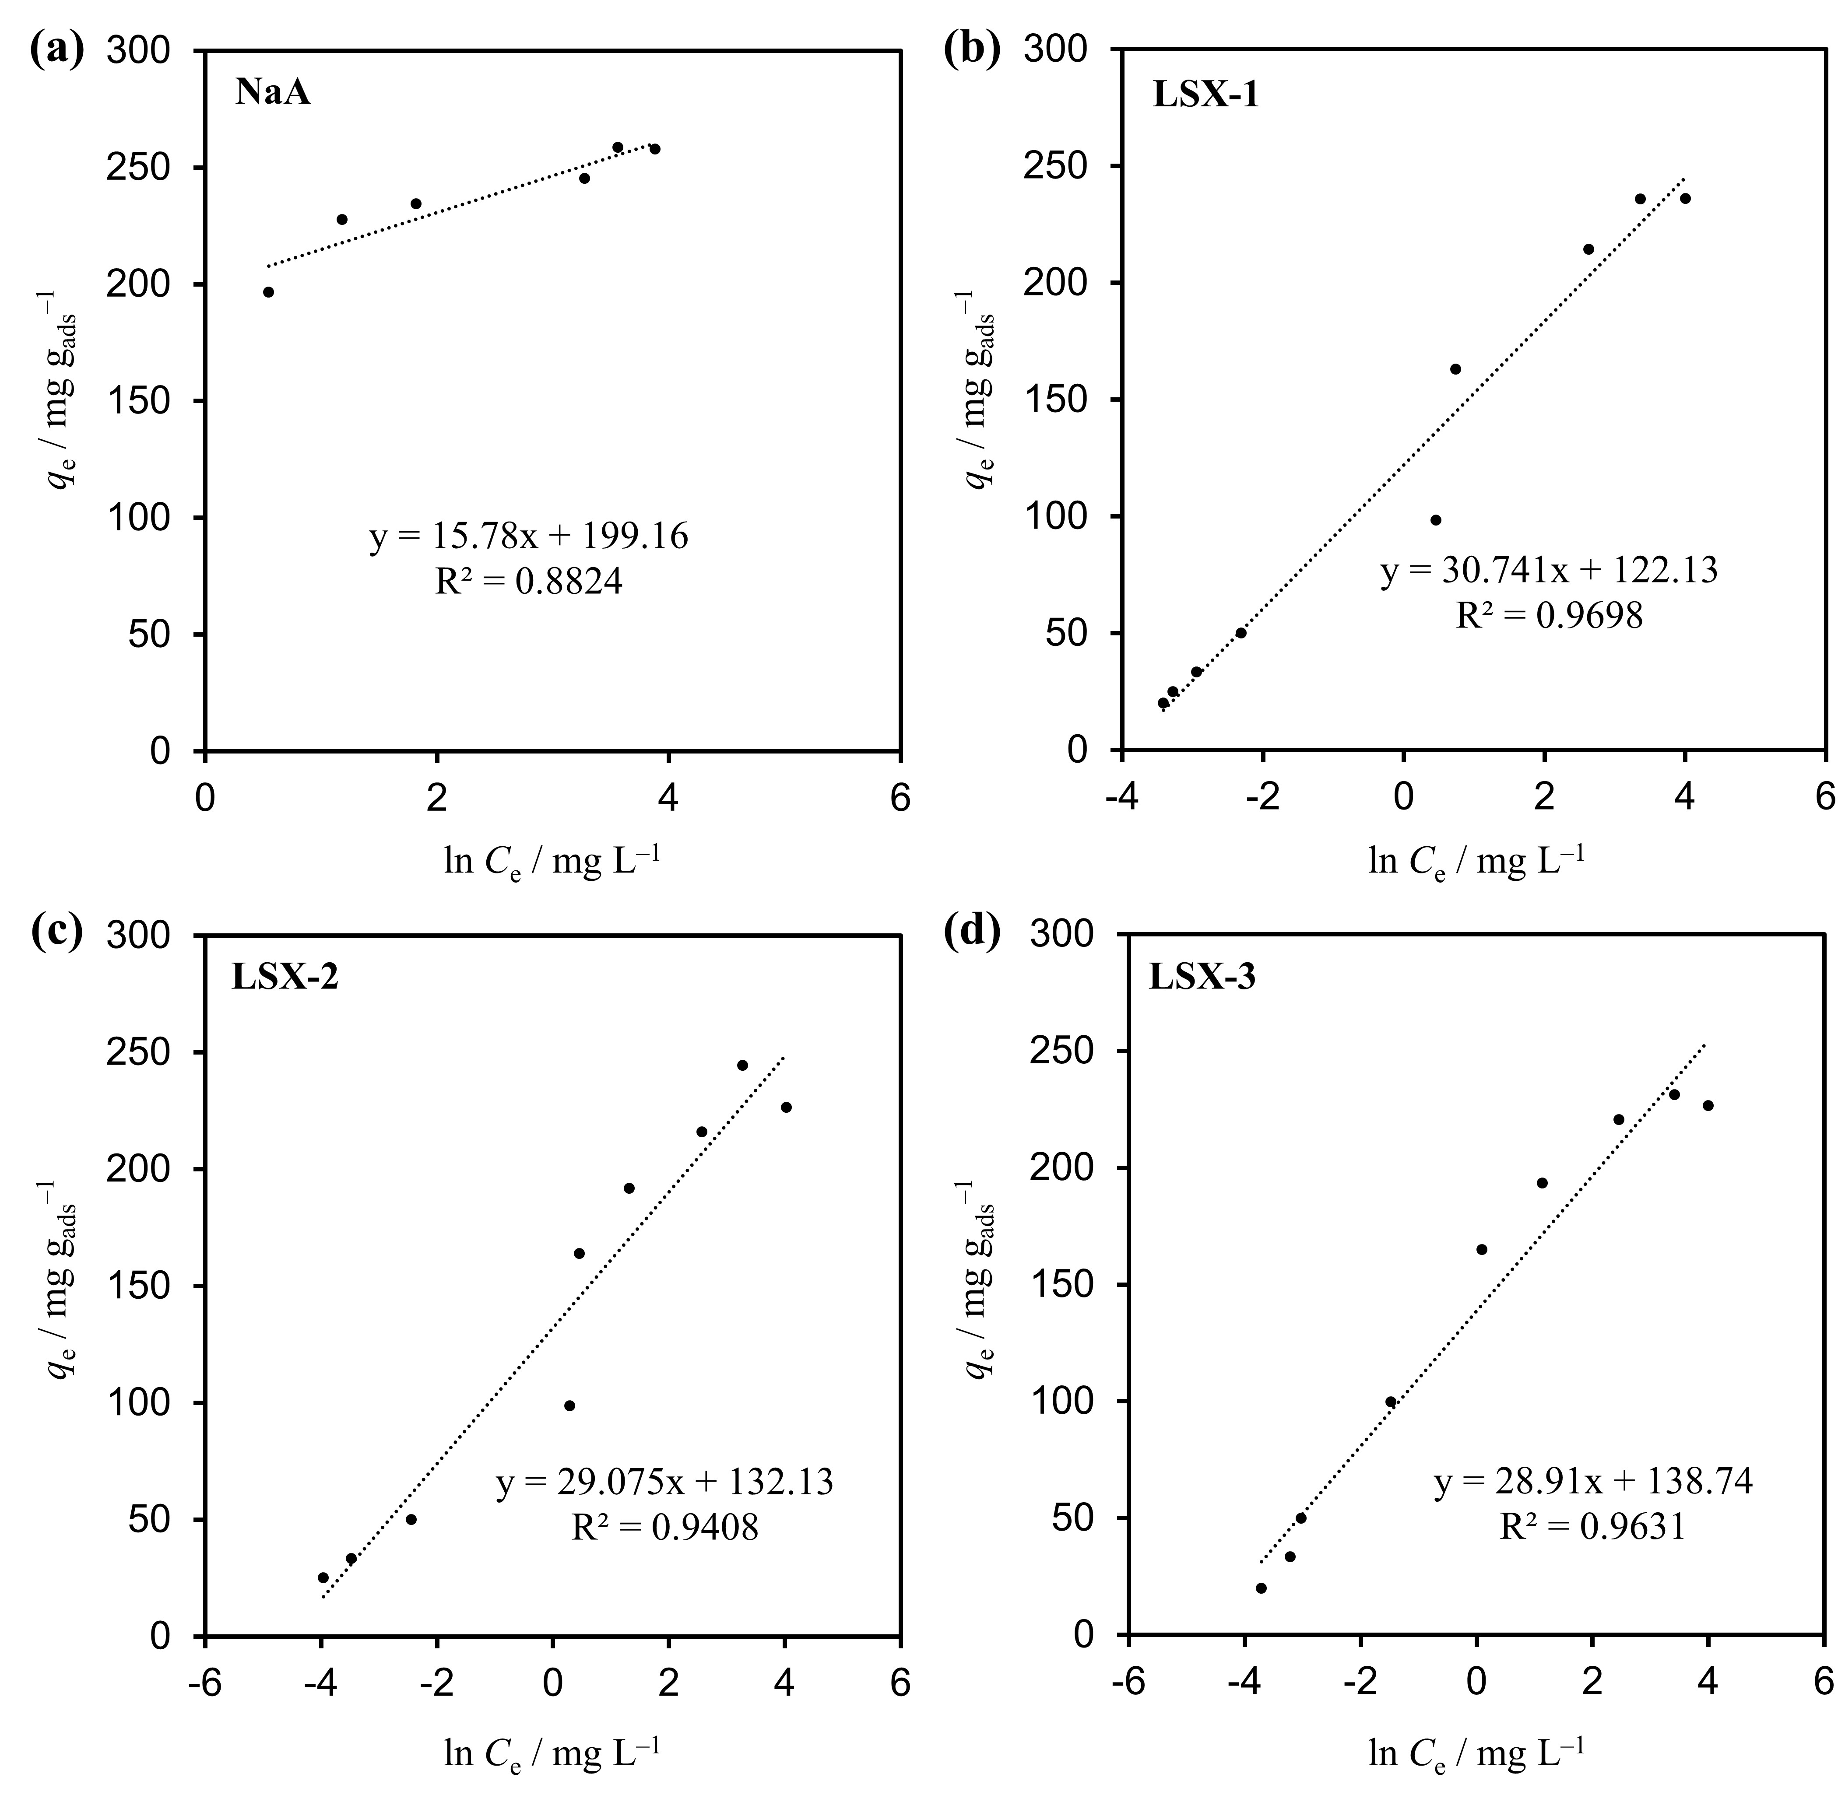
Fig. S10. Isotherm fittings using the Temkin model. (a) NaA, (b) LSX-1, (c) LSX-2, and (d) LSX-3.
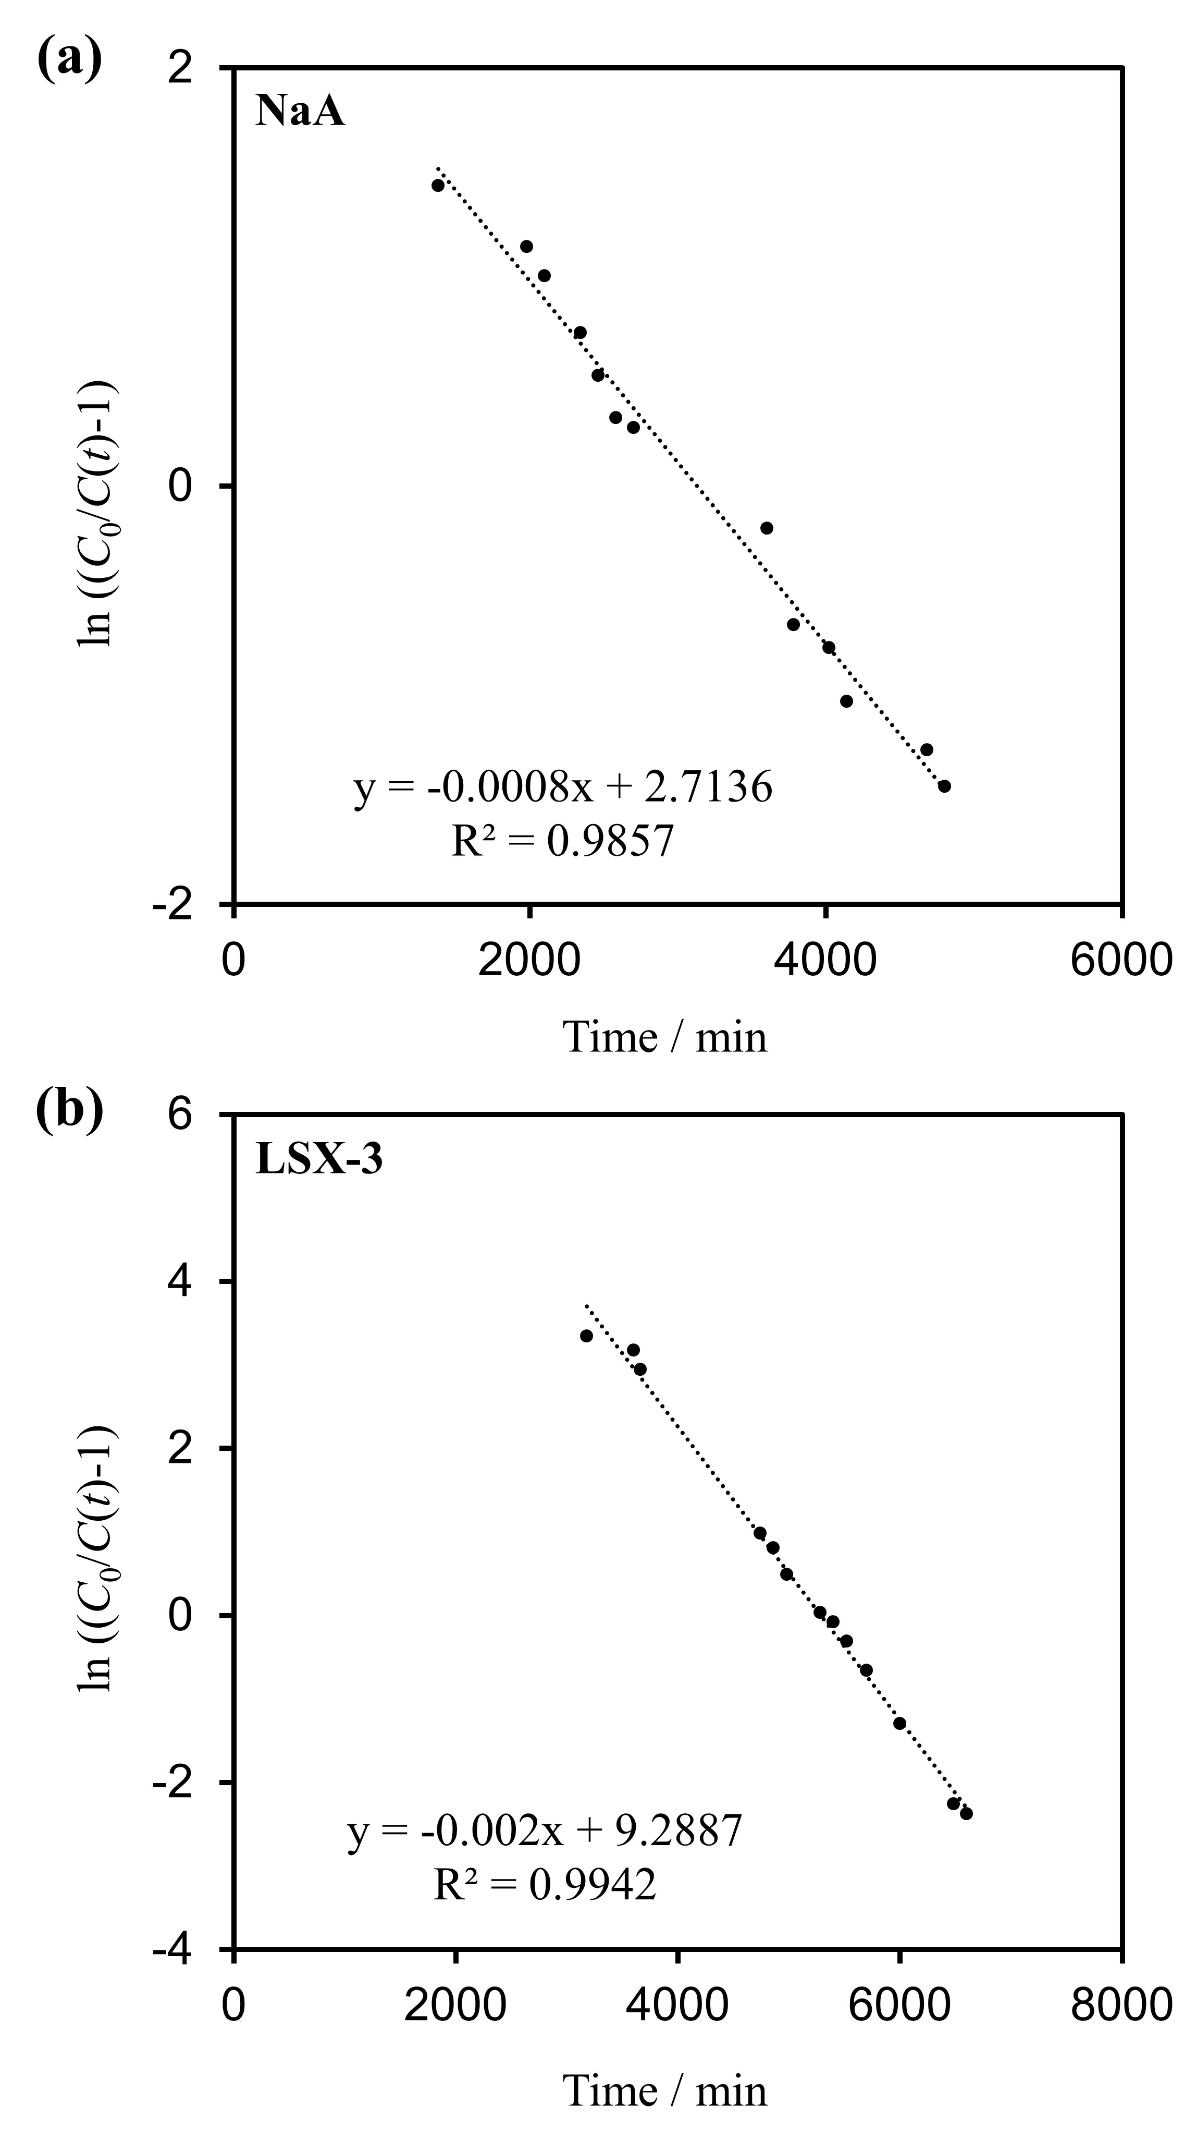
Fig. S11. Thomas model fitting of the Sr²⁺ breakthrough curves for (a) NaA and (b) LSX-3 in a continuous flow of 10 mg L^{–1} of Sr²⁺ solution (flow rate: 60 BV h^{–1}).

