Electronic Supplementary Material

Co-reaction of methanol and alkanes with different carbon numbers over microsphere catalysts

Mingwei Peng ¹, Lei Shi ()¹, Jinzhe Li ()², Zhongmin Liu ()²

1 School of Chemical Engineering, Shenyang University of Chemical Technology, Shenyang 110142, China
2 National Engineering Research Center of Lower-Carbon Catalysis Technology, Dalian National Laboratory for Clean Energy, Dalian Institute of Chemical Physics, Chinese Academy of Sciences, Dalian 116023, China

E-mails: shilei@syuct.edu.cn (Shi L); lijinzhe@dicp.ac.cn (Li J); liuzm@dicp.ac.cn (Liu Z)

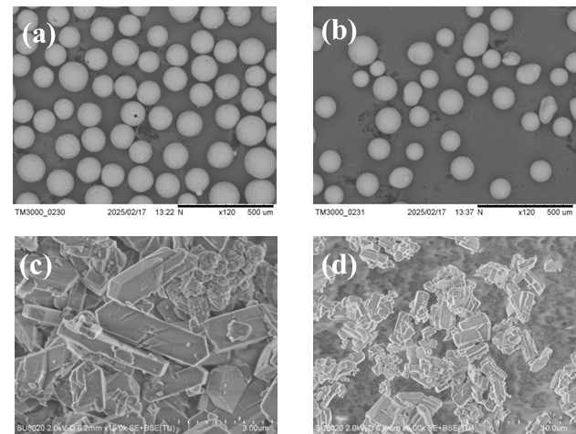
Fig. S1 SEM images of (a) microsphere Cat.1#, (b) microsphere Cat.2#, (c) zeolite ZSM-5(50), and (d) zeolite ZSM-5(131).
Fig. S2 XRD patterns of microsphere catalyst and zeolite.

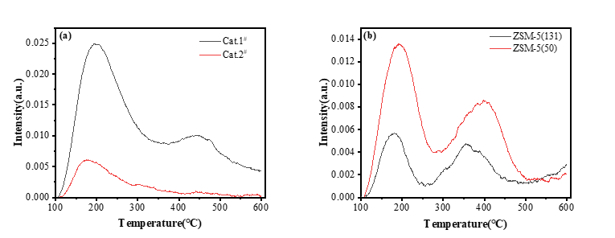
Fig. S3 Temperature programmed desorption curves of ammonia for catalysts (a) and ZSM-5 molecular sieves (b).
Fig. S4 The IR spectra of 2, 6-di-tert-butylpyridine in microsphere catalysts.

Table S1 Pore structure properties of microsphere catalysts with different surface acidity
Sample | S_{surface}(m²g⁻¹) | S_{micro}(m²g⁻¹) | S_{external}(m²g⁻¹) | V_{pore}(cm³g⁻¹) | V_{micro}(cm³g⁻¹) | Average pore diameter
Cat.1# | 182.2 | 145.6 | 36.5 | 0.154 | 0.075 | 33.974Å
Cat.2# | 208.6 | 150.7 | 57.9 | 0.236 | 0.074 | 45.243Å

Table S2 Pore structure properties of ZSM-5 zeolite before and after reaction
Sample | S_{surface}(m²g⁻¹) | S_{micro}(m²g⁻¹) | S_{external}(m²g⁻¹) | V_{pore}(cm³g⁻¹) | V_{micro}(cm³g⁻¹)
ZSM-5(50) | 229.4 | 164.9 | 64.4 | 0.194 | 0.085
ZSM-5(50)-C₁₆ | 193.6 | 164.4 | 29.2 | 0.182 | 0.085
ZSM-5(131) | 250.2 | 199.1 | 51.1 | 0.206 | 0.101
ZSM-5(131)-C₁₆ | 223.5 | 208.6 | 14.8 | 0.196 | 0.107

Table S3 Pore structure properties of catalyst before and after reaction
Sample | S_{surface}(m²g⁻¹) | S_{micro}(m²g⁻¹) | S_{external}(m²g⁻¹) | V_{pore}(cm³g⁻¹) | V_{micro}(cm³g⁻¹)
Cat.2#-P | 208.6 | 150.7 | 57.9 | 0.236 | 0.074
Cat.2#-C₈ | 190.2 | 124.3 | 65.8 | 0.23 | 0.061
Cat.2#-C₁₆ | 209.7 | 135.9 | 73.7 | 0.278 | 0.067

Table S4 Pore structure properties of catalyst before and after reaction
Samples | S_{surface}(m²g⁻¹) | S_{micro}(m²g⁻¹) | S_{external}(m²g⁻¹) | V_{pore}(cm³g⁻¹) | V_{micro}(cm³g⁻¹)
Cat.1#-P | 182.2 | 145.6 | 36.5 | 0.154 | 0.075
Cat.1#-C₈ | 173.4 | 135.4 | 38 | 0.163 | 0.069
Cat.1#-C₁₆ | 166.3 | 131.6 | 34.7 | 0.13 | 0.068

Fig. S5 Pore size distribution of the microsphere catalyst.
Fig. S6 Thermogravimetric analysis of catalysts after reaction of alkanes with different carbon numbers.
Fig. S7 Temperature programmed desorption curves of ammonia for catalysts before and after reaction.

