Supporting Information
Modulating the Secondary Coordination Sphere of the Cu Site for Boosting Acetylene Hydrochlorination
Dingqiang Feng¹, Linfeng Li¹, Yunsheng Dai², Wei Li¹, Jinli Zhang¹, Bao Wang()¹, Jiangjiexing Wu()³
¹School of Chemical Engineering and Technology, Tianjin University, Tianjin 300072, China
²Yunnan Precious Metals Lab Co., Ltd., Kunming 650106, China
³School of Marine Science and Technology, Tianjin University, Tianjin 300072, China

Corresponding authors: Dr. Bao Wang, E-mail: wangbao2020@tju.edu.cn
Dr. Jiangjiexing Wu, E-mail: wjjx1987@tju.edu.cn

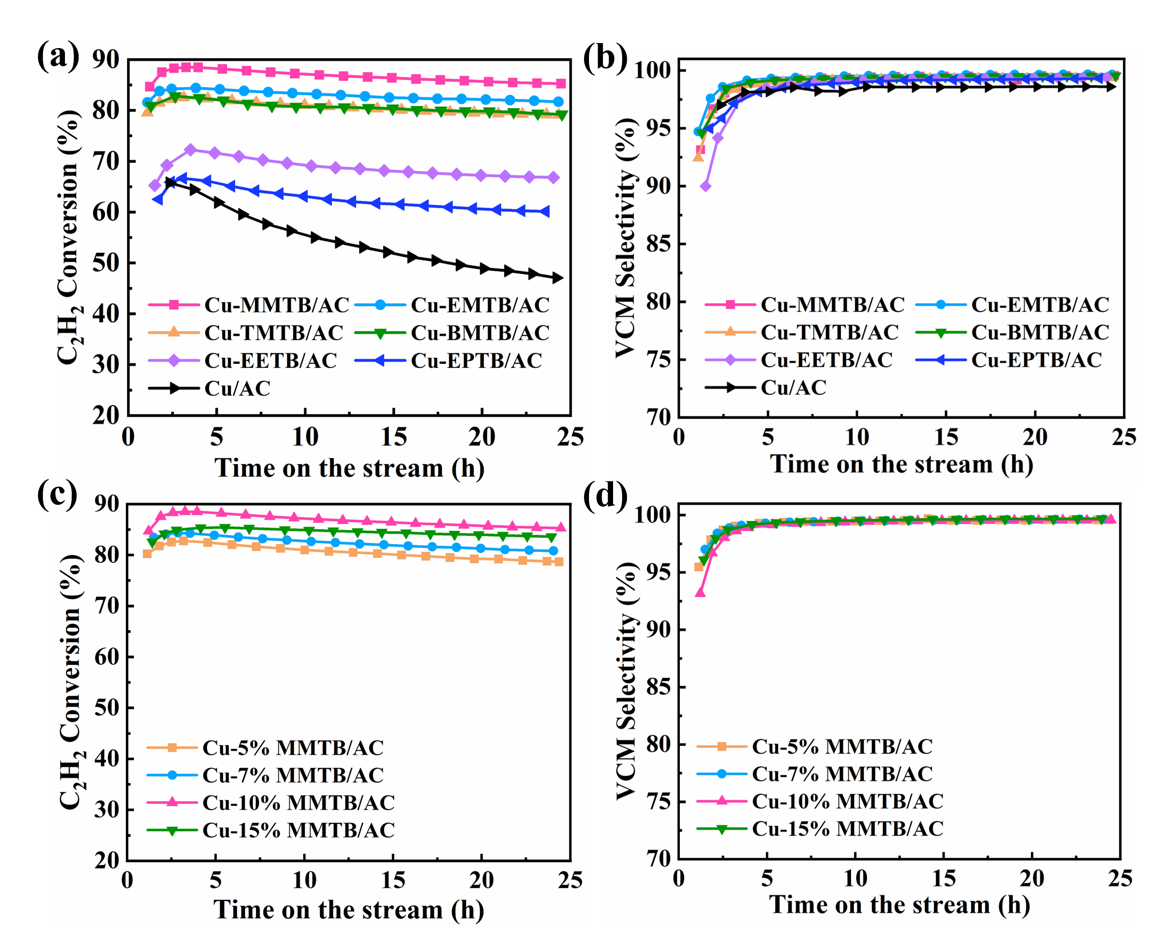
Fig. S1 (a, b) C₂H₂ conversion and VCM selectivity of Cu catalysts. (c, d) C₂H₂ conversion and VCM selectivity of Cu-MMTB/AC with various MMTB additions. (T = 180°C, V(HCl)/V(C₂H₂) = 1.2 and GHSV(C₂H₂) = 180 h⁻¹)

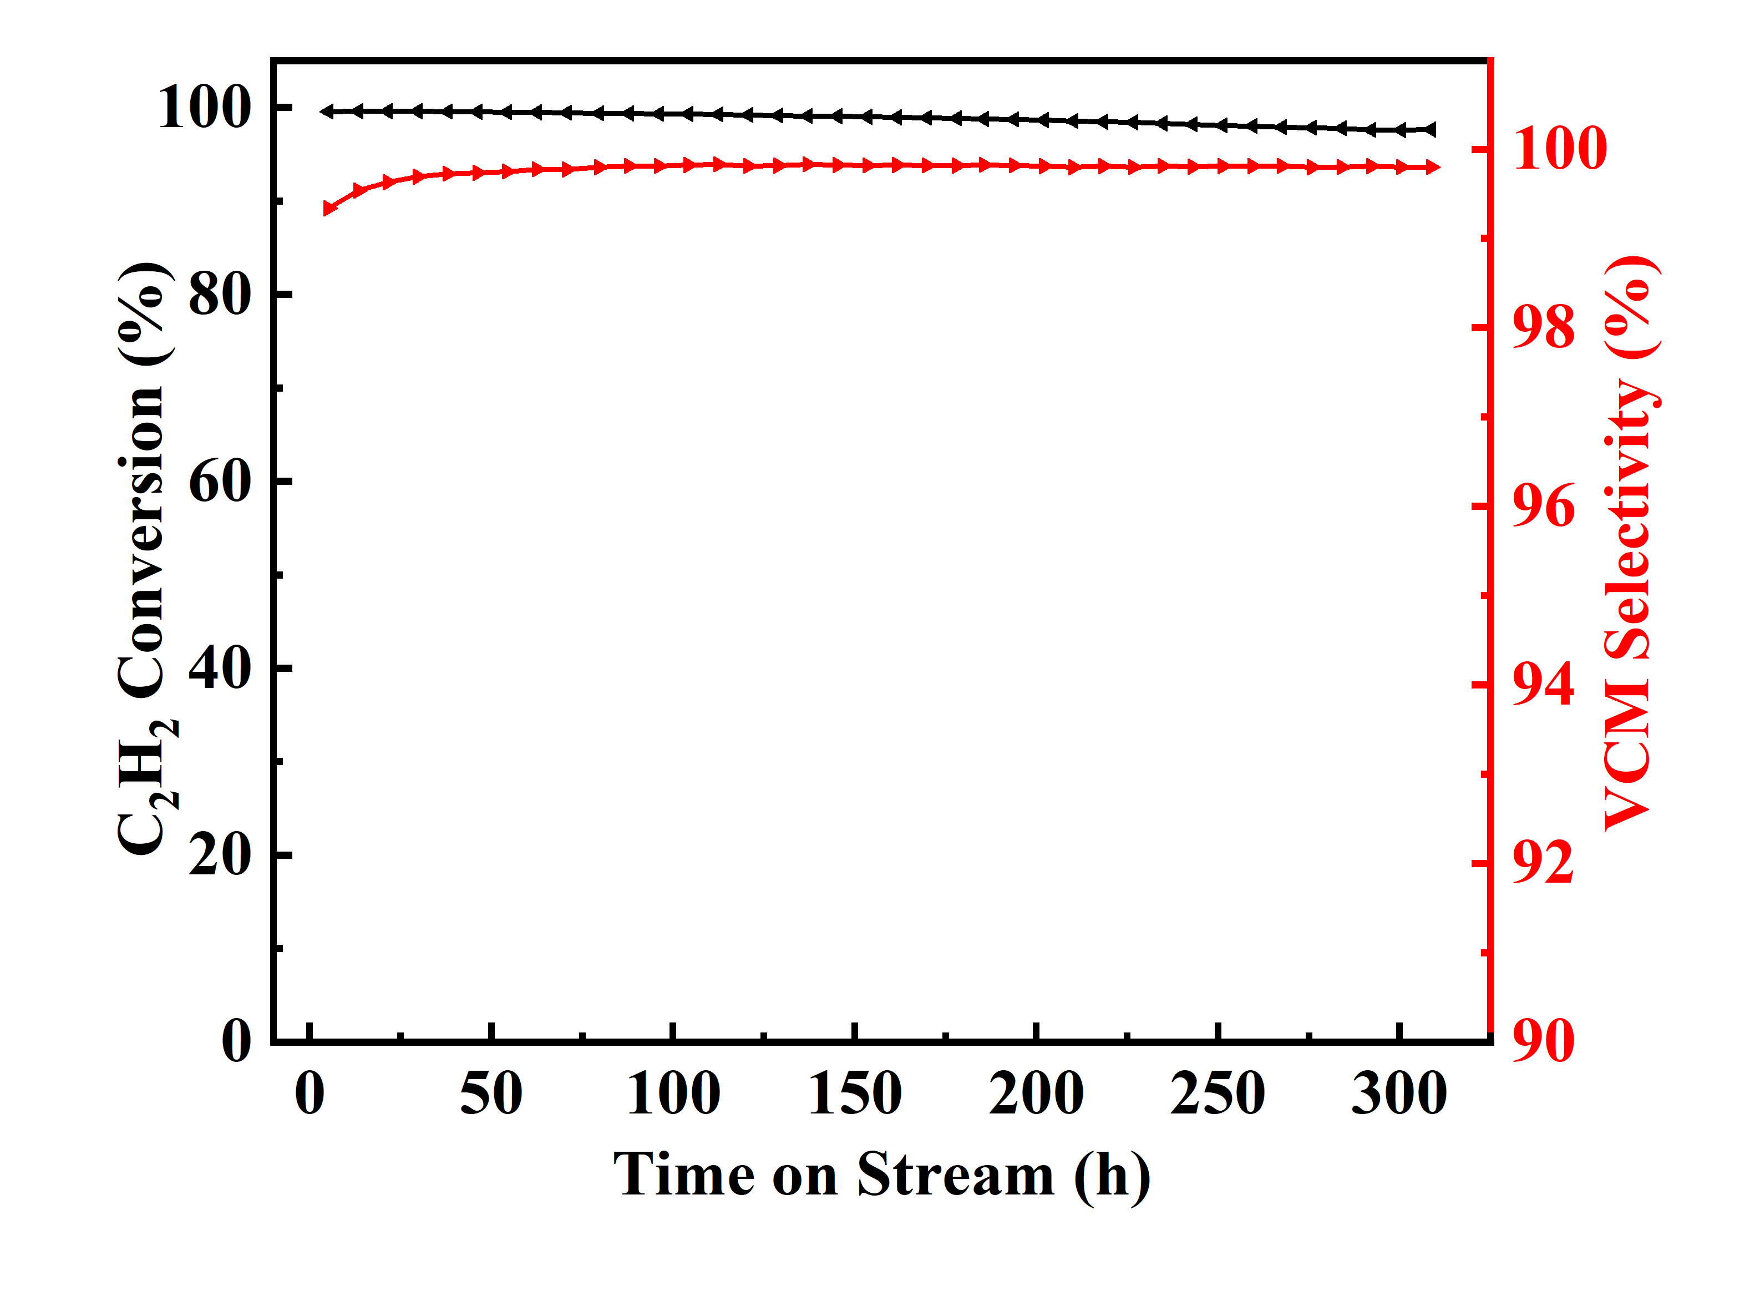
Fig. S2 The long-life test performance of Cu-MMTB/AC for acetylene hydrochlorination. (T = 180°C, V(HCl)/V(C₂H₂) = 1.2 and GHSV(C₂H₂) = 50 h⁻¹)
Fig. S3 XPS Cu 2p spectra of fresh Cu-ligand catalysts. (a)Cu-MMTB. (b) Cu-EMTB. (c) Cu-TMTB. (d) Cu-BMTB. (e) Cu-EETB. (f) Cu-EPTB.

Fig. S4 XPS Cu LMM spectra of fresh Cu-ligand catalysts. (a)Cu-MMTB. (b) Cu-EMTB. (c) Cu-TMTB. (d) Cu-BMTB. (e) Cu-EETB. (f) Cu-EPTB.

Fig. S5 C₂H₂ adsorption schematic structure of the catalysts. (a) Cu-MMTB. (b) Cu-EMTB. (c) Cu-TMTB. (d) Cu-BMTB. (e) Cu-EETB. (f) Cu-EPTB.

Fig. S6 EXAFS fitting of the first-shell for Cu foil.

Fig. S7 EXAFS fitting of the first-shell for Cu/AC.

Fig. S8 Coordination structure schematic between copper chloride and MMTB.

Fig. S9 Energy barrier diagram of the catalysts catalyzed acetylene hydrochlorination reaction based on the Langmuir-Hinshelwood mechanism.

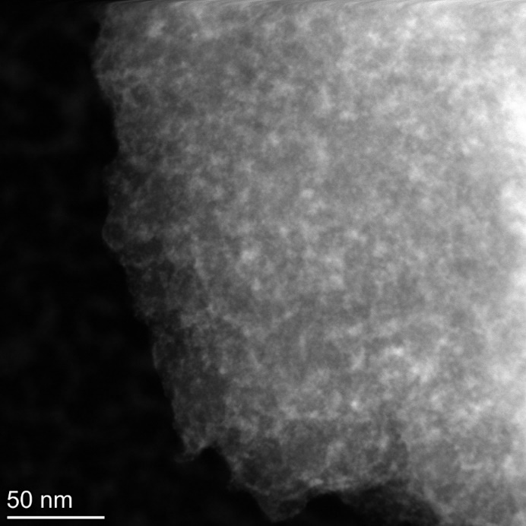
Fig. S10 HAADF-STEM image of Cu-MMTB/AC.

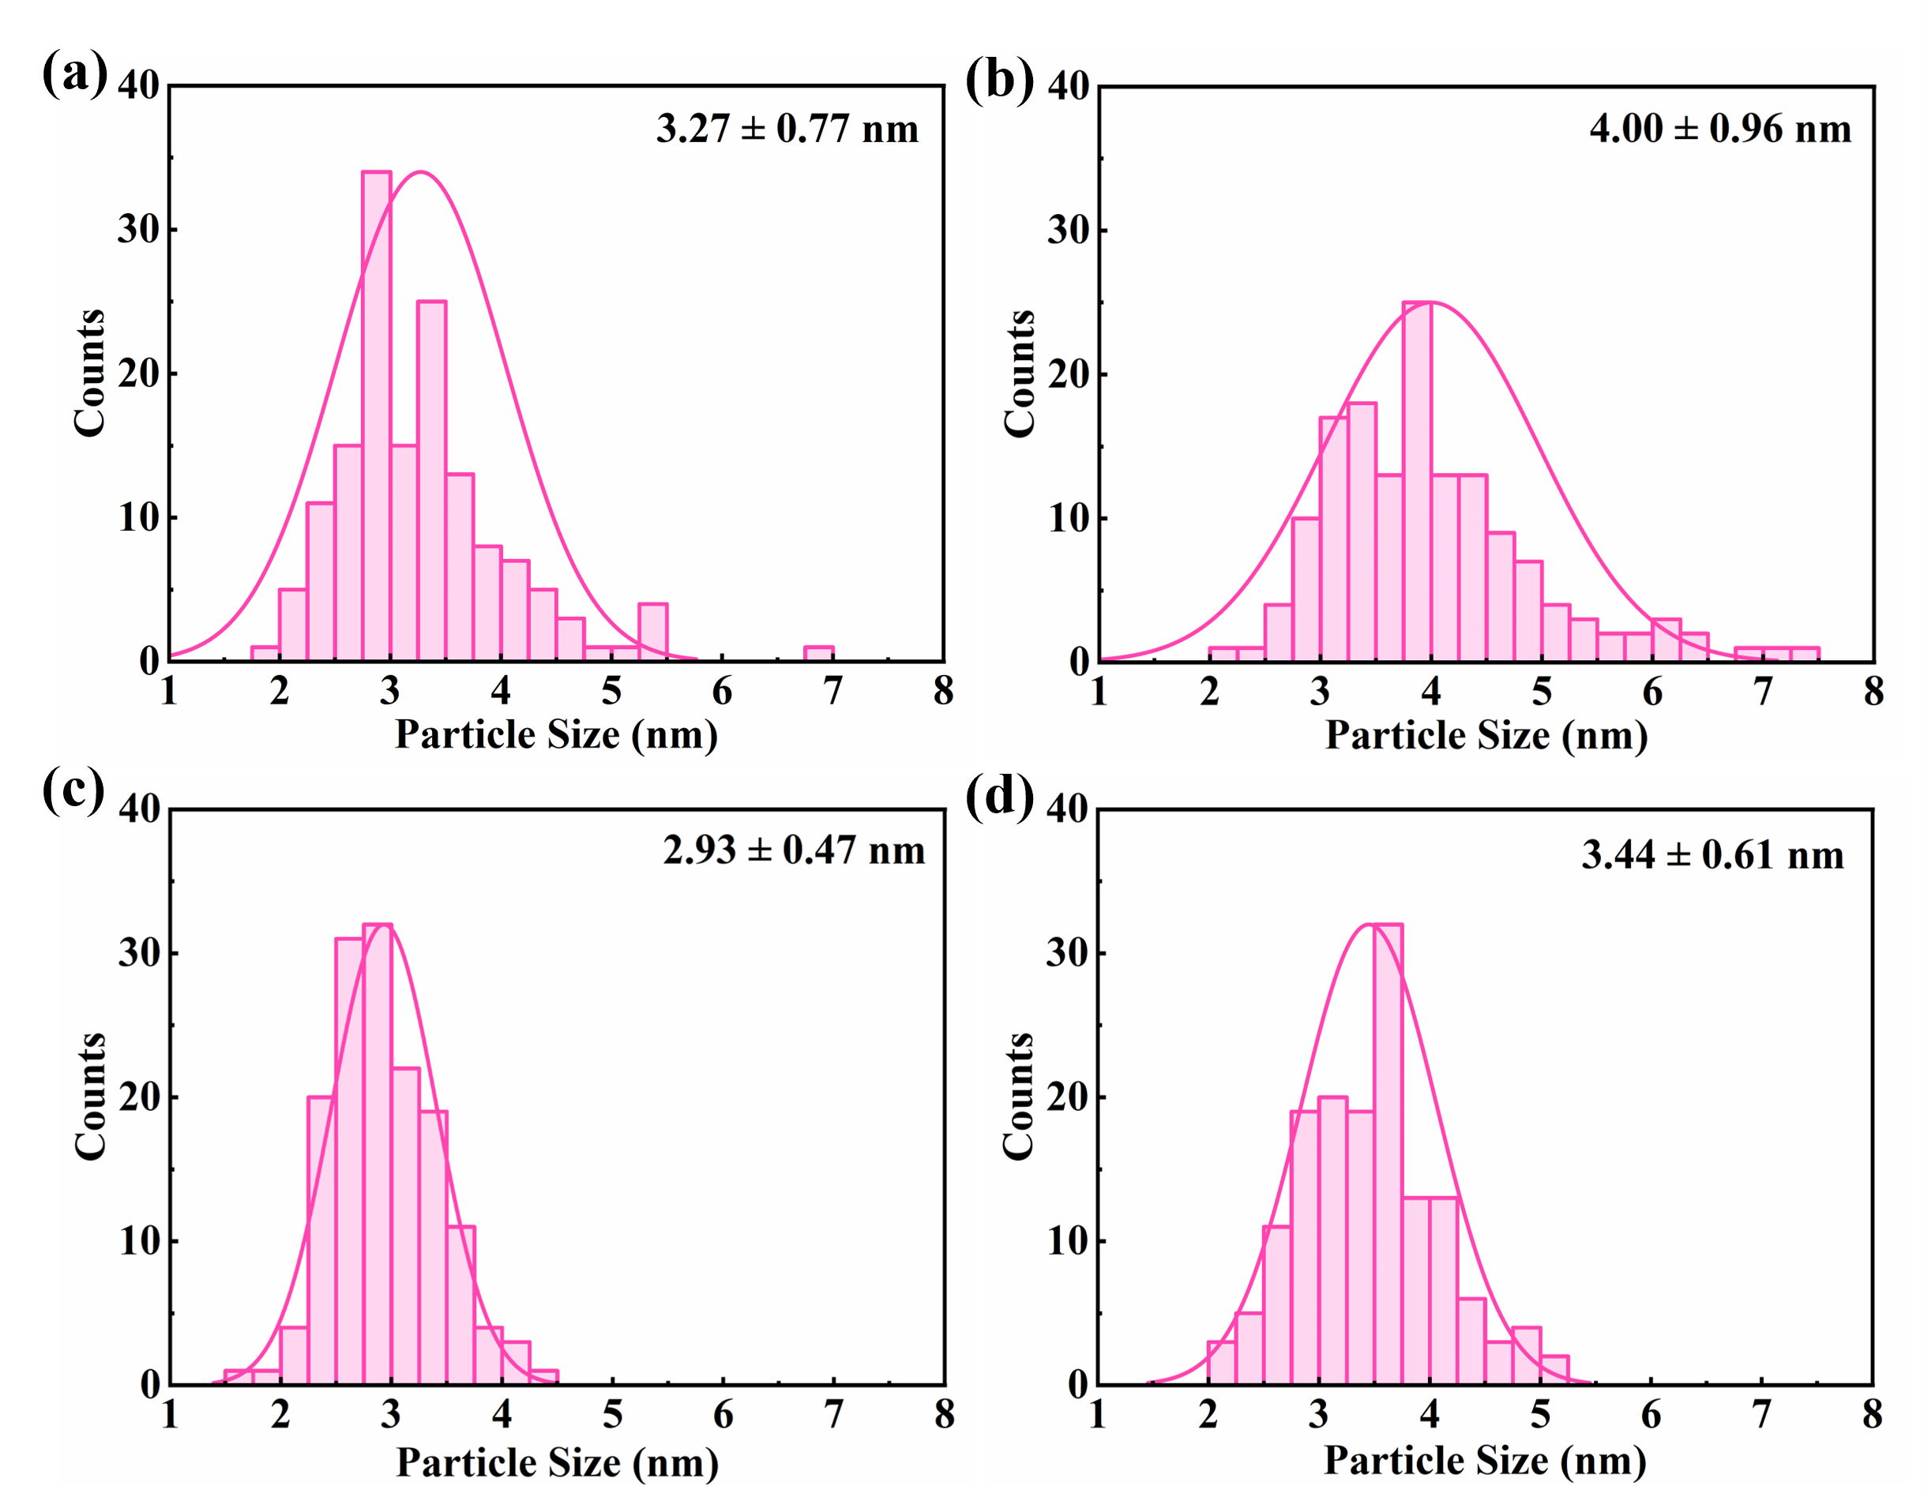
Fig. S11 The particle size distribution of the catalysts. (a) Cu/AC. (b) Cu/AC-used. (c) Cu-MMTB/AC. (d) Cu-MMTB/AC-used.

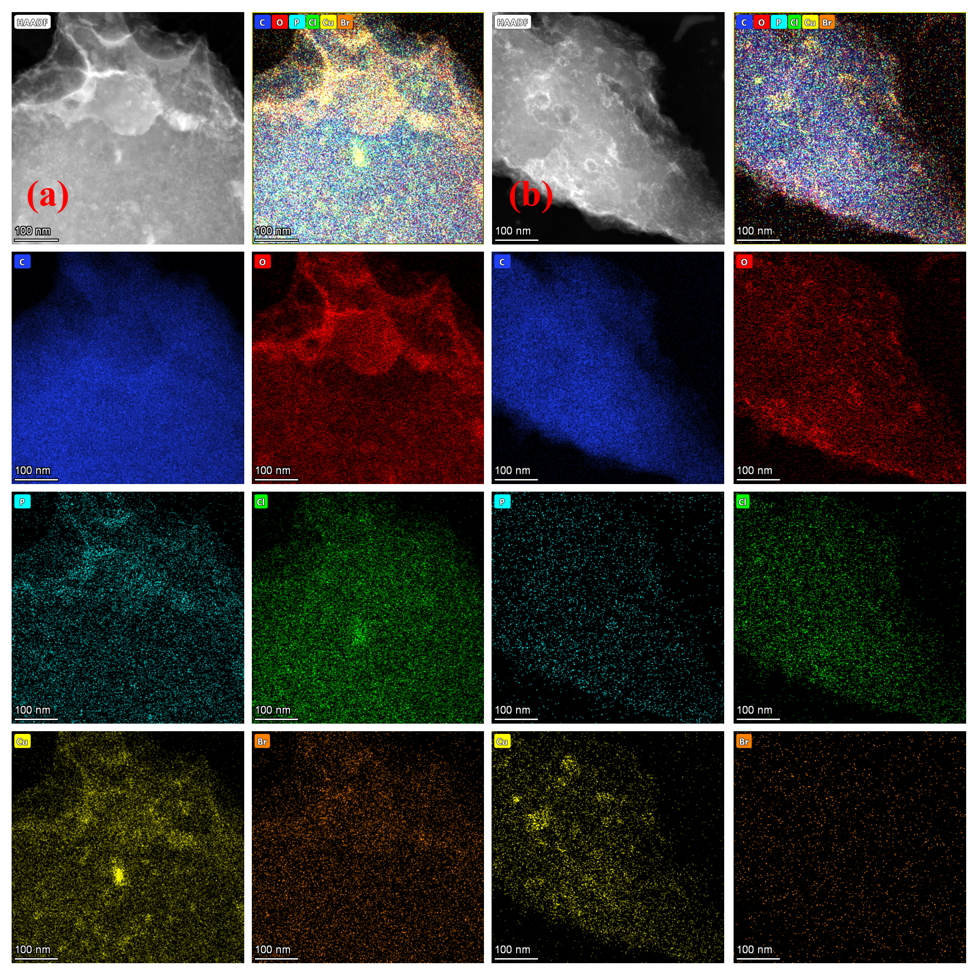
Fig. S12 EDS image of samples. (a) Cu/AC. (b) Cu-MMTB/AC-used.

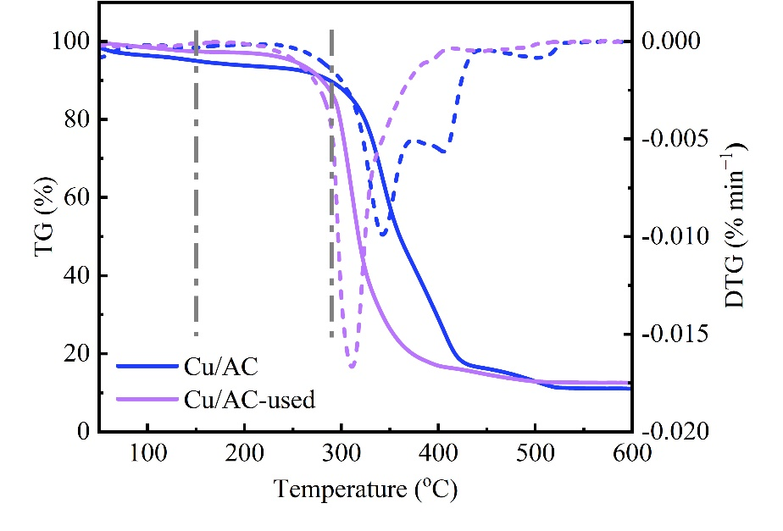
Fig. S13 TG-DTG curve of Cu/AC and Cu/AC-used.

Table S1. The catalytic performance of Cu catalysts published in the last five years
Catalysts | Reaction Conditions | Initial maximum C₂H₂ conversion | During the time period
Cu-MOMTPPC/SAC [1] | T = 180°C, V(HCl)/V(C₂H₂) = 1.2, GHSV(C₂H₂) = 180 h⁻¹ | 92.2% | 48 h
Cu/PC800 [2] | T = 150°C, V(HCl)/V(C₂H₂) = 1.2, GHSV(C₂H₂) = 90 h⁻¹ | 83.1% | 10 h
Cu-TPPO/AC [3] | T = 180°C, V(HCl)/V(C₂H₂) = 1.2, GHSV(C₂H₂) = 180 h⁻¹ | 88.0% | 12 h
Cu/O-FLP [4] | T = 180°C, V(HCl)/V(C₂H₂) = 1.15, GHSV(C₂H₂) = 360 h⁻¹ | 59.4% | 9 h
Cu-iPr₂PCl/AC [5] | T = 180°C, V(HCl)/V(C₂H₂) = 1.15, GHSV(C₂H₂) = 180 h⁻¹ | 93.7% | 24 h
Cu-MPPO/AC [6] | T = 180°C, V(HCl)/V(C₂H₂) = 1.2, GHSV(C₂H₂) = 180 h⁻¹ | 96.1% | 24 h
Cu/NP-AC [7] | T = 180°C, V(HCl)/V(C₂H₂) = 1.15, GHSV(C₂H₂) = 180 h⁻¹ | 92.4% | 12 h
Cu-NHP-AC/N [8] | T = 150°C, V(HCl)/V(C₂H₂) = 1.08, GHSV(C₂H₂) = 90 h⁻¹ | 88.4% | 40 h
Cu-Urea/USY [9] | T = 160°C, V(HCl)/V(C₂H₂) = 1.25, GHSV(C₂H₂) = 120 h⁻¹ | 73.6% | 8 h
Cu/O-FLP [10] | T = 180°C, V(HCl)/V(C₂H₂) = 1.15, GHSV(C₂H₂) = 180 h⁻¹ | 61.4% | 9 h
Cu-MMTB/AC^{This work} | T = 180°C, V(HCl)/V(C₂H₂) = 1.2, GHSV(C₂H₂) = 180 h⁻¹ | 88.5% | 24 h

Table S2. The long-life performance of Cu catalysts published in the last five years
Catalysts | Long-Life Reaction Conditions | Final C₂H₂ Conversion | Longevity
Cu-MOMTPPC/SAC [1] | T = 180°C, V(HCl)/V(C₂H₂) = 1.20, GHSV(C₂H₂) = 36 h⁻¹ | 98.7% | 360 h
Cu/PC800 [2] | T = 150°C, V(HCl)/V(C₂H₂) = 1.20, GHSV(C₂H₂) = 90 h⁻¹ | 83.1% | 10 h
Cu-TPPO/AC [3] | T = 180°C, V(HCl)/V(C₂H₂) = 1.20, GHSV(C₂H₂) = 50⁻¹ | 94.0% | 327 h
Cu/O-FLP [4] | T = 180°C, V(HCl)/V(C₂H₂) = 1.15, GHSV(C₂H₂) = 360 h⁻¹ | 59.4% | 9 h
Cu-iPr₂PCl/AC [5] | T = 180°C, V(HCl)/V(C₂H₂) = 1.15, GHSV(C₂H₂) = 40 h⁻¹ | 95.0% | 400 h
Cu-MPPO/AC [6] | T = 180°C, V(HCl)/V(C₂H₂) = 1.20, GHSV(C₂H₂) = 50 h⁻¹ | 90.0% | 600 h
Cu/NP-AC [7] | T = 180°C, V(HCl)/V(C₂H₂) = 1.15, GHSV(C₂H₂) = 180 h⁻¹ | 92.4% | 12 h
Cu-NHP-AC/N [8] | T = 150°C, V(HCl)/V(C₂H₂) = 1.08, GHSV(C₂H₂) = 90 h⁻¹ | 88.4% | 40 h
Cu-Urea/USY [9] | T = 160°C, V(HCl)/V(C₂H₂) = 1.25, GHSV(C₂H₂) = 120 h⁻¹ | 73.6% | 8 h
Cu/O-FLP [10] | T = 180°C, V(HCl)/V(C₂H₂) = 1.15, GHSV(C₂H₂) = 180 h⁻¹ | 61.4% | 9 h
Cu-MMTB/AC^{This work} | T = 180°C, V(HCl)/V(C₂H₂) = 1.20, GHSV(C₂H₂) = 50 h⁻¹ | 97.5% | 308 h

Table S3. The catalytic performance of Au, Ru and Hg catalysts published
Catalysts | Reaction Conditions | C₂H₂ conversion | During the time period
[AuCl₂(phen)]Cl/AC [11] | T = 180°C, V(HCl)/V(C₂H₂) = 1.20, GHSV(C₂H₂) = 280 h⁻¹ | 96.0% | 40 h
Au NCS/AC [12] | T = 180°C, V(HCl)/V(C₂H₂) = 1.15, GHSV(C₂H₂) = 160 h⁻¹ | 88.0% | 8 h
Au/MCN [13] | T = 180°C, V(HCl)/V(C₂H₂) = 1.15, GHSV(C₂H₂) = 220 h⁻¹ | 93.1% | 7 h
AuPPh₃Cl/AC [14] | T = 170°C, V(HCl)/V(C₂H₂) = 1.10, GHSV(C₂H₂) = 360 h⁻¹ | 96.3% | 48 h
[Prmim]AuCl₄/AC [15] | T = 180°C, V(HCl)/V(C₂H₂) = 1.20, GHSV(C₂H₂) = 370 h⁻¹ | 77.1% | 50 h
Ru/AC [16] | T = 170°C, V(HCl)/V(C₂H₂) = 1.10, GHSV(C₂H₂) = 180 h⁻¹ | 78.8% | 48 h
Ru(NH₄)₂Cl₆/AC [16] | T = 170°C, V(HCl)/V(C₂H₂) = 1.10, GHSV(C₂H₂) = 180 h⁻¹ | 90.5% | 48 h
Ru/AC-N₂ [17] | T = 180°C, V(HCl)/V(C₂H₂) = 1.15, GHSV(C₂H₂) = 180 h⁻¹ | 84.4 % | 24 h
Ru-L1/AC [18] | T = 180°C, V(HCl)/V(C₂H₂) = 1.15, GHSV(C₂H₂) = 180 h⁻¹ | 96.5% | 24 h
Hg-Cs/AC [19] | T = 170°C, V(HCl)/V(C₂H₂) = 1.20, GHSV(C₂H₂) = 180 h⁻¹ | 51.2% | 24 h
HgCl₂-4KCl/AC[20] | T = 220°C, V(HCl)/V(C₂H₂) = 1.20, GHSV(C₂H₂) = 180 h⁻¹ | 70.0% | 50 h
Se–HgCl₂/AC [21] | T = 170°C, V(HCl)/V(C₂H₂) = 1.15, GHSV(C₂H₂) = 200 h⁻¹ | 83.0% | 12 h
Cu-MMTB/AC^{This work} | T = 180°C, V(HCl)/V(C₂H₂) = 1.20, GHSV(C₂H₂) = 180 h⁻¹ | 88.5% | 24 h

Table S4. EXAFS fitting parameters at the Cu K-edge for various samples
Sample | Path | Distance (Å) | C.N. | σ² (Å²) | ΔE₀ (eV) | R factor
Cu foil | Cu−Cu | 2.55 | 12 | 0.009 | 4.9 | 0.002
Cu/AC | Cu−Cl | 2.20 | 4.7 | 0.015 | −9.9 | 0.017
Cu-MMTB/AC | Cu−Cl | 2.21 | 4.3 | 0.016 | −9.0 | 0.012
Note: ªCN, coordination number; ^{b}R, the distance to the neighboring atom; ^{c}σ², the mean square relative displacement (MSRD); ^{d}ΔE₀, inner potential correction. R factor indicates the goodness of the fit. S₀² was fixed to 0.933, according to the experimental EXAFS fit of Cu foil by fixing CN as the known crystallographic value. A reasonable range of EXAFS fitting parameters: 0.700 < S₀² < 1.000; CN > 0; σ ² > 0 Å²; |ΔE₀| < 10 eV, R factor < 0.020.
Table S5. Mulliken charges of copper chloride and MMTB pre- and after-coordination.
Atom |  | Pre-Coordination | After-Coordination
Copper Chloride | ^{1#}Cu | 0.442 | 0.389
Copper Chloride | ^{2#}Cu | 0.433 | 0.386
Copper Chloride | ^{3#}Cu | 0.455 | 0.441
Copper Chloride | ^{1#}Cl | −0.184 | −0.243
Copper Chloride | ^{2#}Cl | −0.222 | −0.235
Copper Chloride | ^{3#}Cl | −0.269 | −0.307
Copper Chloride | ^{4#}Cl | −0.174 | −0.264
Copper Chloride | ^{5#}Cl | −0.208 | −0.191
Copper Chloride | ^{6#}Cl | −0.273 | −0.317
Copper Chloride | Sum Cu | 1.33 | 1.22
Copper Chloride | Sum Cl | −1.33 | −1.56
Copper Chloride | Sum Cu+Cl | 0.00 | −0.341
MMTB | Oxygen | −0.347 | −0.324
MMTB | Sum MMTB | 0.00 | 0.341

Table S6. Energy based on the Eley-Rideal mechanism (kcal·mol⁻¹)
Paths | Cu-MMTB | Cu-EMTB | Cu-EETB
Cat | 0 | 0 | 0
C₂H₂* | −8.46 | −10.8 | −11.6
TS1 | 1.63 | 1.26 | 1.18
C₂H₂Cl* | −13.7 | −12.6 | −13.0
HCl* | −18.4 | −18.1 | −18.4
TS2 | −16.8 | −15.7 | −15.9
VCM* | −47.9 | −45.4 | −52.3
VCM | −39.5 | −39.5 | −39.5

Table S7. Energy based on the Langmuir-Hinshelwood mechanism (kcal·mol⁻¹)
Paths | Cu-MMTB | Cu-EMTB | Cu-EETB
co-ads | 0 | 0 | 0
TS | 13.2 | 15.9 | 14.3
VCM* | −33.6 | −28.4 | −29.4

Table S8. Cu and P content of Cu catalysts in terms of the total mass.
Sample | Cu (wt.%) | P (wt.%)
Cu/AC | 10.4 | -
Cu/AC-used | 10.3 | -
Cu-MMTB/AC | 10.3 | 0.577
Cu-MMTB/AC-used | 10.9 | 0.586

Table S9. TG-DTG results for Cu catalysts
Sample | 150°C (%) | 290°C (%) | Δ (%) | Coke (%)
Cu/AC | 95.0 | 89.7 | 5.34 | 5.72
Cu/AC-used | 97.4 | 86.7 | 10.8 | 5.72
Cu-MMTB/AC | 95.9 | 89.6 | 6.29 | 5.05
Cu-MMTB/AC-used | 97.2 | 86.2 | 11.0 | 5.05

Reference
1. Wang Y, Nian Y, Zhang J, Li W, Han Y. MOMTPPC improved Cu-based heterogeneous catalyst with high efficiency for acetylene hydrochlorination. Molecular Catalysis, 2019, 479: 110612.
2. Wang T, Jiang Z, Tang Q, Wang B, Wang S, Yu M, Chang R, Yue Y, Zhao J, Li X. Interactions between atomically dispersed copper and phosphorous species are key for the hydrochlorination of acetylene. Communications Chemistry, 2022, 5(1): 2.
3. Wang B, Zhang T, Liu Y, Li W, Zhang H, Zhang J. Phosphine-oxide organic ligand improved Cu-based catalyst for acetylene hydrochlorination. Applied Catalysis A: General, 2022, 630: 118461.
4. Peng J, Dong D, Wang Z, Yang H, Qiao D, Wang Q, Sun W, Liu M, Wang J, Zhu M, Dai B, He F, Huang C. Manipulating micro-electric field and coordination-saturated site configuration boosted activity and safety of frustrated single-atom Cu/O Lewis pair for acetylene hydrochlorination. Nano Research, 2023, 16(7): 9039-9049.
5. Zhang T, Wang B, Nian Y, Liu M, Jia Y, Zhang J, Han Y. Excess copper chloride induces active sites over Cu-ligand catalysts for acetylene hydrochlorination. ACS Catalysis, 2023, 13(12): 8307-8316.
6. Wang B, Zhang T, Li L, Zhang H, Wu J, Zhang J. Data-informed discovery of high-performance Cu-ligand catalysts for acetylene hydrochlorination. Chemical Engineering Journal, 2024, 480: 148323.
7. Li F, Wang X, Zhang P, Wang Q, Zhu M, Dai B. Nitrogen and phosphorus co-doped activated carbon induces high density Cu⁺ active center for acetylene hydrochlorination. Chinese Journal of Chemical Engineering, 2023, 59: 193-199.
8. Wang X, Zhu R, Dai Y, Xia H, Niu Q. N-Hydroxyethyl-2-Pyrrolidone improved Cu-based catalysts with high performance for acetylene hydrochlorination. Catalysis Letters, 2024, 154(5): 2285-2293.
9. Dang L, Wang L, Yan H, Gong B, Yang C, Wang J, Sun H, Li X, Wu R, Liang C. Urea modified USY zeolite supported Cu-based catalyst for acetylene hydrochlorination. Materials Today Communications, 2024, 40: 110070.
10. Peng J, Yin X, Dong D, Guo Z, Wang Q, Liu M, He F, Dai B, Huang C. Promotion effect of epoxy group neighboring single-atom Cu site on acetylene hydrochlorination. Chinese Chemical Letters, 2024, 35(6): 109508.
11. Huang C, Zhu M, Kang L, Dai B. A novel high-stability Au(III)/Schiff-based catalyst for acetylene hydrochlorination reaction. Catalysis Communications, 2014, 54: 61-65.
12. Qiao X, Liu X, Yang Y, Mao Z, Li T, Gao L, Zhao C, Guan Q, Li W. Carbon-Supported Au Catalyst in Acetylene Hydrochlorination: Enhancing Catalytic Performance by Complexation of Dicarbonyl Ligands. ChemCatChem, 2022, 14(21): e202200785.
13. Dai B, Li X, Zhang J, Yu F, Zhu M. Application of mesoporous carbon nitride as a support for an Au catalyst for acetylene hydrochlorination. Chemical Engineering Science, 2015, 135: 472-478.
14. Dong Y, Li W, Yan Z, Zhang J. Hydrochlorination of acetylene catalyzed by an activated carbon supported chlorotriphenylphosphine gold complex. Catalysis Science & Technology, 2016, 6(22): 7946-7955.
15. Zhao J, Gu S, Xu X, Zhang T, Yu Y, Di X, Ni J, Pan Z, Li X. Supported ionic-liquid-phase-stabilized Au(iii) catalyst for acetylene hydrochlorination. Catalysis Science & Technology, 2016, 6(9): 3263-3270.
16. Gu J, Gao Y, Zhang J, Li W, Dong Y, Han Y. Hydrochlorination of Acetylene Catalyzed by an Activated Carbon-Supported Ammonium Hexachlororuthenate Complex. Catalysts, 2017, 7(1): 17.
17. Man B, Zhang H, Zhang C, Li X, Dai H, Yu F, Zhu M, Dai B, Zhang J. Hydrochlorination of acetylene over the Ru-based catalysts treated by plasma under different atmospheres. Plasma Science and Technology, 2019, 21(8): 085501.
18. Li J, Zhang H, Cai M, Li L, Li Y, Zhao R, Zhang J. Enhanced catalytic performance of activated carbon-supported ru-based catalysts for acetylene hydrochlorination by azole ligands. Applied Catalysis A: General, 2020, 592: 117431.
19. Xu X-L, Zhao J, Lu C-S, Zhang T-T, Di X-X, Gu S-C, Li X-N. Improvement of the stability of Hg/AC catalysts by CsCl for the high-temperature hydrochlorination of acetylene. Chinese Chemical Letters, 2016, 27(6): 822-826.
20. Xu X, He H, Zhao J, Wang B, Gu S, Li X. The ligand coordination approach for improving the stability of low-mercury catalyst in the hydrochlorination of acetylene. Chinese Journal of Chemical Engineering, 2017, 25(9): 1217-1221.
21. Sun S, Xu H, Fan Y, Liu Z, Hong Q, Huang W, Qu Z, Yan N. Construction of a Thermally Stable Low-HgCl₂ Catalyst via Chalcogen Bonding and Its Enhanced Activity in Acetylene Hydrochlorination. Industrial & Engineering Chemistry Research, 2022, 61(46): 17057-17064.

