Electronic Supplementary Material
Formation of atomically dispersed zirconium through the utilization of nanoconfined environments
Xuan-Yi Liu^{1,2}*, Yang Wang^{1,2}*, Le-Ping Gao^{1,2}, Kai Zhang^{1,2}, Yang Liu^{1,2}, Xiang-Bin Shao^{1,2}, Song-Song Peng^{1,2}, Jiahui Kou ()^{1,3}, Lin-Bing Sun ()^{1,2}
1 State Key Laboratory of Materials-Oriented Chemical Engineering, Nanjing 211816, China
2 College of Chemical Engineering, Nanjing Tech University, Nanjing 211816, China
3 College of Materials Science and Engineering, Nanjing Tech University, Nanjing 211816, China
* These authors contributed equally to this work.

E-mails: jhkou@njtech.edu.cn (Kou J); lbsun@njtech.edu.cn (Sun L-B)

EXPERIMENTAL DETAILS
Chemicals
All chemicals were used as received without further purification. Tetrachlorosilicate (TEOS) was purchased from Sinopharm Chemical Reagent. Pluronic P123 (EO₂₀PO₇₀EO₂₀, Mn=∼5800) and hydrochloric acid (HCl, 37%) were purchased from Sigma-Aldrich. Zirconium hypochlorite (ZrOCl₂·8H₂O) was purchased from Shanghai Adamas Reagent. Acetic acid was purchased from Shanghai Lingfeng Chemical Reagent. Benzyl alcohol was purchased from Shanghai Maclean Biochemical Technology. Deionized water was used throughout this study.
Methods
Synthesis of SBA-15. Weigh 3.0 g of template P123 precisely, dissolve it in 22.5 g of deionized water and 90 g of a solution with a concentration of 2 mol L⁻¹ HCl, put it on the mixing platform, stir it steadily for about 0.8 h to dissolve it, and then place the mixture in a water bath with a constant temperature of 40 °C. Ensure that the temperature of the water bath is maintained at 40 °C throughout the process, and stir for another 30 minutes or more. Then add 6.38 g tetraethyl orthosilicate (TEOS) to the mixture, stir at a constant speed for 24 h at a constant temperature of 40 °C, then transfer the mixture to an autoclave lined with polytetrafluoroethylene material, place it in an oven, and age for 24 h at a temperature of 100 °C. Finally, the sample from the kettle is poured out, filtered and washed, and room-temperature dried to obtain the original powder SBA-15 (named TOS). The raw powder SBA-15 is calcined for 5 h at 550 °C in high-purity air to obtain SBA-15 (named TFS) with the template removed.
Materials characterization. X-ray diffraction (XRD) patterns were recorded on a Bruker D8 Avance diffractometer operated at 40 kV and 40 mA at a step width of 2° min⁻¹. The N₂ adsorption-desorption isotherms at 77 K were measured on a BELSORP-MAX analyzer. All of the samples were degassed at 393 K for 6 h. The pore size distribution was calculated from the Barrett-Joyner-Halenda (BJH) method according to the adsorption branch. Fourier transform infrared (FTIR) spectra were tested with a Nicolet Nexus 470 spectrometer at the spectra resolution of 2 cm^{–1}. Thermogravimetric (TG) analyses and their derivatives (DTG) were carried out on a thermobalance (STA-499C, NETZSCH). About 5 mg of sample was heated from room temperature to 800 °C in a flow of air (20 mL·min^{–1}). X-ray photoelectron spectroscopy (XPS) analysis was performed using an ESCALAB-220I-XL (Thermo-Electron, VG Company) device equipped with an Al Kα X-ray source (hv = 1486.6 eV) at 10 kV and 35 mA, and the binding energies were referred to C 1s at 284.8 eV. The above mixture was centrifuged and the content of Fe in the supernatant was quantified by a Perkin Elmer Optima 7300 DV inductively coupled plasma atomic emission spectrometer (ICP-AES). The morphology of the materials were identified by transmission electron microscopy (TEM, JEOL 2100F) operated at an accelerating voltage of 200 kV and aberration-corrected high-angle annular dark-field scanning transmission electron microscopy (HAADF-STEM, Titan Cubed Themis G2 300). The TEM and HAADF-STEM characterizations reflect the local information of the sample and demonstrate the atomic level dispersion of the metal at the microscopic level with the most direct picture. The combination of these characterizations gives comprehensive information on metal dispersion. The X-ray absorption near edge structure (XANES) of Zr K-edge were performed at the BL11B beamline of Shanghai Synchrotron Radiation Facility (SSRF). The samples were ground and daubed uniformly on the unique double-sided carbon adhesive tape, the data were collected in fluorescence mode and the curves are normalized. The EXAFS spectroscopy measured with FLY (fluorescence yield) mode was numerically fitted by the real space multiple scattering program of FEFF9. Note: Ѕ₀² is the amplitude reduction factor, according to the experimental EXAFS fitted with of Co foil reference by fixing CN as the known crystallographic value. ARTEMIS evaluates a variety of statistical parameters relevant to the evaluation of the fit. For example, E₀ is rarely more than 10 eV or less than -10 eV, that S₀² and σ² should never be negative. σ² value in the range between 0.001 and 0.01 will not be got a penalty. ARTEMIS software thinks any fit which R-factor has 2% or less misfit between data and theory is not assessed a penalty. The errors were automatically generated by the Athena and Artemis software. The GC test results were analysed by a Varian 3800 Gas Chromatograph.

DFT CALCULATIONS
The DFT calculations were performed by employing PBE0 functional implemented in Gaussian-16 package. The self-consistent field procedures of full accuracy were performed with ultrafine convergence and without any orbital symmetry constraints. The elements were performed with the basis set of def2svp, in addition to geometry optimization using the GD3BJ dispersion correction, and single-point energies were obtained at def2qzvp basis set level.

Table S1. Physicochemical properties of TOS, TFS, Zr₁@TOS, and Zr@TFS
Sample | S_{BET} (m²⋅g⁻¹) | V_{p} (cm³⋅g⁻¹) | a₀ (nm) ª | Zr content (wt%) ^{b}
TOS | 114 | 0.269 | 12.2 | /
TFS | 846 | 1.258 | 11.6 | /
Zr₁@TOS | 721 | 1.111 | 12.2 | 0.46
Zr@TFS | 700 | 1.049 | 11.6 | 0.48
ª Unit cell constant calculated according to a₀=2×3^{-1/2}×d₁₀₀. ^{b} The metal contents were determined by ICP-AES.

Table S2. EXAFS fitting parameters at the Zr K-edge for different samples (Ѕ₀² = 0.88)
Sample | Shell | CN | R (Å) | σ² (Å²) | ΔE₀ (eV) | R factor
Zr foil | Zr-Zr | 12 | 3.29±0.01 | 0.00124 | 5.32 | 0.002
ZrO₂ | Zr-O | 8.2±0.1 | 1.96±0.02 | 0.00134 | -6.76 | 0.0035
 | Zr-Zr | 6.2±0.2 | 3.41±0.01 | 0.00102 | 4.51 | 0.0035
Zr₁@TOS | Zr-O | 3.9±0.32 | 1.95±0.01 | 0.00092 | 1.21 | 0.0021
Zr@TFS | Zr-O  Zr-Zr | 4.30±0.57  6.28±0.66 | 1.81±0.02  3.11±0.03 | 0.00122  0.00263 | 0.61  1.23 | 0.0191

Table S3. Structure-energy analysis for Zr₁@TOS
Energy (Total)  (Ha) | Energy (SiO₂)  (Ha) | Energy (Zr)  (Ha) | Binding  energy  (Ha) | Binding  energy (kJ/mol)
-4023.19 | -3975.25 | -46.84 | -1.11 | -726.31
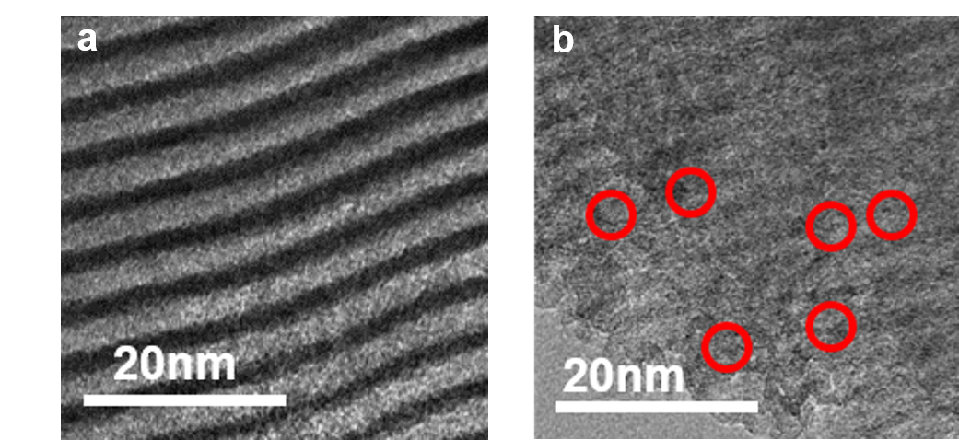
Fig. S1. TEM images of (a) Zr₁@TOS and (b) Zr@TFS. Typical ZrO₂ nanoparticles are marked by red circles.

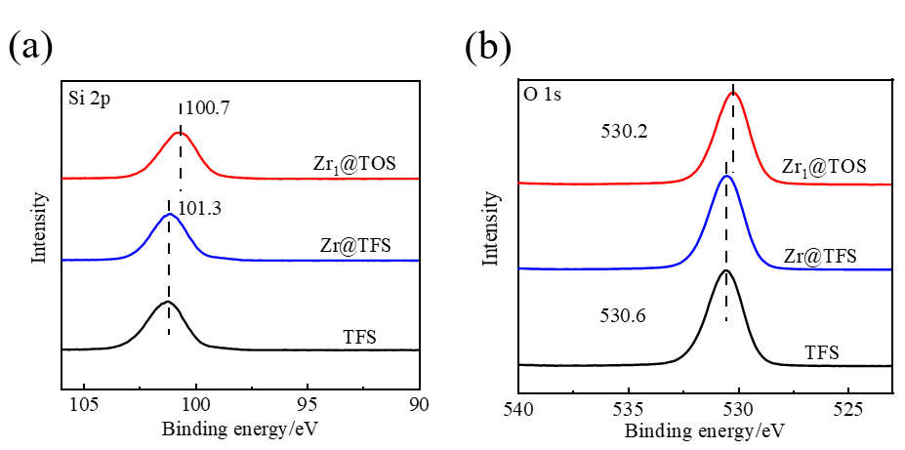
Fig. S2. (a) Si 2p and (b) O 1s spectra of Zr₁@TOS, Zr@TFS, and TFS samples.

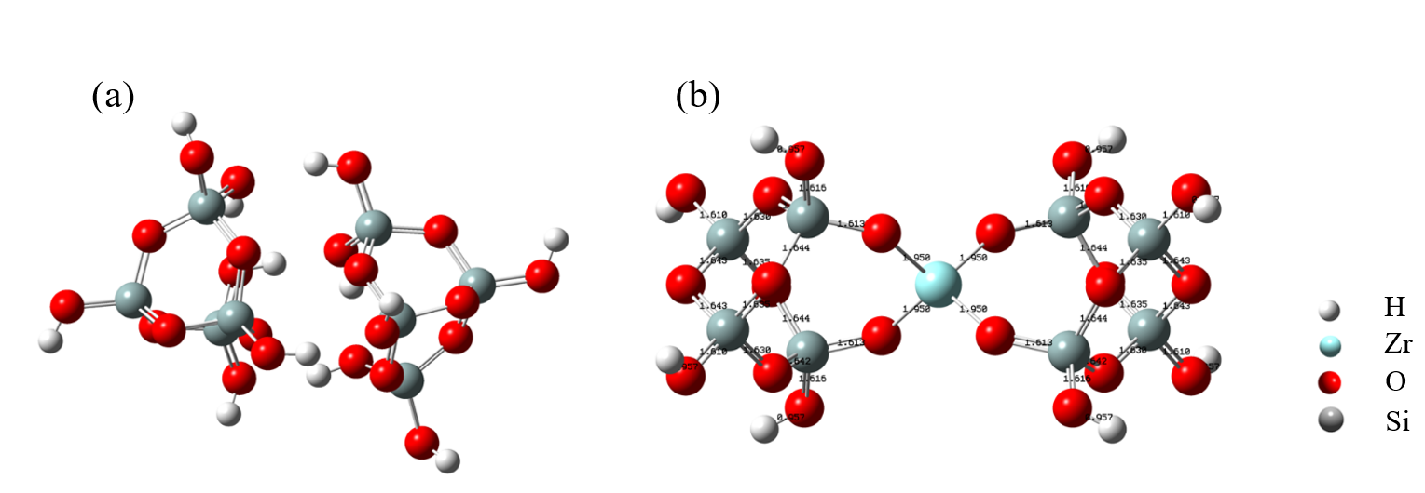
Fig. S3. The chemical structure models of (a) TOS and (b) Zr₁@TOS from DFT calculations.
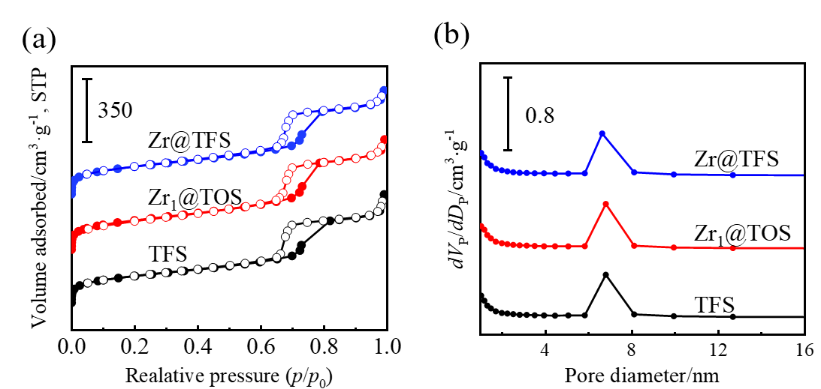
Fig. S4. (a) N₂ adsorption-desorption isotherms and (b) pore size distributions of TFS, Zr₁@TOS, and Zr@TFS samples. Curves are plotted offset for clarity

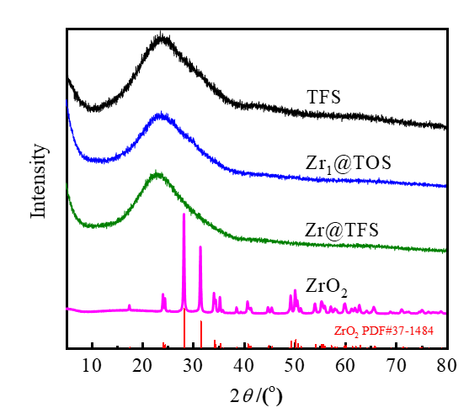
Fig. S5. XRD patterns of Zr₁@TOS, Zr@TFS and TFS.

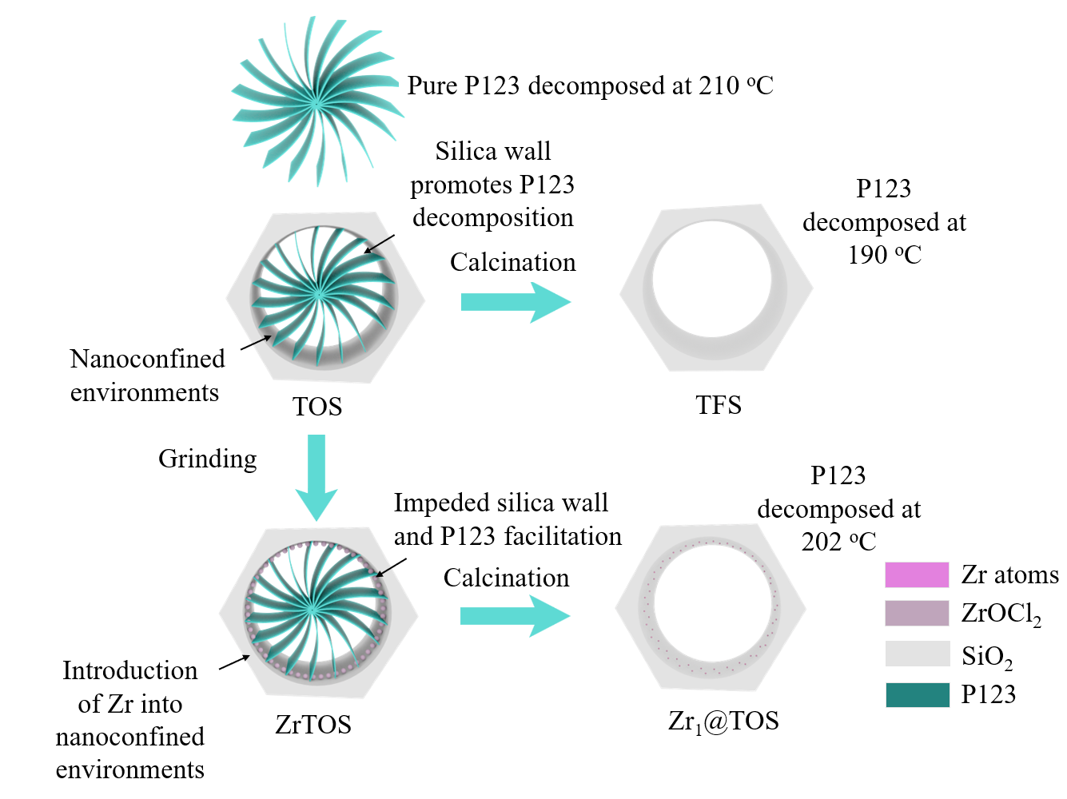
Fig. S6. Mechanism diagram for the thermal analysis of the single atom formation process.

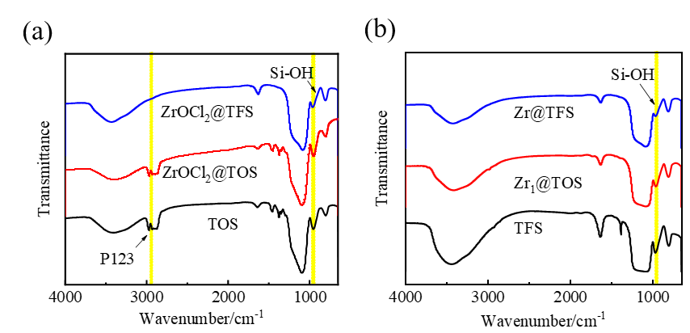
Fig. S7. IR spectra of TOS, Zr₁@TOS, and Zr@TFS samples (a) before and (b) after calcination.

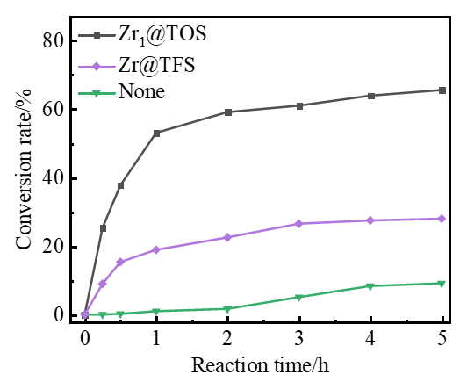
Fig. S8. Conversion versus time for the esterification of acetic acid and benzyl alcohol over Zr₁@TOS, Zr@TFS and none catalyst.

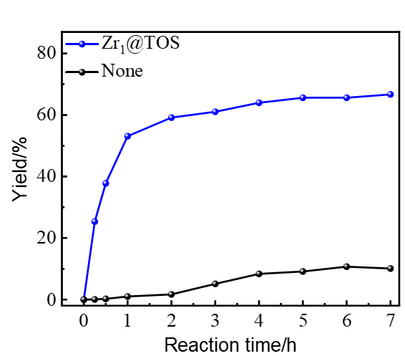
Fig. S9. Benzyl acetate yield in esterification of acetic acid and benzyl alcohol without catalyst and over Zr₁@TOS after prolonging the reaction time.
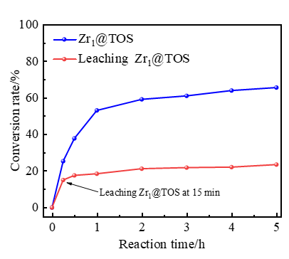
Fig. S10. Esterification of acetic acid and benzyl alcohol over Zr₁@TOS and its hot-filtration at 15 min.

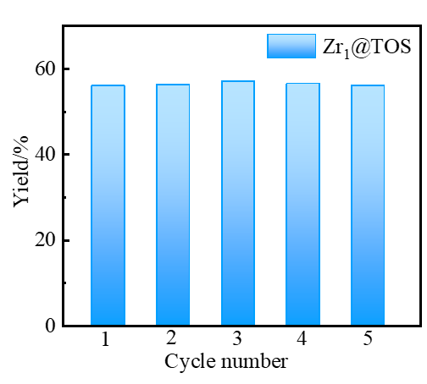
Fig. S11. Cyclic performance of Zr₁@TOS in catalyzing esterification reaction between acetic acid and benzyl alcohol. Each reaction was run for 1 h.

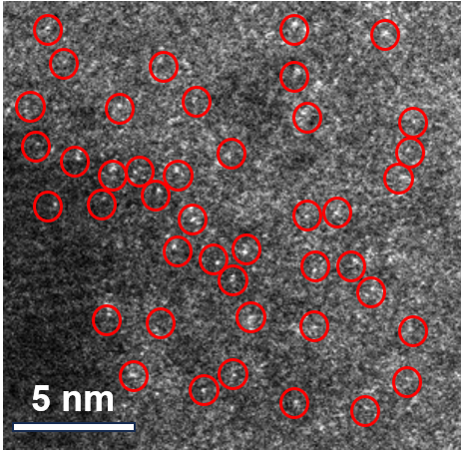
Fig. S12. AC HAADF-STEM image of Zr₁@TOS after esterification reaction. Red circles denote the locations of typical single Zr atoms.

