Electronic Supplementary Material

Tailoring ammonia adsorption in UiO-67 via defect and metal site engineering
Guilian Wang¹*, Ka Tsun Wong²*, Yihan Lu¹, Yuhui Huang¹, S. C. Edman Tsang², Pu Zhao (*)¹
1 State Key Laboratory of Bioinspired Interfacial Materials Science, Innovation Center for Chemical Science, College of Chemistry, Chemical Engineering and Materials Science, Soochow University, Suzhou 215123, China
2 Department of Chemistry, University of Oxford, Oxford OX1 3QR, UK

E-mail: puzhao@suda.edu.cn

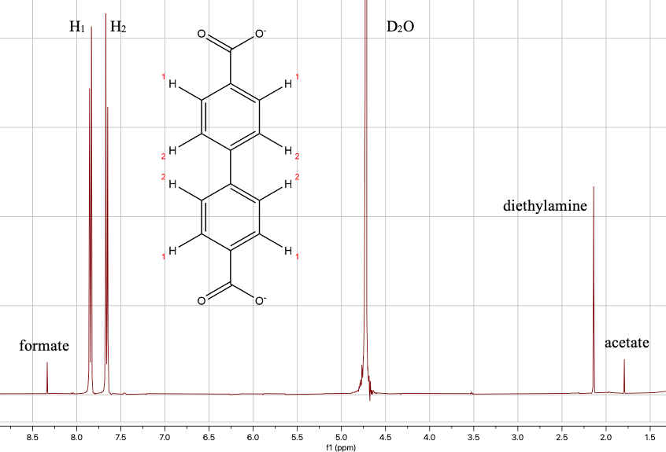
Fig. S1 Appearance of a typical ¹H NMR spectrum of Acet samples with peaks assigned to their corresponding protons.

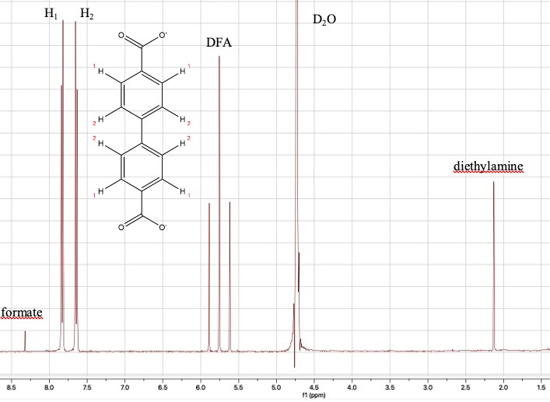
Fig. S2 Appearance of a typical ¹H NMR spectrum of Dif samples with peaks assigned to their corresponding protons.
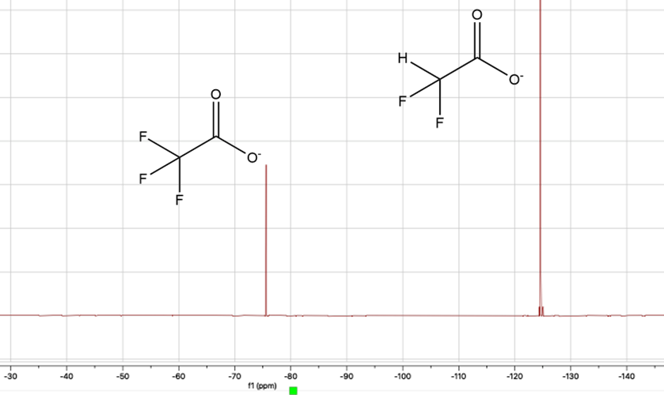
Fig. S3 Appearance of a typical ¹⁹F NMR spectrum of Trif samples with peaks assigned to their corresponding F atoms.

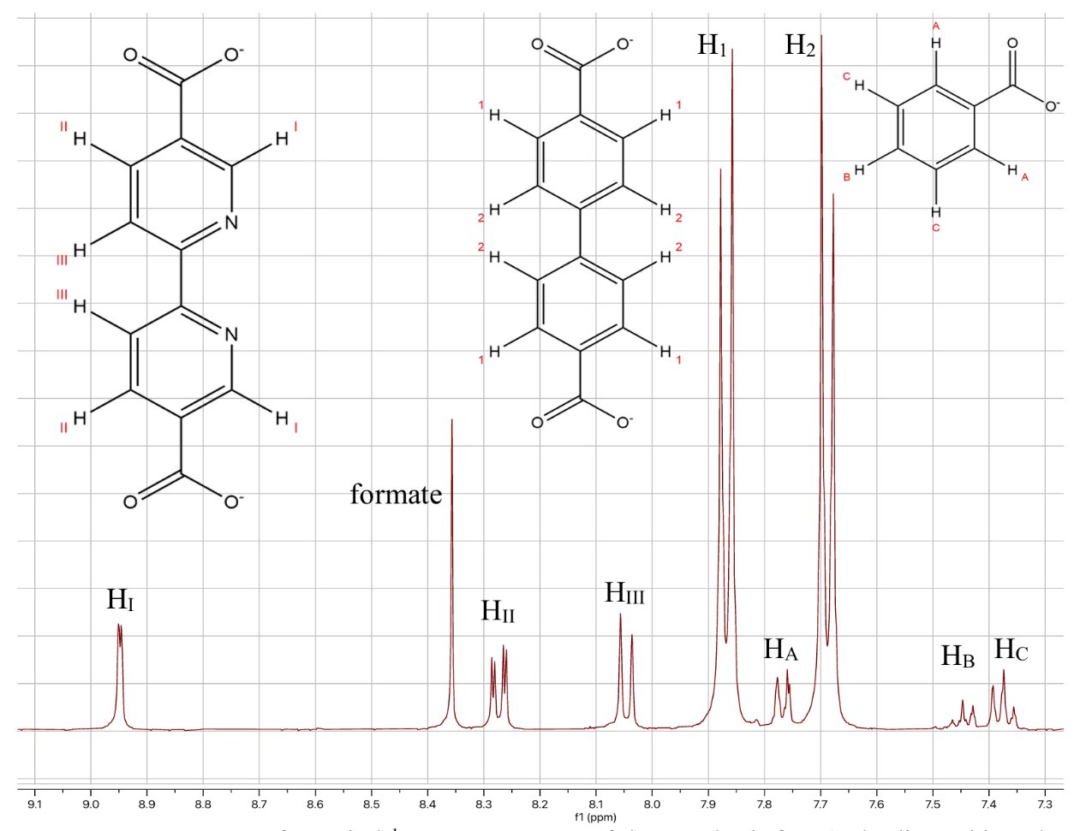
Fig. S4 Appearance of a typical ¹H NMR spectrum of UiO-67-bpydc samples before Cu loading, with peaks assigned to their corresponding protons.
Fig. S5 TGA curves of 20py and 20py-Cu. The weight percentage is referenced to the final mass at 800 °C.

Fig. S6 Percentage change in final adsorption capacity for individual UiO-67-bpydc samples before and after Cu loading. Note that the value for 10py is calculated from an extrapolated isotherm.
Fig. S7 Three consecutive NH₃ adsorption-desorption cycles at 298 K for Trif20.

Fig. S8 Three consecutive NH₃ adsorption-desorption cycles at 298 K for 5py-Cu.

Fig. S9 PXRD patterns of Trif20 before and after three NH₃ adsorption-desorption cycles.

Fig. S10 PXRD patterns of 5py-Cu before and after three NH₃ adsorption-desorption cycles.

Fig. S11 PXRD patterns of 5py-Cu before and after immersion in deionized water for 24 hours.

Table S1 Volume of modulator added in the synthesis of each defect-engineered UiO-67 sample. The number in the sample label refers to the molar equivalents of modulator relative to ZrCl₄.
Sample | Acid | Volume of acid/mL
Acet8 | Acetic acid | 0.254
Acet30 | Acetic acid | 0.952
Acet60 | Acetic acid | 1.90
Acet90 | Acetic acid | 2.85
Dif5 | Difluoroacetic acid (DFA) | 0.175
Dif20 | Difluoroacetic acid (DFA) | 0.700
Dif30 | Difluoroacetic acid (DFA) | 1.05
Trif5 | Trifluoroacetic acid (TFA) | 0.212
Trif10 | Trifluoroacetic acid (TFA) | 0.424
Trif20 | Trifluoroacetic acid (TFA) | 0.848

Table S2 Mass of the two linkers added in the synthesis of each UiO-67-bpydc sample. The number in the sample labels denote the percentage of H₂bpydc. For each sample mixture, the total molar quantity of linkers is 1.11 mmol.
Sample | H₂bpdc/mg | H₂bpydc/mg
5py | 256 | 14
10py | 242 | 27
15py | 229 | 40
20py | 215 | 54

Table S3 The defect content, number of missing linkers per Zr₆ formula unit, and actual chemical formulae of defect-engineered UiO-67 samples calculated from NMR data.
Sample | Mod/Linker | Defect Content (%) | No. of missing  linkers per Zr₆ formula unit | Formula  Zr₆O₄(OH)₄(bpdc)_{6-x}(mod)_{2x}
Acet8 | 0.115 | 5.4 | 0.33 | Zr₆O₄(OH)₄(bpdc)_{5.67}(acet)_{0.66}
Acet30 | 0.206 | 9.3 | 0.56 | Zr₆O₄(OH)₄(bpdc)_{5.44}(acet)_{1.12}
Acet60 | 0.263 | 11.6 | 0.70 | Zr₆O₄(OH)₄(bpdc)_{5.30}(acet)_{1.40}
Acet90 | 0.276 | 12.1 | 0.73 | Zr₆O₄(OH)₄(bpdc)_{5.27}(acet)_{1.46}
Dif5 | 0.385 | 16.1 | 0.97 | Zr₆O₄(OH)₄(bpdc)_{5.03}(DFA)_{1.94}
Dif20 | 1.689 | 45.8 | 2.75 | Zr₆O₄(OH)₄(bpdc)_{3.25}(DFA)_{5.50}
Dif30 | 1.780 | 47.1 | 2.83 | Zr₆O₄(OH)₄(bpdc)_{3.17}(DFA)_{5.66}
Trif5 | 0.546 | 21.4 | 1.29 | Zr₆O₄(OH)₄(bpdc)_{4.71}(TFA)_{3.58}
Trif10 | 1.231 | 38.1 | 2.29 | Zr₆O₄(OH)₄(bpdc)_{3.71}(TFA)_{4.58}
Trif20 | 2.011 | 50.1 | 3.01 | Zr₆O₄(OH)₄(bpdc)_{2.99}(TFA)_{6.02}

Table S4 pK_{a} values of the linker and modulators^{[1]}.
Species | pK_{a}
H₂bpdc linker | 3.77 ± 0.10*
Acetic acid | 4.76
Difluoroacetic acid | 1.24
Trifluoroacetic acid | 0.23
*The value for H₂bpdc is that for pK_{a1} and is a predicted value.

Table S5 The defect content, number of missing linkers per Zr₆ formula unit, and actual chemical formulae of defect-engineered UiO-67 samples calculated from TGA data.
Sample | Mod/Linker | Defect Content (%) | No. of missing  linkers per Zr₆ formula unit | Formula  Zr₆O₄(OH)₄(bpdc)_{6-x}(mod)_{2x}
Acet8 | 64.8 | 5.7 | 0.34 | Zr₆O₄(OH)₄(bpdc)_{5.66}(acet)_{0.68}
Acet90 | 62.9 | 12.9 | 0.77 | Zr₆O₄(OH)₄(bpdc)_{5.23}(acet)_{1.54}
Dif5 | 62.0 | 16.4 | 0.98 | Zr₆O₄(OH)₄(bpdc)_{5.02}(DFA)_{1.96}
Dif30 | 50.4 | 47.8 | 2.87 | Zr₆O₄(OH)₄(bpdc)_{3.13}(DFA)_{5.74}
Trif5 | 60.6 | 21.1 | 1.26 | Zr₆O₄(OH)₄(bpdc)_{4.74}(TFA)_{3.52}
Trif20 | 48.7 | 51.3 | 3.08 | Zr₆O₄(OH)₄(bpdc)_{2.92}(TFA)_{6.16}

Table S6 Comparison of defect contents calculated from NMR and TGA data respectively.
Sample | Defect Content (%)
Sample | NMR | TGA
Acet8 | 5.4 | 5.7
Acet90 | 12.1 | 12.9
Dif5 | 16.1 | 16.4
Dif30 | 47.1 | 47.8
Trif5 | 21.4 | 21.1
Trif20 | 50.1 | 51.3

Table S7 %bpydc of 5py, 10py, 15py and 20py.
Sample | bpydc/bpdc | %bpydc
5py | 0.0673 | 6.3
10py | 0.1457 | 12.7
15py | 0.2175 | 17.9
20py | 0.2956 | 22.8

Table S8 The data of percentage change in final adsorption capacity for individual samples before and after Cu loading.
Sample | % change in final adsorption
5py | +50.6
10py | +31.3
15py | -1.5
20py | -11.5

References
- Forgan, R.S., Modulated self-assembly of metal-organic frameworks. Chemical Science, 2020. 11(18): p. 4546-4562.

