Electronic Supplementary Material

High CO₂ conversion via plasma assisted reverse water-gas shift reaction over Ag/ZnO catalyst
Chunhong Pan^{1,2}, Biao Wang (*)^{1,2}, Jinman Mao^{1,2}, Mengjia Li^{1,2}, Huimin Wang^{1,2}, Wenyi Chen^{1,2}, Feng Gao³, Guoping Hu (*)^{1,2}, Xiaolei Fan (*)^{4,5,6}, Feng Huang^{1,2}
1 School of Rare Earths, University of Science and Technology of China, Hefei 230026, China
2 Key Laboratory of Rare Earths, Ganjiang Innovation Academy, Chinese Academy of Sciences, Ganzhou 341000, China
3 School of Materials, Sun Yat-sen University, Shenzhen 518107, China
4 Department of Chemical Engineering, School of Engineering, The University of Manchester, Manchester M139PL, UK
5 Ningbo China Beacons of Excellence Research and Innovation Institute, University of Nottingham Ningbo China, Ningbo 315048, China
6 Institute of Wenzhou, Zhejiang University, Wenzhou 325006, China

E-mails: biaowang@gia.cas.cn (Wang B); gphu@gia.cas.cn (Hu G); xiaolei.fan@manchester.ac.uk (Fang X)

1. Supplementary figures
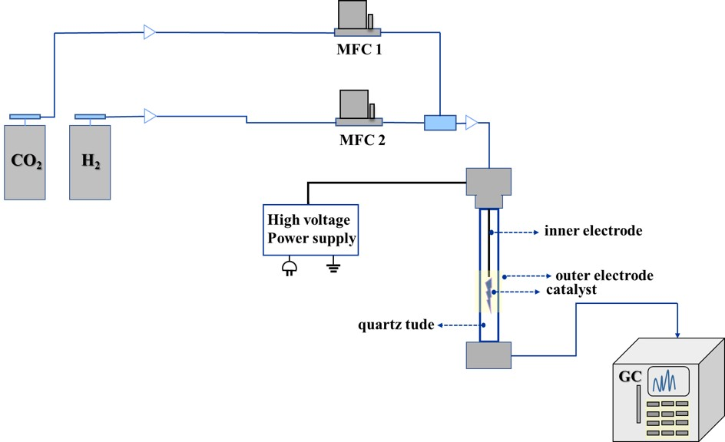
Fig. S1 Schematic of the DBD plasma collaborating with catalysts reaction.

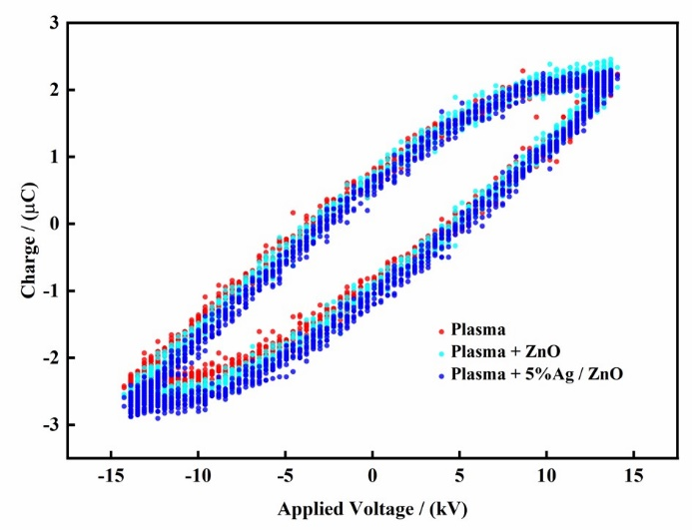
Fig. S2 Q-U Lissajous figures of the discharges. The peak to-peak applied voltage was 28 kV for Plasma Only, Plasma + ZnO and Plasma + Ag/ZnO, respectively (H₂/CO₂ = 3:1, total flow rate = 20 mL · min⁻¹, discharge power = 25.31±0.2 W).

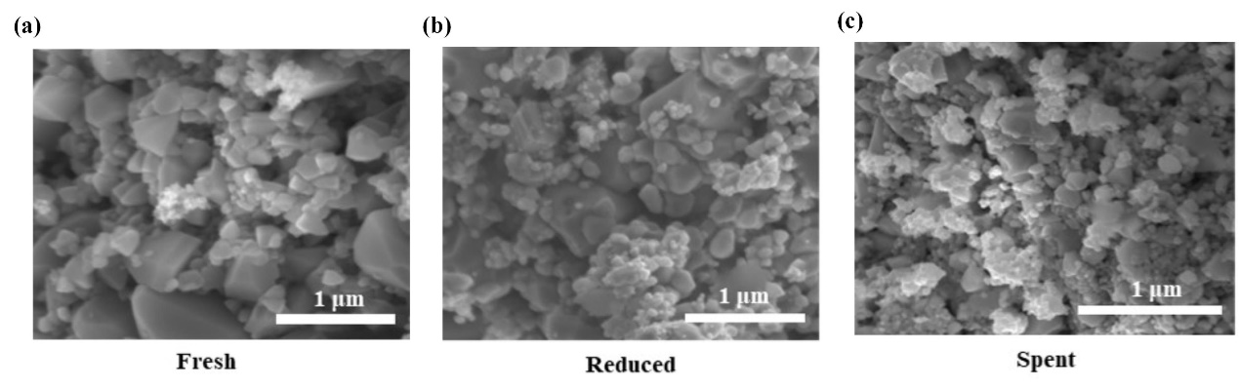
Fig. S3 SEM images of (a) fresh, (b) reduced and (c) used Ag/ZnO.

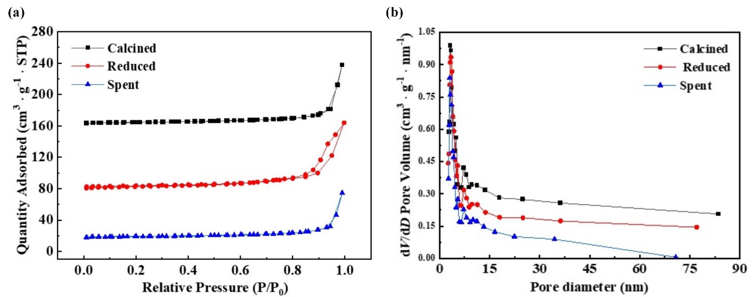
Fig. S4 (a) N₂ adsorption isotherms of and the calcined, reduced, and used Ag/ZnO catalyst; (b) corresponding pore size distributions.

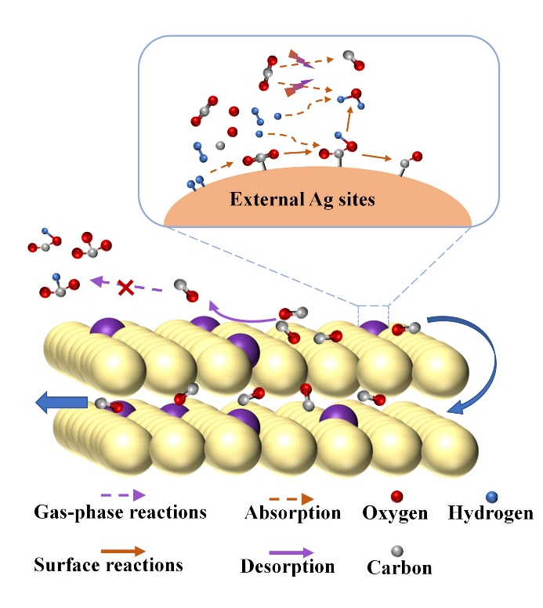
Fig. S5 Schematic of plasma assisted RWGS reaction over the Ag/ZnO catalyst.

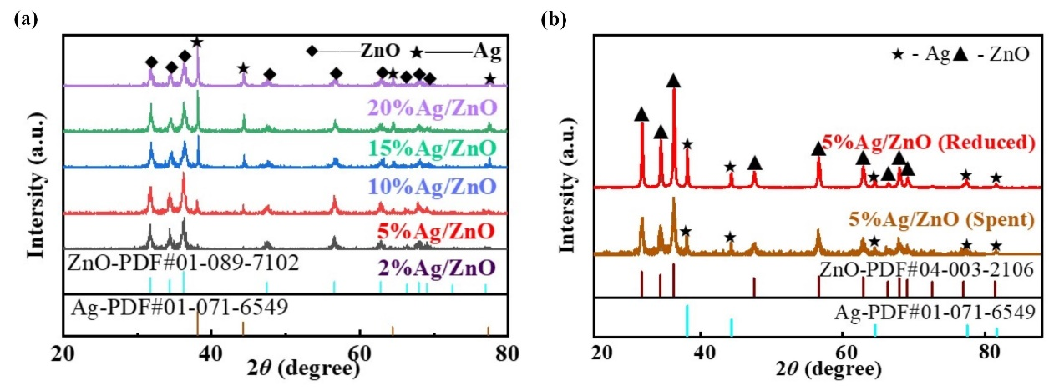

Fig. S6 XRD patterns of (a) Ag/ZnO catalysts supported by different Ag contents and (b) Reduced and Spent Ag/ZnO catalyst.
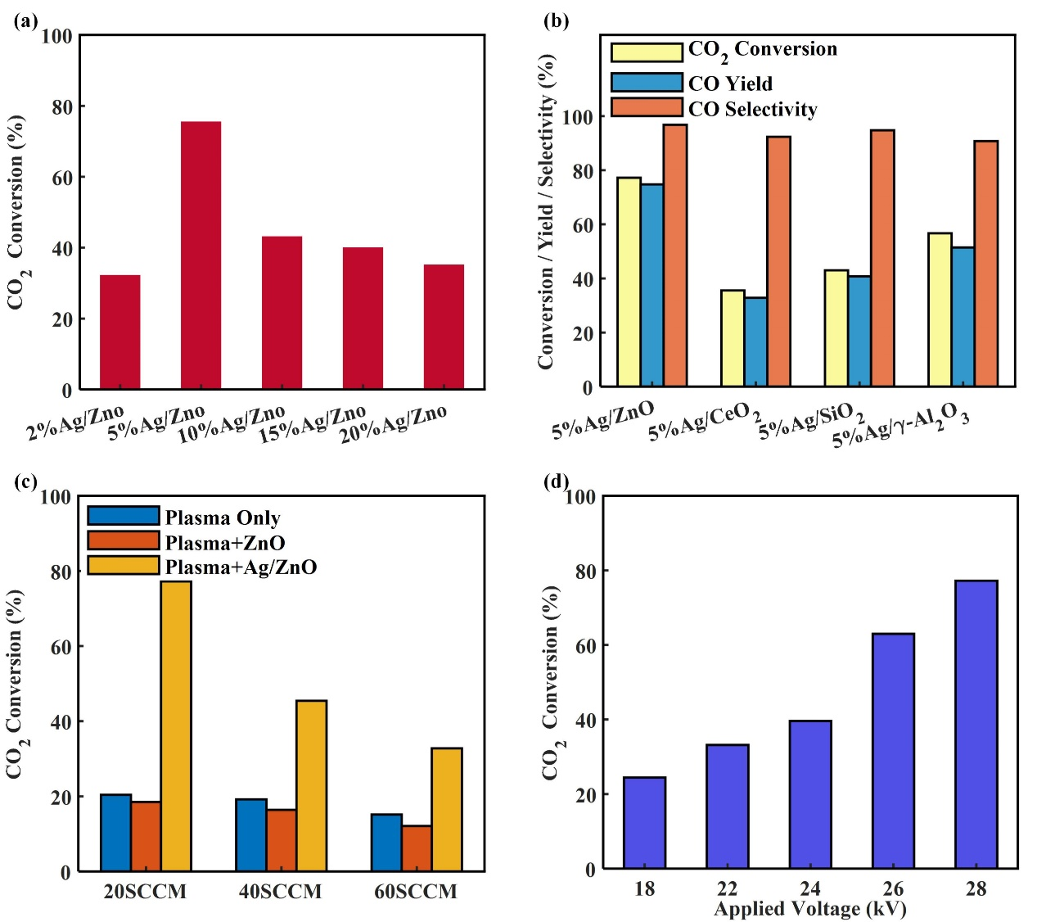
Fig. S7 (a) CO₂ conversion of the Ag/ZnO catalysts with different Ag loading amounts under NTP conditions; (b) Catalytic performance of Ag-based catalysts supported on different materials; Catalytic performance at different flow rates(c) and (d) different applied voltages.

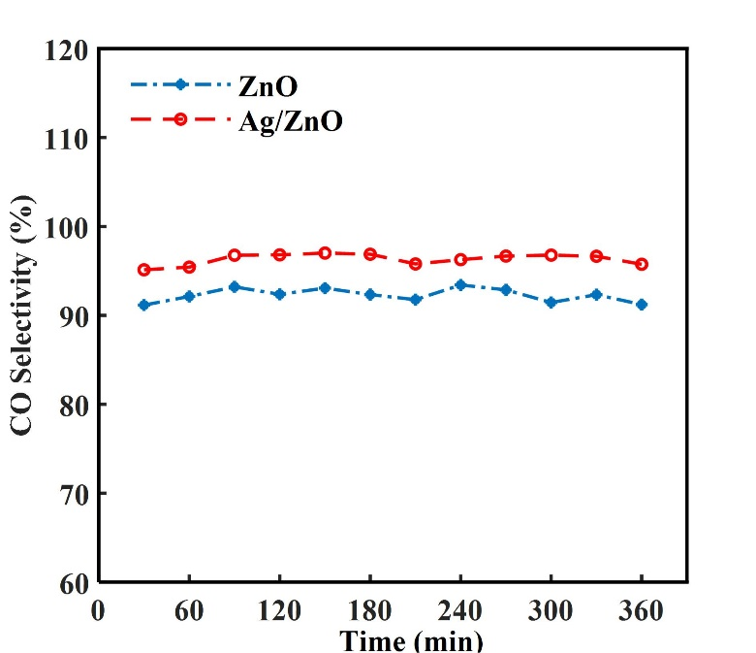
Fig. S8 The stability tests of different plasma-assisted RWGS systems (H₂/CO₂ = 3:1, total flow = 20 mL·min⁻¹, applied peak voltage of 28 kV ± 0.2 kV, frequency of 7.5 kHz, discharge power of 25.31 ± 0.2 W).
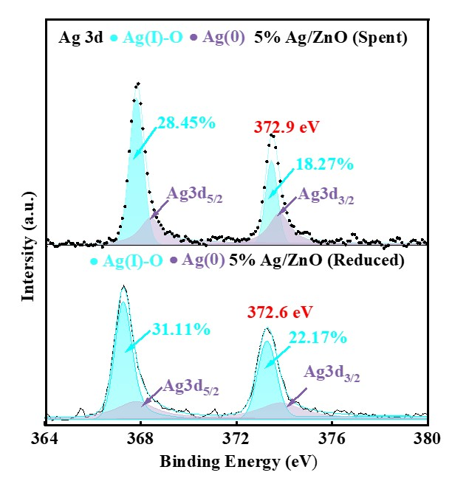
Fig. S9 Ag 3d XPS spectra of the reduced and used Ag/ZnO catalyst.

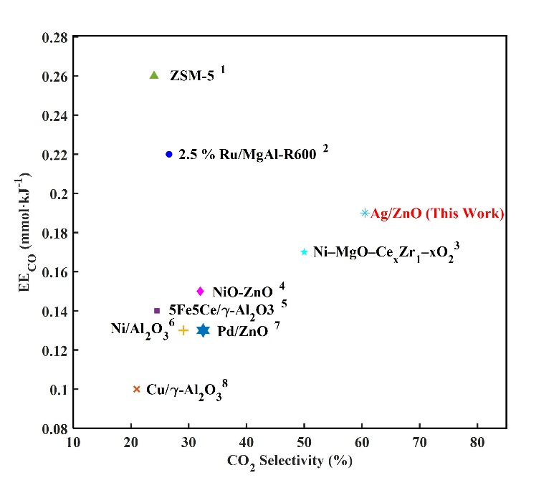
Fig. S10 Comparing of energy efficiency of CO production with plasma catalytic RWGS reactions that previous reported (1, 2, 3, 4, 5, 6, 7, 8).

2. Supplementary table
Table S1 Porous properties of the calcined, reduced and used Ag/ZnO catalyst.
Catalyst | BET surface area (m²/g) | Pore volume (cm³/g) | Pore diameter (nm)
Calcined | 17 | 0.12 | 36
Reduced | 14 | 0.10 | 40
used | 13 | 0.09 | 33
*Determined at P/P₀ = 0.99

3. Reference
1. Chen S, Liu T, Niu J, Huang J, Peng X, Zhou H, et al. Plasma-catalytic CO₂ methanation over Ni supported on MCM-41 catalysts: Effect of metal dispersion and process optimization. Carbon Capture Science & Technology. 2024;11:100194.
2. Xu S, Sarayute CS, Shao Y, Xu S, Wang YC, Haigh S, et al. Mechanistic study of non-thermal plasma assisted CO₂ hydrogenation over Ru supported on MgAl layered double hydroxide. Applied Catalysis B: Environmental. 2020;268:118752.
3. Kim Y, Kim KJ, Song Y, Lee YL, Roh HS, Na K. Highly CO-selective Ni–MgO–CexZr₁–xO₂ catalyst for efficient low-temperature reverse water–gas shift reaction. Journal of Industrial and Engineering Chemistry. 2023;118:341-50.
4. Tang CW, Chuang SSC. The effect of reduction of pretreated NiO–ZnO catalysts on the water–gas shift reaction for hydrogen production as studied by in situ DRIFTS/MS. International Journal of Hydrogen Energy. 2014;39(2):788-797.
5. Pastor-Pérez L, Shah M, Le Saché E, Ramirez Reina T. Improving Fe/Al₂O₃ Catalysts for the Reverse Water-Gas Shift Reaction: On the Effect of Cs as Activity/Selectivity Promoter. Catalysts. 2018;8(12):608.
6. Zeng YX, Wang L, Wu CF, Wang JQ, Shen BX, Tu X. Low temperature reforming of biogas over K-, Mg- and Ce-promoted Ni/Al₂O₃ catalysts for the production of hydrogen rich syngas: Understanding the plasma-catalytic synergy. Applied Catalysis B: Environment and Energy. 2018;224:469-78.
7. Sun Y, Wu J, Wang Y, Li J, Wang N, Harding J, et al. Plasma-Catalytic CO₂ Hydrogenation over a Pd/ZnO Catalyst: In Situ Probing of Gas-Phase and Surface Reactions. JACS Au. 2022;2:1800 - 10.
8. Liu M, Yi Y, Wang L, Guo H, Bogaerts A. Hydrogenation of Carbon Dioxide to Value-Added Chemicals by Heterogeneous Catalysis and Plasma Catalysis. Catalysts. 2019;9(3):275.

