Electronic Supplementary Material

Integrating the first- and second-generation bioethanol co-production from wheat and wheat straw process: techno-economic feasibility and life cycle assessment
Xingchen Yang¹, Zhenli Yan^{2,3}, Chaojun Du⁴, Zigao Zhao^{2,3}, Yujie Chen⁴, Haoran Wu ()^{1,3}, Huanhuan Zhang¹, Chun Chang ()^{1,5}
¹ School of Chemical Engineering, Zhengzhou University, Zhengzhou 450001, China
² Tianguan Nanyang Cellulosic ethanol Co.Ltd., Nanyang 473000, China
³ National Key Laboratory of Biobased Transport Fuel Technology, Zhengzhou 450001, China
⁴ Nanyang Research Institute of Zhengzhou University, Nanyang Institute of Technology, Nanyang 473004, China
⁵ Henan Center for Outstanding Overseas Scientists, Zhengzhou 450001, China
E-mails: haoranwu@zzu.edu.cn (Wu H); chunchang@zzu.edu.cn (Chang C)

Experimental section
- Liquefaction and saccharification process
The liquefaction and saccharification process conditions of 1G grain are shown in Table S1, and the chemical reactions occurring during saccharification are shown in Table S2. Wheat debranning treatment can remove a large number of non-starch substances in wheat bran, thus increasing the starch content, promoting the efficient hydrolysis of starch, and improving the utilization rate of fermentable sugar, which is helpful to improve the utilization rate of ethanol fermentation device. Wheat bran contains protein, dietary fiber and minerals, which can be used in food, feed, medicine, environmental protection and industrial fields. Gluten flour (wheat gluten protein) is the main by-product produced in the production of wheat starch, which has poor water solubility and can be used in the food industry, such as gluten, vegetarian sausage and vegetarian chicken. After separating part of wheat bran and wheat gluten, the main component is starch. The sugar solution obtained after the liquefaction of the starch enters the fermentation section and is fermented together with the 2G sugar flow. The mixture of a small amount of syrup and wet distiller's grains is dried to produce DDGS without artificial additives, which can be used to raise livestock.
1. Green chemistry indicators
Green chemistry indicators such as E-factors, Process Mass Intensity (PMI), and Carbon efficiency (CE) are extensively employed in the ongoing advancement of chemical processes to evaluate their level of environmental sustainability¹. Lignocellulosic biomass possesses a high carbon content and shows great potential as a sustainable alternative to replace traditional fossil fuels. It is crucial to study the environmental friendliness of its development process and assess its impact on the environment. The E-factor, CE, and PMI are calculated using Equations (1)-(3), respectively².
E-factor =$\frac{\sum{\text{m}\text{(waste)}}}{\sum{\text{m}}\left(\text{product}\right)}\text{=}\frac{{\text{m}}_{\text{1}}\text{-}{\text{m}}_{\text{2}}\text{-}{\text{m}}_{\text{3}}}{{\text{m}}_{\text{3}}}$ (1)
CE = $\frac{\sum{\text{mole of carbon atoms in products}}}{\sum{\text{mole}}\text{ of carbon atoms in raw material}}\text{×}$ 100% (2)
PMI =$\frac{\sum{\text{m(total input)}}}{\sum{\text{m}}\left(\text{product}\right)}\text{=}\frac{{\text{m}}_{\text{1}}}{{\text{m}}_{\text{3}}}$ (3)
where m₁ represents the initial mass of materials added, m₂ is the mass of raw materials, solvents, catalysts, and other substances recovered, and m₃ means the total mass of the final product.
2. Techno-economic analyses
In this study, an economic evaluation of the conversion of biomass feedstock into biofuel was conducted. Initially, the relevant chemical process will be established to achieve the mass and energy balance. Following this, we will estimate the equipment and project costs associated with the production process, and determine the Minimum Ethanol Selling Price (MESP) through discounted cash flow analysis, along with its Internal Rate of Return (IRR) over a specified plant lifespan³. All investment data presented in this paper are based on the Chinese context. The source of the investment data was referred to the previous literatures⁴.
Cost estimates were calculated using the following Equation (4). The total production cost (TPC) consists of raw materials, capital, waste management, energy usage, and fixed operating expenses such as labor, insurance, working capital, and maintenance⁵. The total capital investment (TCI) is segmented into fixed capital investment (FCI) and working capital (WC). Within FCI, there is a breakdown between total direct costs (TDCs) and total indirect costs (TICs). TDCs encompass expenses related to piping and controls, equipment procurement and installation, site development, and service facility expenditures. TICs are composed of project supervision costs, contract costs project emergency costs, etc. Inside-battery-limits (ISBL) equipment consists of equipment in the pretreatment, product production, and recovery subsystems. 2019 was assumed to be the benchmark year, the lifetime was assumed to be 30 years and the annual operating time was set to 8,000 h. The equipment cost in the original value (C₀) was converted to the value in the reference year (C₂₀₁₉) using the chemical engineering plant cost index (CEPCI), as illustrated in Equation (5). The CEPCI value was 607 in 2019⁶.
${\text{C}}_{\text{1}}\text{ = }{\text{C}}_{\text{0 }}\text{(}\frac{{\text{S}}_{\text{1}}}{{\text{S}}_{\text{0}}}{\text{)}}^{\text{n}}$ (4)
${\text{C}}_{\text{2019}}$=${ \text{C}}_{\text{0}}\text{ (}\frac{{\text{CEPCI}}_{\text{2019}}}{{\text{CEPCI}}_{\text{0}}}\text{)}$ (5)
The characteristic scaling exponent 'n' was determined to be 0.7 within the usual range of 0.6 to 0.8. The variables 'C₀' and 'C₁' represent the purchase costs of the original and new equipment, respectively, while 'S₀' and 'S₁' represent the sizes of the original and new equipment, respectively.
3. Life Cycle Analysis
LCA is structured into four distinct steps: defining objectives and scope, conducting life cycle inventory collection, performing life cycle impact assessment, and interpreting life cycle results. The initial step involves defining the objectives and scope of the assessment. This entails establishing the system boundaries of the evaluation by describing the product, process, or activity under review, as well as identifying relevant environmental constraints and impacts. The second step focuses on life cycle inventory collection and analysis. During this phase, the resources utilized—including water, energy, and materials—are identified and quantified, along with their associated environmental emissions, such as air emissions, solid waste deposition, and liquid effluents. This establishes a comprehensive LCA model. The third step is dedicated to evaluating the life cycle impact. In this stage, the study calculates the human and ecological benefits and detriment associated with the target life cycle, while also quantifies environmental indicators by analyzing water, energy, material usage, and emissions documented in the inventory. The final step involves the interpretation of life cycle results. This step assesses the findings from both the inventory analysis and the impact analysis, providing clarity on the influence of each component on the overall results through sensitivity analysis. This analysis helps identify critical areas for improvement and facilitates the development of actionable recommendations.
The production process of bioethanol involves many fields, such as agricultural planting, logistics and transportation, chemical engineering, and environmental protection. In this study, the biomass planting and raw material collection stage are mainly based on the relevant domestic process parameters, striving to conform to the actual situation of domestic production. Due to the lack of long-term agricultural planting data of biomass, the planting input is taken from the reported literature, and there will be some deviation in the LCA results⁷. In this study, we established the Life Cycle Assessment (LCA) model for the integrated 1G + 2G process processes and evaluated its environmental impact in accordance with the ISO 14040 standard.
In this study, 1 ton of fuel ethanol is taken as the functional unit, and the system boundary is defined from raw material planting to fuel ethanol use. As shown in Figure 2, the system boundary consists of the raw material planting stage (Stage 1, S1), raw material transportation stage (Stage 2, S2), fuel ethanol production stage (Stage 3, S3), fuel ethanol transport stage (Stage 4, S4), and fuel ethanol combustion use stage (Stage 5, S5).
The Life Cycle Assessment (LCA) stages are interconnected through material flows. By-products are generated simultaneously with the primary products at each stage, and these by-products can be recycled into other life cycles as raw materials. Therefore, it is essential to allocate material inputs, energy consumption, and environmental emissions to each product according to established allocation principles. The most common methods for distribution include energy law and economic law. Murphy et al⁸. demonstrated that the application of economic law and energy law influenced the final Life Cycle Assessment (LCA) findings by 14-15% and 30%, respectively. This paper chooses the market value distribution method in economic law.
The life cycle stages of the process are depicted in Figure 2. During the raw material planting stage (S1), inputs include electricity and diesel fuel, along with the harvesting of wheat and its by-product, wheat straw. In the raw material transportation stage (S2), diesel fuel is consumed for transportation, leading to the emission of gases from diesel combustion. The fuel ethanol production stage (S3) utilizes electricity and steam to produce fuel ethanol, as well as co-products such as wheat gluten, bran, biogas, lignin, and DDGS. In the transportation stage (S4), fuel ethanol is transported, with the emission of gases from diesel combustion as a by-product. Finally, in stage S5, the use of fuel ethanol results in the release of pollutant gases and inhalable particulate matter.
In the LCA model, there are inherent uncertainties in the data; therefore, it is essential to assess the impact of changes in system input or output parameters on the life cycle analysis results through sensitivity analysis. Sensitivity analysis examines and quantifies the influence of various parameters at each stage of the process on the overall results. This analysis can be categorized into local sensitivity analysis and global sensitivity analysis, depending on the number of parameters being evaluated. Local sensitivity analysis, which is frequently employed in LCA studies, and focuses on understanding how changes at different stages affect the environmental impacts of fuel ethanol throughout its life cycle.
In this study, the key parameters as the amount of nitrogen fertilizer, diesel fuel, steam, and combustion efficiency of fuel ethanol were examined to evaluate the impact of each critical element on the overall environment. In the S1 raw material planting stage, the amount of nitrogen fertilizer was changed, which significantly contributes to GWP, FAETP, and other impact categories. Thus, the amount of nitrogen fertilizer used in the agricultural production stage was designated as the sensitivity analysis parameter. For the S2 raw material transportation stage, this study focused on the amount of diesel fuel utilized during transport. In the S3 fuel ethanol production stage, the consumption of steam in the production process was investigated, while in the S4 fuel ethanol transportation stage, the diesel consumption was assessed during transportation. Finally, the parameter altered in the S5 fuel ethanol usage stage was the emissions resulting from fuel ethanol combustion. The variation values for the parameters mentioned above are set at ± 10% and ± 20%, respectively.
When defining the system boundary, wheat straw is characterized as agricultural waste. Consequently, the pollution associated with the wheat planting phase is relevant solely to the life cycle analysis of wheat grains. The power supply is treated as a fixed variable, with variability minimized by utilizing the Chinese data from the Ecoinvent 3 allocation cut-off by classification database. To lower investment costs, other by-products, such as lignin and biogas, are evaluated only for their economic value, without consideration of the pollution arising from their subsequent usage.
This research mainly focuses on the technical optimization of the 1G + 2G ethanol production process and its direct environmental impact, so the parameter settings of the power generation structure are unified in the system boundary to reduce the variable interference. The plant is located in Henan Province, China. The electricity and steam utilized are sourced from a local thermal power plant. The life cycle data is derived from the Ecoinvent 3 allocation cut-off by classification database specific to China. Given the notable variations in power generation structures across different regions, the standardized power generation structure from the Ecoinvent 3 database was selected in this work. This option assumes that the thermal power plant operates using bituminous coal. In light of the selected system boundary, we will not consider the optimization of the power grid and steam in this study. Instead, our primary focus will be on optimizing technology associated with the production of fuel ethanol. Although the generation structure does contribute to the overall environmental impact, in this study, it was set as a fixed variable in order to focus on the environmental impact of improvements in the technology process itself. In determining the system boundary of the study, this study does not consider the use of biogas produced for power generation, because this will increase the investment cost. The biogas produced in the process is directly exported as a product, and its impact in the life cycle is evaluated by measuring its economic value. Similarly, lignin is also exported directly as a product.

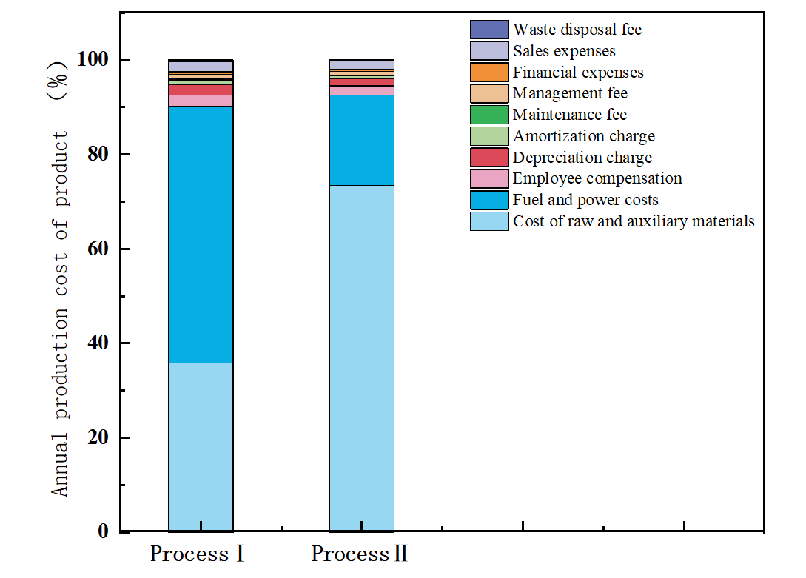
Figure S1. Proportion of annual production cost of products

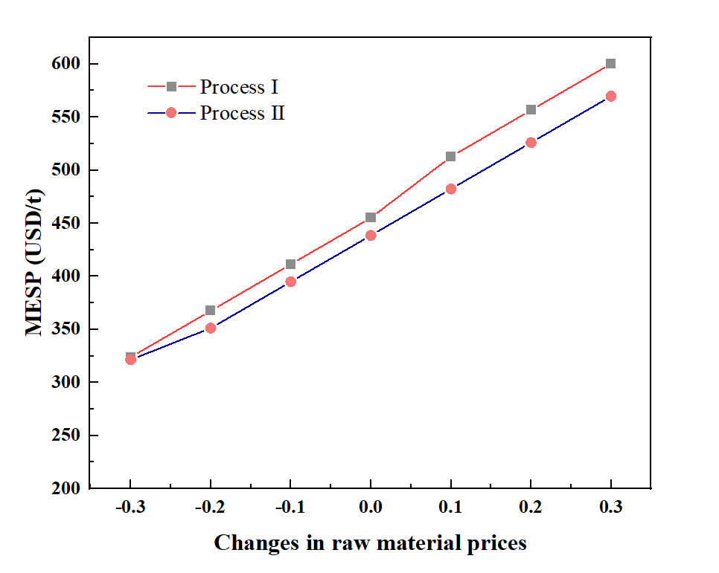
Figure S2. Sensitivity analysis of biomass raw material price

Table S1. Process conditions of grain liquefaction and saccharification

Process conditions | Project | Parameter
Liquefaction | Temperature（℃） | 90
Liquefaction | Pressure（atm） | 3.4
Liquefaction | Liquefaction time （min） | 100
Liquefaction | Liquefaction enzyme （U/g） | 15
Saccharification | Temperature（℃） | 60
Saccharification | Pressure（atm） | 2.72
Saccharification | Saccharification time（h） | 40
Saccharification | Glucoamylase （U/g） | 150

Table S2. Mass balance of the process II
Input |  | Output
Stream | (t/h) | Stream |  | (t/h)
Straw | 84 | Etoh |  | 30.47
Grain | 50 | Bran |  | 0.15
Amylase | 0.004 | Gluten |  | 5.80
Glucoamylase | 0.006 | H₂O |  | 425.22
Pullulanase | 0.01 | Rstill |  | 24.03
Enzyme | 1.8 | Lignin |  | 6.21
Xylanase | 0.7 | CO₂ |  | 42.28
H₂O₂ | 0.4 | Solid |  | 2.93
NaOH | 0.4 | Gas |  | 37.27
H₂O | 411 | Biogas |  | 0.10
Air | 55 | Ddgs |  | 33.20
Yeast | 0.6
Csl | 0.2
Ammonia | 1
Antifoam | 0.7
Diammonium Phosphate | 1
H₂SO₄ | 0.5
Total | 607 | Total |  | 607

Table S3．Results of pinch analysis
Parameter | Process Ⅰ | Process Ⅱ
Set ΔT_{min}（℃） | 10.00 | 10.00
Optimal ΔT_{min}（℃） | 16.00 | 14.50
Cold pinch temperature（℃） | 109.30 | 112.80
Thermal pinch temperature（℃） | 125.30 | 127.30
Cold Utility Requirements（MW） | 69.77 | 208.56
Thermal Utility Requirements（MW） | 45.08 | 117.25
CO₂ Emissions（kg/h） | 10580 | 24140

Table S4． Energy requirements for biorefinery process without (wo) and with (w) heat integration
Parameter | Process Ⅰ |  | Process Ⅱ
Parameter | wo | w | wo | w
Q_{H} （MW） | 52.42 | 45.08 | 208.92 | 117.25
Q_{C}（MW） | 107.43 | 69.77 | 278.72 | 208.56
Total （MW） | 159.85 | 114.85 | 487.63 | 325.81
Integrated savings (hot) （%） |  | 14.00 |  | 43.88
Integrated savings (cold) （%） |  | 35.06 |  | 25.17
Q_{R}（MW） |  | 68.22 |  | 130.13
Energy recovery potential（%） |  | 52.60 |  | 60.51
CO₂ Emissions（kg/h） | 22570 | 10580 | 61350 | 24140
CO₂ Emission reduction（%） |  | 53.12 |  | 60.65

Table S5. Energy saving comparison of heat exchange network design schemes
Parameter | Process Ⅰ |  |  |  | Process Ⅱ
Parameter | Q_{H}（MW） | Q_{C}（MW） | Total （MW） | P6 |  | Q_{H}（ MW） | Q_{C}（MW） | Total （MW） | P6
Q_{ori} | 52.42 | 107.43 | 159.85 | 0.59 |  | 208.92 | 278.71 | 487.63 | 0.62
Q_{opti} | 45.08 | 69.77 | 114.85 | 0.82 |  | 117.25 | 208.56 | 325.81 | 0.93
Q_{min} | 34.38 | 59.39 | 93.77 | 1 |  | 108.83 | 192.67 | 301.50 | 1

Table S6. Annual Profit Distribution Report for the Two Processes
Items | Annual amount（million USD）
Items | Process I | Process II
Product sales revenue | 200 | 260
Total cost | 97 | 147
Sales taxes and surcharges | 119 | 16
Total profit | 86 | 95
Income tax | 22 | 24
Net profit | 65 | 71
Statutory surplus reserve | 6 | 7
Discretionary surplus reserve | 24 | 3
Undistributed profits | 55 | 60

Table S7. Product price
Parameter item | Describe
Base year | 2019
Fuel ethanol（USD /t） | 863
High-purity low-pressure liquid CO₂（USD /t） | 31
Lignin（USD/t） | 68
Biogas（USD /m³） | 27
Bran（USD /t） | 30
Gluten（USD /t） | 54
DDGS（USD /t） | 41
Table S8. Fixed capital investment of bioethanol co-production process
Project |  | ProcessⅠ  (thousand USD) | ProcessⅡ  (thousand USD)
Equipment purchase cost | Cost of process equipment | 5570.24 | 5729.14
Equipment purchase cost | Purchase cost of internal filler of equipment | 1114.05 | 1145.83
Equipment purchase cost | Cost of process pipeline and anticorrosion and thermal insulation works | 2005.29 | 2062.49
Equipment purchase cost | Cost of instrument automatic control system | 779.84 | 802.08
Equipment purchase cost | Electrical equipment costs | 668.44 | 687.50
Equipment purchase cost | Cost of production tools | 139.26 | 143.23
Equipment purchase cost | Purchase cost of spare parts | 334.21 | 343.74
Equipment purchase cost | Freight and miscellaneous charges of equipment | 389.92 | 401.04
Equipment purchase cost | Purchase cost of utility equipment | 1671.07 | 1718.75
Equipment purchase cost | Additions to vehicle purchases | 1113.99 | 1145.83
Equipment purchase cost | Total | 13786.36 | 14179.63
Installation engineering cost | Reactor | 2834.96 | 3131.49
Installation engineering cost | Tower equipment | 3567.36 | 3567.36
Installation engineering cost | Heat exchanger | 1856.75 | 1856.75
Installation engineering cost | Storage tank, reflux tank, buffer tank | 239.50 | 354.68
Installation engineering cost | Liquid conveying equipment | 69.73 | 70.50
Installation engineering cost | Compressor | 10.93 | 10.93
Installation engineering cost | Process piping | 783.84 | 825.00
Installation engineering cost | Instrument and automatic control system | 152.41 | 160.41
Installation engineering cost | Other equipment | 544.32 | 572.92
Installation engineering cost | Total | 10059.80 | 10550.03
Construction cost | Civil engineering | 5514.55 | 5671.85
Construction cost | Site construction | 2757.28 | 2835.93
Construction cost | Overhead costs | 2757.28 | 2835.93
Construction cost | Business tax | 330.88 | 340.32
Construction cost | Urban construction and maintenance tax | 19.86 | 20.42
Construction cost | Education surtax | 9.93 | 10.22
Construction cost | Total | 11389.75 | 11714.64
Fixed assets |  | 35235.92 | 36444.30

Table S9. Annual production cost of bioethanol co-production process
Project | Process I | Process II
Project | （million USD） | （million USD）
Cost of raw materials | 34.83 | 107.76
Fuel and power costs | 52.80 | 28.19
Employee compensation and welfare expenses | 2.33 | 2.85
Depreciation charge | 2.16 | 2.20
Amortization charge | 0.99 | 1.00
Maintenance costs | 0.17 | 0.17
Management fee | 0.93 | 1.14
Financial expenses | 0.59 | 0.59
Sales expenses | 2.05 | 2.60
Waste disposal fee | 0.32 | 0.35
Total cost | 97.16 | 146.85

Table S10. Life cycle substance inventory of 1G+2G ethanol integration process (basis: 1 t bioethanol)
Raw materials/Resources | Units | Wheat + wheat straw ethanol
S1 raw material planting
Land use | m² | 4440
Wheat seeds | kg | 50
Nitrogen fertilizer | kg | 83
Phosphate fertilizer | kg | 70
Potash fertilizer | kg | 43
Herbicide | kg | 2.664
Pesticide | kg | 1.332
Diesel (soil preparation and ploughing) | kg | 67
Power consumption | kWh | 35
Water requirement for irrigation | m³ | 932
S2 Raw material transportation
Diesel | L | 35
Transportation distance | km | 50+65
S3 Fuel ethanol production
Wheat + wheat straw | t | 6
5 wt% hydrogen peroxide | kg | 6
Sodium hydroxide | kg | 0.5
Liquefaction enzyme | kg | 0.6
Glucoamylase | kg | 2
Cellulase | kg | 0.1
Xylanase | kg | 0.03
Tween 80 | kg | 0.06
98% sulfuric acid | kg | 0.1
Yeast | kg | 1
(NH₄)₂HPO₄ | kg | 0.02
Electricity | kwh | 277
Water | kg | 5
Steam | m³ | 5
Anhydrous ethanol transport | km | 350
Diesel | L | 35
S4 Product transport
Diesel | L | 50
Fuel Ethanol Distribution Distance | km | 500
S5 Product use
Lignin | kg | 0.4
CO₂ | t | 3
Bran | t | 0.8
Gluten | t | 2
DDGS | t | 1
Biogas | m³ | 0.003
1G+2GFuel ethanol | t | 1
Fuel ethanol (t): Wheat grain (t) =1:3 Fuel ethanol (t): Wheat Straw (t) =1:3.2

References:

1. Ayodele, T. R., Ogunjuyigbe, A. S. O. & Alao, M. A. Economic and environmental assessment of electricity generation using biogas from organic fraction of municipal solid waste for the city of Ibadan, Nigeria. J Clean Prod 203, 718–735 (2018).
2. Madabhushi, S. R., Pinto, N. D. S. & Lin, H. Comparison of process mass intensity (PMI) of continuous and batch manufacturing processes for biologics. N Biotechnol 72, 122–127 (2022).
3. D’Angelo, S. C., Dall’Ara, A., Mondelli, C., Pérez-Ramírez, J. & Papadokonstantakis, S. Techno-Economic Analysis of a Glycerol Biorefinery. ACS Sustain Chem Eng 6, 16563–16572 (2018).
4. Zhao, Y. et al. Pinch combined with exergy analysis for heat exchange network and techno-economic evaluation of coal chemical looping combustion power plant with CO2 capture. Energy 238, 121720 (2022).
5. Zhao, X. & Liu, D. Multi-products co-production improves the economic feasibility of cellulosic ethanol: A case of Formiline pretreatment-based biorefining. Appl Energy 250, 229–244 (2019).
6. Wiranarongkorn, K., Im-orb, K., Patcharavorachot, Y., Maréchal, F. & Arpornwichanop, A. Comparative techno-economic and energy analyses of integrated biorefinery processes of furfural and 5-hydroxymethylfurfural from biomass residue. Renewable and Sustainable Energy Reviews 175, 113146 (2023).
7. Czyrnek-Delêtre, M. M., Smyth, B. M. & Murphy, J. D. Beyond carbon and energy: The challenge in setting guidelines for life cycle assessment of biofuel systems. Renew Energy 105, 436–448 (2017).
8. Murphy, C. W. & Kendall, A. Life cycle inventory development for corn and stover production systems under different allocation methods. Biomass Bioenergy 58, 67–75 (2013).

