Electronic Supplementary Materials
Harnessing MOF-derived homogeneous hierarchical nickel phyllosilicate for epoxy composites: breaking the dilemma between flame retardancy and mechanical and tribological properties via co-deploying polyphosphazene and DOPO
Jinian Yang ()¹, Jie Dong¹, Bingyi Li¹, Weilong Chen¹, Hanxin Yang¹, Dehan Chen¹, Shibin Nie ()²
1 School of Materials Science and Engineering, Anhui University of Science and Technology, Huainan 232001, China
2 School of Public Security and Emergency Management, Anhui University of Science and Technology, Hefei 231131, China

E-mails: yangjinian@163.com, jnyang@aust.edu.cn (Yang J); nieshibin88@163.com (Nie S)

2. Experimental
2.1 Raw materials
Nickel nitrate hexahydrate (Ni(NO₃)₂·6H₂O), sodium silicate nonahydrate (Na₂SiO₃·9H₂O), sodium hydroxide (NaOH), 4,4′-diaminodiphenyl ether (ODA), triethylamine (TEA), hexachlorocyclotriphosphazene (HCCP), 9,10-dihydro-9-oxa-10-phospaphenanthrene-10-oxide (DOPO), acetone, acetonitrile, anhydrous ethanol, methanol, N,N-dimethylformamide (DMF), terephthalic acid (H₂BDC), and 4,4′-diaminodiphenylmethane (DDM) were all analytically pure and commercially available. Industrial-grade bisphenol A epoxy resin (grade designator: E44) with an epoxy equivalent weight of 213-244 g/eq was purchased from JITIAN CHEMICAL. All raw materials were used without further purification.
2.2 Sample preparation
(1) Synthesis of MOF-derived NiPS: First, MOF precursor was synthesized by dissolving 0.393 g Ni(NO₃)₂·6H₂O and 0.249 g H₂BDC in 15 mL DMF. After adding 3 mL of 0.2 mol/L NaOH and stirring for 1 h, the mixture was heated in a Teflon-lined autoclave at 100 °C for 15 h. The resulting light green MOF powders were centrifuged, washed with DMF and methanol, and vacuum-dried at 60 °C. Subsequently, 0.4 g MOF and 0.57 g Na₂SiO₃·9H₂O were dispersed in a 60 mL ethanol/water mixture (v/v=1:1). Under constant ultrasonication (180 W, 30 min), 3 mL NaOH solution (1 mol/L) was added dropwise. The mixture was treated hydrothermally at 170 °C for 15 h. The product was collected by washing with water and ethanol, followed by vacuum drying at 60 °C overnight, resulting in light-green homogeneous hierarchical NiPS.
2.3 Characterization
The x-ray diffractograms (XRD) of the samples were obtained using an x-ray diffractometer with CuK_{α} target radiation model XRD-6000.The functional groups of the samples were characterized using a Nicolet 380 Fourier Transform Infrared Spectrometer (FT-IR). Samples were thermogravimetrically analyzed using a synchronous thermal analyzer model TGA/DSC 3⁺ in nitrogen and air atmosphere at a rate of 50 mL/min with temperatures ranging from 30 to 700 °C. The elemental composition and distribution of the samples were obtained using an x-ray photoelectron spectrometer (XPS) model ESCALAB Xi⁺. morphology of the sample was mainly characterized by scanning electron microscopy (SEM, S-3000N and Regulus8100) and transmission electron microscopy (TEM, JEOL-2010) while TEM-attached energy dispersive spectroscopy (EDS) was used for ascertaining the elemental dispersion. The limiting oxygen index (LOI) was calculated using a CH-2 oxygen index meter according to GB/T 2406.2-2009 with a sample size of 100 × 6.5 × 3 mm³ while vertical combustion (UL-94) was evaluated using a CFZ-2 vertical combustion tester with a sample size of 100 x 13 x 3 mm³ following a national standard of GB/T 2408-2008, of which the ignition time was 20 s. The flammability properties of the samples were determined using a cone calorimeter according to IOS 5660 with a sample size of 100 × 100 × 3 mm³ and external heat flux of 50 kW/m². The graphitization of residual char was analyzed by the Raman spectroscopy model inViaQontor. Uniaxial tensile measurements were tested using a universal testing machine model KQL WDW-50 according to GB/T 1040.1-2006, and dry-sliding properties were tested using a friction and wear tester model M-200 with the specific experimental parameters in accordance with our previous reports^{[1]}.
Figures
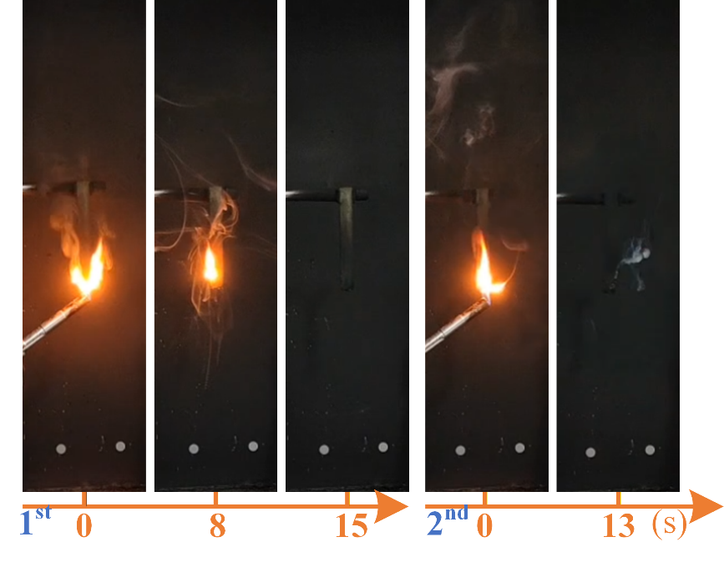
Fig. S1 Digital pictures of screenshots from UL-94 videos for E98D2
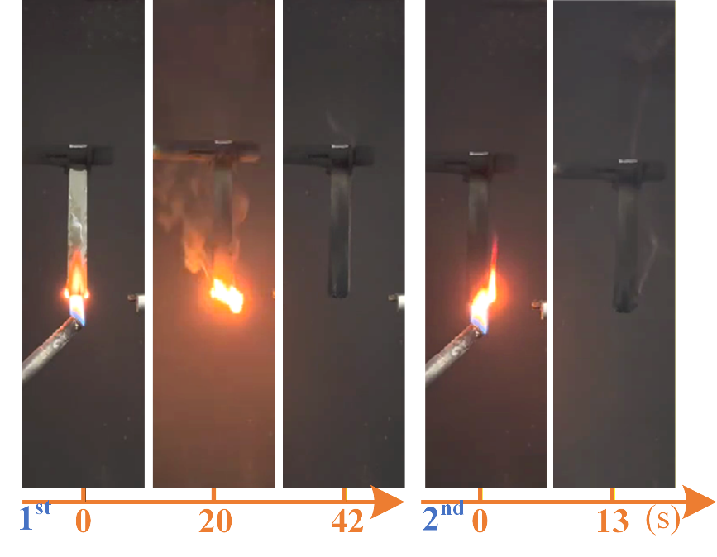
Fig. S2 Digital pictures of screenshots from UL-94 videos for E97D3
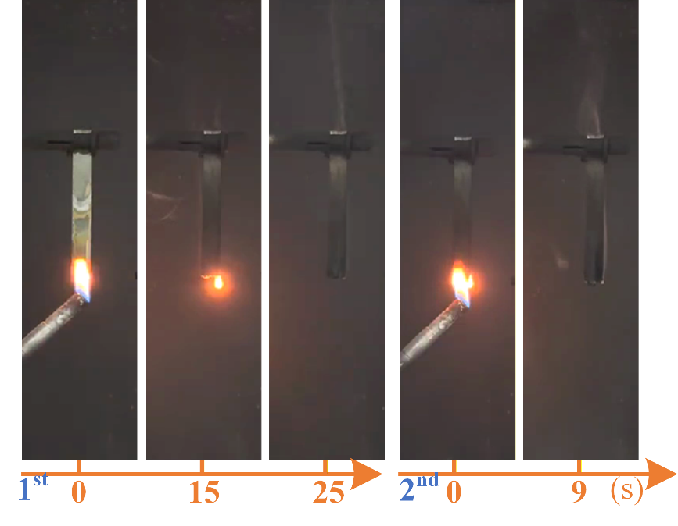
Fig. S3 Digital pictures of screenshots from UL-94 videos for E95N3D2

Tables
Table S1 Compositions of each formula (mass%)
Sample No. | EP+DDM | NiPS | NiPS@PZN | DOPO | Marked as
1  2  3  4  5  6  7  8  9 | 100  98  97  97  95  94  97  E95NP3D2  E94NP3D3 | —  —  —  3  3  3  —  —  — | —  —  —  —  —  —  3  3  3 | —  2  3  —  2  3  —  2  3 | E100  E98D2  E97D3  E97N3  E95N3D2  E94N3D3  E97NP3  E95NP3D2  E94NP3D3
Notes: E means epoxy resin, D indicates DOPO, N represents MOF-derived homogeneous hierarchical NiPS, and NP refers the abbreviation of NiPS@PZN; the number is the corresponding mass fraction of each component.
Table S2 Characteristic parameters of the investigated samples
Sample | under a nitrogen atmosphere
Sample | T_{5%} (°C) | (dW/dT)_{5%} (%/K) | T_{max} (°C ) | (dW/dT)_{max} (%/K) | Char (%)
E100  E94N3D3  E94NP3D3 | 361.4  337.8  336.5 | -0.34  -0.14  -0.14- | 391.0  377.6  379.3 | -1.52  -1.38  -1.29 | 17.1  21.7  23.7
Sample | under an air atmosphere
Sample | T_{5%} (°C) | (dW/dT)_{5%} (%/K) | T_{max1}/_{max2}/_{max3} (°C) | (dW/dT)_{max1}/_{max2}/_{max3} (%/K) | Char (%)
E100  E94N3D3  E94NP3D3 | 301.3  298.3  290.8 | 0.20  0.17  0.17 | 305.6/387.1/556.0  306.2/374.4/554.6  305.4/373.5/550.7 | -0.20/-0.56/-0.65  -0.18/-0.59/-0.60  -0.24/-0.47/-0.62 | 0.74  3.28  3.33
Note: the subscripts of max1, max2 and max2 denote the three peaks that appeared in the DTG thermograms from low to high temperature.
Reference:
[1] Yang J-n, Li Z-y, Xu Y-x, Nie S-b, Liu Y. Effect of nickel phyllosilicate on the morphological structure, thermal properties and wear resistance of epoxy nanocomposites. Journal of Polymer Research, 2020, 27(9): 274. doi: https://doi.org/10.1007/s10965-020-02250-x

