Electronic Supplementary Material
Explainable AI-driven discovery of optimal modular architectures of CO₂ reduction reactor clusters
Kaihao Fu^{1,3}, Xinyuan Li², Ping Li¹, Wenze Guo², Chenxi Cao ()², Wangli He², Wenli Du², Feng Qian²

1 Key Laboratory of Green Chemical Engineering and Industrial Catalysis, School of Chemical Engineering, East China University of Science and Technology, Shanghai 200237, China
2 Key Laboratory of Smart Manufacturing in Energy Chemical Process, Ministry of Education, East China University of Science and Technology, Shanghai 200237, China
3 Suzhou Laboratory, Suzhou 215123, China

E-mail: caocx@ecust.edu.cn

S1 Dataset generation

S1.1 Random structure dataset.
As a stratified sampling technique, Latin Hypercube Sampling (LHS) divides each dimension of the input space into intervals of equal probability and then samples randomly within each interval, thereby achieving more uniform coverage of the input space with fewer samples. Given that the geometric dimensions are continuous variables with constraints, while module topology and connection schemes are discrete variables, the following sampling strategy was adopted: First, an excessive number of random geometric dimension combinations [H₁, H₂, H₃, H₄, H₅] were sampled using LHS in the unconstrained geometric dimension space (55,000 samples), from which approximately 5,000 samples satisfying the geometric constraints were retained. Subsequently, discrete variables N_{k} and G_{k} were sampled using the LHS method. A total of 528 possible module topology were described using an index N, and the three types of inter-stack connection schemes were also represented by index (Z = 1, U = 2, S = 3), yielding approximately 5,000 combinations of module topology and inter-stack connection schemes [N, G₃, G₄, G₅]. These geometric and topological structures were then randomly combined, with the topological index N being restored to [N₁, N₂, N₃, N₄, N₅]. When N_{k} = 1, indicating the absence of a particular architectural hierarchy of the reactor module, H_{k} and G_{k} were set to 0. For instance, in a single-stack structure where N₃ = 1, the inter-stack distribution channel H₃ does not exist. Finally, the equivalent transport resistance network model was used to solve the performance features of the approximately 5,000 random structures, ultimately forming the random structure dataset. The frequency distribution histogram of the structural parameters is shown in Figure S1.
Figure S1 The frequency histogram of the random reactor module architecture dataset: (a) H₁, (b) H₂, (c) H₃, (c) H₄, (d) H₅, (e) N, (g) G₃, (h) G₄, (i) G₅.

S1.2 Pareto-optimal structure data set
Figure S2 Performance of Pareto-optimal reactor module designs.

Figure S3 Feature correlation matrix of Pareto-optimal designs.

S2 Machine learning Model details

S2.1 Calculation efficiency between different model
Figure S4 Comparison of computation time between machine learning model and equivalent transport resistance model: (a) Architecture [2, 2500, 1, 1]; (b) All samples

S2.2 Hyperparameters and performance of machine learning model
Table S1 Optimized hyperparameters with 5-fold cross-validation.
Model | Parameter | Value | Metrics
XGB regression model for reaction performance | max_depth | 4 | R²_{train} = 0.99; R²_{test} = 0.90
XGB regression model for reaction performance | n_estimators | 250 | R²_{train} = 0.99; R²_{test} = 0.90
XGB regression model for reaction performance | learning_rate | 0.2 | R²_{train} = 0.99; R²_{test} = 0.90
XGB regression model for cost | max_depth | 6 | R²_{train} = 0.99; R²_{test} = 0.99
XGB regression model for cost | n_estimators | 250 | R²_{train} = 0.99; R²_{test} = 0.99
XGB regression model for cost | learning_rate | 0.05 | R²_{train} = 0.99; R²_{test} = 0.99
XGB regression model for carbon footprint | max_depth | 6 | R²_{train} = 0.99; R²_{test} = 0.90
XGB regression model for carbon footprint | n_estimators | 200 | R²_{train} = 0.99; R²_{test} = 0.90
XGB regression model for carbon footprint | learning_rate | 0.2 | R²_{train} = 0.99; R²_{test} = 0.90
XGB classification model | max_depth | 4 | F_{1,train} = 1.00; F_{1,test} = 0.97
XGB classification model | n_estimators | 30 | F_{1,train} = 1.00; F_{1,test} = 0.97
XGB classification model | learning_rate | 0.7 | F_{1,train} = 1.00; F_{1,test} = 0.97

Table S2 Model error analysis
Objective | Train set |  |  | Test set
Objective | MAE | RMSE | MAPE | MAE | RMSE | MAPE
C_{t} | 3274.39 CNY/a | 4440.25 CNY/a | 2.16% | 7005.55 CNY/a | 10080.16 CNY/a | 4.07%
X | 0.25% | 0.41% | 0.40% | 0.61% | 1.43% | 1.05%
m_{CO2,net} | 0.14t/a | 0.20 t/a | 0.75% | 1.07 t/a | 2.31 t/a | 6.79%

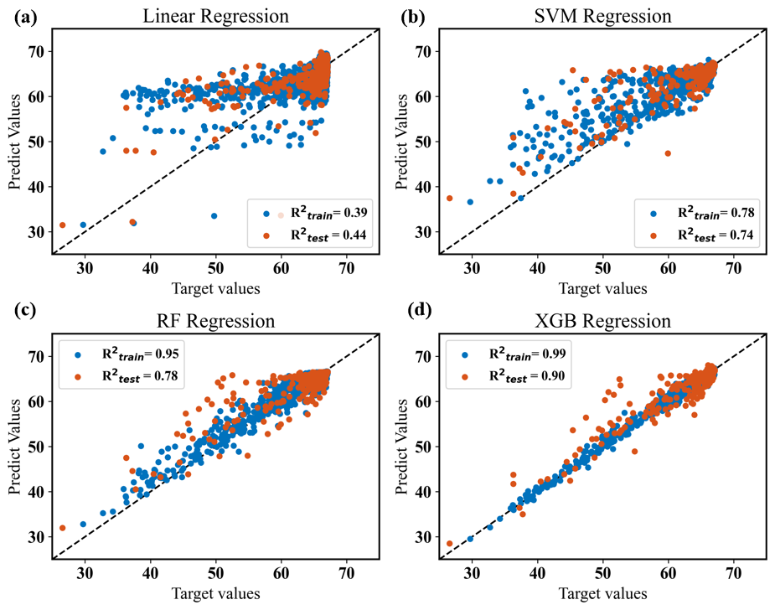
Fig. S5 Regression performance of different models
Table S3 Performance of different models
Model | Train |  |  |  | Test
Model | R² | RMSE | MAE | MAPE(%) | R² | RMSE | MAE | MAPE(%)
XGBoost | 0.9916 | 0.4101 | 0.2482 | 0.4001 | 0.8955 | 1.426 | 0.6063 | 1.045
Linear Regression | 0.3854 | 3.508 | 2.021 | 3.514 | 0.4393 | 3.304 | 1.995 | 3.369
SVM | 0.7836 | 2.081 | 0.6715 | 1.294 | 0.7361 | 2.267 | 0.8065 | 1.489
Random Forest | 0.9499 | 1.001 | 0.5269 | 0.8991 | 0.7794 | 2.072 | 0.91923 | 1.621

S3 Cost Model details
S3.1 Cost of equipment investment
The cost of equipment includes the cost of microreactor materials C_{C}, the cost of catalyst C_{cat}, and the cost of insulation materials C_{in}:
(S1)
The cost of microreactor materials can be calculated as:
(S2)
where C_{B} is the base cost of the same kind of equipment, Q_{C} and Q_{B} are the design capacity of the equipment and base equipment, respectively. M is a cost exponent of equipment, f_{M}, f_{P}, f_{T} are correction factors of material, pressure, and temperature, respectively. For reactors, the design capacity is the reactor volume or mass; for heat exchangers, the design capacity is the area of heat transfer. Q_{C} is calculated by:
(S3)
where ρ_{m} is the material density, V_{mc} is the material consumption. The parameters used in this work and the base cost and capacity of microreactor are shown in Table S18.
Table S4 Parameters used for reactor cost calculations
C_{B} | Q_{B} | M | f_{M} | f_{P} | f_{T}
2142 CNY | 1.6 kg | 0.82 | 3.4 | 1 | 2.1
The cost of insulation can be calculated by:
(S4)
where δ is the thickness of insulation layer, S is the heat dissipation area, and P_{i} is the price of insulation material per volume. The calculation of δ is based on GB/T8175, guide for design of thermal insulation of equipment and pipes:
(S5)

where A₁ is a constant, A₁ = 1.8975×10⁻³; f_{n} is the heating price, f_{n} = 4 CNY; t is the annual operating hours, t = 8000 h; T_{a} is the operation temperature, which can be taken as qualitative temperature; S is the annual apportionment rate of the loan for insulation project investment, taken as 0.2638, α surface heat dissipation coefficient is generally taken as 11.63 W/(m²·K); λ is the thermal conductivity of insulation material, P_{i} is its unit volume cost, aluminum silicate insulation cotton was selected, thermal conductivity of 0.035 W/(m·K), unit cost of 260 CNY.
The cost of Ni/Al₁₂O₁₉ catalyst is calculated according to the following formula, and the unit catalyst price p_{cat} is 1000 CNY/kg. For 2500 channels with about 30 g catalyst, the price is about:
(S6)
S3.2 Cost of reactor operation
The operation cost mainly comes from the energy consumption C_{op} (CNY/a) generated in fluid transportation, and the annual operation cost can be calculated as：
(S7)
where t is the annual operation time, taking 8000 h and p as the unit price, the industrial electricity price can take 0.5 CNY/kWh. P_{a} is the mechanical power of fluid transport installation, which can be calculated by:
(S8)
(S9)
(S10)
where η is the pumping efficiency, taken as 0.6; P_{e} is the pump power; g is gravitational acceleration; ρ and q_{v} are the density and volume flow rate of fluid; z₂ - z₁ is the height difference of the fluid, which is ignored in this work; P₂ - P₁ is the pressure drop; u₂ and u₁ are the velocities before and after the fluid enters the conveying equipment.

S3.3 Geometry of individual microreactor stacks
Table S5 Structural diagram of individual microreactor stacks
Single stack structure | Vertical view | Side view
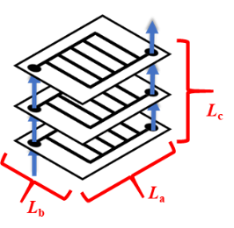 | 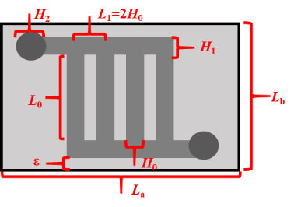 | 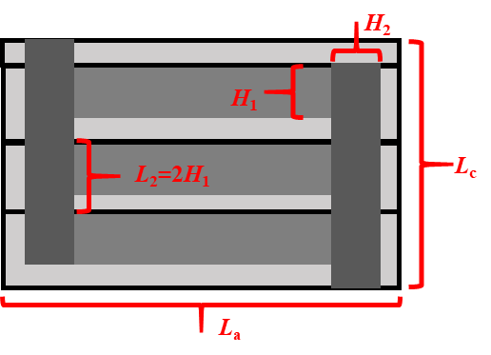

Table S6 Detailed parameters of individual microreactor stacks
Description | Symbol | Expression
Length of 1st-level distributor | L₁ | L₁ = 2H₀
Length of 2nd-level distributor | L₂ | L₂ = 2H₁
Length of stack | L_{a} | L_{a} = N₁L₁ + H₀ + 2H₂ + 2ε₁
Width of stack | L_{b} | L_{b} = L₀ + 2H₁ + 2ε₁
Thickness of stack | L_{c} | L_{c} = N₂L₂ + H₁
Heat dissipation area | S_{stack} | S_{stack} = 2(L_{a}L_{b} + L_{a}L_{c} + L_{b}L_{c})
Volume of reaction channel | V_{ch,0} | V_{ch,0} = H₀²L₀
Channel volume of 1st-level | V_{ch,1} | V_{ch,1} = N₁(V_{ch,0} + 2H₁²L₁)
Channel volume | V_{ch,stack} | V_{ch,stack} = N_{k}(V_{ch,1} + 2πH_{k}²L_{k}/4)
Envelop volume | V_{en,stack} | V_{en,stack} = L_{a}L_{b}L_{c}
Material consumption volume | V_{mc,stack} | V_{mc,stack} = V_{en,stack} – V_{ch,stack}
Necessary margin on the plate | ε₁ | ε₁ = 0.02 m

S3.4 Geometry of microreactor stack arrays
Table S7 Structural diagram of microreactor stack arrays
Structure | Diagram
Overall schematic structure (5th-level) | 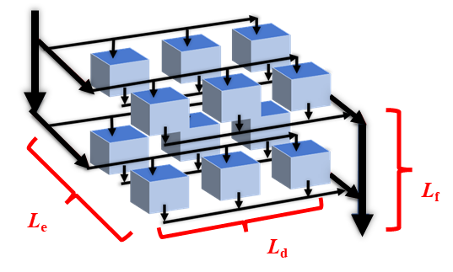  3D view
Z-type parallel connection | 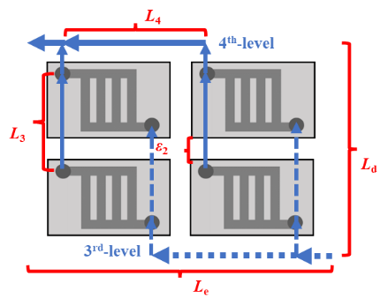  Vertical view | 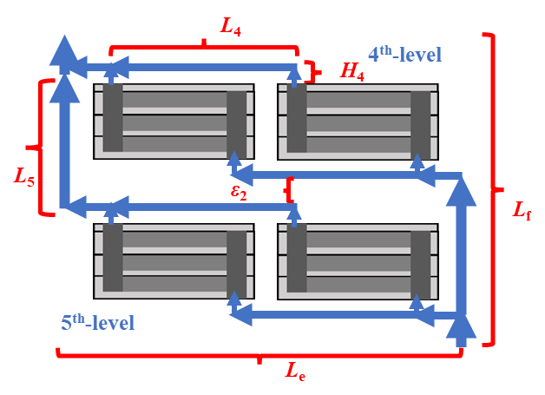  Side view
U-type parallel connection | 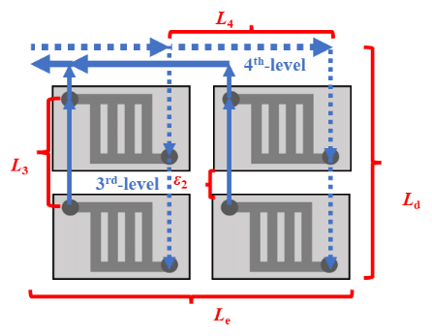  Vertical view | 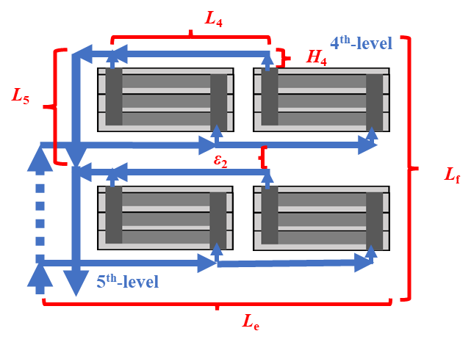  Side view
Series connection | 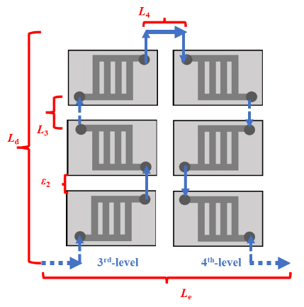  Vertical view | 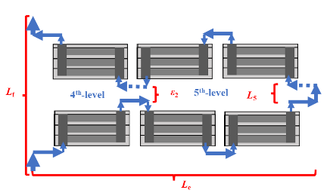  Side view

Table S8 Detailed parameters of microreactor stack arrays
Description | Symbol | Expression
Z-type parallel connection structure
Length of 3rd-level distributor | L₃ | L₃ = min (L_{a} + ε₂, L_{b} + ε₂)
Length of 4th-level distributor | L₄ | L₄ = max (L_{a} + ε₂, L_{b} + ε₂)
Length of 5th-level distributor | L₅ | L₅ = L_{c} + 2H₄ + ε₂
Length of stacks | L_{d} | L_{d} = N₃L₃ + ε₂
Width of stacks | L_{e} | L_{e} = N₄L₄ + ε₂
Thickness of stacks | L_{f} | L_{f} = N₅L₅ + ε₂
Channel volume | V_{ch,k} | V_{ch,k} = N_{k}(V_{ch,k-1} + 2πH_{k}²L_{k}/4)
Connection tube material consumption | V_{tube,k} | V_{tube,k} = 2L_{k}N_{k}π(H_{k,out}² − H_{k}²)/4
U-type parallel connection structure
Length of 3rd-level distributor | L₃ | L₃ = min (L_{a} + ε₂, L_{b} + ε₂)
Length of 4th-level distributor | L₄ | L₄ = max (L_{a} + ε₂, L_{b} + ε₂)
Length of 5th-level distributor | L₅ | L₅ = L_{c} + 2H₄ + ε₂
Length of stacks | L_{d} | L_{d} = N₃L₃
Width of stacks | L_{e} | L_{e} = N₄L₄
Thickness of stacks | L_{f} | L_{f} = N₅L₅
Channel volume | V_{ch,k} | V_{ch,k} = N_{k}(V_{ch,k-1} + 2πH_{k}²L_{k}/4)
Connection tube material consumption | V_{tube,k} | V_{tube,k} = 2L_{k}N_{k}π(H_{k,out}² − H_{k}²)/4
Series connection structure
Length of 3rd-level distributor | L₃ | L₃ = ε₂ + 2ε₁
Length of 4th-level distributor | L₄ | L₄ = ε₂ + 2ε₁
Length of 5th-level distributor | L₅ | L₅ = 2H₄ + ε₂
Length of stacks | L_{d} | L_{d} = min (L_{a} + ε₂, L_{b} + ε₂) N₃ + ε₂
Width of stacks | L_{e} | L_{e} = max (L_{a} + ε₂, L_{b} + ε₂) N₄ + ε₂
Thickness of stacks | L_{f} | L_{f} = (L_{c} + 2H₄ + ε₂) N₅ + ε₂
Channel volume | V_{ch,k} | V_{ch,k} = N_{k}(V_{ch,k-1} + πH_{k}²L_{k}/4)
Connection tube material consumption | V_{tube,k} | V_{tube,k} = L_{k}N_{k}π(H_{k,out}² − H_{k}²)/4
All structure
Heat dissipation area | S | S = N₃N₄N₅S_{stack}
Envelop volume | V_{en} | V_{en} = L_{d}L_{e}L_{f}
Material consumption volume | V_{mc} | V_{mc} = V_{mc,tube} + N₃N₄N₅V_{mc,stack}
Margin between stacks | ε₂ | ε₂ = 0.25 m
Wall thickness of connection tubes | d_{tube} | d_{tube} = 0.002 m

S4 Supplementary results
Table S9 Optimal architectural patterns for N_{t} = 2500 and σ = 0.
Clustering result | Performance features for different module architectures
N_{t} = 2500, σ= 0  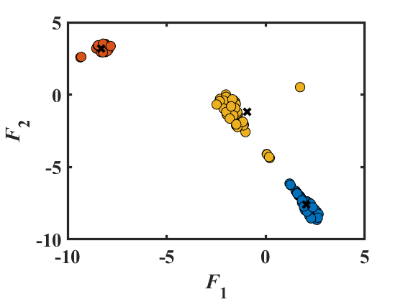 | 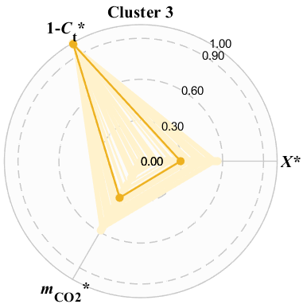 | 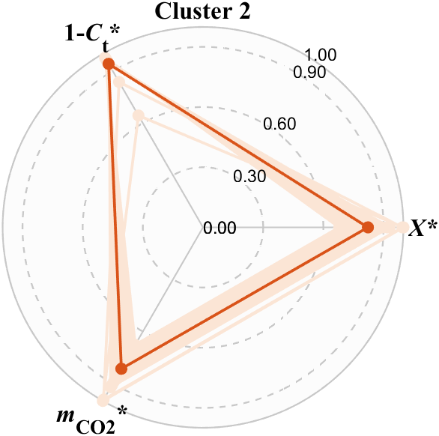 | 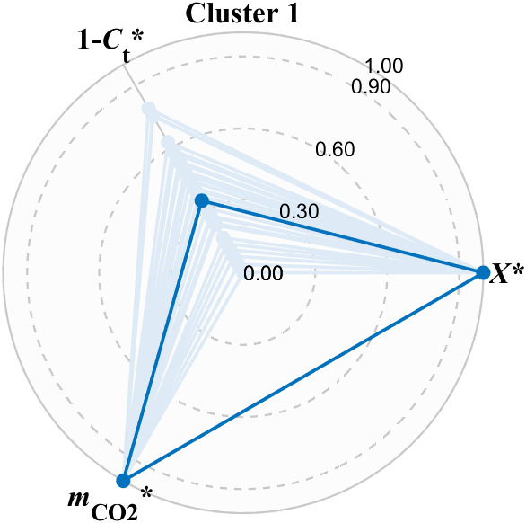
 | Small-sized single-stack reactors | Small-sized few-stack parallel modules | Large-sized single-stack reactors

Table S10 Optimal architectural patterns for N_{t} = 5000 and σ = 0.
Clustering result | Performance features for different module architectures
N_{t} = 5000, σ = 0 | 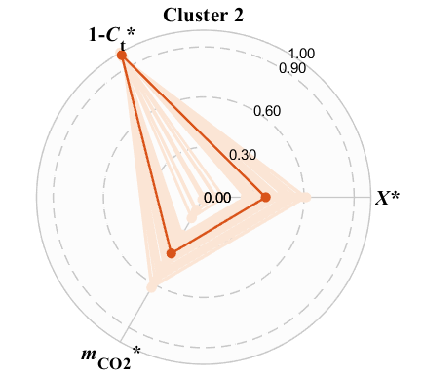 | 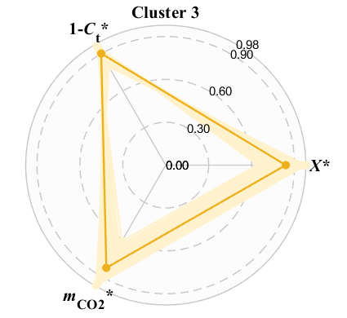
 | Small-sized single-stack reactors | Small-sized few-stack parallel modules
 | 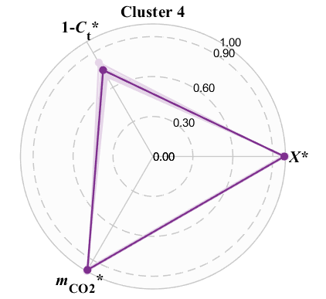 | 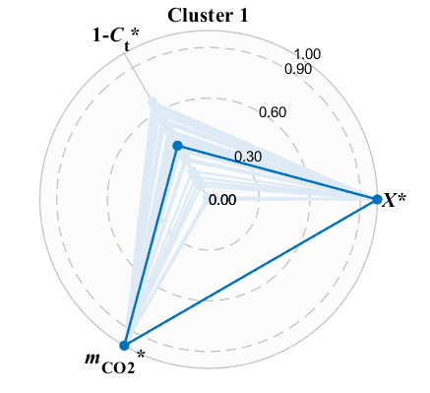
 | Large-sized single-stack reactors | Large-sized few-stack parallel modules

Table S11 Optimal architectural patterns for N_{t} = 5000 and σ = 0.48
Clustering result | Performance features for different module architectures
N_{t} = 5000, σ= 0.48  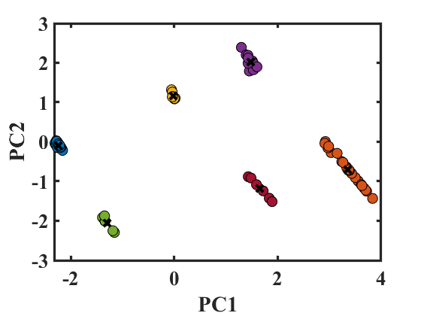 | 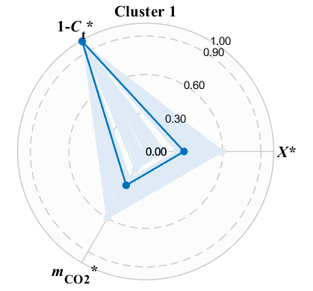 | 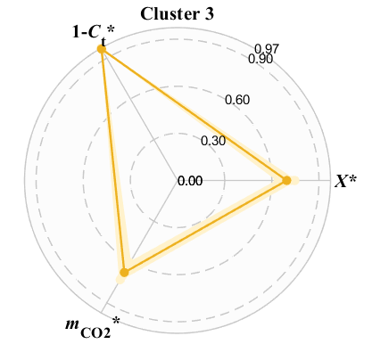 | 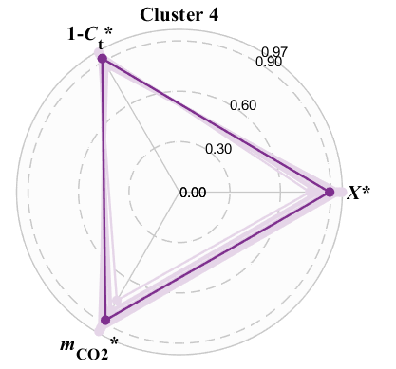
 | Small-sized single-stack reactors | Small-sized few-stack parallel modules | Small-sized multi-stack parallel modules
 | 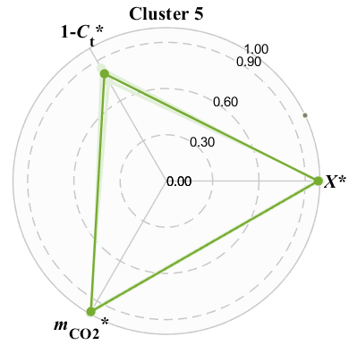 | 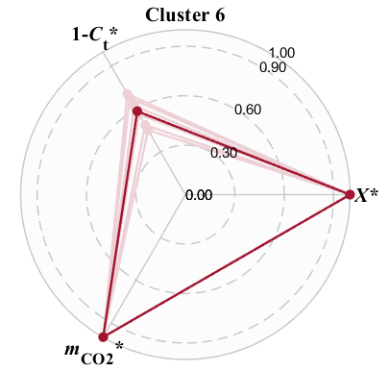 | 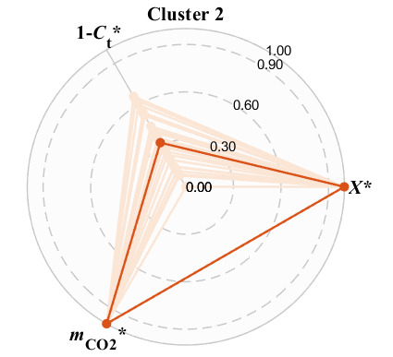
 | Large-sized single-stack reactors | Large-sized few-stack parallel modules | Large-sized multi-stack parallel modules

