Electronic Supplementary Material
Coordination crosslinking engineering of alkynyl-based polyimide membranes for H₂/CO₂ separation
Bingbing Gao¹, Qi Zhang¹, Wei Zhang¹, Yunxiang Bai¹, Chunfang Zhang¹, Yang Liu², Lijun Liang³, Liangliang Dong ()¹

1 Key Laboratory of Synthetic and Biological Colloids, Ministry of Education, School of Chemical and Material Engineering, Jiangnan University, Wuxi 214122, China
2 Key Laboratory of Bio-based Materials Science & Technology, Ministry of Education, College of Material Science and Engineering, Northeast Forestry University, Harbin 150040, China
3 College of Automation, Hangzhou Dianzi University, Hangzhou 310018, China
E-mail: liangliangdong@jiangnan.edu.cn

Text S1 Analytical techniques
Attenuated total reflection Fourier-transform infrared spectroscopy (ATR-FTIR) (TENSOR II, Bruker, Germany) was used to analyze the characteristic functional groups on the membrane surface. The elemental composition of the membrane surface was determined by X-ray photoelectron spectroscopy (XPS) (ESCALAB 250Xi, Thermo Fisher, England). Scanning electron microscopy (SEM) (S-4800, Hitachi, Japan) was employed to characterize the surface morphology of the membranes. The molecular weights of the polymers were determined using gel permeation chromatography coupled with multi-angle laser light scattering (GPC-MALLS) (DAWN HELEOS II System). Dimethylformamide served as the mobile phase at a flow rate of 1 mL/min. X-ray diffraction (XRD) (Bruker D8-Advance) was employed to determine the crystal structures and intermolecular distances between polymer chains. The gas composition of the permeate was determined using gas chromatography (FULI INSTRUMENTS GC9790Plus). Contact angles were measured through a contact angle measuring instrument (OCA 40, Peking Defei technic apparatus co. ltd). Water droplets (1.5 μL) were dropped on the surface of the EBPA-TB-CN and EBPA-TB-COOH membranes for determining contact angles. Nuclear Magnetic Resonance (NMR) spectroscopy was performed on a Bruker AV400 spectrometer using dimethyl sulfoxide-d₆ (DMSO-d₆) as the solvent to investigate the sample structures. The fractional free volume (FFV) (vol%), an important structural parameter used to determine gas diffusion in the membrane based on the Cohen-Turnbull model [1], is estimated by the following equation:
$FFV=13V_{}$ (S1)
The FFV represents the fractional free volume of the membranes, while V_{w}​ (cm³/g) denotes the van der Waals volume, calculated using Bondi's group contribution method [2]. The density, ρ (g/cm³), of the pure membrane and its corresponding MMMs was determined at 25 °C using a specific pycnometer, and calculated using the following equation:
$=\frac{m_{a}{}_{0}}{m_{b}m_{a}m_{c}}$ (S2)
where m_{a}​ is the mass of the membrane sample (g), m_{b}​ is the mass of the specific gravity bottle filled with n-heptane (g), m_{c​} is the total mass of the specific gravity bottle containing both n-heptane and the membrane sample (g), and ρ₀​ is the density of n-heptane (g/cm³) [3].

Text S2 DFT calculation
Calculations in this study were performed using the PBE0 method, with the cc-pVTZ basis set for H atoms and the LanL2DZ basis set for Pd²⁺. The observed orbital interaction primarily stems from the coupling between the H σ-bonding orbital and the metal d-orbital, with the H σ-bonding orbital contributing more significantly to the resulting molecular orbital.

Text S3 Gas permeation test
Pure gas permeation tests were performed using an automated, pressure-variable/volume-constant permeation system (Maxwell Robotics, USA). Gas permeability for H₂ and CO₂ was evaluated at 25°C using a constant-pressure/variable-volume method. A circular membrane sample with a constant effective area of 9.07 cm² was used for each experiment. The maximum operating pressure was 6 bar. Permeability was calculated based on the solution-diffusion model using the following equation:
$P=\frac{F}{A*P/L}$ (S3)
where F is the flux (cm³(STP)/min), L is the membrane thickness (cm), A is the effective membrane area (cm²), ΔP is the pressure differential between the feed and permeate, and P is the permeability (Barrer) [3]. (1 Barrer = 10⁻¹⁰ [cm³(STP) cm]/(cm²scmHg)). Furthermore, the solubility coefficients of each gas permeating through the membranes were ascertained using the time-lag method, detailed in Equation [3-4]:
$S=\frac{C}{P}$ (S4)
where S is the solubility coefficients, C is the concentration of gas adsorbed in the prepared membranes, and P is the operating pressure.
The diffusion coefficient (D) was indirectly determined using the following equation: $D=\frac{P}{S}$ (S5)
For the mixed-gas separation test, a binary mixture of 50% H₂ and 50% CO₂ served as the feed gas, with argon as the sweep gas. A transmembrane pressure of 0.1-0.6 MPa was maintained. The permeate gas composition was analyzed by gas chromatography, and the mixed-gas selectivity was calculated accordingly. Permeate gas composition was analyzed using a gas chromatograph (FULI INSTRUMENTS GC9790Plus) equipped with a thermal conductivity detector. Mixture gas selectivity was calculated accordingly, and permeability (P_{i}) was defined as follows [5]:
$P_{i}={10}^{10}\frac{y_{i}}{x_{i}}\frac{V_{p}l}{P_{up}TRA}\frac{dp}{dt}$ (S6)
where x_{i} is the feed ratio of component i, y_{i} is the concentration of component i in the permeate gas, P_{up}​ is the upstream feed gas pressure, V_{p}​ is the membrane module volume, l is the membrane thickness, and dp/dt is the rate of pressure increase at steady state (cmHg s⁻¹).
The separation factor (α) quantifies the ability of membrane to separate a binary gas mixture and is defined as follows [6]:
${}_{/B}=\frac{P_{A}}{P_{B}}=\frac{D_{A}S_{B}}{D_{B}S_{A}}$ (S7)
where P_{A} and P_{B} are the permeability of gas A and gas B, respectively.

Text S4 Gas adsorption performance
The gas adsorption performance of EBPA-TB-COOH and EBPA-TB-COOH@Pd²⁺-6 membranes is a crucial indicator for comprehensively evaluating membrane material properties. The static volumetric method measured the gas adsorption performance of the samples. A high-pressure adsorption analyzer (HPA-100) was used to measure the H₂ and CO₂ adsorption of the membrane samples at 25 ℃ within a test range of 0-0.3 MPa.
Gas sorption (C’_{A}) in EBPA-TB-COOH@Pd²⁺ membranes can be described using the dual-mode sorption model as expressed using Equation S8:
$C_{A}= k_{D}P_{A}+ \frac{{C'}_{H}bP_{A}}{1 + bP_{A}}$ (S8)
where k_{D} is Henry’s constant, Cˊ_{H} is Langmuir sorption capacity, and b is the affinity parameter.

Text S5 long-term of the stability EBPA-TB-COOH@Pd²⁺-6 Membranes
A continuous 360-hour stability test was performed on the EBPA-TB-COOH@Pd²⁺-6 membranes under simulated real-world conditions. CO₂ and H₂ feed gases were supplied at total pressures ranging from 2 to 6 bar to accurately replicate the operational stresses present in industrial applications. This high-pressure regimen facilitated a robust and comprehensive evaluation of the gas separation performance.

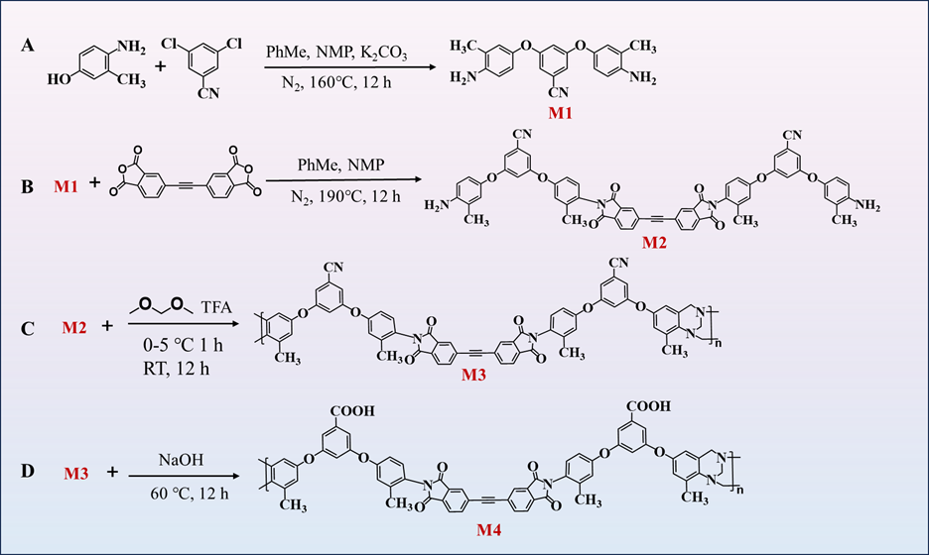
Fig. S1. The synthesis of EBPA-TB-COOH polymer.

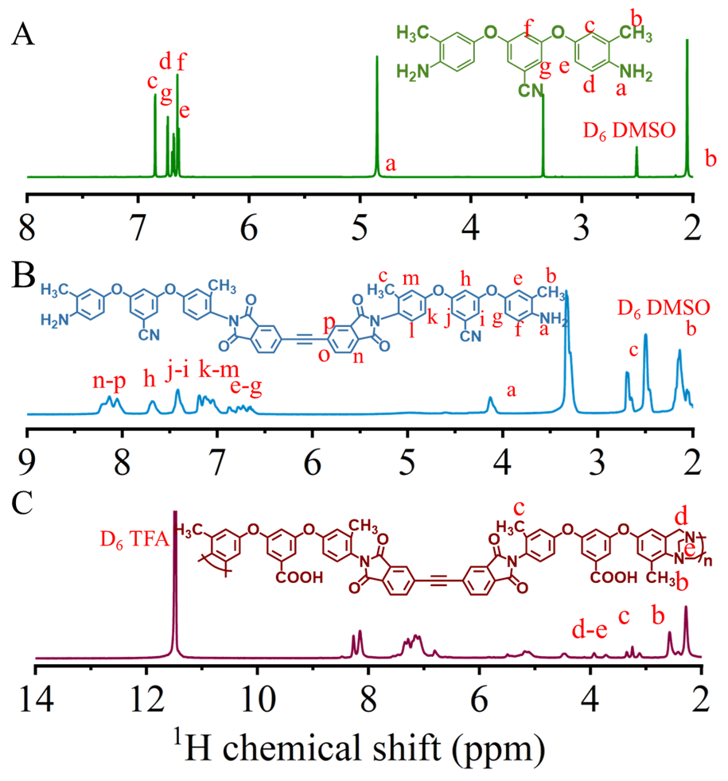
Fig. S2. ¹H NMR spectra (in DMSO-D₆ and TFA-D₆) of monomer and EBPA-TB-COOH polymer.
Fig. S2. shows the ¹H NMR spectra of 3,5-bis(4-amino-3-methylphenoxy) benzonitrile (A), the intermediate EBPA-TB-COOH (B), and the EBPA-TB-COOH polymer (C). In Fig. S2C, the proton peak at 11.5 ppm, assigned to a -COOH, may overlap with the solvent peak. Single peaks observed between 4.0 and 5.0 ppm confirm the presence of TB units, while aromatic proton signals appear between 7.1 and 8.5 ppm.

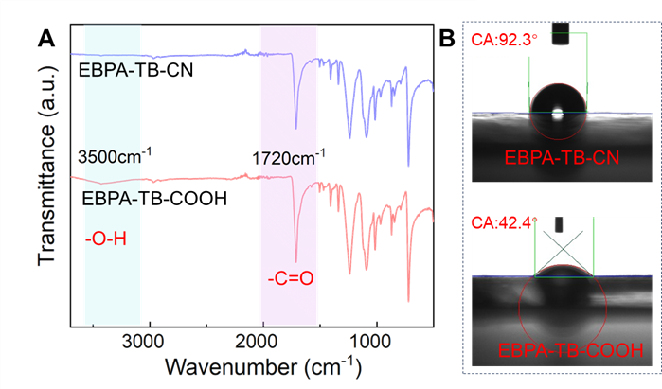
Fig. S3. (A) ATR-FTIR spectra and (B) contact angle of EBPA-TB-CN and EBPA-TB-COOH membranes.
Before the coordination reaction, ATR-FTIR and contact angle analyses were employed to investigate the membrane surface properties (Fig. S3). To demonstrate the necessity of carboxyl groups as coordinating ligands, we prepared both EBPA-TB-CN and EBPA-TB-COOH membranes. As shown in Fig. S3A, a distinctive -COOH peak appears at 3500 cm⁻¹ relative to EBPA-TB-CN, indicating the successful completion of carboxylation. As depicted in Fig. S3B, hydrolysis changes the surfaces of membrane from hydrophobic to hydrophilic, decreasing the water contact angle from 92.3° to 42.4°. This enhanced hydrophilicity provides a crucial foundation for the subsequent coordination reaction between Pd²⁺ and the -COOH.

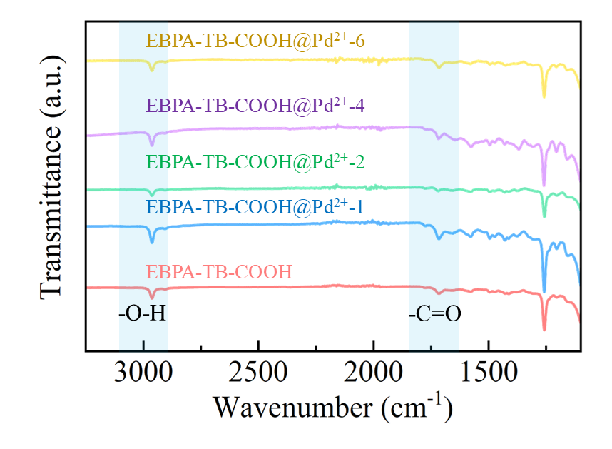
Fig. S4. ATR-FTIR spectra of the EBPA-TB-COOH@Pd²⁺ membranes.

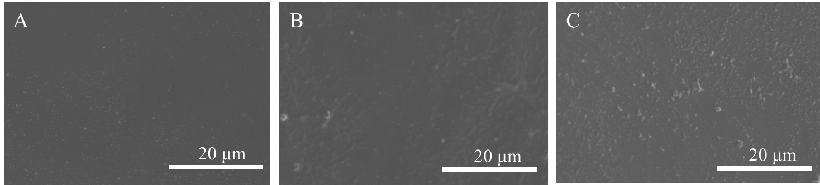
Fig. S5. Surface SEM images of (A) EBPA-TB-COOH@Pd²⁺-1, (B) EBPA-TB-COOH@Pd²⁺-2, (C) EBPA-TB-COOH@Pd²⁺-4 membranes.

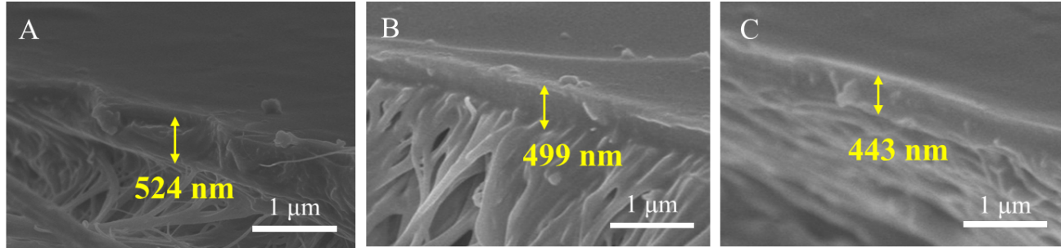
Fig. S6. Cross-sectional SEM images of (A) EBPA-TB-COOH@Pd²⁺-1, (B) EBPA-TB-COOH@Pd²⁺-2, (C) EBPA-TB-COOH@Pd²⁺-4 membranes.
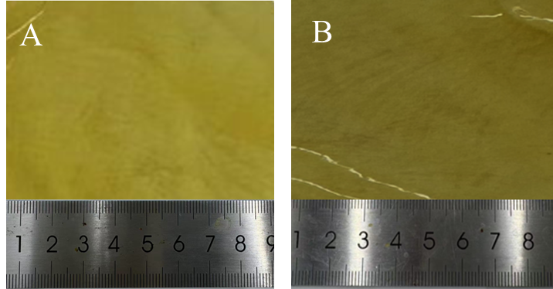
Fig. S7. Optical photos of the free-standing (A) EBPA-TB-COOH and (B) EBPA-TB-COOH@Pd²⁺-6 membranes
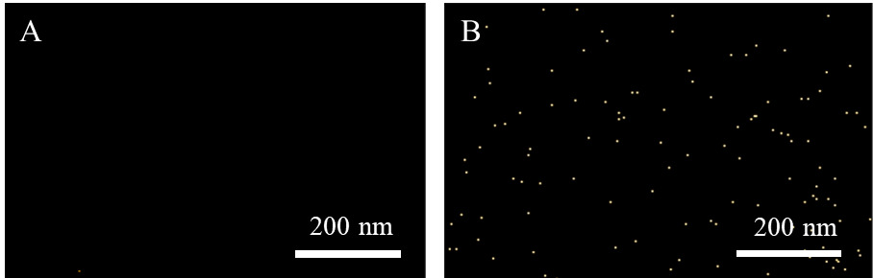
Fig. S8. Cross-sectional EDS mapping of Pd²⁺ distribution on (A) EBPA-TB-COOH and (B) EBPA-TB-COOH@Pd²⁺-6 membranes.
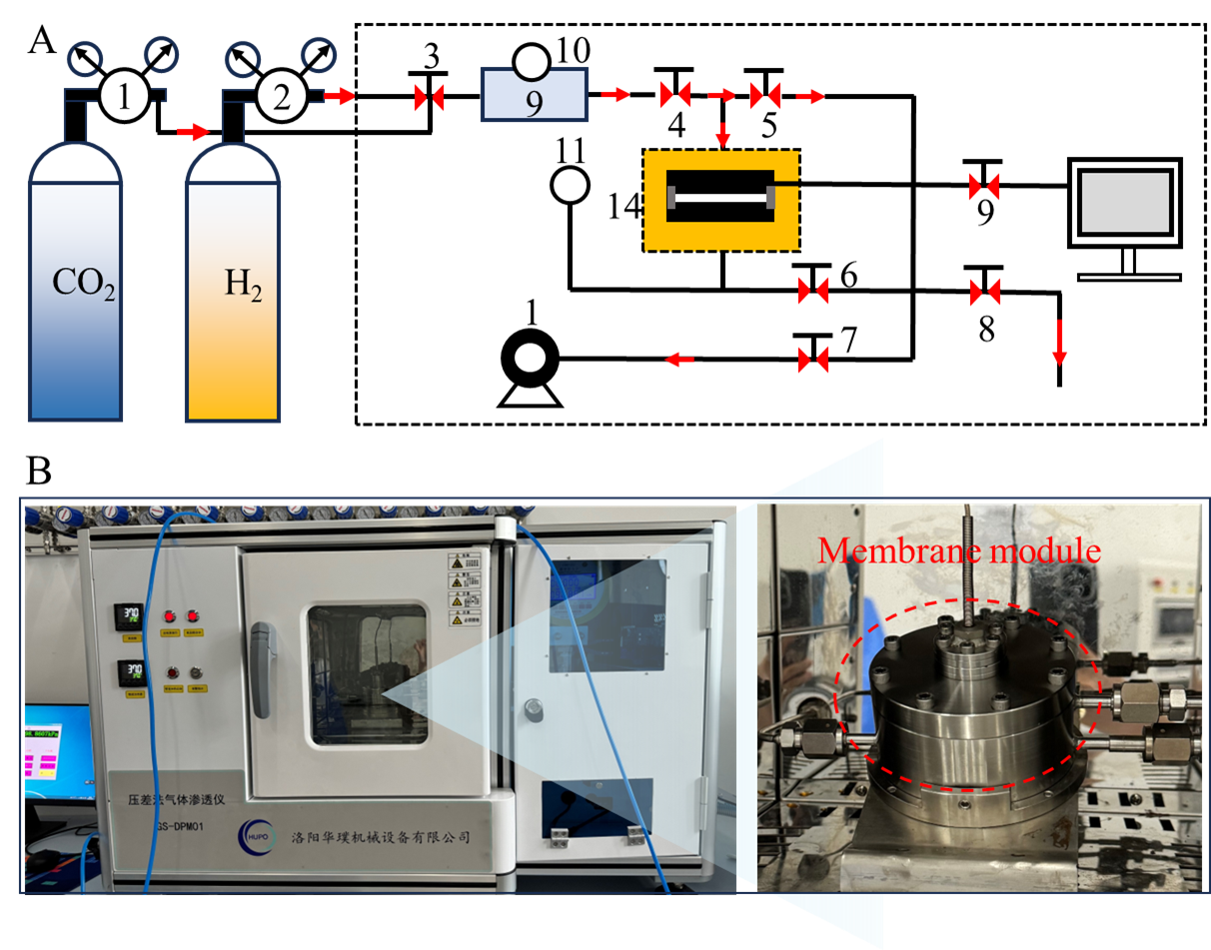
Fig. S9. (A) Schematic illustration of the gas permeability experimental apparatus. (B) Differential pressure permeation analyzer (1-2) Pressure gauge, (3-9) valve, (10) buffer tank, (11) pressure gauge, (12) computer, (13) pump, (14) membrane module, and (15) temperature control.
Fig. S9 shows the gas permeation apparatus used to measure the permeability of individual and mixed gases through the membranes. A vacuum was established in the system, valve 4 was opened, and all others remained closed. Each experiment, lasting 1 h, involved the introduction of a feed gas at 1 bar of the upstream volume. For the mixed-gas experiments, all valves except valve 8 were opened, and the permeate side was swept with argon to maintain a transmembrane pressure of 1 bar. This procedure was repeated at least thrice for each membrane.
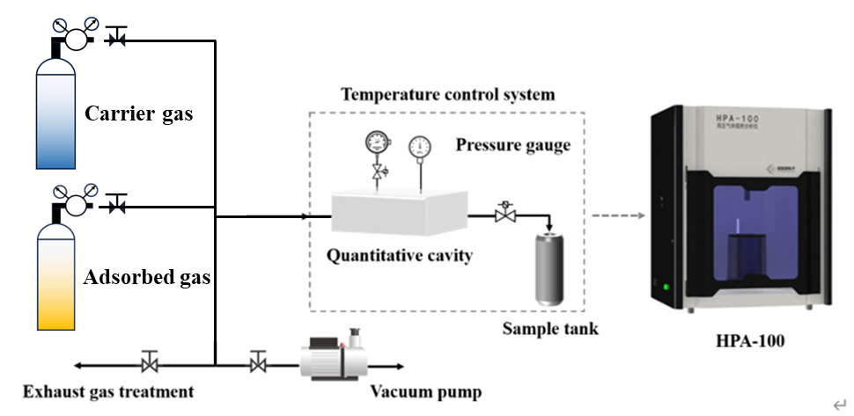
Fig. S10. Gas adsorption performance testing device
Fig.S10 shows a schematic diagram of the gas adsorption test setup for the membrane samples. The specific operating procedures are as follows: First, load the prepared membrane sample into the sample tube, secure a sealing ring around the tube opening, and install it into the analysis port. Then, rotate and secure the external constant temperature bath. Set the temperature of the low-temperature thermostat to the desired experimental temperature and turn on the circulating pump, allowing the temperature to stabilize. Subsequently, activate the gas adsorption analyzer and turn on the vacuum pump to degas the membrane sample under vacuum for 4 h. Open the gas cylinders and then open the valves for the carrier gases (N₂, He), and adsorption gases (CO₂, H₂), adjusting their output pressures to 0.5 MPa. Note that He is used to determine the dead volume of the sample tube. Finally, set the termination pressure to 0.3 MPa, the progressive pressure to 0.03 MPa, and the equilibrium time to 300 seconds. It is important to note that each sample can only be tested with one gas.

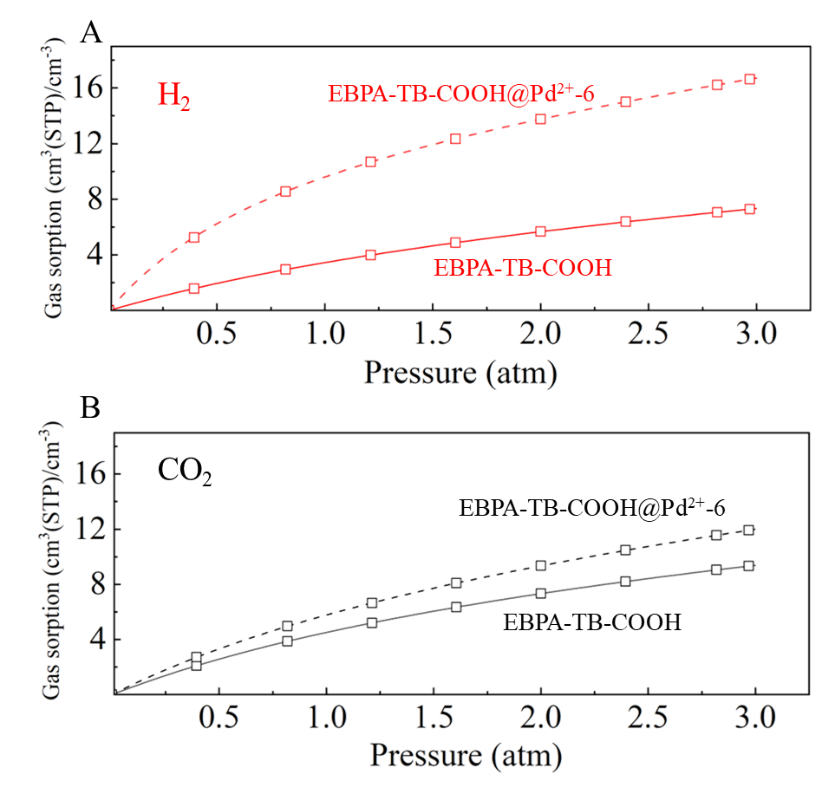
Fig. S11. H₂ and CO₂ sorption isotherms of EBPA-TB-COOH and EBPA-TB-COOH@Pd²⁺-6 membranes.
Fig. S11 illustrates the H₂ and CO₂ sorption isotherms for the EBPA-TB-COOH membranes at 25°C. The observed isotherms are well-described by the dual-mode sorption model. Upon incorporating Pd²⁺ into EBPA-TB-COOH, a slight increase in CO₂ adsorption was observed, while H₂ adsorption significantly improved. This resulted in a significant improvement in the solubility selectivity of H₂/CO₂. Table S4 presents the fitted parameter values for EBPA-TB-COOH@Pd²⁺. Notably, the incorporation of Pd²⁺ leads to a significant enhancement in the Langmuir sorption capacity, particularly for H₂ [7]. Compared to EBPA-TB-COOH membranes, the EBPA-TB-COOH@Pd²⁺-6 membrane exhibited the higher C′_{H} values of H₂ and CO₂.

Table S1. Molecular weights of EBPA-TB-COOH polymer
Samples | Mn (g/mol) | Mw (g/mol) | PDI
EBPA-TB-COOH | 1.87×10⁴ | 2.16×10⁴ | 1.30

Table S2. XRD data of the EBPA-TB-COOH@Pd²⁺ membranes
Membranes | 2θ (deg.) | d-spacing (Å) | 2θ (deg.) | d-spacing (Å)
EBPA-TB-COOH | 15.55 | 5.69 | 22.39 | 3.97
EBPA-TB-COOH@Pd²⁺-1 | 15.74 | 5.63 | 22.67 | 3.94
EBPA-TB-COOH@Pd²⁺-2 | 15.94 | 5.56 | 22.88 | 3.89
EBPA-TB-COOH@Pd²⁺-4 | 16.03 | 5.52 | 22.95 | 3.88
EBPA-TB-COOH@Pd²⁺-6 | 16.19 | 5.47 | 23.04 | 3.86

Table S3. Density and FFV of the EBPA-TB-COOH@Pd²⁺ membranes
Membranes | ρ (g/cm³) | FFV (vol%)
EBPA-TB-COOH | 0.84 | 0.41
EBPA-TB-COOH@Pd²⁺-1 | 0.90 | 0.37
EBPA-TB-COOH@Pd²⁺-2 | 0.92 | 0.36
EBPA-TB-COOH@Pd²⁺-4 | 0.94 | 0.34
EBPA-TB-COOH@Pd²⁺-6 | 0.98 | 0.32

Table S4. Parameters of the dual-mode sorption model for H₂ and CO₂ sorption in EBPA-TB-COOH@Pd²⁺ membranes at 25 °C. The units for k_{D}, b, and 𝐶′_{𝐻} are cm³(STP) cm⁻³·atm⁻¹, atm⁻¹, and cm³(STP)cm⁻³, respectively.
Membranes | H₂ |  |  |  | CO₂
Membranes | k_{D} | b | Cˊ_{H} |  | k_{D} | b | Cˊ_{H}
EBPA-TB-COOH | 0.70 | 0.40 | 9.60 |  | 0.74 | 0.41 | 12.98
EBPA-TB-COOH@Pd²⁺-6 | 1.85 | 1.18 | 14.32 |  | 1.22 | 0.47 | 14.25

Table S5. Comparison of the H₂/CO₂ separation performance of EBPA-TB-COOH@Pd²⁺ membranes with polymeric membranes reported in the literature.
Membrane | Test conditions | P_{(H2)} (Barrer) | α (H₂/CO₂) | Ref.
PBI | 35°C | 27.0 | 14.0 | 8
HCB-PI | 35°C | 30.3 | 2.2 | 9
TBDA-HTB | 35°C | 161.8 | 2.3 | 10
PIM-PI-1 | 35°C | 529.6 | 0.5 | 11
6FDA-TMPD | 35°C | 548.8 | 1.2 | 12
6FDA-IPD | 35°C | 35.0 | 9.2 | 12
PBI-2 | 35°C | 2.0 | 12.0 | 13
XLPBI-6H | 35°C | 0.9 | 22.0 | 14
FPI | 35°C | 89.6 | 2.1 | 15
6FDA-BAP:DAT | 35°C | 336.8 | 1.3 | 16
PDA | 30°C | 16.6 | 23.4 | 17
M-TB-OR | 35°C | 22.4 | 5.1 | 18
6FDA-TFMB/DABA | 35°C | 174.1 | 1.3 | 19
6FDA-DAM_{0.7}-TFMB_{0.1}-DCB_{0.2} | 35°C | 65.1 | 1.3 | 20
EBPA-TB-COOH | 886.4 | 521.2 | 1.7 | This work
EBPA-TB-COOH@Pd²⁺-1 | 711.6 | 70.5 | 10.1 | This work
EBPA-TB-COOH@Pd²⁺-2 | 619.1 | 57.9 | 11.8 | This work
EBPA-TB-COOH@Pd²⁺-4 | 542.1 | 23.8 | 22.8 | This work
EBPA-TB-COOH@Pd²⁺-6 | 512.5 | 16.8 | 30.4 | This work
Reference
- M.H. Cohen, D. Turnbull, Molecular transport in liquids and glasses, The Journal of Chemical Physics, 1959,31: 1164-1169.
- A. Bondi, Van der Waals volumes and radii, The Journal of Chemical Physics, 1964, 68: 441-451.
- Dong L L, Zhang W H, Qu Z, Wan C, Yao Z, Xu J B, Kang X T, Bai Y X, Zhang C F. Cardo-type porous organic nanospheres: Tailoring interfacial compatibility in thermally rearranged mixed matrix membranes for improved hydrogen purification. Journal of Membrane Science, 2020, 612: 118414.
- Dong L L, Zhang C F, Bai Y X, Shi D J, Li X J, Zhang H J, Chen M Q, High-Performance PEBA2533-Functional MMT Mixed Matrix Membrane Containing High-Speed Facilitated Transport Channels for CO₂/N₂ Separation, ACS Sustainable Chemistry & Engineering,2016, 4(6): 3486-3496.
- Dong L L, Chen M Q, Li J, Shi D J, Dong W F, Li X J, Bai Y X, Metal-organic framework-graphene oxide composites: A facile method to highly improve the CO₂ separation performance of mixed matrix membranes, Journal of Membrane Science,2016, 520: 801-811.
- Hu LQ, Lee WI, Chen K, Roy S, Fung K, Kisslinger K, Deng E, Ding Y F, Ajayan P M, Nam C Y, Lin H Q. Atomically Fine-Tuning Organic-Inorganic Carbon Molecular Sieve Membranes for Hydrogen Production. ACS NANO, 2025, 19(4): 4663-4671.
- Li P R, Xiao G Y, Hou M J, Lu Y H, Li L, Wang T H. Boosted gas separation performances of polyimide and thermally rearranged membranes by Fe-doping. Chemical Engineering Journal, 2024, 499: 156108.
- Zhu L X, Swihart M T, Lin H Q. Tightening polybenzimidazole (PBI) nanostructure via chemical cross-linking for membrane H₂/CO₂ separation. Journal of Materials Chemistry A, 2017, 5(37): 19914-19923.
9. Xiao Y Y, Lei X F, Zhang Z X, Chen S Y, Xiong G, Ma X H, Zhang Q Y. Carbazole-Based Polyimide Membranes with Hydrogen-Bonding Interactions for Gas Separation. Macromolecules, 2024, 57(12): 5941-5957.
10. Abdulhamid M A. Troöger’s base-derived dianhydride as a promising contorted building block for polyimide-based membranes for gas separation. Separation and Purification Technology, 2023, 310: 123208.
11. Ghanem B S, McKeown N B, Budd P M, Selbie J D, Fritsch D. High-performance membranes from polyimides with intrinsic microporosity. Advanced Materials, 2008, 20(14): 2766.
12. Tanaka K, Okano M, Toshino H, Kita H, Okamoto K I. Effect of methyl substituents on permeability and permselectivity of gases in polyimides prepared from methyl-substituted phenylenediamines. Journal of Polymer Science Part B-Polymer Physics, 1992, 30(8): 907-914.
13. Pal N, Agarwal M. Performance evaluation of biopolymer mixed matrix membrane for CO₂/H₂ separation. International Journal of Hydrogen Energy, 2023, 48(96): 37762-37773.
14. Swaidan R, Al-Saeedi M, Ghanem B, Litwiller E, Pinnau I. Rational Design of Intrinsically Ultramicroporous Polyimides Containing Bridgehead-Substituted Triptycene for Highly Selective and Permeable Gas Separation Membranes. Macromolecules, 2014, 47(15): 5104-5114.
15. Lu Z Y, Jian L F, Zhang J Y, Du Q Y, Yuan Z F, Tan W Y, Min Y G. Intrinsically Microporous Polyimides Based on a Rigid-Soft Structure for Hydrogen Separation. Acs Applied Materials & Interfaces, 2025, 17(6): 9786-9796.
16. Wang S Y, Zhang J F, Sun Y C, Fan F X, Zhao Q Z, He G H, Ma C H. Thermally rearranged polyimide membranes incorporating triptycenes for improved CO₂ capture and hydrogen separation. Separation and Purification Technology, 2025, 364: 132302.
17. Low B T, Xiao Y C, Chung T S, Liu Y. Simultaneous occurrence of chemical grafting, cross-linking, and etching on the surface of polyimide membranes and their impact on H₂/CO₂ separation. Macromolecules, 2008, 41(4): 1297-1309.
18. Wu L, Chen X L, Zhang Z G, Xu S, Ma C H, Li N W. Enhanced molecular selectivity and plasticization resistance in ring-opened Tröger’s base polymer membranes. Journal of Membrane Science, 2021, 634: 119399.
19. Zhang Z G, Ren X L, Huo G L, Kang S Y, Wang Z G, Li N W. Tuning interchain cavity of fluorinated polyimide by DABA for improved gas separation performance. Journal of Membrane Science, 2023, 675: 121485.
20. Wang C, Cai Z L, Xie W, Jiao Y, Liu L, Gong L L, Zhang Q W, Ma X H, Zhang H J, Luo S J. Finely tuning the microporosity in dual thermally crosslinked polyimide membranes for plasticization resistance gas separations. Journal of Membrane Science, 2022, 659: 120769.

