Electronic Supplementary Material

Controllable synthesis and characterization of spherical CeO₂ abrasives for chemical mechanical polishing

Chao Fang¹*, Guanghui Shi^{2,3}*, Sibin Li¹, Xiaofeng Xie¹, Chenghao Liu^{1,4}, Zhi Qi^{1,4}, Peiyu Zhang⁵, Geng Li⁶, Tao Qi^{1,4}, Xiao Wang ()^{2,7}, Guoping Hu ()^{1,4}

¹ Key Laboratory of Rare Earths, Ganjiang Innovation Academy, Chinese Academy of Sciences, Ganzhou 341119, China
² Suzhou Laboratory, Suzhou 215000, China
³ School of Physics, Southeast University, Nanjing 211189, China
⁴ School of Rare Earths, University of Science and Technology of China, Hefei 230026, China
⁵ School of Chemistry and Chemical Engineering, Shandong University, Jinan 250100, China
⁶ China Rare Earth Group Research Institute, Shenzhen 518000, China
⁷ Institute of Technology for Carbon Neutrality, Shenzhen Institutes of Advanced Technology, Chinese Academy of Sciences, Shenzhen 518055, China

E-mails: gphu@gia.cas.cn (Hu G);
* These authors contributed equally to this work.

Figure S1. Mass spectrum of the gas sample collected from autoclave.

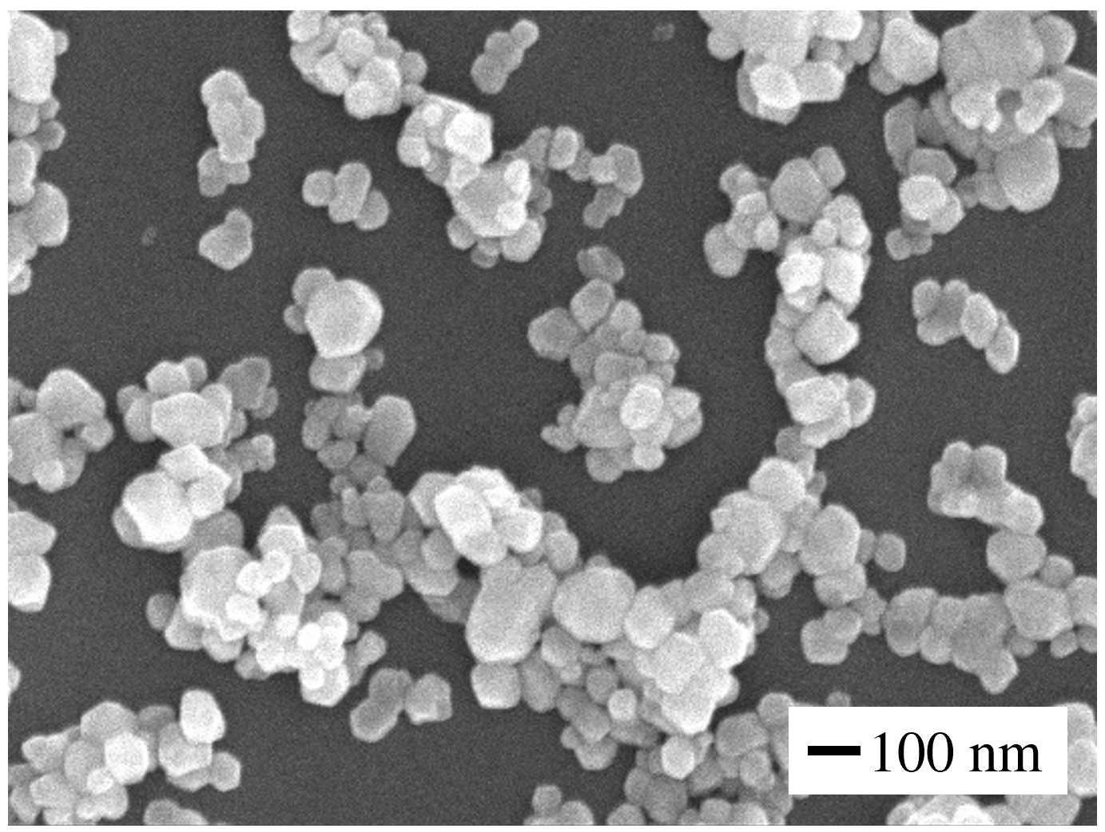

Figure S2. SEM image of commercial CeO₂ particles.

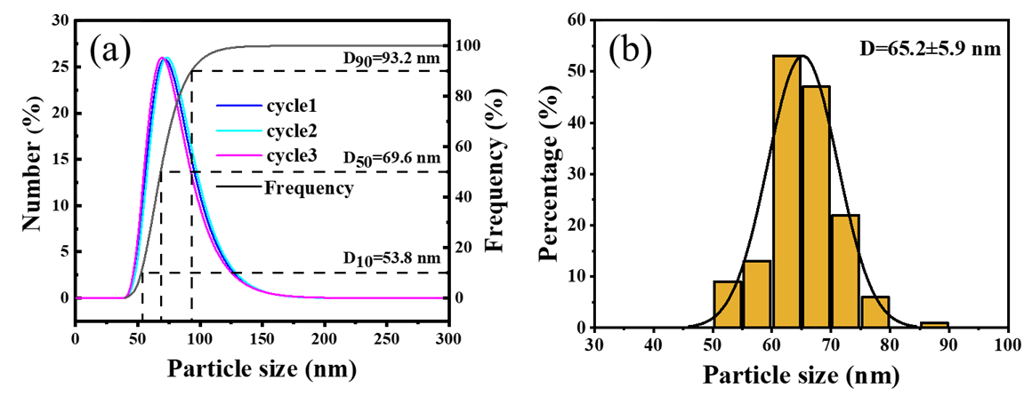

Figure S3. Size distribution of CeO₂ particles as determined by using (a) particle size analyzer and (b) Image J software.

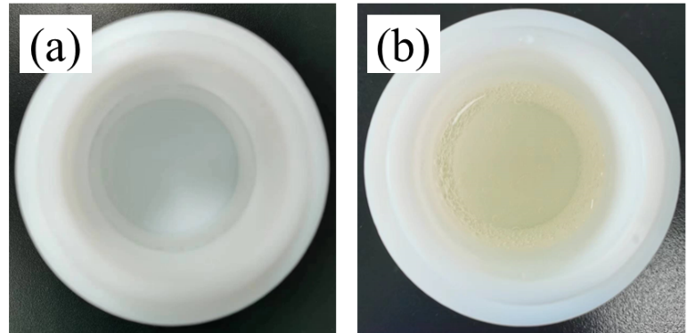

Figure S4. Comparison of the solution (a) before and (b) after hydrothermal reaction with 3.0 mol/L cerium nitrate at 423.15 K for 1.5 h.

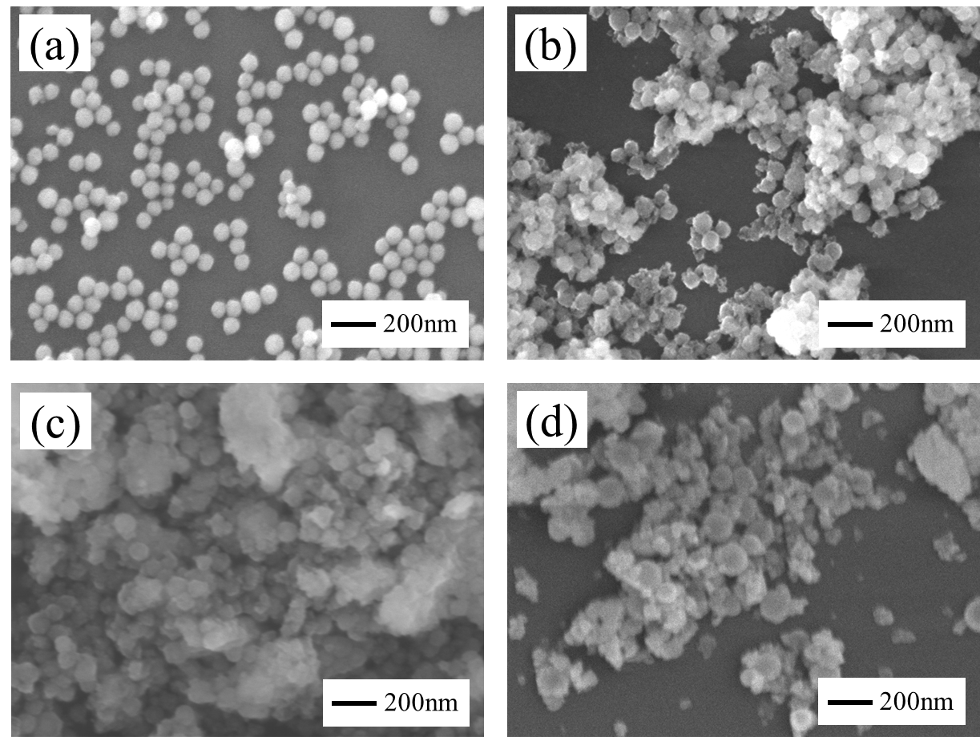

Figure S5. SEM images of CeO₂ particles prepared for different hydrothermal reaction times: (a) 2.5 h, (b) 3.5 h, (c) 4.5 h, and (d) 5.5 h. Other conditions: [Ce(NO₃)₃] = 3.0 mol/L, temperature = 423.15 K.

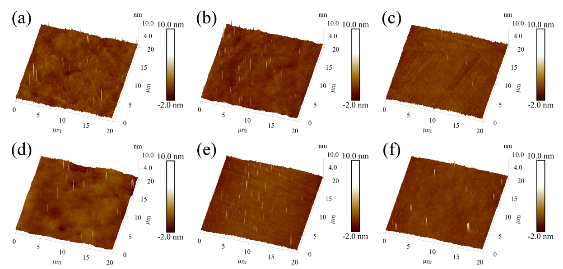

Figure S6. 3D surface topography of silicon wafers using prepared CeO₂ abrasives of different particle sizes: (a) 32 nm, (b) 65 nm, (c) 162 nm, (d) 280 nm, (e) 342 nm, and (f) 531 nm. Other conditions: mass fraction = 0.5 wt.%, polishing time = 15 min.

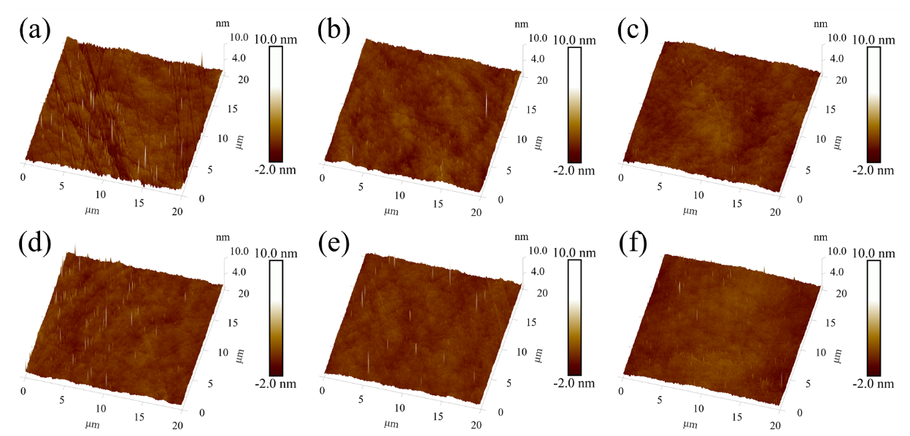

Figure S7. 3D surface topography of silicon wafers after CMP using prepared CeO₂ abrasives for different times: (a) 3 min, (b) 5 min, (c) 10 min, (d) 15 min, (e) 20 min, and (f) 30 min. Other conditions: mass fraction = 0.5 wt.%, particle size = 65 nm.

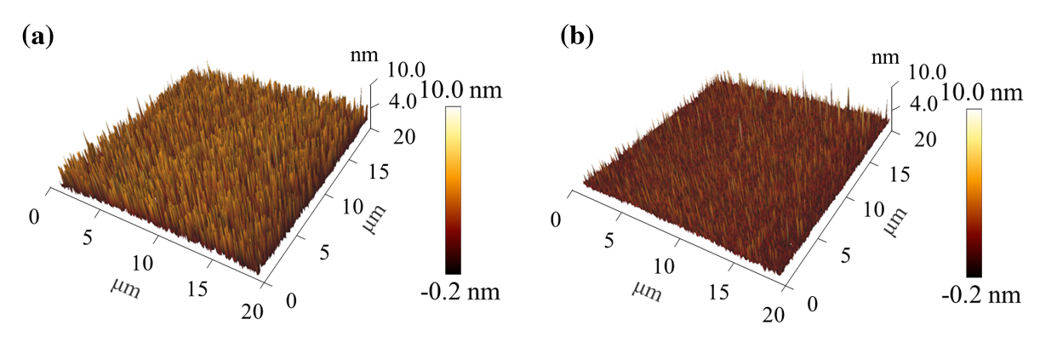

Figure S8. 3D surface topography of silicon wafers after CMP using commercial CeO₂ abrasives for (a) 5 min and (b) 15 min.

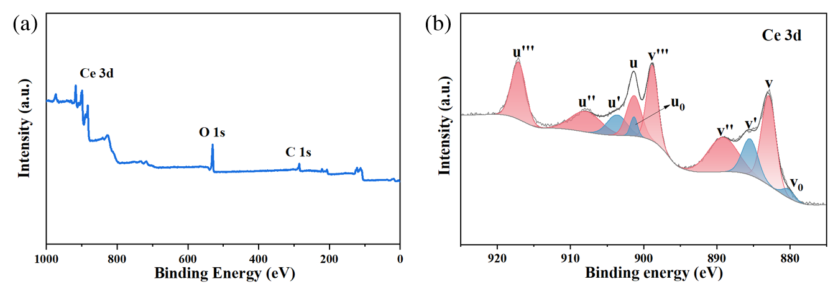

Figure S9. XPS spectrum of synthesized CeO₂, corresponding to (a) full spectrum and (b) Ce 3d photoelectron profiles.

Table S1. Standard Gibbs free energies of formation at 298.15 K for reactants and products.
Species | Phase | Δ_{f}G° (298.15 K)  (kJ/mol) | Species | Phase | Δ_{f}G° (298.15 K)  (kJ/mol)
Ce³⁺ | aq. | –672.00 ^{[1]} | H₂O | liquid | −237.13 ^{[2]}
Ce⁴⁺ | aq. | –503.80 ^{[3]} | NO₂ | gas | 51.31 ^{[2]}
NO₃⁻ | aq. | –108.74 ^{[2]} | NO | gas | 86.55 ^{[2]}
H⁺ | aq. | 0.00 ^{[2]} | CH₄ | gas | –50.8 ^{[2]}
CH₃COO⁻ | aq. | –369.4 ^{[2]} | CO₂ | gas | –394.36 ^{[2]}
CeO₂ | solid | –1108.97 ^{[2]}

Table S2. Thermodynamic comparison of individual and coupled reactions at A (298.15 K, 1 atm, ambient condition) and B (453.15 K, 6 atm, hydrothermal condition).
Equation | Condition | ΔG°(T)  (kJ/mol) | ΔG_{P}  (kJ/mol) | ΔG  (kJ/mol)
Eq. 1 | 298.15 K, 1 atm | 91.12 | 0.03 | 91.15
Eq. 1 | 453.15 K, 6 atm | 39.11 | 6.80 | 45.91
Eq. 2 | 298.15 K, 1 atm | 225.63 | 0.03 | 225.67
Eq. 2 | 453.15 K, 6 atm | 164.99 | 6.80 | 171.79
Eq. 1+3 | 298.15 K, 1 atm | –342.83 | –21.53 | –364.36
Eq. 1+3 | 453.15 K, 6 atm | –626.61 | 28.04 | –598.57
Eq. 2+3 | 298.15 K, 1 atm | –1118.47 | –51.65 | –1170.12
Eq. 2+3 | 453.15 K, 6 atm | –1874.42 | 90.27 | –1784.15

Table S3. Peak deconvolution parameters for the Ce 3d XPS spectrum in Fig. S9.
 | Ce³⁺ |  |  |  |  | Ce⁴⁺
 | v₀ | v' | u₀ | u' |  | v | v'' | v''' | u | u'' | u'''
Binding Energy（eV） | 880.2 | 885.5 | 901.3 | 903.7 |  | 882.9 | 889.2 | 898.8 | 901.3 | 907.9 | 917.1
Area | 6233 | 33474 | 7991 | 23775 |  | 75534 | 60857 | 49790 | 35231 | 36527 | 48800

Text S1. Characterization of CeO₂ surface activity.
The surface activity of CeO₂ (i.e., Ce³⁺/Ce⁴⁺ ratio) was characterized with an X-ray photoelectron spectroscopy (XPS, AXIS Supra+ spectrometer, Shimadzu, Japan) with Al Kα radiation (hv = 1486.6 ev) as the excitation source. The Ce 3d spectra, resulting from orbital splitting and energy transfer, were deconvoluted into ten components, with six peaks assigned to Ce⁴⁺ and four peaks assigned to Ce³⁺ (Fig. S9). The binding energies and area of each peaks were summarized in Table S3, and the Ce³⁺ concentration could be calculated based on the following equations [4], where A denotes the integrated peak area:
Ce³⁺ concentration = A(Ce³⁺)/ [A(Ce³⁺) + A(Ce⁴⁺)] (1)
A(Ce³⁺) = A(v') + A(u') (2)
A(Ce⁴⁺) = A(v) + A(u) + A(v'') + A(u'') + A(v''') + A(u''') (3)

Text S2. Thermodynamic calculation method.
The Gibbs free energy changes for the individual reactions were evaluated from the standard Gibbs energies of formation of the involved species according to Eq. (4). For the nitrate-driven oxidation of Ce³⁺ (Reactions 1 and 2), standard-state thermodynamic properties of the aqueous ions were taken from established thermodynamic compilations [5], whereas the temperature-dependent contributions of the gaseous products (NO and NO₂) and liquid water were adjusted from 298.15 K to the target hydrothermal temperatures using standard Shomate-type thermochemical expressions as compiled in the NIST/JANAF database [2]. The values of ΔfG° (298.15K) used in this work are summarized in Table S1.
ΔG° = Σνᵢ ΔfG°(products) − Σνᵢ ΔfG°(reactants) (4)
Under non-standard conditions, the reaction free energy was determined using Eq. (5), where Q denotes the reaction quotient. For the coupled overall processes involving CeO₂ precipitation (Eqs. 1+3 and 2+3), the overall ΔG was estimated by summing the free-energy contribution of the initial oxidation step and that of the subsequent acetate-mediated CeO₂ formation step. Within the RT ln Q term, the gas-phase contribution was estimated from the stoichiometric mole fractions and partial pressures of the evolved gases.
ΔG(T,P,pH) = ΔG°(T) + RT ln Q (5)
To maintain a transparent and comparative framework, several standard approximations were adopted. Gaseous species were treated as ideal, such that fugacity was approximated by partial pressure under the investigated conditions. The activities of pure liquid water and solid CeO₂ were taken as unity. Under the acidic conditions considered here, the proton activity was defined according to Eq. (6). Unless otherwise specified, the activities of dissolved aqueous species, including Ce³⁺, Ce⁴⁺, NO³⁻, and CH₃COO⁻, were approximated as unity. Consequently, the pressure-dependent term was dominated by the gaseous products.
a(H⁺) = 10⁻ᵖᴴ (6)
Possible non-ideal effects in the hydrothermal fluid, such as ion pairing, aqueous complexation, and activity-coefficient variations, were not explicitly included. Accordingly, the present calculations are intended as a semi-quantitative evaluation of the thermodynamic driving forces associated with nitrate decomposition, Ce³⁺ oxidation, and CeO₂ precipitation, rather than as a rigorous equilibrium speciation model. This level of approximation is commonly adopted in first-order hydrothermal thermodynamic analyses and is suitable for comparing the relative feasibility of competing reaction pathways [6, 7].

References
1. Abellan, P.; Moser, T. H.; Lucas, I. T.; Grate, J. W.; Evans, J. E.; Browning, N. D. The formation of cerium(iii) hydroxide nanoparticles by a radiation mediated increase in local pH. RSC Adv. 2017, 7, 3831-3837.
2. Chase, M., NIST-JANAF Thermochemical Tables, 4th Edition. In American Institute of Physics: 1998.
3. Montaigne, T.; Szenknect, S.; Broudic, V.; Imbert, P.-H.; Tocino, F.; Martin, C.; Miserque, F.; Jégou, C.; Dacheux, N. Oxidative dissolution of (U,Ce)O₂ materials in aqueous solutions containing H₂O₂. npj Mater. Degrad. 2023, 7, 34.
4. Deshpande, S.; Patil, S.; Kuchibhatla, S. V. N. T.; Seal, S. Size dependency variation in lattice parameter and valency states in nanocrystalline cerium oxide. Appl. Phys. Lett. 2005, 87, 133113.
5. Wagman, D. D.; Evans, W. H.; Parker, V. B.; Schumm, R. H.; Halow, I.; Bailey, S. M.; Churney, K. L.; Nuttall, R. L. The NBS Tables of Chemical Thermodynamic Properties. J. Phys. Chem. Ref. Data 1982, 11, 1–392.
6. Helgeson, H. C.; Kirkham, D. H.; Flowers, G. C. Theoretical prediction of the thermodynamic behavior of aqueous electrolytes by high pressures and temperatures; IV, Calculation of activity coefficients, osmotic coefficients, and apparent molal and standard and relative partial molal properties to 600 degrees C and 5kb. Am. J. Sci. 1981, 281, 1249-1516.
7. Helgeson, H. C.; Kirkham, D. H. Theoretical prediction of thermodynamic properties of aqueous electrolytes at high pressures and temperatures. III. Equation of state for aqueous species at infinite dilution. Am. J. Sci. 1976, 276, 97-240.

