Supplementary material

Hydrogen Uptake Kinetics Measurement
Hydrogen uptake was measured by a volumetric (Sieverts-type/PCT) method using the HPSA-auto system. In this method, the amount of hydrogen absorbed by the sample is determined from the decrease in gas-phase hydrogen after the gas contacts the sample in a calibrated closed volume. The instrument continuously records pressure and temperature in real time, and the gas-phase hydrogen amount is calculated using the Modified Benedict–Webb–Rubin (MBWR) equation of state to account for non-ideal behavior under high-pressure conditions. Before measurement, the relevant volumes (e.g., reservoir volume, tube volume, and sample-cell volume) are calibrated, and baseline runs can be used for system correction. The hydrogen uptake is then obtained by gas mass balance and normalized by sample mass to give the uptake capacity. In simplified form, the gas-phase hydrogen amount is expressed as n = PV/(RT), and the uptake is calculated from the difference between the initial and equilibrium gas-phase hydrogen amounts after correction.
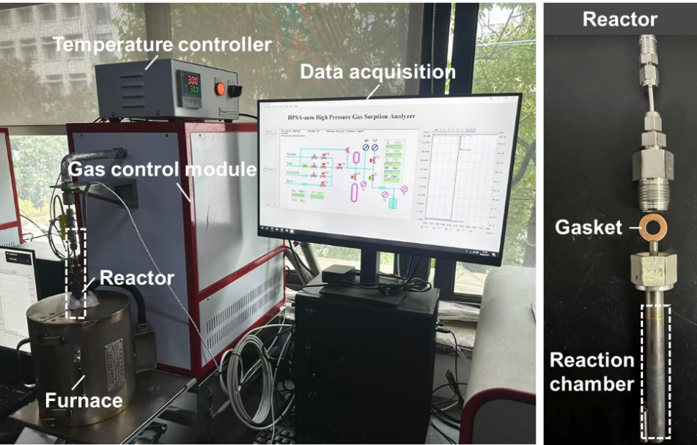
Fig. S1 Photograph of the auto PCT (volumetric) apparatus used in this study.

Kinetic Model Fitting of Hydrogen Uptake Data
To elucidate the hydrogen uptake kinetics and identify the rate-controlling mechanisms, the experimental data were fitted using five commonly adopted kinetic models, including the pseudo-first-order (PFO), pseudo-second-order (PSO), Elovich, Johnson–Mehl–Avrami–Kolmogorov (JMAK), and Weber–Morris (intraparticle diffusion) models. These models represent different possible controlling processes, such as surface adsorption, chemisorption, nucleation and growth, and diffusion-controlled transport. By comparing the fitting quality and linearity, the dominant kinetic mechanism can be identified. The corresponding equations are summarized as follows:
(1) Pseudo-first-order (PFO) model
$$ln⁡(q_{e} − q_{t}) = ln⁡q_{e} − k_{1}t$$
(2) Pseudo-second-order (PSO) model
$$\frac{t}{q_{t}} = \frac{1}{k_{2}q_{e}^{2}} + \frac{t}{q_{e}}$$
(3) Elovich model
$$q_{t} = \frac{1}{β}ln⁡(αβ) + \frac{1}{β}ln⁡t$$
(4) Johnson–Mehl–Avrami–Kolmogorov (JMAK) model
$$ln⁡[−ln⁡(1 − α)] = nln⁡t + ln⁡k$$
(5) Weber–Morris (intraparticle diffusion) model
$$q_{t} = k_{d}t^{1/2} + C$$
where $q_{t}$and $q_{e}$are the hydrogen uptake amounts at time $t$and equilibrium, respectively; $k_{1}$, $k_{2}$, $k$, and $k_{d}$are rate constants; $α$is the fractional uptake; $n$is the Avrami exponent; and $α$, $β$(in Elovich model) are constants related to adsorption rate and activation energy. $C$reflects the boundary layer effect.
Fig. S2 Fitting results of the hydrogen uptake kinetic data at 673 K and 5 MPa using different kinetic models: (a) pseudo-first-order (PFO) model; (b) pseudo-second-order (PSO) model; (c) Elovich model; (d) Johnson–Mehl–Avrami–Kolmogorov (JMAK) model.

Supplementary SEM Images of 8YSZ After Different Treatments
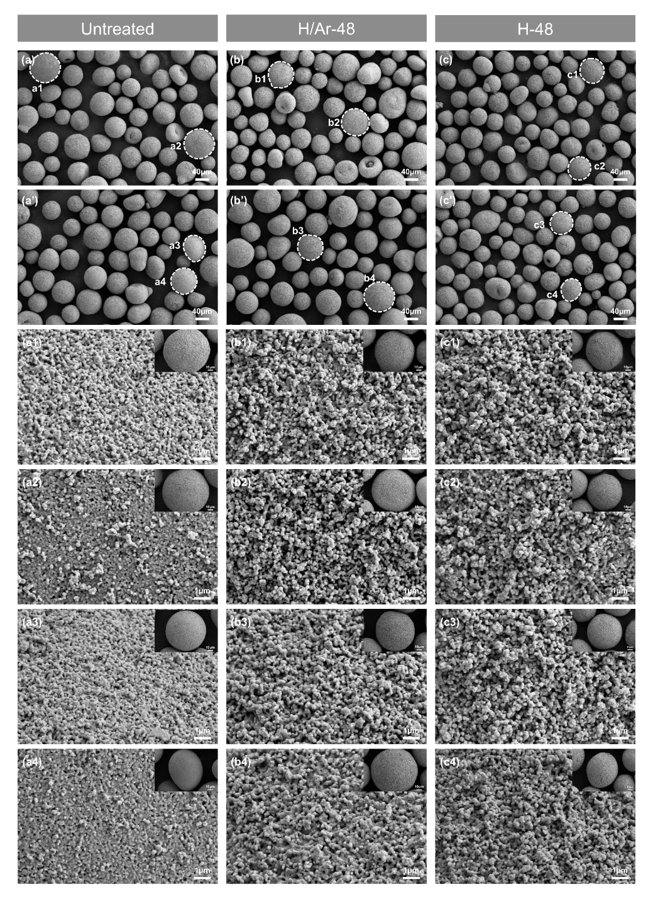
Fig. S3 SEM images of the surface morphological evolution of 8YSZ powders under different treatment conditions: Untreated, H/Ar-48, and H-48.

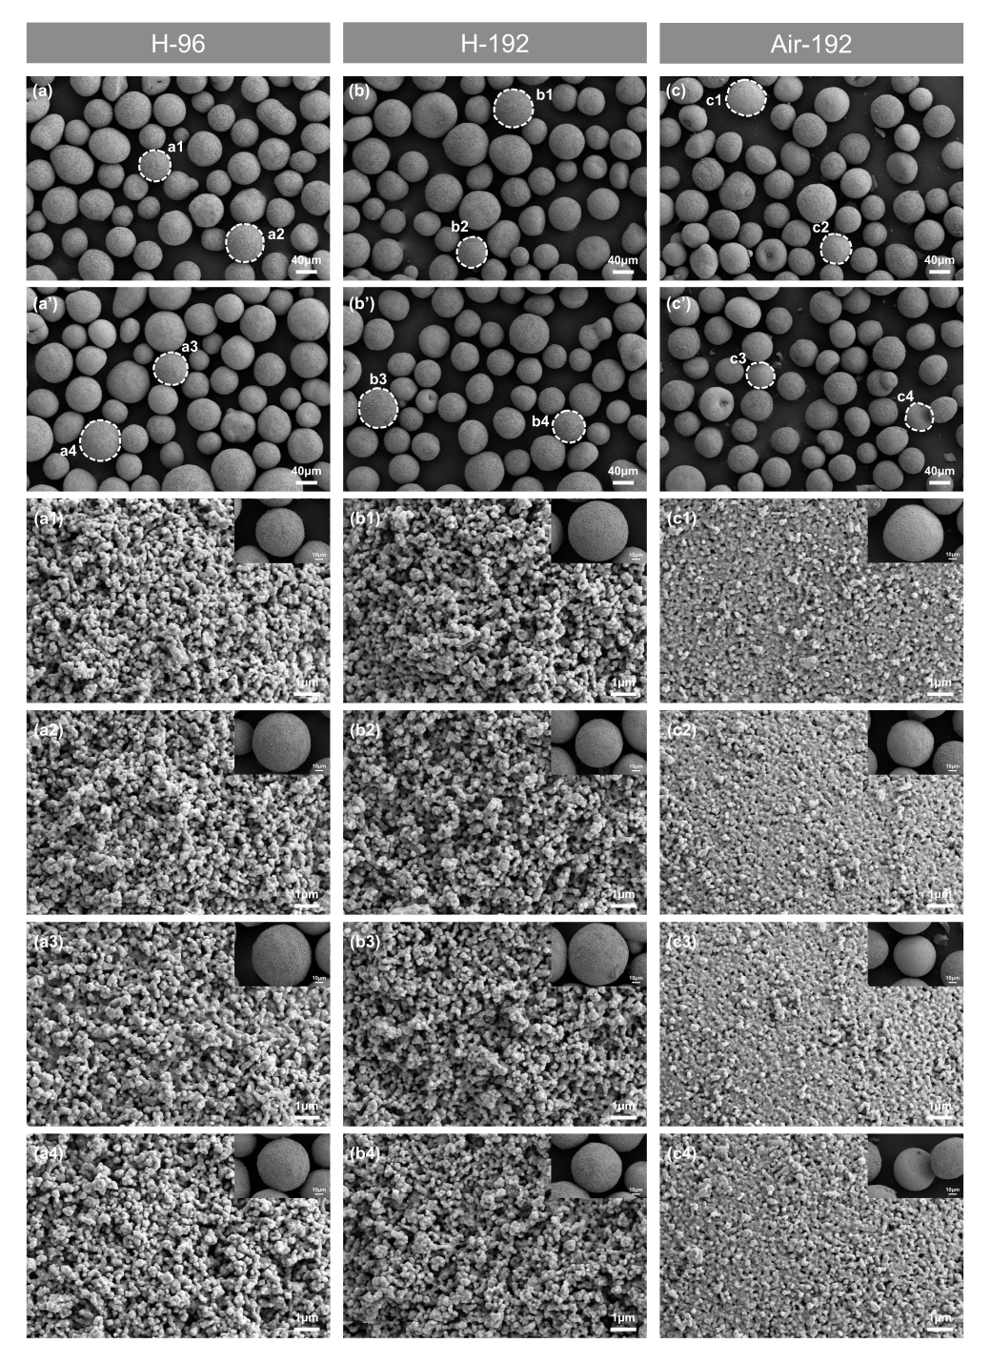
Fig. S4 SEM images of the surface morphological evolution of 8YSZ powders under different treatment conditions: H-96, H-192, and Air-192.

XPS Fitting Results
Table S1. Fitting parameters of O 1s XPS spectra.
Sample | Species | BE (eV) | FWHM (eV) | Area ratio
Untreated | O_{lattice} | 529.78 | 1.51 | 1.00
Untreated | O_{defect} | 531.65 | 1.75 | 0.20
Untreated | O_{ads} | 533.19 | 1.91 | 0.04
H/Ar-48 | O_{lattice} | 529.89 | 1.49 | 1.00
H/Ar-48 | O_{defect} | 531.69 | 1.82 | 0.21
H/Ar-48 | O_{ads} | 533.25 | 1.85 | 0.04
H-48 | O_{lattice} | 529.85 | 1.52 | 1.00
H-48 | O_{defect} | 531.35 | 2.04 | 0.31
H-48 | O_{ads} | 532.72 | 1.99 | 0.05
H-96 | O_{lattice} | 529.85 | 1.60 | 1.00
H-96 | O_{defect} | 531.56 | 2.19 | 0.46
H-96 | O_{ads} | 533.12 | 2.08 | 0.07
H-192 | O_{lattice} | 529.69 | 1.52 | 1.00
H-192 | O_{defect} | 532.01 | 2.25 | 0.75
H-192 | O_{ads} | 533.48 | 1.93 | 0.08
Air-192 | O_{lattice} | 529.65 | 1.43 | 1.00
Air-192 | O_{defect} | 531.62 | 1.81 | 0.25
Air-192 | O_{ads} | 533.32 | 2.04 | 0.05

Table S2. Fitting parameters of Zr 3d XPS spectra.
Sample | Species | BE (eV) | FWHM (eV) | Area ratio
Untreated | Zr⁴⁺(3d_{5/2}) | 181.91 | 1.40 | 1.00
Untreated | Zr⁴⁺(3d_{3/2}) | 184.30 | 1.40 | 0.67
H/Ar-48 | Zr⁴⁺(3d_{5/2}) | 181.93 | 1.42 | 1.00
H/Ar-48 | Zr⁴⁺(3d_{3/2}) | 184.28 | 1.42 | 0.67
H/Ar-48 | Zr³⁺(3d_{5/2}) | 181.30 | 1.45 | 0.10
H/Ar-48 | Zr³⁺(3d_{3/2}) | 183.65 | 1.45 | 0.07
H-48 | Zr⁴⁺(3d_{5/2}) | 181.94 | 1.40 | 1.00
H-48 | Zr⁴⁺(3d_{3/2}) | 184.34 | 1.40 | 0.67
H-48 | Zr³⁺(3d_{5/2}) | 181.45 | 1.45 | 0.20
H-48 | Zr³⁺(3d_{3/2}) | 183.85 | 1.45 | 0.13
H-96 | Zr⁴⁺(3d_{5/2}) | 181.95 | 1.40 | 1.00
H-96 | Zr⁴⁺(3d_{3/2}) | 184.30 | 1.40 | 0.67
H-96 | Zr³⁺(3d_{5/2}) | 181.56 | 1.48 | 0.30
H-96 | Zr³⁺(3d_{3/2}) | 183.96 | 1.48 | 0.20
H-192 | Zr⁴⁺(3d_{5/2}) | 182.03 | 1.46 | 1.00
H-192 | Zr⁴⁺(3d_{3/2}) | 184.39 | 1.46 | 0.67
H-192 | Zr³⁺(3d_{5/2}) | 181.47 | 1.47 | 0.45
H-192 | Zr³⁺(3d_{3/2}) | 183.85 | 1.47 | 0.30
Air-192 | Zr⁴⁺(3d_{5/2}) | 181.91 | 1.40 | 1.00
Air-192 | Zr⁴⁺(3d_{3/2}) | 184.31 | 1.40 | 0.67
Table note: The spin–orbit splitting (ΔE = BE 3d_{3/2} – BE 3d_{5/2}) was constrained to 2.40 ± 0.05 eV; the 3d_{5/2}:3d_{3/2} area ratio was fixed at 3:2; and FWHMs were tied within each doublet.

High-Temperature and High-Pressure Phase Transformation of 8YSZ in a DAC
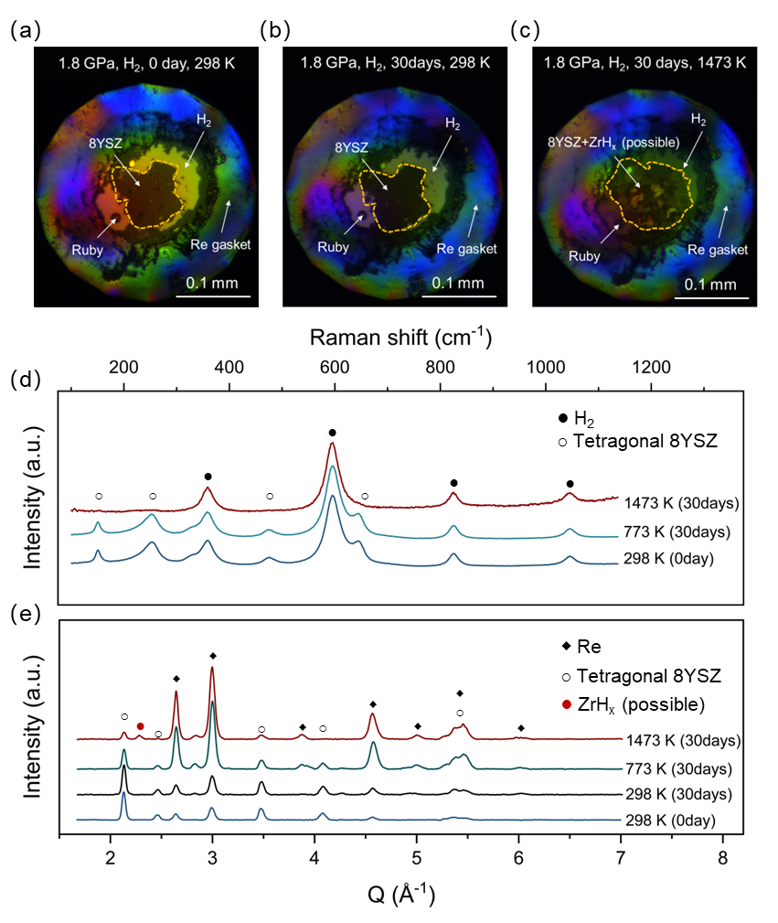
Fig. S5 Morphology and phase characterization of 8YSZ powders under different hydrogen-treatment conditions: (a) optical image, 1.8 GPa H₂, 0 days, 298 K; (b) optical image, 1.8 GPa H₂, 30 days, 298 K; (c) optical image, 1.8 GPa H₂, 30 days, 1473 K; (d) Raman spectra; (e) X-ray diffraction patterns.

XRD Patterns of 8YSZ Under Different Treatment Conditions
The legend entries represent the processing sequences. For instance, “Ar-1773 K-0.5 h → H₂-673 K-48 h” denotes a two-step treatment, where the sample was first annealed in Ar at 1773 K for 0.5 h and subsequently exposed to H₂ at 673 K for 48 h.
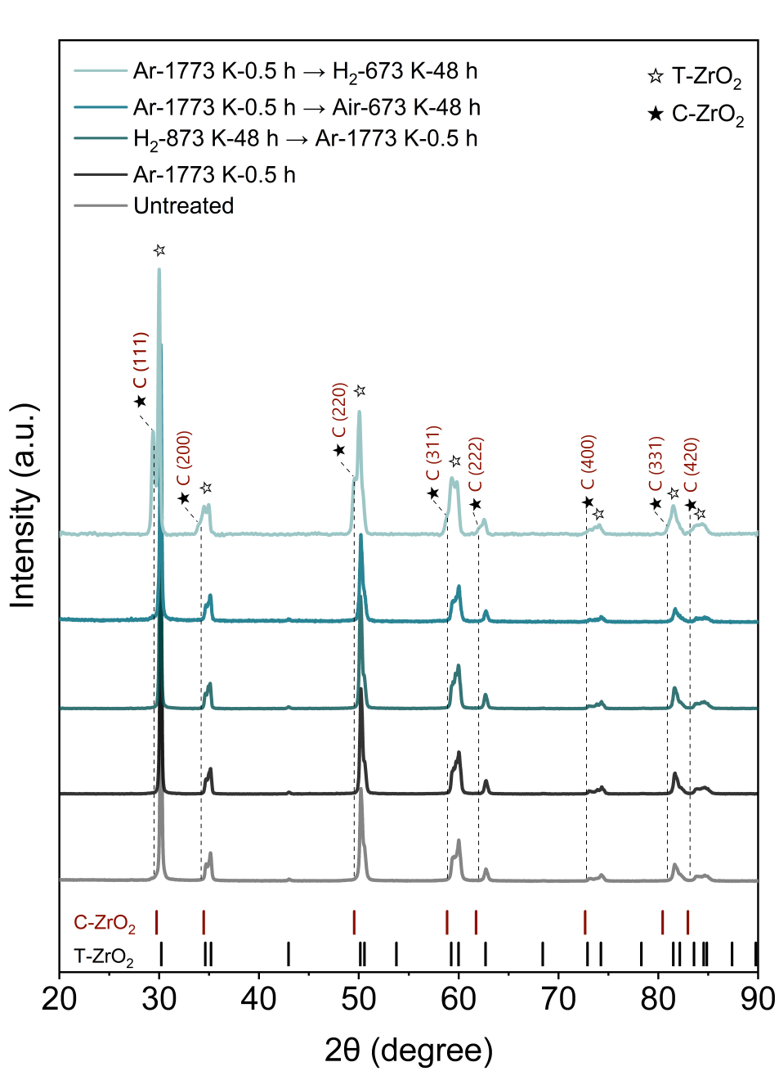
Fig. S6 XRD patterns of 8YSZ powders subjected to different heat- and hydrogen-treatment sequences.

Rietveld Refinement Results of XRD Patterns
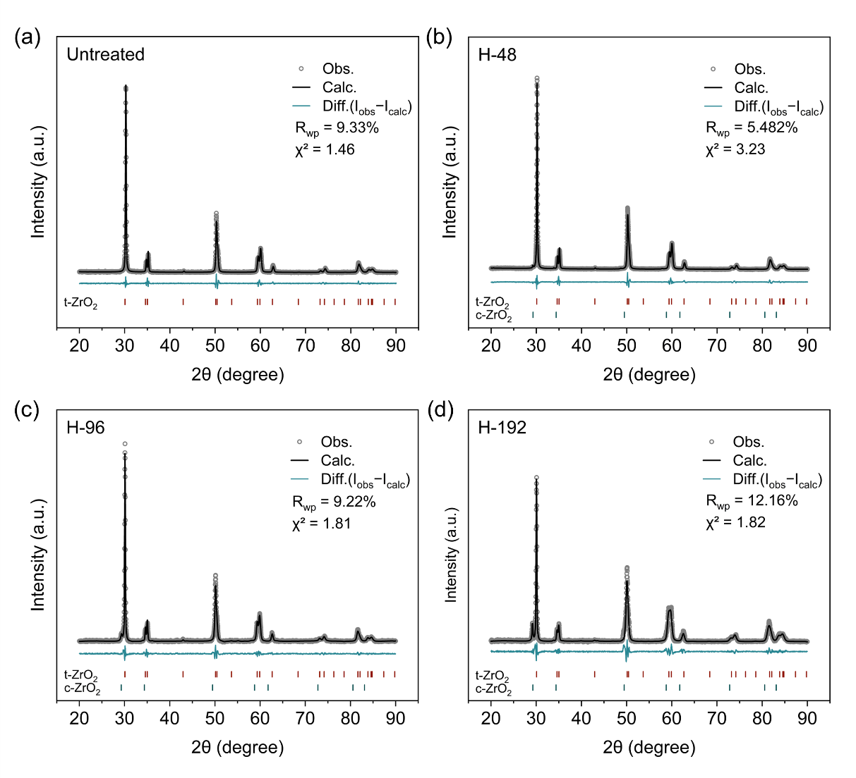
Fig. S7 Rietveld refinement results of XRD patterns for 8YSZ powders after different hydrogen exposure durations: (a) Untreated; (b) H-48; (c) H-96; (d) H-192.

