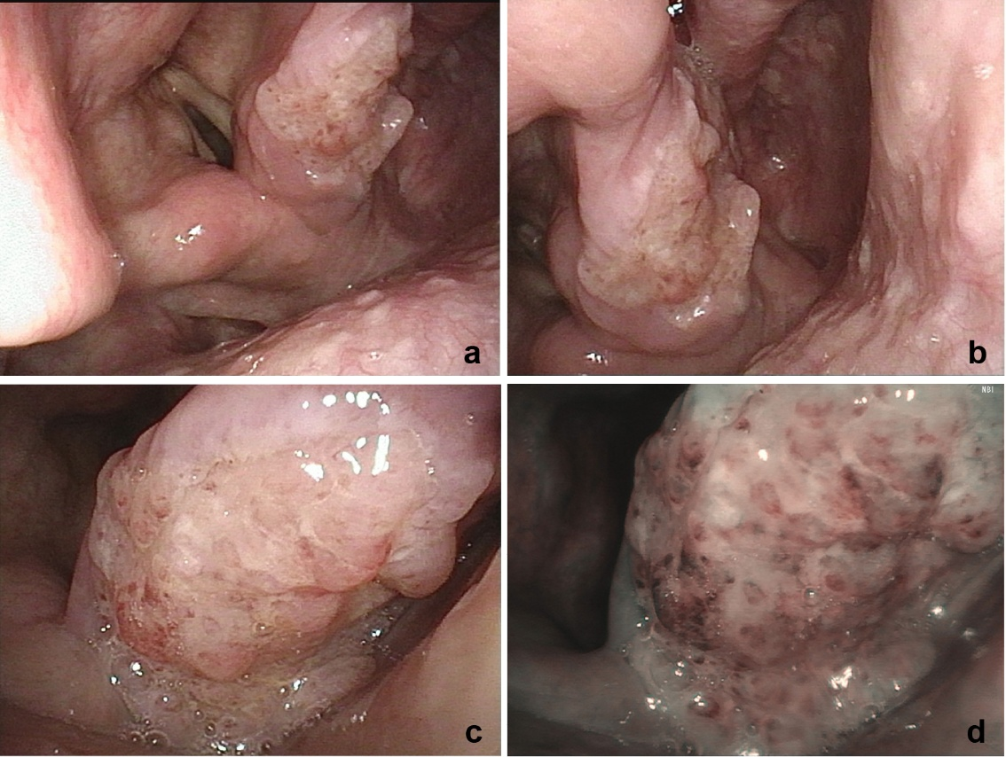
Fig.S1 Initial fiberoptic laryngoscopy demonstrates hypopharyngeal carcinoma. (a–c) Tumor located lateral to the right arytenoid cartilage. (d) NBI findings.

