Supplementary figures of
Mediation Pathways from Lifestyle to Hearing Impairment: The Role of Inflammatory and Metabolic Biomarkers in a Prospective Cohort Study (Runhua Li et al.)
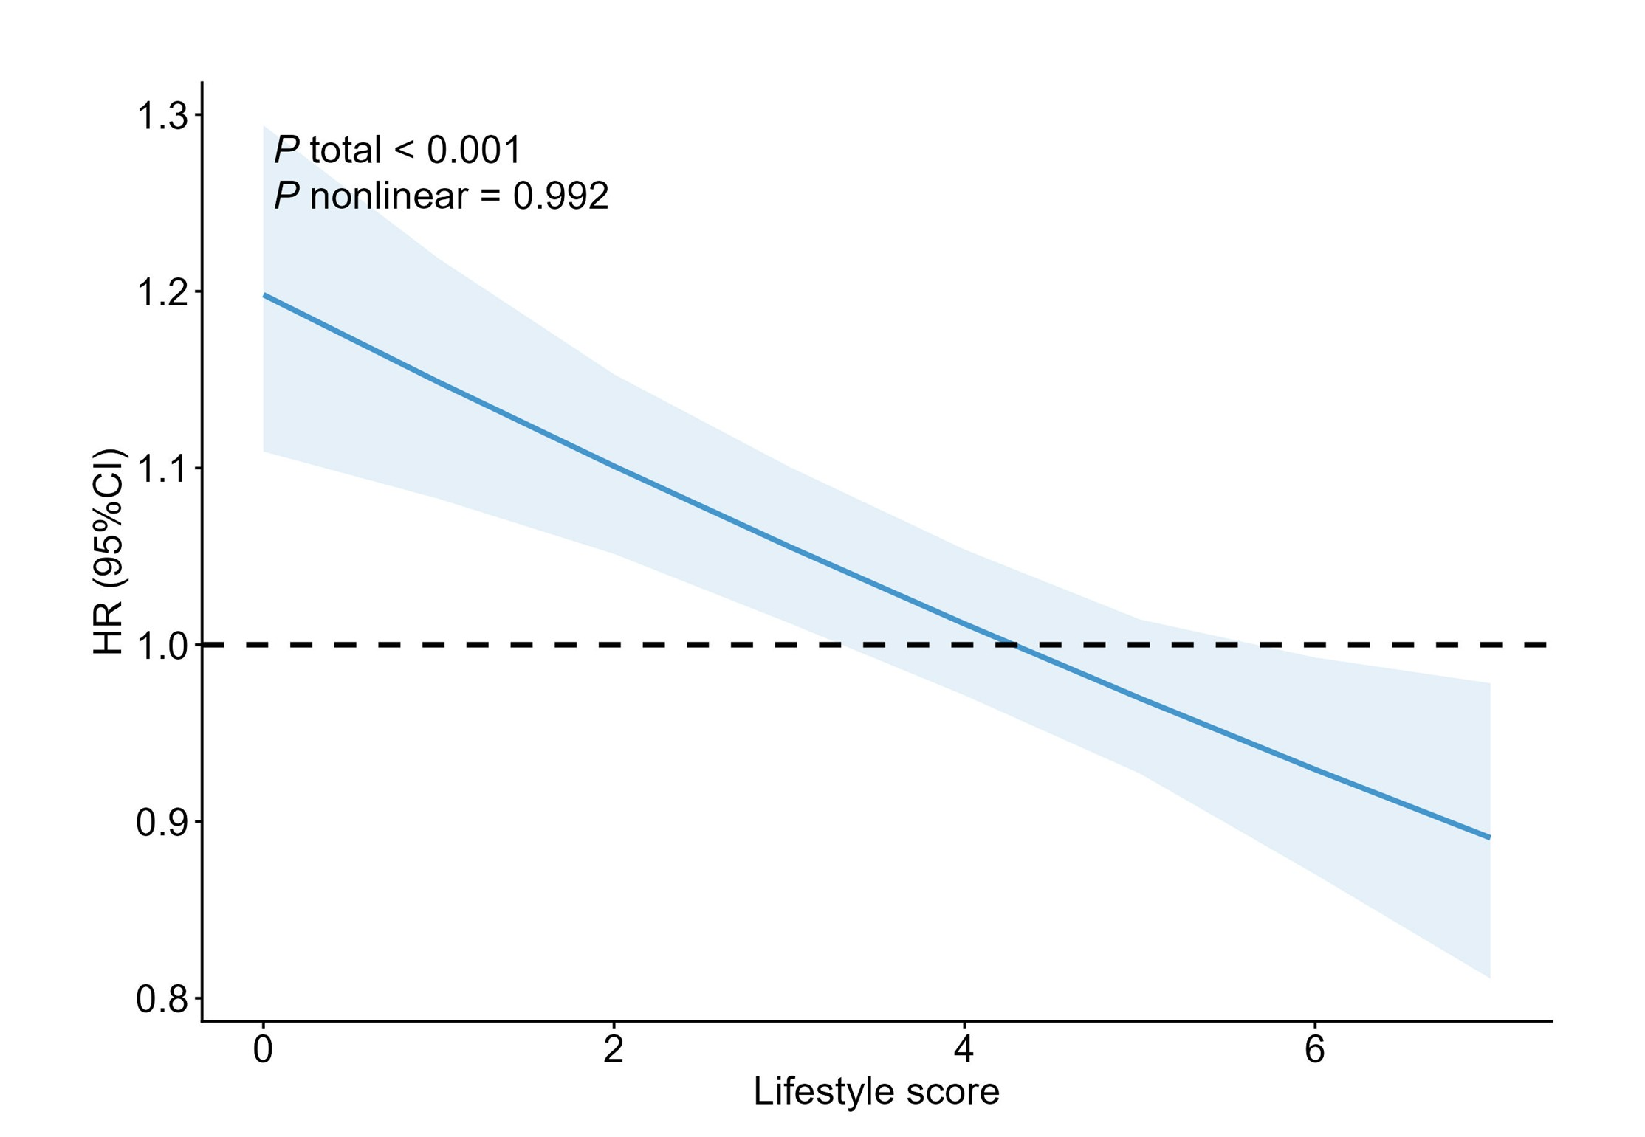
Figure S1. Associations between lifestyle score and the risk of incident hearing impairment by restricted cubic spline regression (N = 441,844).
Curves were delineated by restricted cubic splines with 3 knots at 10th, 50th and 90th percentiles.
Abbreviations: CI, confidence interval; HR, hazards ratio.
Model was adjusted for age, sex, ethnicity, qualifications, average total household income before tax, hypertension, type 2 diabetes mellitus, hypercholesterolemia, use of ototoxic drugs, noisy work place and loud music exposure frequency.

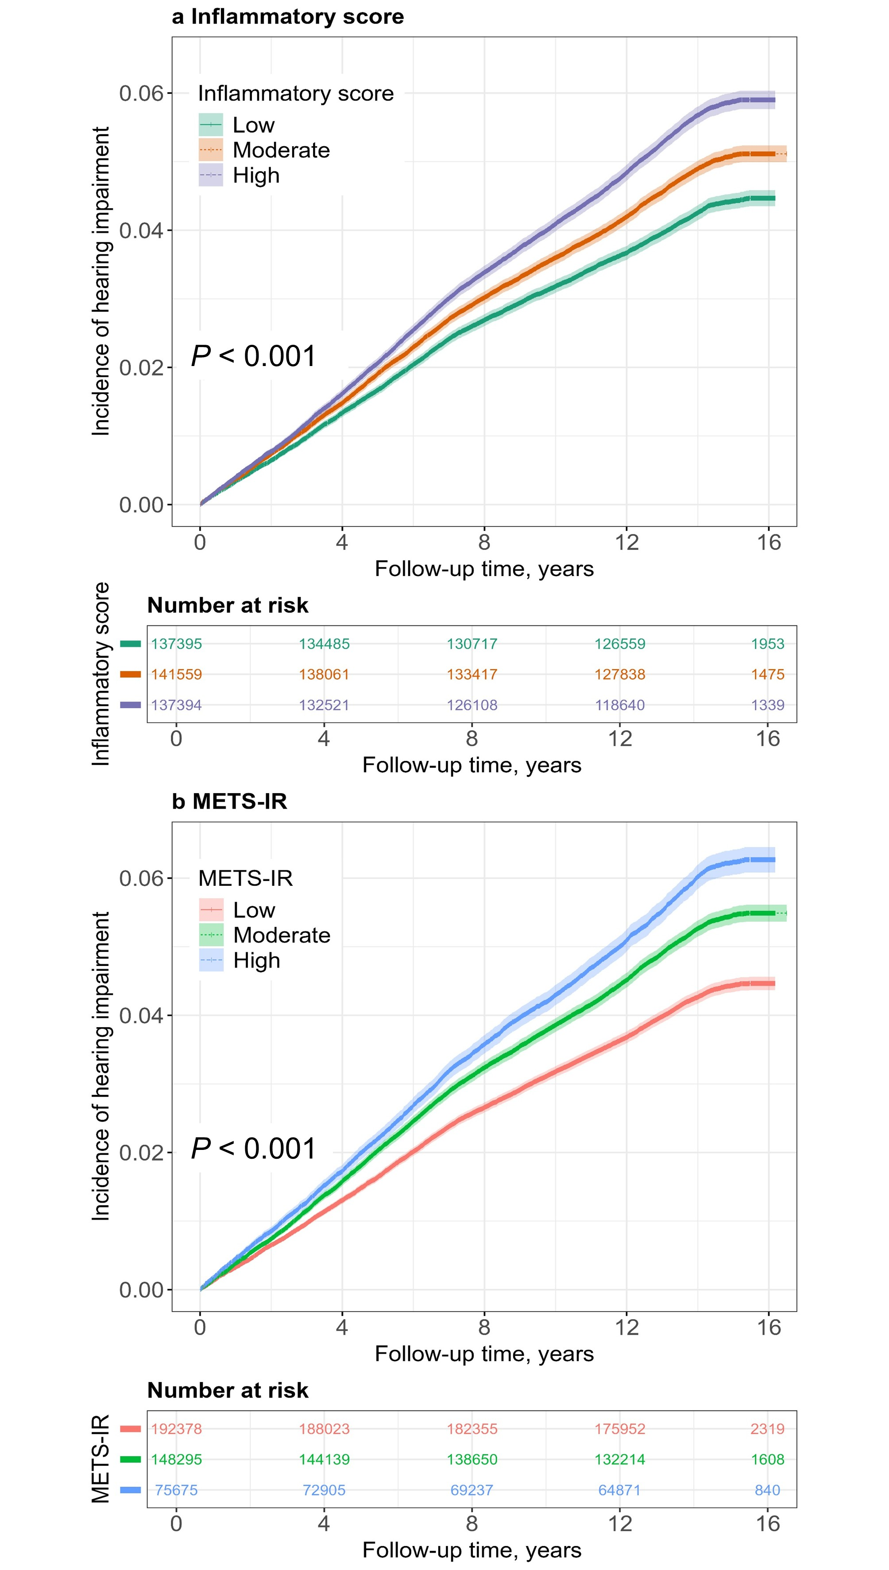
Figure S2. Kaplan‐Meier curves of the cumulative incidence of hearing impairment (N = 416,348).
(a) Kaplan‐Meier curve of the cumulative incidence of hearing impairment caused by Inflammatory score. (b) Kaplan‐Meier curve of the cumulative incidence of hearing impairment caused by METS-IR.
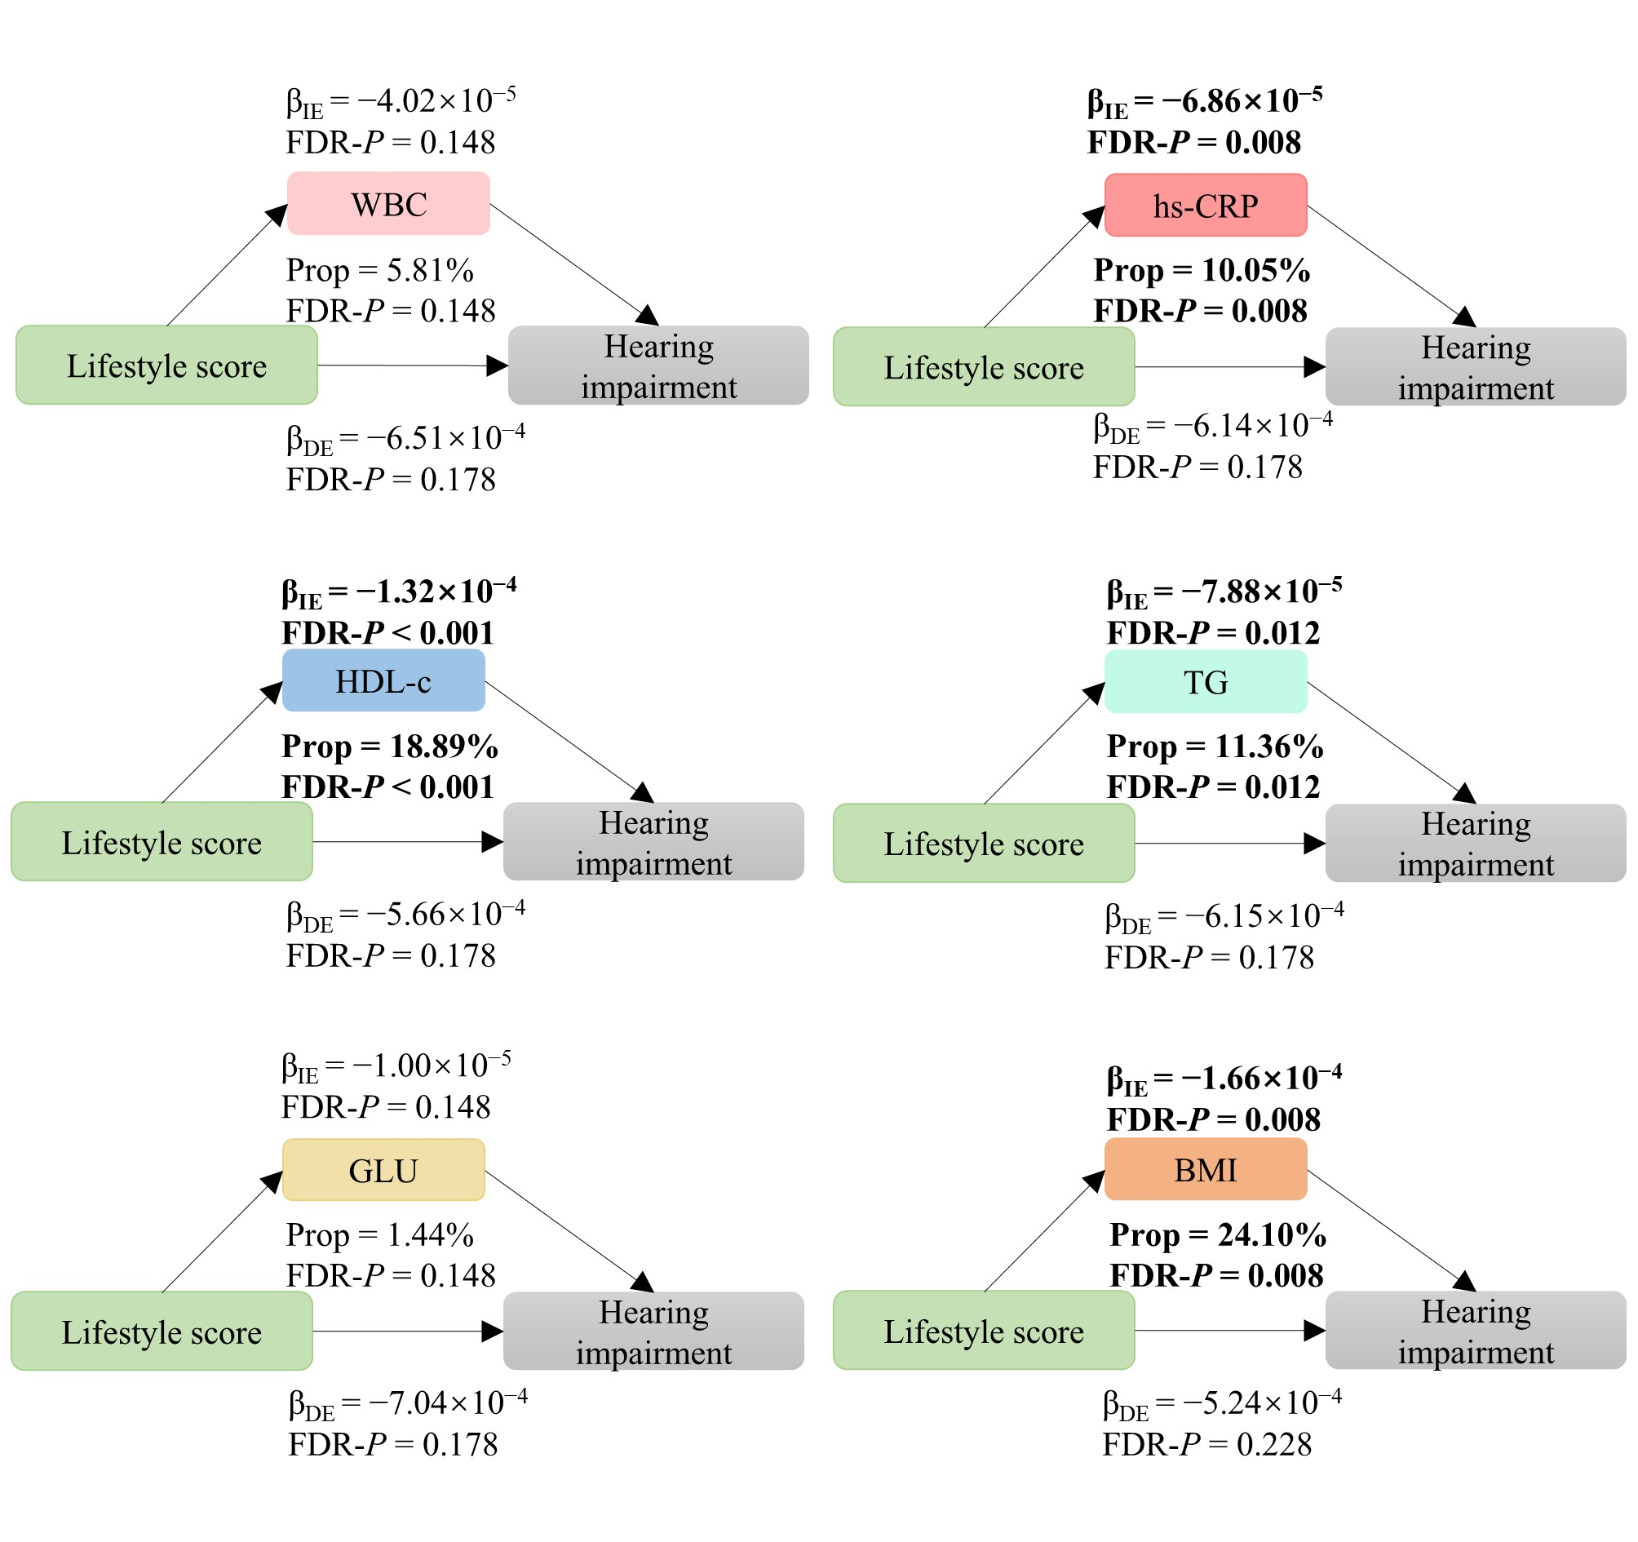
Figure S3. Sensitivity analyses of mediating role of biomarkers in the associations of lifestyle score with hearing impairment after excluding participants with baseline diabetes or hyperlipidemia (N = 196,761).
Note: β, original regression coefficient; Prop, the proportion of mediation effect; IE, indirect effects; DE, direct effect; WBC, white blood cell count; hs-CRP, high-sensitivity C-reactive protein; HDL-c, high-density lipoprotein cholesterol; TG, triglycerides; GLU, glucose; BMI, body mass index.
Inflammatory markers: Mediation models were adjusted for age, sex, ethnicity, qualifications, average total household income before tax, hypertension, type 2 diabetes mellitus, hypercholesterolemia, use of ototoxic drugs, noisy workplace, and loud music exposure frequency.
Metabolic markers: Mediation models were adjusted for age, sex, ethnicity, qualifications, average total household income before tax, hypertension, use of ototoxic drugs, noisy workplace, and loud music exposure frequency.

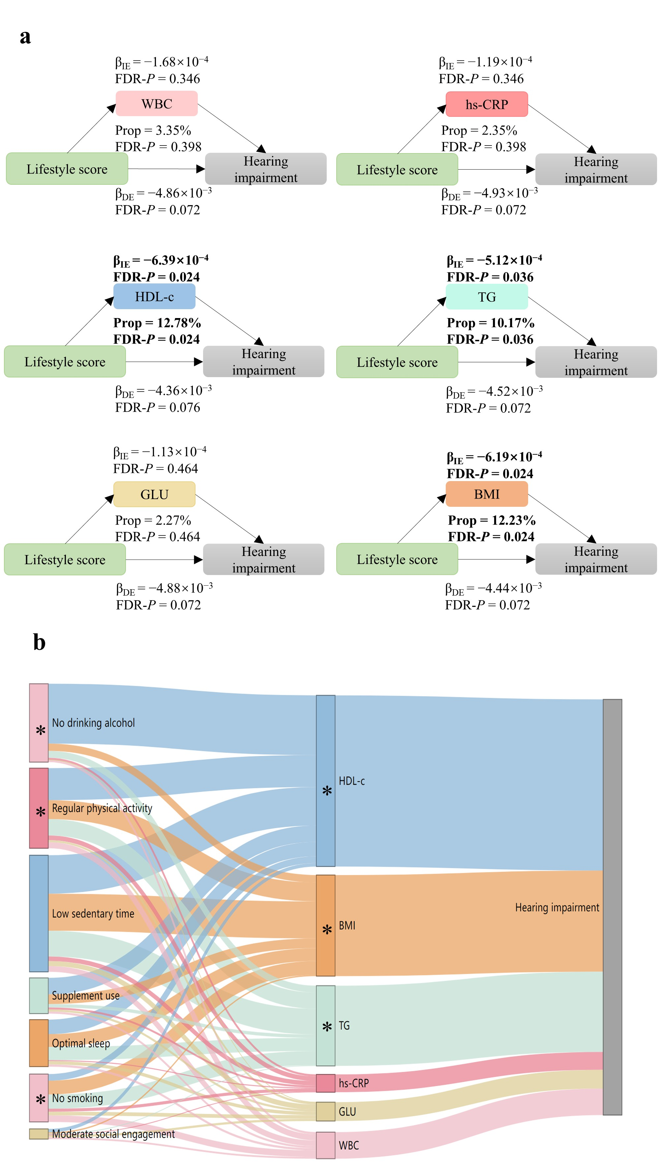
Figure S4. Sensitivity analyses of the mediating role of biomarkers in the associations between lifestyle and hearing impairment, using biomarker measurements from the first follow-up assessment (2012–2013) (N = 11,770).
Note: β, original regression coefficient; Prop, the proportion of mediation effect; IE, indirect effects; DE, direct effect; WBC, white blood cell count; hs-CRP, high-sensitivity C-reactive protein; HDL-c, high-density lipoprotein cholesterol; TG, triglycerides; GLU, glucose; BMI, body mass index.
The branch width in the Sankey diagram represents the absolute value of the indirect effect (|β_{IE}|). The pathway between a lifestyle factor and a biomarker is considered to show a significant mediation effect (FDR-adjusted P < 0.05) only if both the lifestyle factor and the biomarker are marked with “*”.
Inflammatory markers: Mediation models were adjusted for age, sex, ethnicity, qualifications, average total household income before tax, hypertension, type 2 diabetes mellitus, hypercholesterolemia, use of ototoxic drugs, noisy workplace, and loud music exposure frequency.
Metabolic markers: Mediation models were adjusted for age, sex, ethnicity, qualifications, average total household income before tax, hypertension, use of ototoxic drugs, noisy workplace, and loud music exposure frequency.

