Supplementary figures of
Exhaled Nitric Oxide in Obstructive Sleep Apnea: Compartment-Specific Associations and Incremental Predictive Value
(Tongshan Qiu et al.)

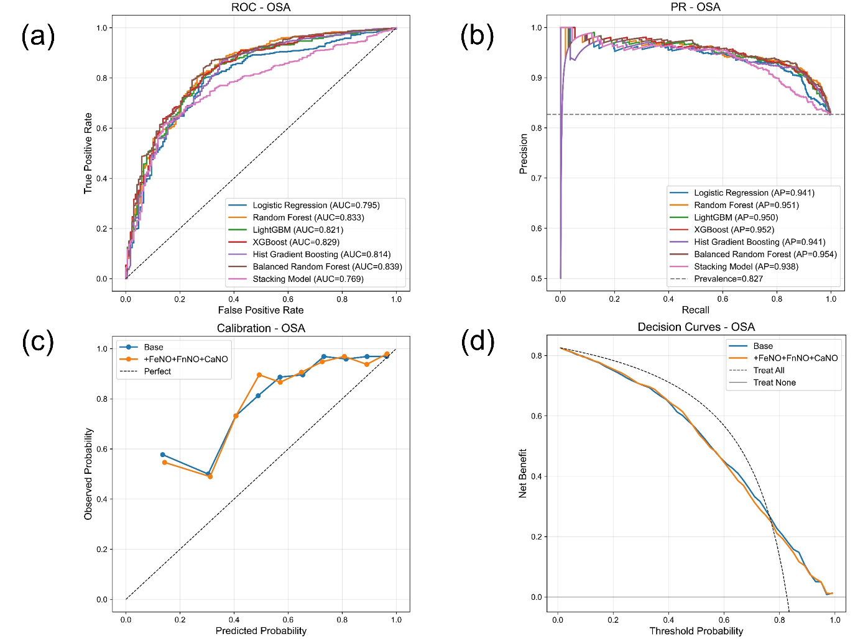
Figure S1. Discrimination, calibration, and decision curve analyses of the complete eNO-panel models for OSA prediction. (a) Receiver operating characteristic curves and (b) precision–recall curves across the seven classification algorithms. (c) Calibration curves and (d) decision curves comparing the base and complete eNO-panel models.

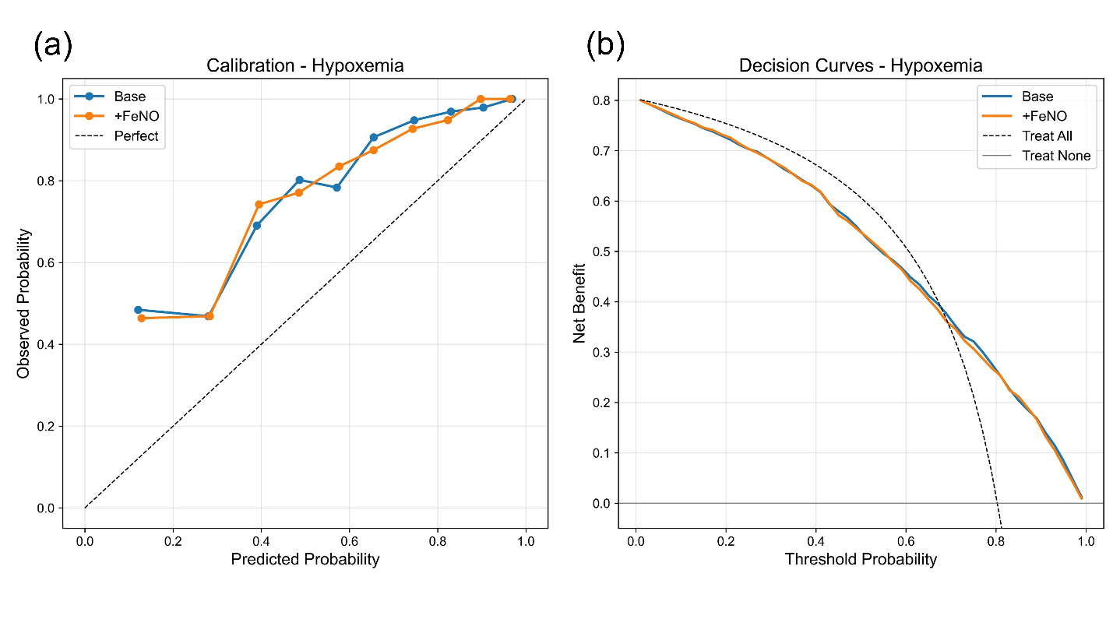Figure S2. Calibration and decision curve analyses for hypoxemia prediction using the base and FeNO50-augmented models. (a) Calibration curves comparing observed and predicted probabilities of hypoxemia. (b) Decision curves comparing net benefit across threshold probabilities.

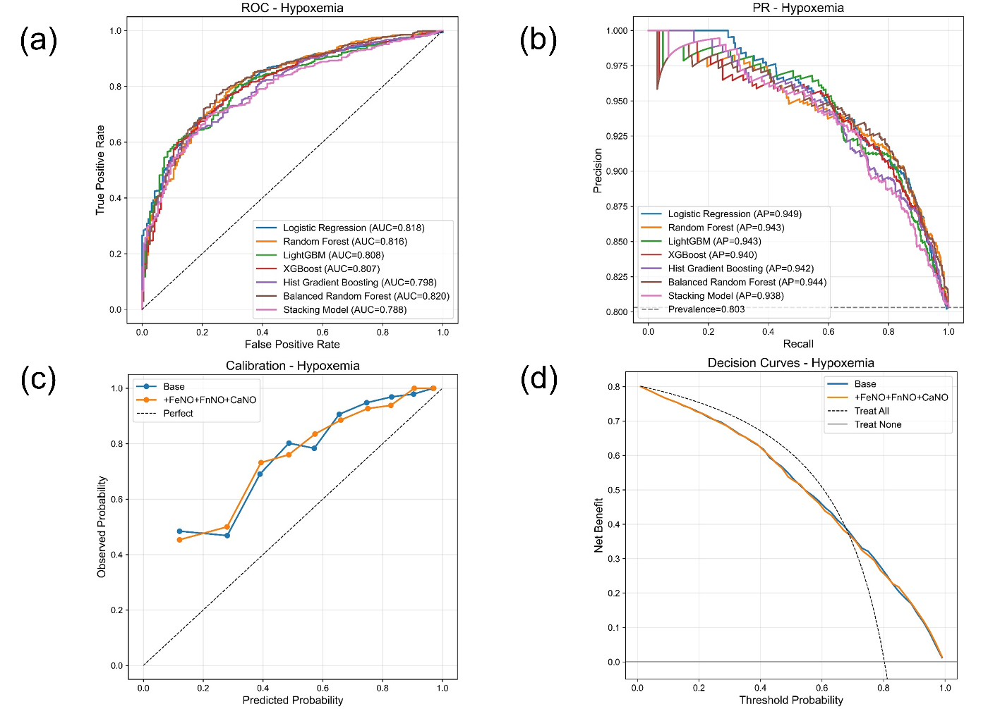Figure S3. Discrimination, calibration, and decision curve analyses of the complete eNO-panel models for hypoxemia prediction. (a) Receiver operating characteristic curves and (b) precision–recall curves across the seven classification algorithms. (c) Calibration curves and (d) decision curves comparing the base and complete eNO-panel models.

