Supplementary materials

Table S1 All nonvolatile chemical compounds in baijiu. Q1 (Da), molecular weight of parent ion after the substance is added with ions through electrospray ion source. Q3 (Da), characteristic fragment ion. Class I, primary classification of substances. Class II, secondary classification of substances. Level, substance identification level. The “1” means the matching scores of the secondary mass spectrometry and RT of the compounds between samples and the database are more than 0.7. The “2” means the matching scores of the secondary mass spectrometry and RT of the compounds between samples and the database are from 0.5 to 0.7 points. The “3” means the Q1, Q3, retention time (RT), declustering potential (DP), collision energy (CE) in samples are consistent with the database. Relative expression, the relative expression of corresponding compounds in baijiu. cpd_ID, the KEGG database number of corresponding compounds.

Figure captions:
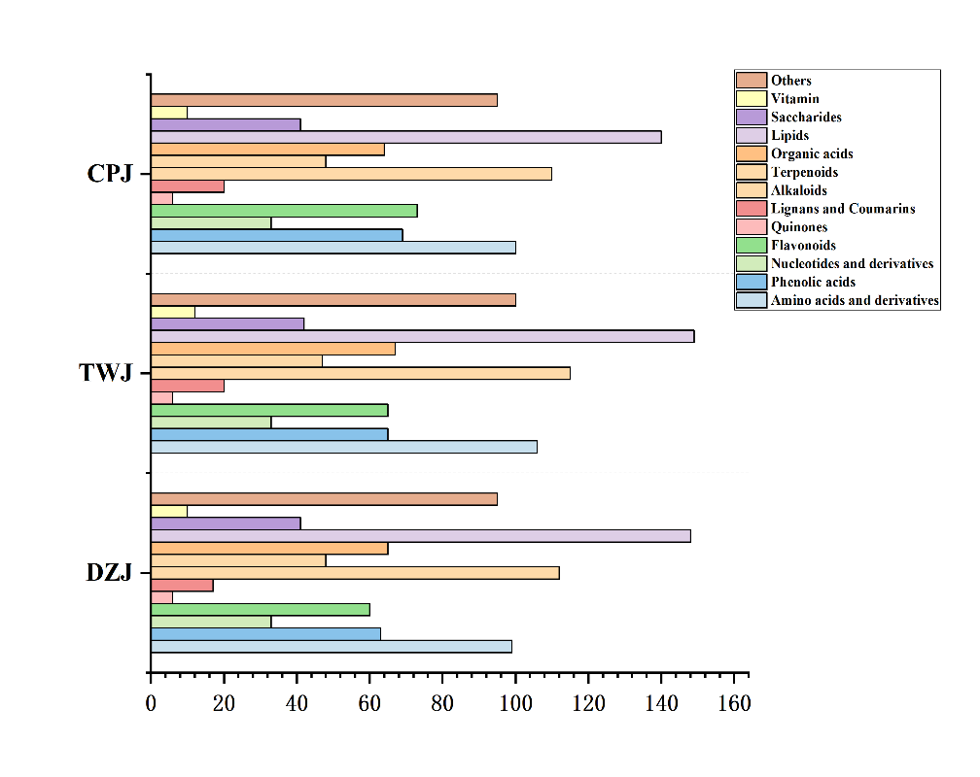

Fig. S1 Bar chart of the number of different types of all non-volatile metabolites.

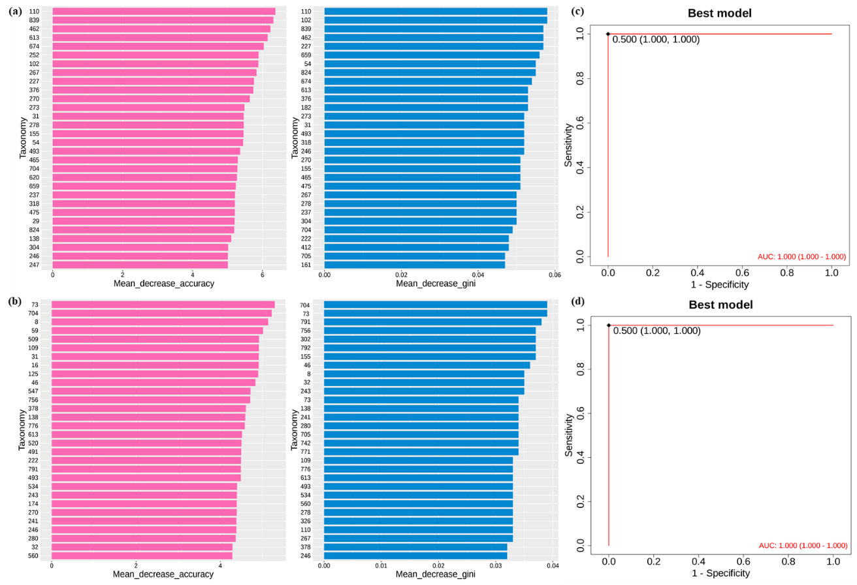
Fig. S2 A–B, The results of random forest analysis. The contribution of variable features to the accuracy of inter group classification was expressed as Mean Difference Accuracy, and the higher the value, the greater the contribution of variables to sample classification. The importance of variables was compared by calculating the effect of each variable on the heterogeneity of observations at each node of the classification tree through the Mean Difference Gini index. A larger value indicates a higher importance of the variable. (A) DZJ vs. CPJ, and (B) TWJ vs. CPJ. C–D, best model of ROC curve. (C) DZJ vs. CPJ, and (D) TWJ vs. CPJ.

