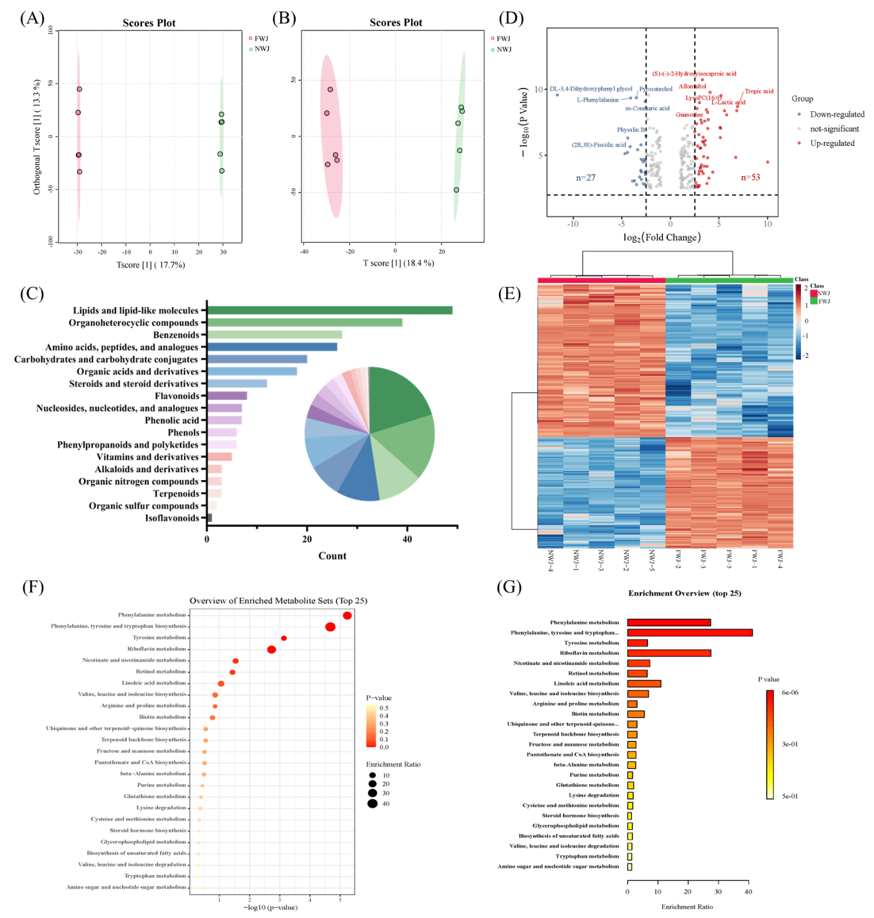
Fig. S1 OPLS-DA plots in positive mode (A) and negative mode (B), classification chart (C), volcano plot (D), heatmap (E), enrichment analysis bubble plot (F) and enrichment analysis (Top 25) (G) of total differential metabolites during fermentation of L. plantarum NCU137. Note: NWJ: unfermented wolfberry juice; FWJ: fermented wolfberry juice for 48h.
Table S1 Chemical shift assignments of ¹Н NMR for NWP and FWP
NO. | Linkage type | Abbreviation | Chemical shift of ¹Н（ppm）
 | α-Glcp-(1→ | Gl_{t} | 5.44
 | →4)-α-Glcp-(1→ | Gl₄ | 5.38
 | →3)-α-Araf-(1→ | Af₃ | 5.27
 | α-Araf-(1→ | Af_{t} | 5.24
 | →3,5)-α-Araf-(1→ | Af₃₅ | 5.12
 | →5)-α-Araf-(1→ | Af₅ | 5.09
 | →4)-α-GalpA-(1→ | GA₄ | 5.09
 | →4)-α-GalpA-(1→ | H₅-GA₄ | 4.78
 | →3)-β-Galp-(1→ | R_{t} | 4.73
 | α-Rhap-(1→ | G₃ | 4.71
 | β-Galp-(1→ | G_{t} | 4.66
 | →3,4,6)-β-Galp-(1→ | G_{3,4,6} | 4.57
 | →3)-β-Glcp-(1→ | Gl₃ | 4.54
 | →3,6)-β-Galp-(1→ | G_{3,6} | 4.53
 | →6)-β-Galp-(1→ | G₆ | 4.50
 | β-Glcp-(1→ | Gl_{t} | 4.45
 | →2,4)-α-Rhap-(1→ | H₆-R_{2,4} | 1.33
 | →6)-α-Rhap-(1→ | H₆-R₆ | 1.26

