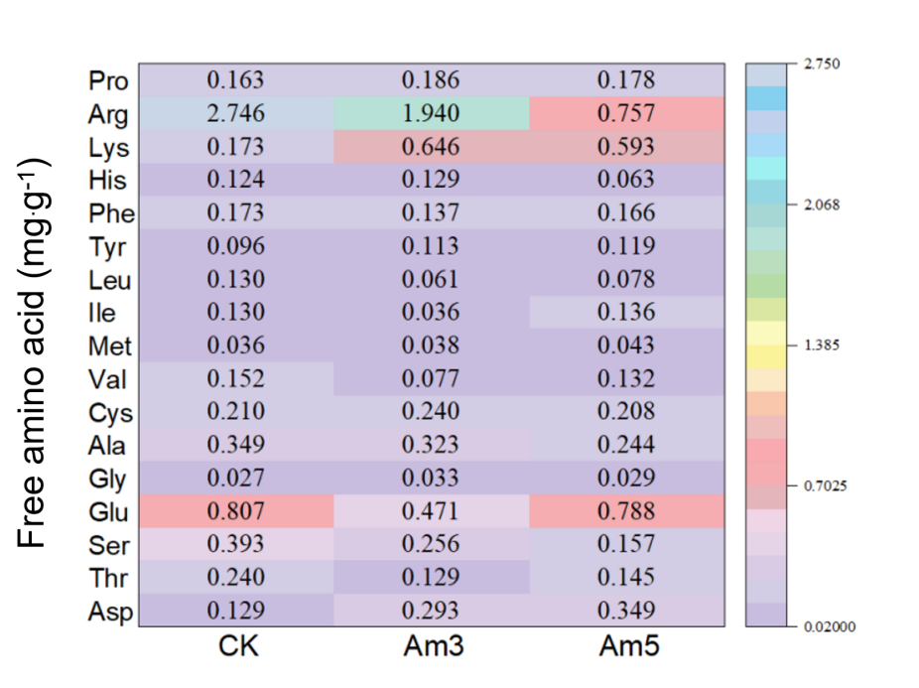
Fig. S1 Amino acid compositions after AESSF process.

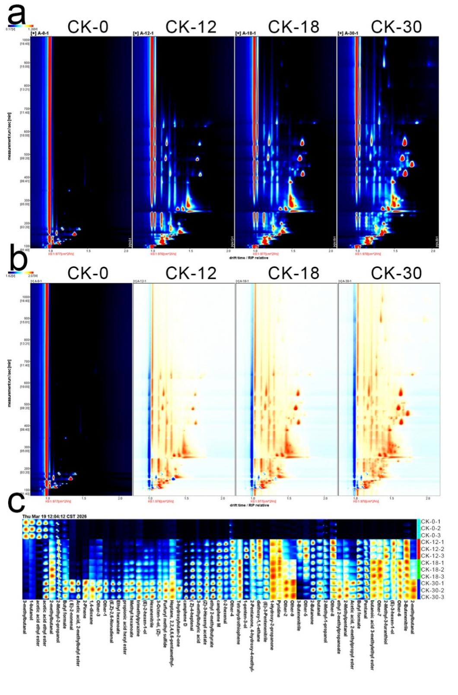
Fig. S2 HS–GC–IMS analysis of CK during AESSF process. (a) 2D topographic plots; (b) Comparison of different; (c) Fingerprints.
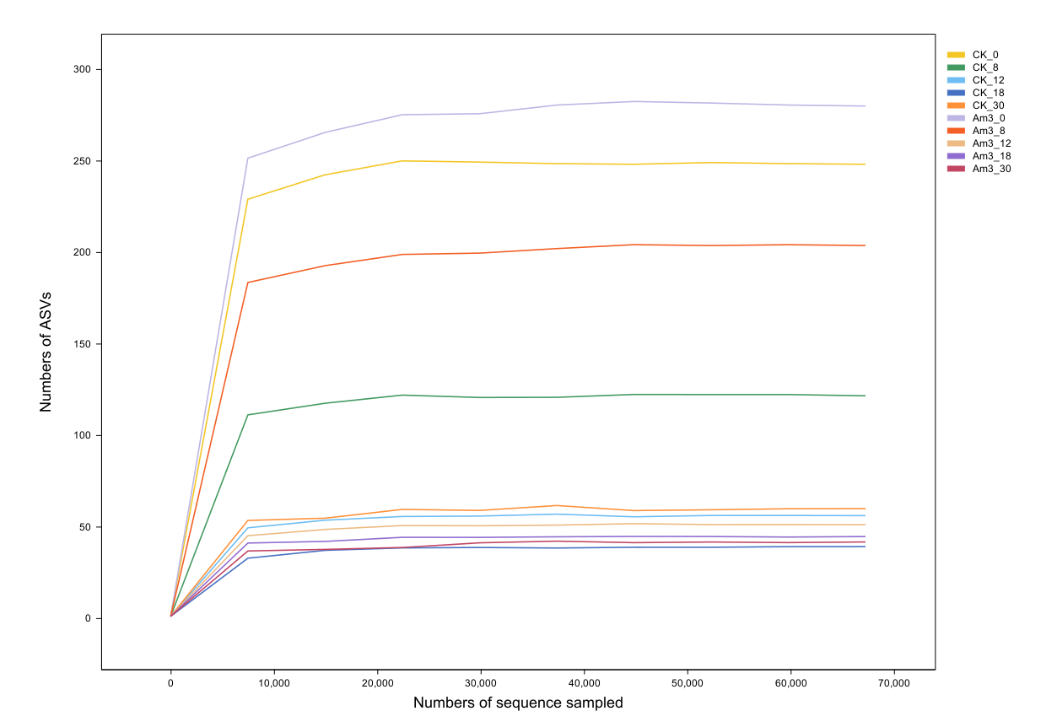
Fig. S3 Rarefaction curves of fungal communities during AESSF process.
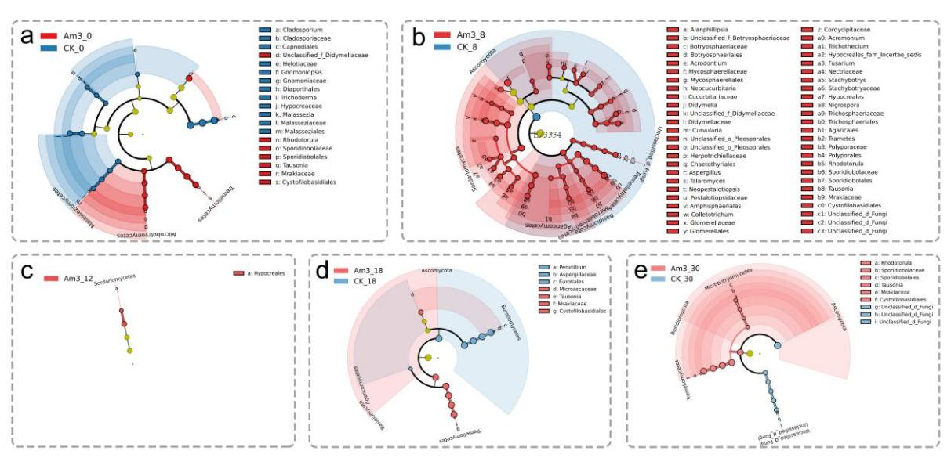
Fig. S4 Linear discriminant analysis effect size (LEfSe) revealing differential fungal taxa at different fermentation stages during AESSF process. (a) Day 0, (b) Day 8, (c) Day 12, (d) Day 18, and (e) Day 30.

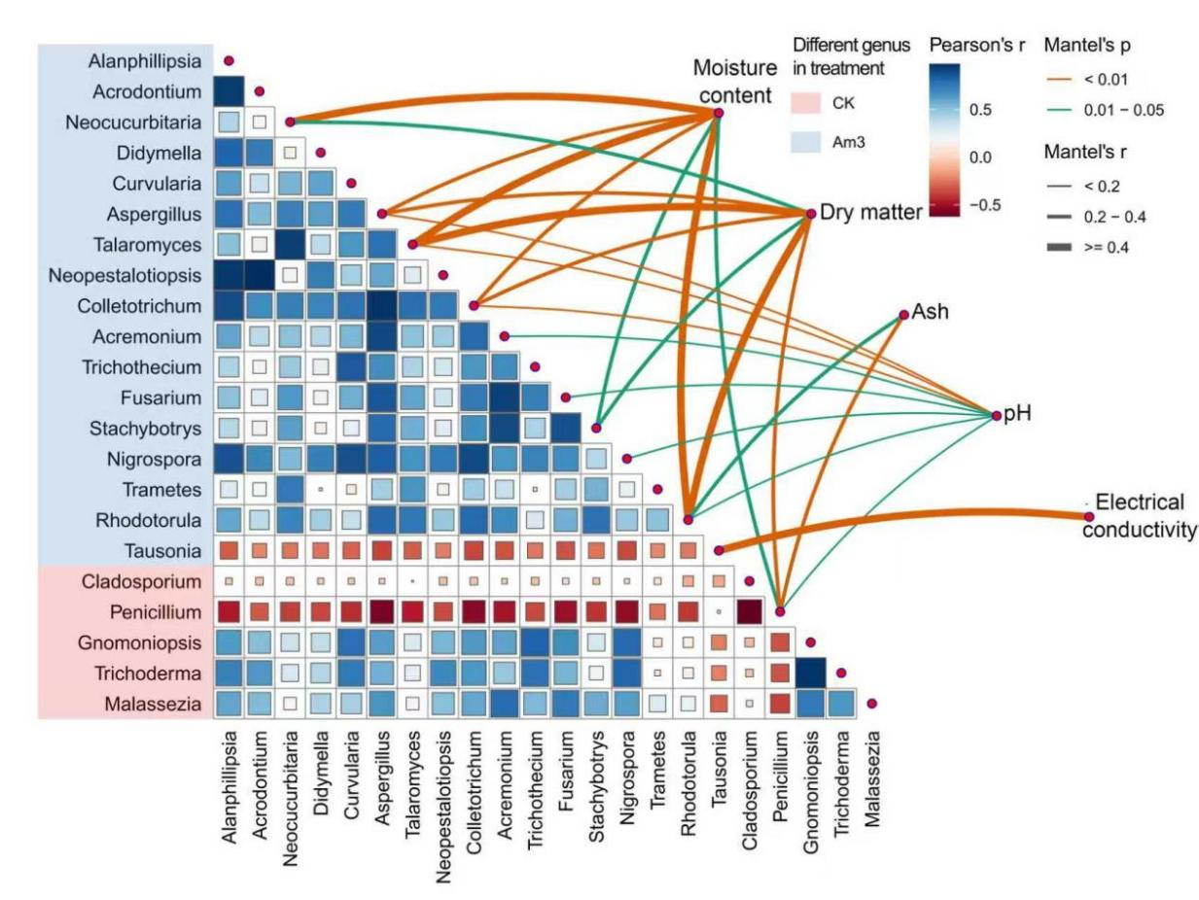
Fig. S5 Correlation analysis between the differential genera identified by LEfSe and environmental physicochemical parameters during AESSF process.
Table S1 Sensory evaluation of COC during AESSF process.
Treatment | Day | Odor | Color | Texture | Visible Fungal Growth
CK | 0 | Fragrant | Dark brown | Soft and compact | None
CK | 8 | Fragrant | Dark brown | Soft and loose | None
CK | 12 | Wine-like aroma | Dark brown | Soft and loose | Sparse white mycelia
CK | 18 | Slightly sour/musty | Dark brown | Hard | Significant mold colonization
CK | 24 | Unpleasant/Musty | Light brown | Hard | Extensive mold coverage
CK | 30 | Strong unpleasant odor | Light brown | Hard | Fully covered with mold
Am1 | 0 | Fragrant | Dark brown | Soft and compact | None
Am1 | 8 | Wine-like aroma | Dark brown | Soft and loose | None
Am1 | 12 | Wine-like aroma | Dark brown | Soft and loose | Trace white mycelia
Am1 | 18 | Slightly unpleasant | Light brown | Hard | Significant mold colonization
Am1 | 24 | Unpleasant/Musty | Light brown | Hard | Extensive mold coverage
Am1 | 30 | Strong unpleasant odor | Light brown | Hard | Fully covered with mold
Am3 | 0 | Fragrant | Dark brown | Soft and compact | None
Am3 | 8 | Wine-like aroma | Dark brown | Soft and loose | None
Am3 | 12 | Wine-like aroma | Dark brown | Soft and loose | Minor visible mycelia
Am3 | 18 | Toasted aroma | Surface blackened | Soft | Trace mycelia
Am3 | 24 | Toasted aroma | Surface blackened | Soft | Minimal/Near absence
Am3 | 30 | Pleasant toasted aroma | Surface blackened | Soft | No obvious mold
Am5 | 0 | Fragrant | Dark brown | Soft and compact | None
Am5 | 8 | Wine-like aroma | Dark brown | Soft and loose | None
Am5 | 12 | Wine-like aroma | Dark brown | Soft and loose | Minor visible mycelia
Am5 | 18 | Toasted aroma | Surface blackened | Soft | Trace mycelia
Am5 | 24 | Toasted aroma | Surface blackened | Soft | Minimal/Near absence
Am5 | 30 | Pleasant toasted aroma | Surface blackened | Soft | No obvious mold

