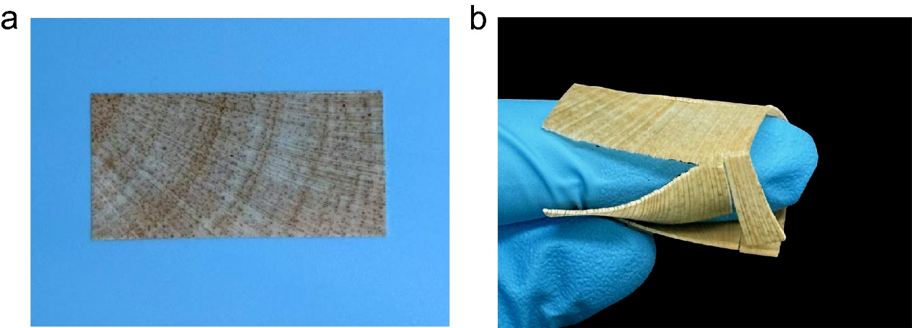
Fig. S1 Photograph of natural wood. (a) Cross-sectional photograph of natural wood. (b) Photograph of natural wood in a bent state, demonstrating its fragility.

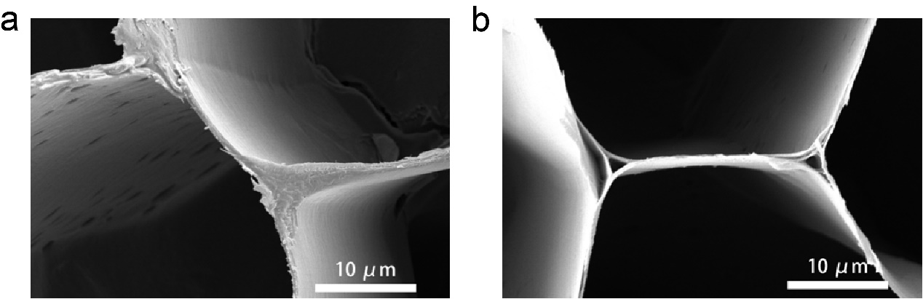
Fig. S2 SEM images of the wood cell wall in cross-section. (a) SEM image of the natural wood cell wall, showing a smooth cell wall. (b) SEM image of cell wall in DES-treated wood, demonstrating the dehiscent cell wall.

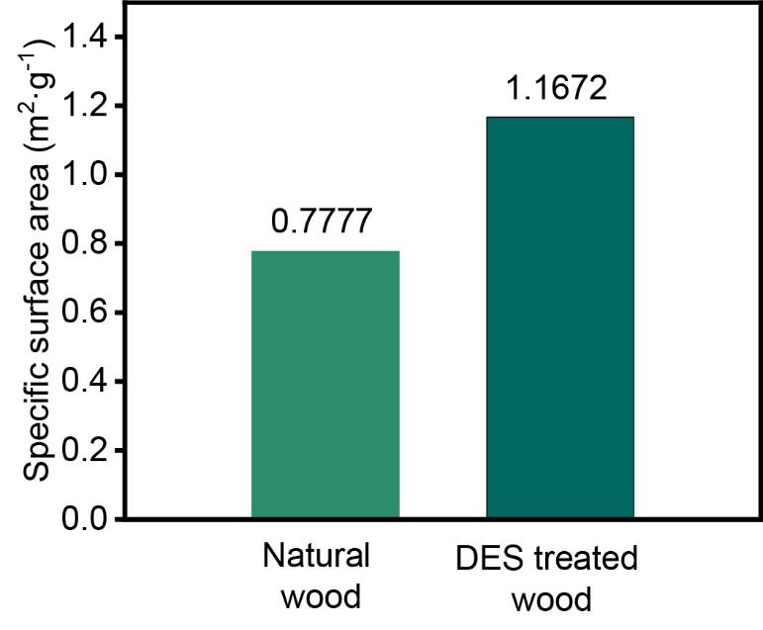
Fig. S3 The specific surface area of natural wood and DES treated wood, showing the DES treated wood with a higher specific surface area.

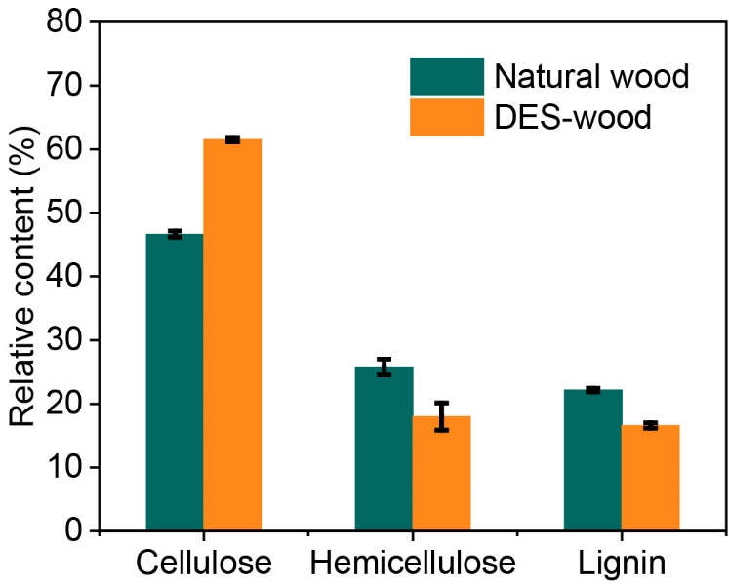
Fig. S4 Cellulose, hemicellulose, and lignin content of natural wood and DES treated wood, revealing the removal of hemicellulose and lignin after DES treatment.

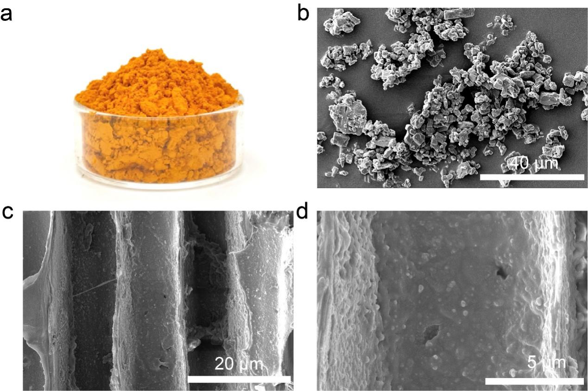
Fig. S5 (a) Macroscopic photograph of curcumin. (b) SEM images of curcumin. (c, d) SEM images of curcumin loading on wood cell wall, indicating successful loading of curcumin on the surface of wood cell wall.
Fig. S6 XRD spectra of DES treated wood and wood woundplast, indicating the successful combination between wood and PVA.
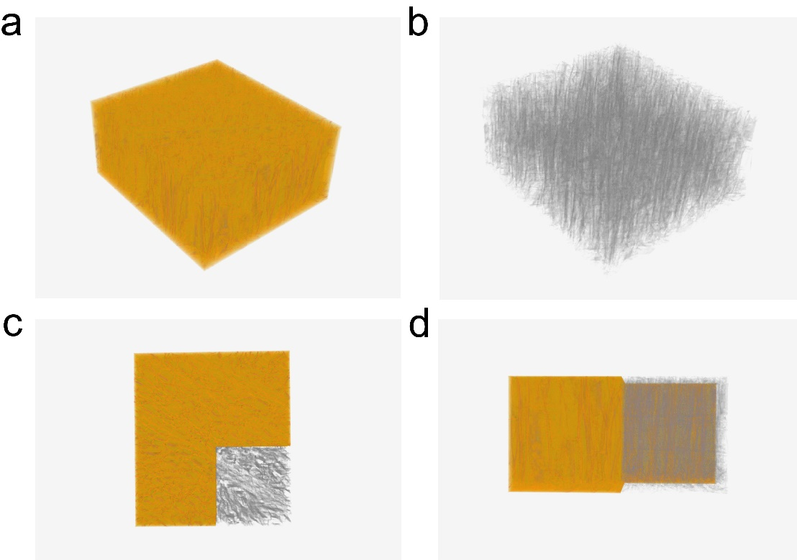
Fig. S7 CT images of wood woundplast. (a, b) PVA fills the wood cell walls, Grey indicates 3D skeletal structure of wood, yellow denotes PVA. (c, d) Top view and main view of wood woundplast, indicating the fully impregnation of PVA.

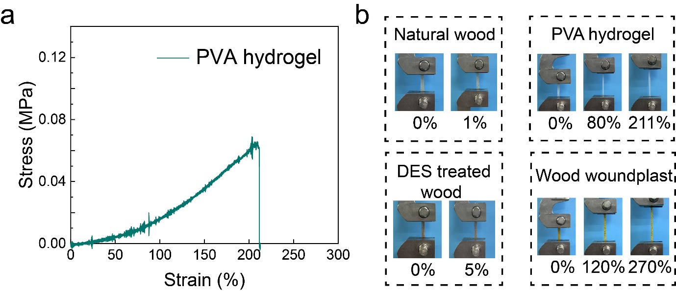
Fig. S8 (a) Mechanical properties of PVA hydrogel, wood woundplast representing 11.4 times stronger and 58.72% more ductile than PVA hydrogel. (b) The macroscopic photographs of natural wood, DES treated wood, PVA hydrogel, and wood woundplast during the stretching process, showing wood woundplast exhibits a high strain capacity of up to 270%.
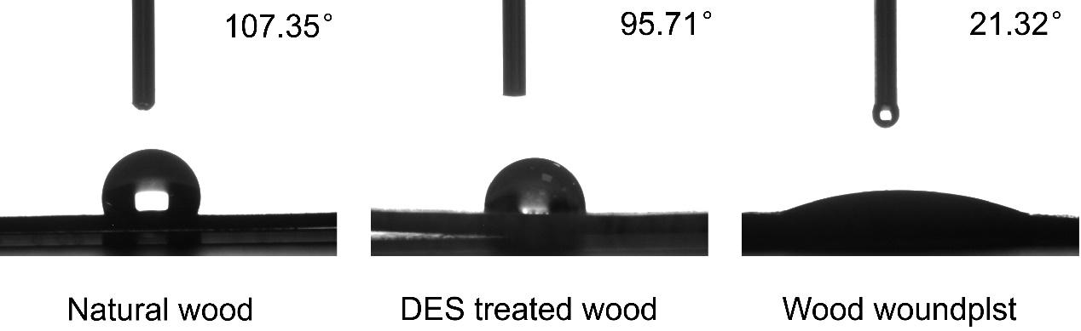
Fig. S9 Hydrophobic angle test of natural wood, DES treated wood, and wood woundplast, indicating the good hydrophilicity of wood woundplast.
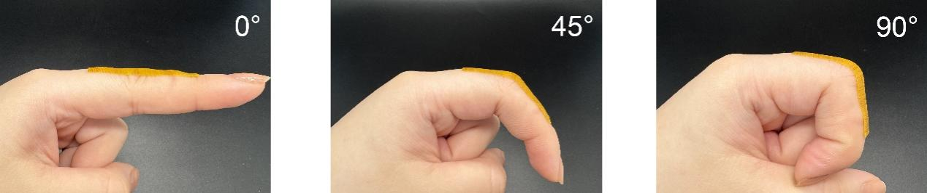
Fig. S1 Wood woundplast conforms well to the skin curvature, indicating the excellent skin adaptability.
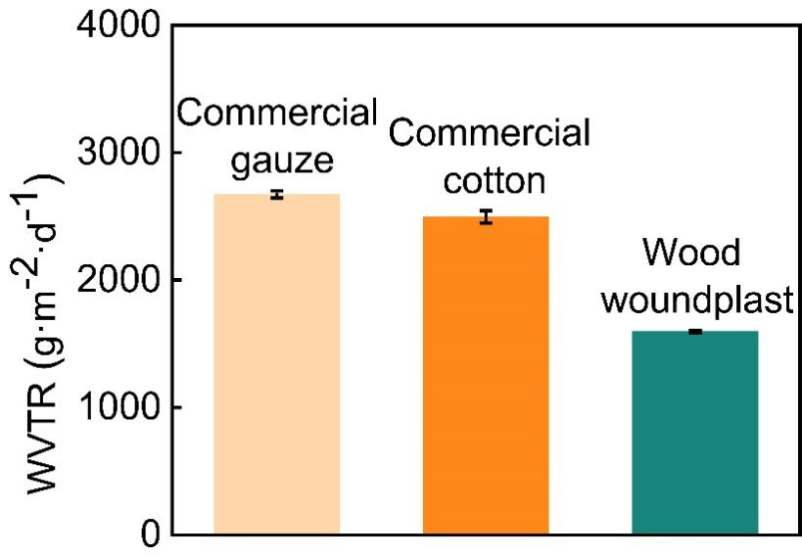
Fig. S11 The water vapor transmission rate (WVTR) of commercial gauze, cotton, and wood woundplast.
Table S1. The gene sequences of GAPDH, IL-6, IL-1β, TNF-α.
Genes | Primer | Sequence (5’-3’)
GAPDH | Forward | TGACCACAGTCCATGCCATC
GAPDH | Reverse | GACGGACACATTGGGGGTAG
IL-6 | Forward | TTCTTGGGACTGATGCTGGTG
IL-6 | Reverse | CACAACTCTTTTCTCATTTCCACGA
IL-1β | Forward | TGCCACCTTTTGACAGTGATG
IL-1β | Reverse | CATCTCGGAGCCTGTAGTGC
TNF-α | Forward | AGCACAGAAAGCATGATCCG
TNF-α | Reverse | CTGATGAGAGGGAGGCCATT

