1 Materials and Methods
1.1 Materials
All materials were purchased from Sinopharm Group Chemical reagent Co., Ltd. (Shanghai, China). Millipore water was used for all experiments.
1.2 Determination of the carboxyl content in the sample
Following the method of Ruan et al. [1] and making some modifications, the carboxyl content in each SPI sample (1 mg‧mL⁻¹) was determined by the conductivity titration method.
1.3 Determination of samples by frozen scanning electron microscopy
The O/W emulsions of different treated proteins were prepared according to the method in manuscript 2.4.2.3, and the surface morphology of the samples was observed and images were taken using a cryo-scanning electron microscope (Gemini 30, ZEISS, Germany).
References
[1] Ruan C Q, Strømme M, Mihranyan A , et al. Favored surface-limited oxidation of cellulose with Oxone® in water. RSC Advances, 2017, 7(64): 40600–40607.
Table S1 Design and results of response surface experiment.
Test number | Factors and codes |  |  | Real factors and levels |  |  | DD (%) | DH (%)
Test number | A | B | C | T/℃ | pH | E/S (U/g) | DD (%) | DH (%)
1 | -1 | -1 | 0 | 50 | 6 | 21.5 | 45.07 ± 2.59 | 1.58 ± 0.57
2 | 1 | -1 | 0 | 60 | 6 | 21.5 | 45.40 ± 2.13 | 1.00 ± 0.07
3 | -1 | 1 | 0 | 50 | 8 | 21.5 | 46.38 ± 1.34 | 1.84 ± 0.29
4 | 1 | 1 | 0 | 60 | 8 | 21.5 | 42.77 ± 1.69 | 1.72 ± 0.18
5 | -1 | 0 | -1 | 50 | 7 | 13 | 43.31 ± 1.02 | 1.16 ± 0.10
6 | 1 | 0 | -1 | 60 | 7 | 13 | 42.91 ± 2.04 | 0.94 ± 0.08
7 | -1 | 0 | 1 | 50 | 7 | 30 | 46.38 ± 1.02 | 1.13 ± 0.14
8 | 1 | 0 | 1 | 60 | 7 | 30 | 43.42 ± 0.21 | 0.72 ± 0.06
9 | 0 | -1 | -1 | 55 | 6 | 13 | 45.66 ± 0.90 | 1.08 ± 0.17
10 | 0 | 1 | -1 | 55 | 8 | 13 | 44.69 ± 2.61 | 1.60 ± 0.15
11 | 0 | -1 | 1 | 55 | 6 | 30 | 46.26 ± 4.44 | 1.06 ± 0.14
12 | 0 | 1 | 1 | 55 | 8 | 30 | 46.54 ± 0.98 | 1.39 ± 0.15
13 | 0 | 0 | 0 | 55 | 7 | 21.5 | 47.11 ± 1.01 | 0.92 ± 0.04
14 | 0 | 0 | 0 | 55 | 7 | 21.5 | 47.42 ± 4.46 | 0.87 ± 0.04
15 | 0 | 0 | 0 | 55 | 7 | 21.5 | 46.92 ± 1.08 | 0.93 ± 0.07
16 | 0 | 0 | 0 | 55 | 7 | 21.5 | 46.88 ± 0.66 | 0.89 ± 0.16
17 | 0 | 0 | 0 | 55 | 7 | 21.5 | 47.28 ± 1.29 | 0.91 ± 0.03

Table S2 Analysis of variance for the degree of deamidation model.
Sources of error | Sum of squares | Degree of freedom | Mean square | F value | P value
Model | 40.26 | 9 | 4.47 | 73.98 | < 0.0001***
A-T | 5.51 | 1 | 5.51 | 91.14 | < 0.0001***
B-pH | 0.5050 | 1 | 0.5050 | 8.35 | 0.0233*
C-E/S | 4.55 | 1 | 4.55 | 75.16 | < 0.0001***
AB | 3.88 | 1 | 3.88 | 64.18 | < 0.0001***
AC | 1.64 | 1 | 1.64 | 27.09 | 0.0012**
BC | 0.3906 | 1 | 0.3906 | 6.46 | 0.0386*
A² | 16.84 | 1 | 16.84 | 278.44 | < 0.0001***
B² | 0.1987 | 1 | 0.1987 | 3.29 | 0.1128
C² | 5.26 | 1 | 5.26 | 86.91 | < 0.0001***
Residual | 0.4233 | 7 | 0.0605
Lack of fit | 0.2100 | 3 | 0.0700 | 1.31 | 0.3864
Pure error | 0.2133 | 4 | 0.0533
Total | 40.69 | 16
Note: In the table, * indicates that the factor has a significant effect on the model (P < 0.05); ** indicates that the factor has a highly significant effect on the model (P < 0.01); *** indicates that the factor has an extremely significant effect on the model (P < 0.001).
Table S3 Analysis of variance for the degree of hydrolysis model.
Sources of error | Sum of squares | Degree of freedom | Mean square | F value | P value
Model | 1.81 | 9 | 0.2010 | 276.10 | < 0.0001***
A-T | 0.2211 | 1 | 0.2211 | 303.79 | < 0.0001***
B-pH | 0.4186 | 1 | 0.4186 | 575.13 | < 0.0001***
C-E/S | 0.0288 | 1 | 0.0288 | 39.57 | 0.0004***
AB | 0.0529 | 1 | 0.0529 | 72.68 | < 0.0001***
AC | 0.0090 | 1 | 0.0090 | 12.40 | 0.0097**
BC | 0.0090 | 1 | 0.0090 | 12.40 | 0.0097**
A² | 0.1188 | 1 | 0.1188 | 163.27 | < 0.0001***
B² | 0.9026 | 1 | 0.9026 | 1240.09 | < 0.0001***
C² | 0.0301 | 1 | 0.0301 | 41.31 | 0.0004***
Residual | 0.0051 | 7 | 0.0007
Lack of fit | 0.0028 | 3 | 0.0009 | 1.59 | 0.3235
Pure error | 0.0023 | 4 | 0.0006
Total | 1.81 | 16
Note: In the table, * indicates that the factor has a significant effect on the model (P < 0.05); ** indicates that the factor has a highly significant effect on the model (P < 0.01); *** indicates that the factor has an extremely significant effect on the model (P < 0.001).
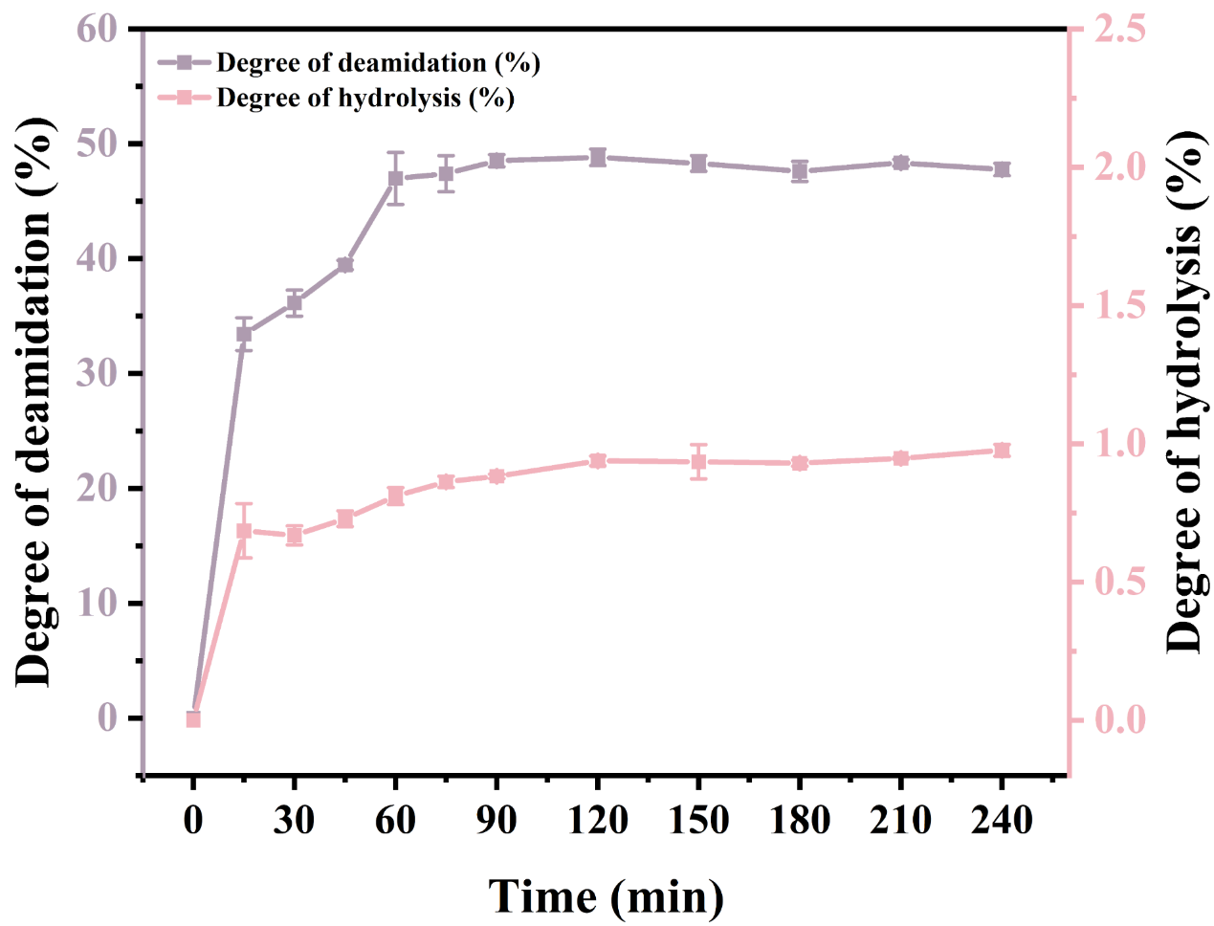
Fig. S1 Degrees of deamidation and hydrolysis of SPI at different processing times.

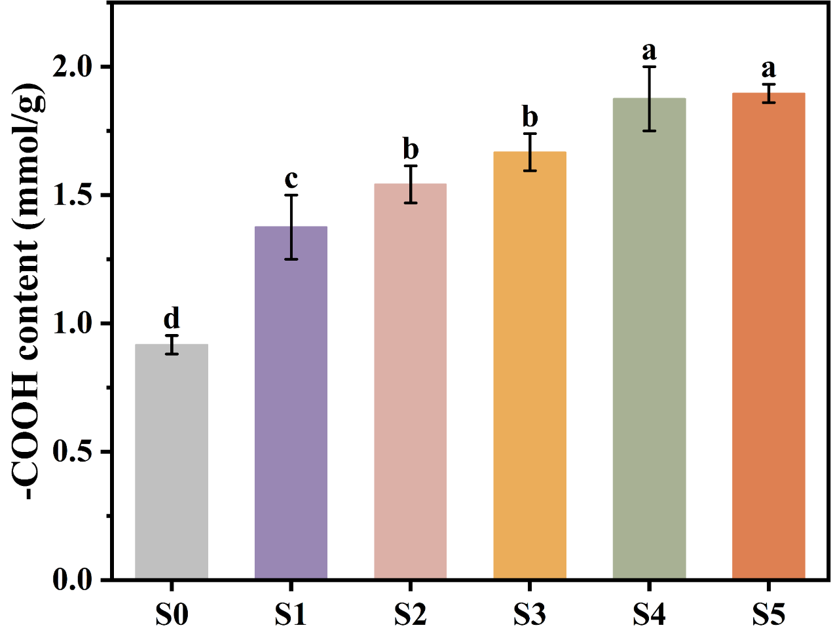
Fig. S2 The carboxyl content of different SPI samples.

Fig. S3 Cryo-SEM images of different samples.

