Supporting information
Engineered Biohydrogel Orchestrates Soil Hydro-Saline-Porous Microenvironments for Saline-Alkali Land Revitalization

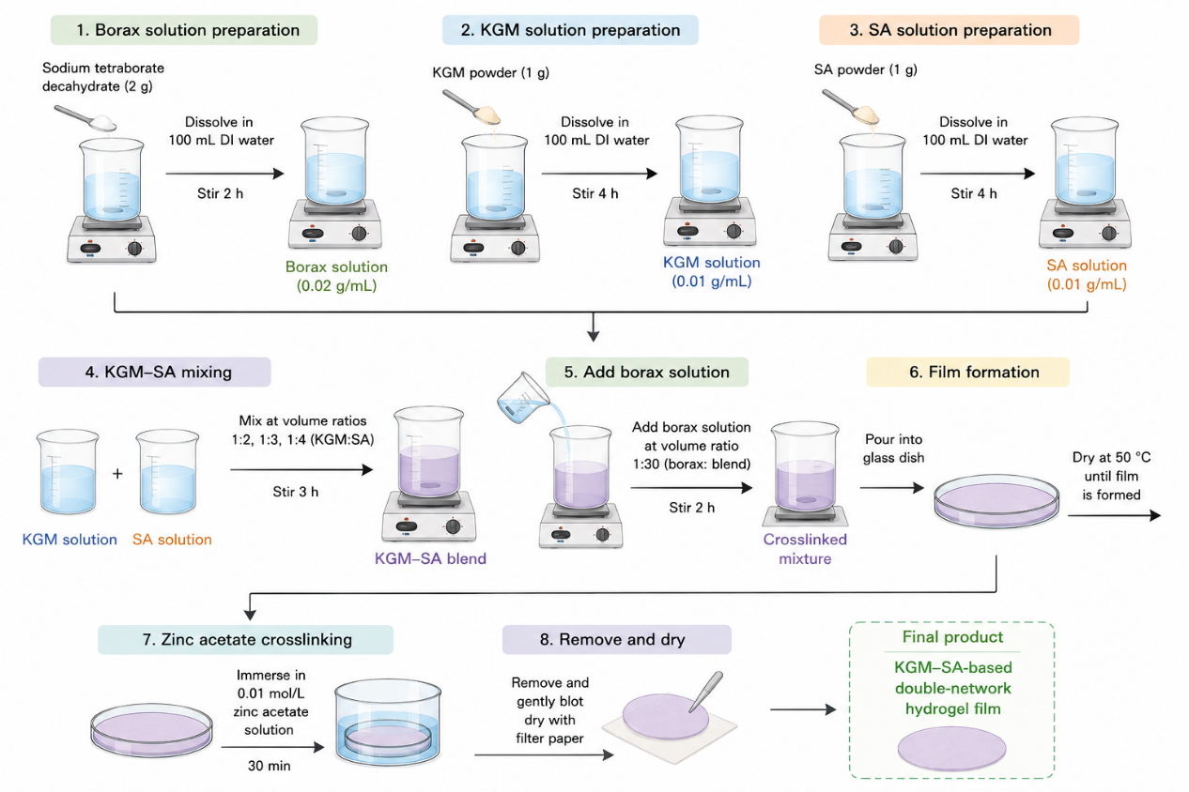
Fig. S1 Fabrication process of KGM–SA/B–Zn double-network hydrogel

Table S1
Sample | SA solution (0.01 g mL⁻¹) | KGM solution (0.01 g mL⁻¹) | SA:KGM (v/v) |  |  | Borax solution |  | Zn²⁺ treatment
SA₂₀KGM₄₀ | 20 mL | 40 mL |  | 1:2 |  | Borax solution added at 1:30 (v/v,) |  | 0.01 mol·L⁻¹ Zn(CH₃COO)₂, 30 min
SA₂₀KGM₆₀ | 20 mL | 60 mL |  | 1:3 | Same |  | Same
SA₂₀KGM₈₀ | 20 mL | 80 mL |  | 1:4 | Same |  | Same

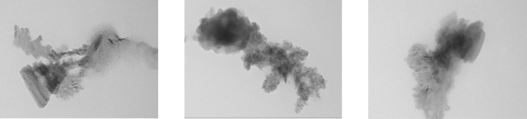
C
B
A
Fig. S2 TEM images of (A) KGM-SA (B) KGM-SA-B (C) KGM-SA-B-Zn.

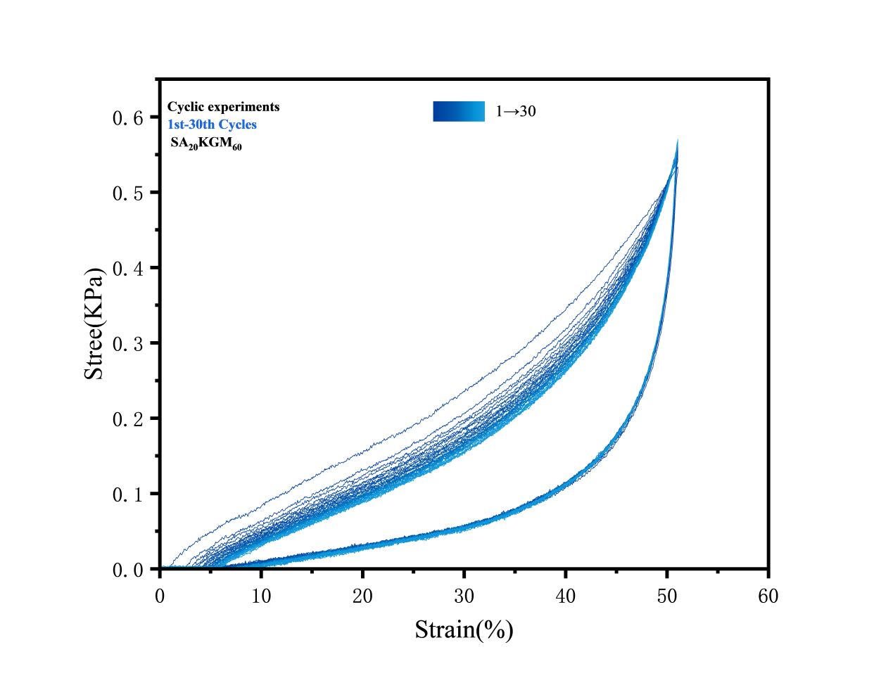
Fig. S3 Load-unload cyclic curves of SA₂₀KGM₆₀ in the cyclic experiment.

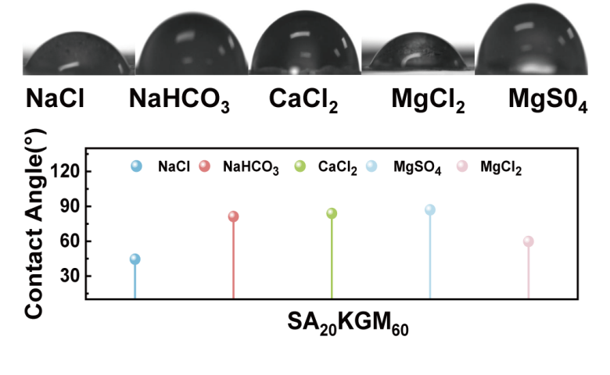
Fig. S4 Droplet photos and quantitative contact angle data of SA₂₀KGM_{60.}

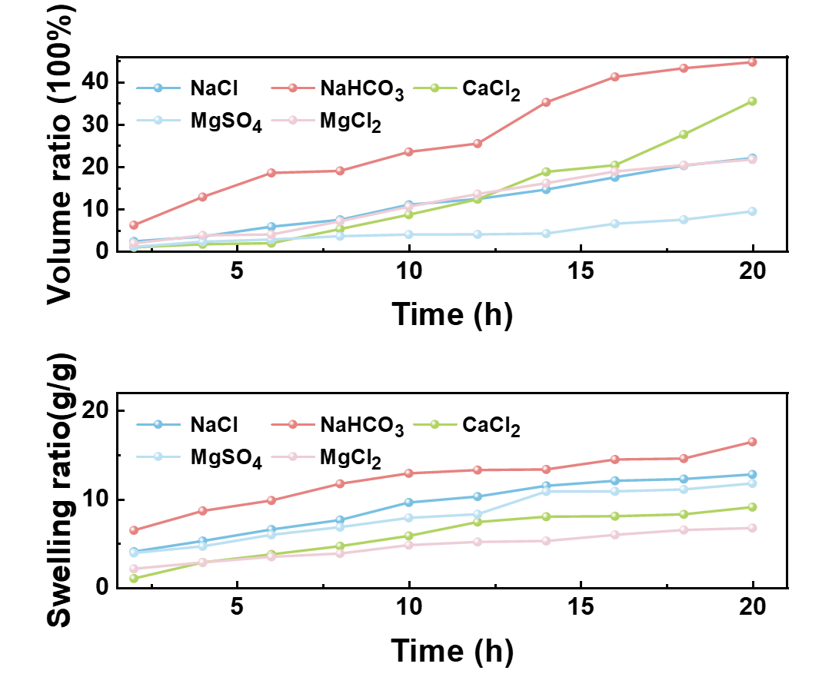
Fig. S5 Time-dependent volume ratio and swelling ratio of SA₂₀KGM₆₀ soaked in different salt solutions over 20 hours.

Table S2 Physicochemical properties of saline-alkali soil before and after treatment with SA₂₀KGM₆₀.
Sample | organic carbon(%) | total salt content(g/kg) | Basicity(%)
Soil | 0.70 | 12.0 | 54.4
Soil with SA₂₀GKM₆₀ | 0.99 | 8.2 | 34.5

