Article Title
Author name¹, … Author name ^{2,*}
Department of Automation, Tsinghua University, Beijing 100084, China
²School of Life Sciences, Tsinghua University, Beijing 100084, China
*Correspondence: Email address
Structured abstract (<250 words)
Background: Single-cell RNA sequencing…
Methods (There is no need for Review article): …
Results: In this study, we conducted…
Conclusions: DE analysis methods should be chosen for…
Keywords: single-cell; RNA-Seq; differential expression
Author summary: (<100 words, A brief summary of less than 100 words should be included, that will appear after the section of abstract in the maintext. The text should be distinct from the scientific abstract, and aims to make your reviews or findings accessible to a wide audience that includes both scientists and non-scientists)

1 INTRODUCTION
In recent years, RNA sequencing (RNA-Seq) technology has been widely used for studying transcriptomes [1]. Standard RNA-Seq experiments need millions of cells for sequencing [2,3], and therefore can only get averaged measurements of gene expressions of the cells sequenced. Many recent studies have shown that even phenotypically identical cells can have very different transcriptomic profiles [4,5]…

2 RESULTS
2.1 Title
We first used dataset GSE48968 from Gene Expression Omnibus (GEO) in our study（Tabel 1）. It contains scRNA-seq data of more than 1,700 primary mouse bone-marrow-derived dendritic cells, and has an average depth of 4.5±3.0 million read pairs per sample [32].

Table 1 Information of gene differential expression analysis methods used
Method | Model | Input | Platform | Threshold | Run time | Reference
SCDE | Poisson and Negative binomial model | Read counts matrix | R(package) | P-value | Minutes | [13]
monocle | Generalized additive models | Read counts matrix | R(package) | P-value | Minutes | [14]
D3E | Non-parametric (Test of distribution) | Read counts matrix | Python(Package) | P-value | 1 hour | [15]
SAMseq | Non-parametric (resampling) | Read count matrix | R(package) | P-value | Minutes | [30]

2.2 Title
We first studied the number of DEG detected by different methods in all the experiments…
2.3 Title
Because SCDE, D3E, BPSC, edgeR, NBPSeq, limma, ballgown and SAMseq could not do the analysis of one sample vs one sample [11,13,15,16,25,28–30]…

…

3 DISCUSSION

4 CONCLUSIONS (if any)

5 MATERIALS AND METHODS (There is no need for Review article)
5.1 Title
For studies … normalizing each data point proportionately (Figure 1). For studies that did not require more than one day of analysis, no normalization was necessary, other than for purposes of data visualization.
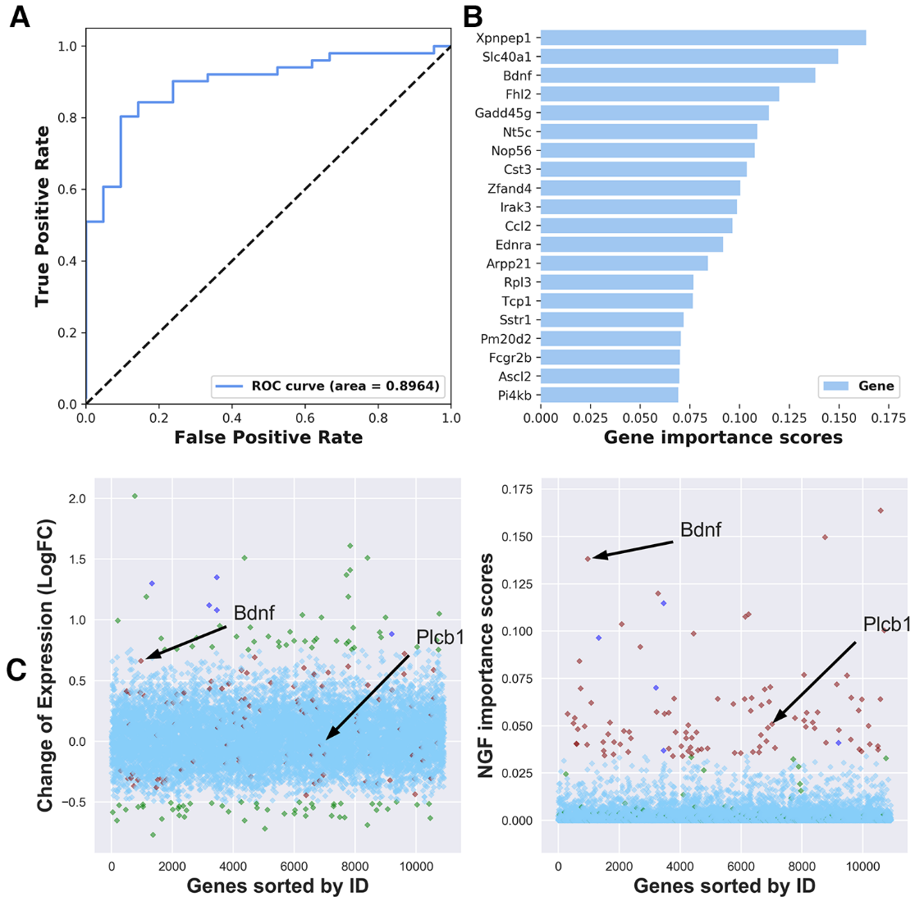

Figure 1. Area under ROC and gene importance scores obtained by NGF. (A) NGF (10,000 trees) shows a high AUC of 0.8964. (B) Top 20 genes ranked by NGF. Gene importance scores given by NGF are represented on x-axis, and gene names ordered by their importance are shown on y-axis. (C) Left: differentially expressed genes (DEGs) by fold change; Right: NGF gene importance scores. The top 100 DEGs (green) and the top 100 genes with the highest NGF importance scores (maroon) are shown. The genes that are in both top lists are shown as blue. Other genes are shown as light sky blue. Overall, the top 100 genes ranked by NGF tend to be differentially expressed but also consist of genes with little variability. Bdnf and Plcb1 are pointed out, as they are important genes related to neuronal regeneration, and they get much higher rank by NGF.

5.2 Title
For studies … normalizing each data point proportionately (Figure 1). For studies that did not require more than one day of analysis, no normalization was necessary, other than for purposes of data visualization.
…

SUPPLEMENTARY MATERIALS (if any)

ACKNOWLEDGEMENTS

COMPLIANCE WITH ETHICS GUIDELINES
The authors declare that they have no conflict of interest or financial conflicts to disclose.
All procedures performed in studies involving animals were in accordance with the ethical standards of the institution or practice at which the studies were conducted, and with the 1964 Helsinki declaration and its later amendments or comparable ethical standards.

REFERENCES
Article in a periodical:
Surname First Initials (NOTE: up to 10 authors before et al.). Year Article title. Abbrev journal title Volume, Complete article page range. (If no page range but an epub article number, please also include DOI.)
e.g., Colwell, R. K., Chao, A., Gotelli, N. J., Lin, S.-Y., Mao, C. X., Chazdon, R. L. and Longino, J. T. (2012) Models and estimators linking individual-based and sample-based rarefaction, extrapolation and comparison of assemblages. J. Plant Ecol., 5, 3–2
Article in a book:
Surname First Initials (NOTE: up to 10 authors before et al.). Year Chapter title, if used. In: Book title. (editors, if included), Chapter page range (if chapter is cited). City: Publisher
King, S.M. (2003). Dynein motors: Structure, mechanochemistry and regulation. In: Molecular Motors, Schliwa, M. ed. Weinheim, 45–78. Germany: Wiley-VCH Verlag GmbH
An entire book:
Surname First Initials (NOTE: up to 10 authors before et al.). Year Book title. Page range. City: Publisher,
Gaydon, A. G. and Wolfhard, H. G. (1960) Flames. 2nd ed. 30―35. London: Chapman and Hall Ltd
Preprint servers:
Preprints deposited in bioRxiv, for example, should be cited using their digital object identifier (doi).
e.g., Gaydon, A. G. and Wolfhard, H. G. Models and estimators linking individual-based and sample-based rarefaction, extrapolation and comparison of assemblages. bioRxiv doi: 10.1101/123456.
Dissertation for Degree:
Surname First Initials. The title of the dissertation. Dissertation for the Doctoral Degree, Page range. The city of the University: University
e.g., Chen, B. (1998) Theoretical studies of dielectronic recombination for Be-like titanium, molybdenum, gold and lead ions and spectrum for highly ionized titanium and gold atoms. Ph. D. Thesis, 99―100. Chengdu: Sichuan University
Proceedings:
Surname First Initials. Year. The title of the article. In: Abbrev Proceedings names, Page range. The city of the publisher: Publisher
e.g., Ding, H., Chen, S., Zeng, S., Zeng, S., Liu, Q. and Luo, Q. (2008) Computation and visualization of spreading depression based on reaction-diffusion equation with recovery. In Proc. SPIE, 7280

