Supplementary Materials and Methods

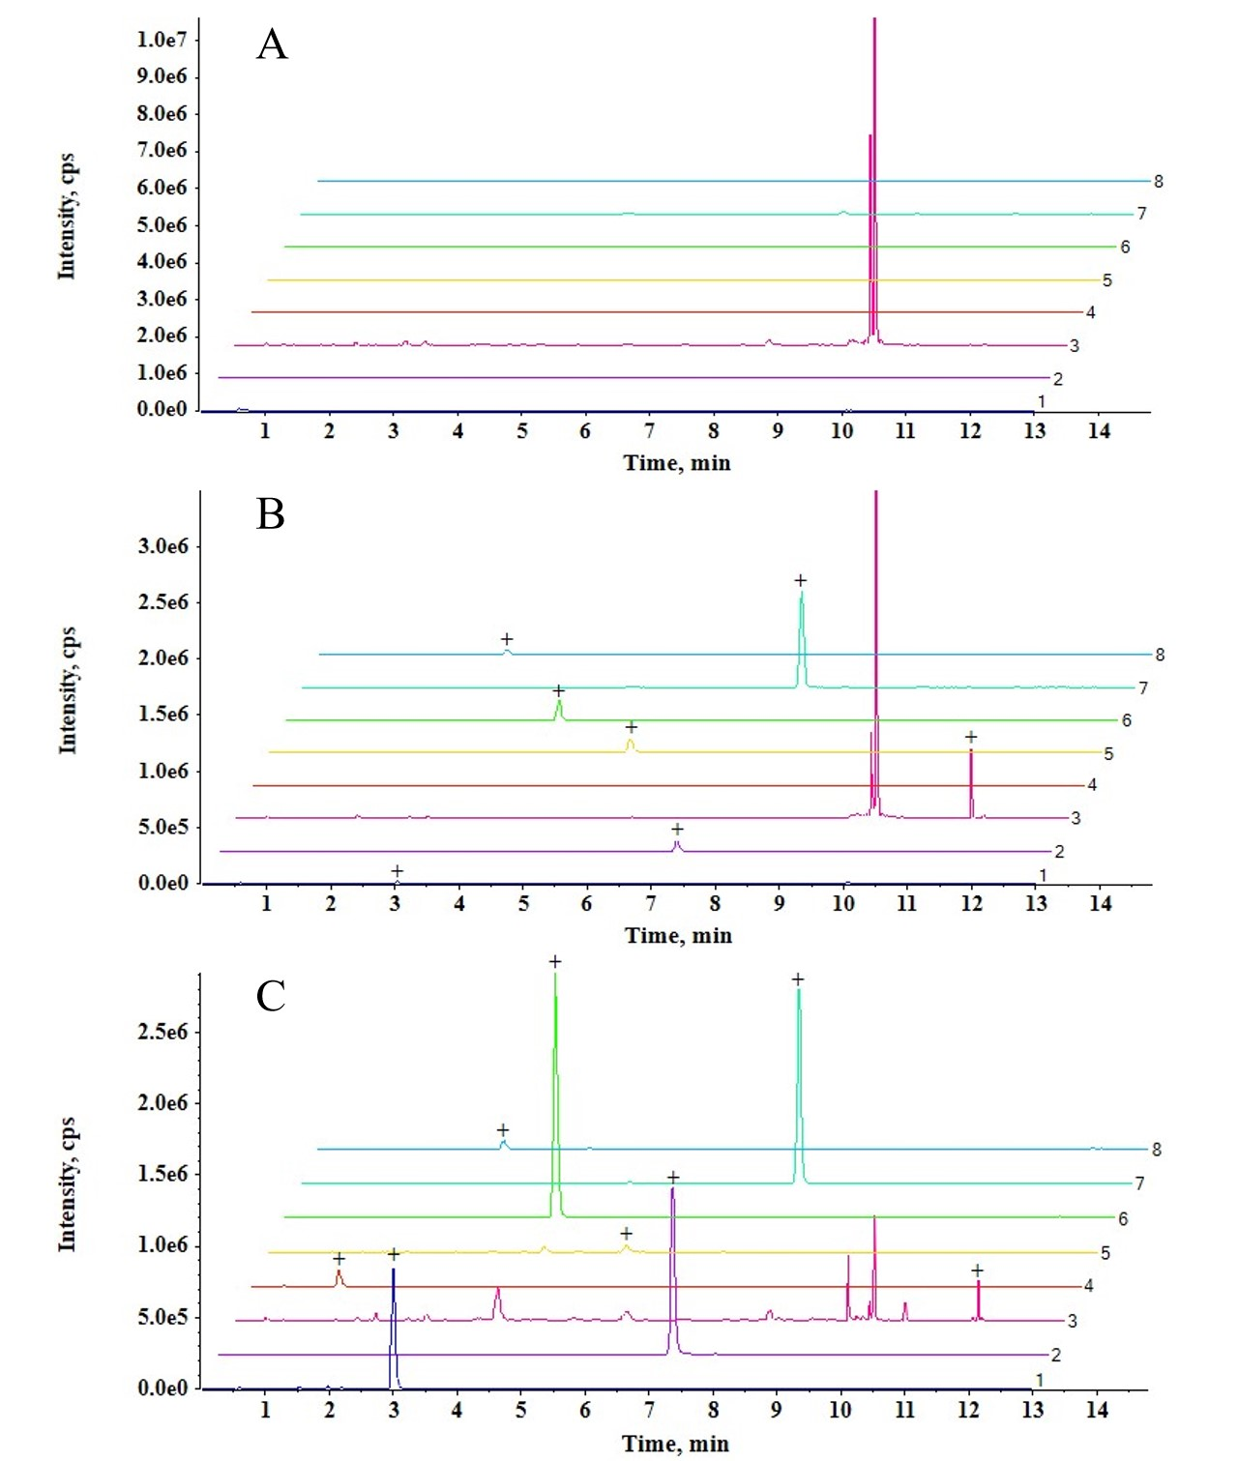
Fig. S1 The specificity results of 7 analytes and internal standards. A: blank plasma samples, B: blank plasma samples spiked with seven analytes and ISs at LLOQ, C: plasma samples obtained 30 min after oral administration of JHP; 1: Tetrahydropalmatine (Rt: 2.98), 2: Dehydrocorydaline (Rt: 7.07), 3: Costunolide (Rt: 11.50, Rt: 11.63), 4: Rhamnosylvitexin (Rt: 1.35), 5: Palmatine hydrochloride (Rt: 5.57), 6: Corydaline (Rt: 4.18), 7: Hydrocortisone (IS, Rt: 7.76), 8: Allocryptopine (Rt: 2.87).

Tabel S1 Key compound screening in JHT intervention for CSG.
Compound name | Similarity  score | Similarity  rank | Significance  score | Significance  rank | Quality  control | Reported
Alismol | 0.911 | 1 | 56.6419421 | 7
Dehydrocostus lactone | 0.91 | 2 | 53.12944903 | 8 | yes
Meliastatin 5 | 0.909 | 3 | 90.38514745 | 2
Mokko lactone; 11α,13-dihydrodehydrocostuslactone | 0.903 | 4 | 43.26264468 | 12
5-caffeoyl quinic acid | 0.9 | 5 | 29.02861446 | 33
4-caffeoyl quinic acid | 0.9 | 6 | 29.02861446 | 34
Toosendanin | 0.899 | 7 | 50.17340942 | 9 | yes | yes
4-P-coumaroylquinic acid | 0.897 | 8 | 23.33032857 | 41
5-P-coumaroylquinic acid | 0.897 | 9 | 23.33032857 | 42
3-P-coumaroylquinic acid | 0.897 | 10 | 23.33032857 | 43
10-acetyl-trichoderonic-acid | 0.897 | 11 | 92.7345832 | 1
Isotoosendanin | 0.896 | 12 | 49.45760474 | 10 |  | yes
1,4-epoxy-6-deoxypseudoanisatin | 0.896 | 13 | 88.10412153 | 3
Trichilenone | 0.894 | 14 | 59.63411248 | 5
Cynarin (isomer) | 0.892 | 15 | 21.42237562 | 51
Isochlorogenic acid B | 0.892 | 16 | 21.4443221 | 48 |  | yes
Isochlorogenic acid C | 0.892 | 17 | 21.4443221 | 49 |  | yes
Isochlorogenic acid A | 0.892 | 18 | 21.4443221 | 50
6-deoxypseudoanisatin (isomer 1) | 0.892 | 19 | 84.22786959 | 4
Colartin | 0.89 | 20 | 33.09126191 | 22
Syringin | 0.89 | 21 | 26.39908262 | 35
Methoxyeugenol | 0.888 | 22 | 25.0234234 | 39
Ohchinal | 0.886 | 23 | 25.13131841 | 38
(-)-secoisolariciresinol-O-α-L-rhamnopyranoside | 0.886 | 24 | 48.27766387 | 11
Abscisic acid | 0.882 | 25 | 37.92343956 | 15
Costunolide | 0.878 | 26 | 22.26711707 | 45 | yes
(+)-dihydrocostunolide | 0.878 | 27 | 16.46194583 | 60
Rhamnosylvitexin | 0.878 | 28 | 12.19839438 | 66
Nimbolinin B | 0.877 | 29 | 26.2782404 | 36
Salannin | 0.876 | 30 | 23.03614802 | 44
1-deacetylnimbolinin A | 0.873 | 31 | 19.70303336 | 55
Kaempferol-3-O-rutinoside | 0.871 | 32 | 14.27968022 | 63
Kaempferol | 0.869 | 33 | 20.17237154 | 53
Protocatechuic acid | 0.864 | 34 | 11.36816383 | 67
Caffeic acid | 0.863 | 35 | 19.94662981 | 54
Allocryptopine | 0.854 | 39 | 17.02803248 | 59 |  | yes
Oblongine | 0.853 | 40 | 31.47090254 | 26
Dehydrocorybulbine | 0.852 | 41 | 40.12874538 | 14
(-)-corydalmine | 0.851 | 44 | 29.1292742 | 29
(-)-scoulerin | 0.851 | 45 | 29.1292742 | 30
(-)-isocorypalmine | 0.851 | 46 | 29.1292742 | 31
(-)-stepholidine | 0.851 | 47 | 29.1292742 | 32
Yuanhunine | 0.85 | 48 | 32.24416938 | 24
(+)-isocorybulbine | 0.85 | 49 | 32.24416938 | 25
(-)-cheilanthifoline | 0.842 | 52 | 33.06659636 | 23
Tetrahydropalmatine | 0.84 | 53 | 37.54518547 | 16 | yes | yes
Corydaline | 0.84 | 54 | 35.433683 | 21 |  | yes
N-methyltetrahydropalmatine | 0.84 | 55 | 37.54518547 | 17
(-)-tetrahydrocoptisine | 0.837 | 56 | 35.73200076 | 18
Canadine | 0.836 | 57 | 35.51759504 | 19
(-)-tetrahydroepiberberine | 0.836 | 58 | 35.51759504 | 20
Oxoglaucine | 0.815 | 61 | 57.04825066 | 6
Dehydrocorydaline | 0.811 | 62 | 25.97939528 | 37 |  | yes
Palmatine | 0.805 | 64 | 40.14120625 | 13 |  | yes
Coptisine | 0.795 | 65 | 29.47921416 | 28
1-(3-carboxypropyl)-3,7-Dimethylxanthine | 0.656 | 67 | 30.56876254 | 27

Tabel S2 Results of specifity experiments (n = 13).
Compounds | Blank plama  (mean ± SD) | LLOQ  (mean ± SD)
Tetrahydropalmatine | 2188±3233 | 192308±37805
Dehydrocorydaline | 22260 ±27984 | 875077 ±147787
Costunolide | 71946±25352 | 1565308±292323
Rhamnosylvitexin | 627±258 | 33031±7199
Palmatine chloride | 3410±1305 | 1468077±279709
Corydaline | 37836±90667 | 1727692±332595
Allocryptopine | 17715±18895 | 509308±95496
Hydrocortisone (IS) | 9892±12936 | 5789231±985363

Tabel S3 Regression equation, linear ranges and LLOQs of 7 analytes in rat plasma.
Compounds | Regression equation | r | Linear range  (ng/mL) | LLOQ  (ng/mL)
Corydaline | y=0.218x+0.0484 | 0.9954 | 1.12~40 | 1.12
Tetrahydropalmatine | y=0.0134x+0.00669 | 0.9930 | 1.12~40 | 1.12
Palmatine chloride | y=0.0738x+0.0254 | 0.9990 | 2.80~100 | 2.80
Costunolide | y=0.0147x+0.00971 | 0.9988 | 7.00~250 | 7.00
Allocryptopine | y=0.0758x+0.0156 | 0.9943 | 0.70~25 | 0.70
Rhamnosylvitexin | y=0.00108x+0.000161 | 0.9978 | 0.70~25 | 0.70
Dehydrocorydaline | y=0.223x+0.0351 | 0.9970 | 0.56~20 | 0.56

Table S4 Intra- and inter-day precision and accuracy of seven analytes in rat plasma
Compounds | Spiked  conc.  (ng/mL) | Intra-day (n = 6) |  |  | Inter-day (n = 18)
Compounds | Spiked  conc.  (ng/mL) | Measured conc.  (ng/mL) | Precision  RSD% | Accuracy  RE% | Measured conc.  (ng/mL) | Precision  RSD% | Accuracy  RE%
Corydaline | 1.12 | 1.16±0.08 | 6.75 | 3.15 | 1.17±0.05 | 4.42 | 2.01
Corydaline | 2.40 | 2.41±0.06 | 2.59 | 0.49 | 2.40±0.09 | 3.87 | 0.00
Corydaline | 6.00 | 6.37±0.12 | 1.82 | 6.08 | 6.17±0.26 | 4.14 | 2.78
Corydaline | 30.00 | 30.93±0.76 | 2.45 | 3.11 | 29.49±1.77 | 6.02 | -1.70
Tetrahydropalmatine | 1.12 | 1.00±0.06 | 5.62 | -10.83 | 1.09±0.08 | 7.73 | -2.55
Tetrahydropalmatine | 2.40 | 2.38±0.05 | 1.98 | -0.69 | 2.41±0.09 | 3.68 | 0.44
Tetrahydropalmatine | 6.00 | 6.50±0.20 | 2.33 | 8.53 | 6.40±0.30 | 3.95 | 5.83
Tetrahydropalmatine | 30.00 | 29.63±0.83 | 2.79 | -1.22 | 29.29±1.68 | 5.73 | -2.37
Palmatine chloride | 2.80 | 2.79±0.06 | 2.21 | -0.22 | 2.91±0.13 | 4.43 | 4.05
Palmatine chloride | 6.00 | 5.78±0.08 | 1.42 | -3.75 | 5.76±0.27 | 4.67 | -3.94
Palmatine chloride | 15.00 | 15.13±0.16 | 1.08 | 0.89 | 14.56±0.62 | 4.28 | -2.93
Palmatine chloride | 75.00 | 80.52±2.54 | 3.15 | 7.36 | 76.46±3.54 | 4.62 | 1.95
Costunolide | 7.00 | 6.92±0.29 | 4.24 | -1.14 | 6.79±0.99 | 14.57 | -2.91
Costunolide | 15.00 | 14.12±0.50 | 3.51 | -5.89 | 13.98±1.18 | 8.46 | -6.78
Costunolide | 37.50 | 34.75± 1.23 | 3.55 | -7.33 | 33.67±1.79 | 5.33 | -10.22
Costunolide | 187.50 | 184.00±2.61 | 1.42 | -1.87 | 173.83±9.54 | 5.49 | -7.29
Allocryptopine | 0.70 | 0.68±0.04 | 5.20 | -2.45 | 0.73±0.08 | 10.74 | 3.73
Allocryptopine | 1.50 | 1.48±0.05 | 3.31 | -1.33 | 1.51±0.07 | 4.93 | 0.93
Allocryptopine | 3.75 | 4.07±0.04 | 0.87 | 8.53 | 4.02±0.23 | 5.77 | 7.20
Allocryptopine | 18.75 | 18.90±0.46 | 2.44 | 0.80 | 19.03±0.75 | 3.92 | 1.48
Rhamnosylvitexin | 0.70 | 0.60±0.06 | 10.64 | -13.62 | 0.72±0.11 | 14.92 | 3.52
Rhamnosylvitexin | 1.50 | 1.38±0.12 | 8.35 | -8.00 | 1.45±0.12 | 8.24 | -3.19
Rhamnosylvitexin | 3.75 | 3.72±0.12 | 3.16 | -0.84 | 3.75±0.31 | 8.32 | 0.12
Rhamnosylvitexin | 18.75 | 20.08±0.86 | 4.30 | 7.11 | 20.19±1.75 | 8.68 | 7.67
Dehydrocorydaline | 0.56 | 0.55±0.01 | 2.55 | -2.27 | 0.55±0.05 | 8.75 | -2.49
Dehydrocorydaline | 1.20 | 1.20±0.03 | 2.84 | -0.42 | 1.16±0.06 | 5.28 | -3.24
Dehydrocorydaline | 3.00 | 3.16±0.07 | 2.31 | 5.17 | 2.99±0.17 | 5.74 | -0.46
Dehydrocorydaline | 15.00 | 15.10±0.30 | 1.91 | 0.33 | 14.70±14.70 | 2.75 | -2.19

Table S5 Recoveries and matrix effects of seven analytes in rat plasma (n = 6)
Compounds | Concentration (ng/mL) | Extraction recovery (%) |  | Matrix effects
Compounds | Concentration (ng/mL) | Average (%) | RSD (%) | Average | RSD (%)
Corydaline | 2.40 | 77.07 | 14.75 | 1.10 | 4.40
Corydaline | 6.00 | 83.68 | 5.36 | 1.11 | 3.16
Corydaline | 30.00 | 73.80 | 9.23 | 1.09 | 3.35
Tetrahydropalmatine | 2.40 | 74.97 | 11.65 | 1.17 | 4.30
Tetrahydropalmatine | 6.00 | 81.63 | 5.33 | 1.19 | 4.79
Tetrahydropalmatine | 30.00 | 76.66 | 14.70 | 1.12 | 4.35
Palmatine chloride | 6.00 | 76.94 | 12.74 | 1.10 | 3.09
Palmatine chloride | 15.00 | 83.40 | 3.54 | 1.04 | 2.39
Palmatine chloride | 75.00 | 73.86 | 9.06 | 0.99 | 2.85
Costunolide | 15.00 | 75.81 | 14.70 | 1.60 | 4.61
Costunolide | 37.50 | 82.70 | 7.41 | 1.57 | 5.70
Costunolide | 187.50 | 81.50 | 11.75 | 1.57 | 1.86
Allocryptopine | 1.50 | 75.25 | 13.60 | 1.16 | 4.80
Allocryptopine | 3.75 | 82.00 | 2.34 | 1.19 | 4.22
Allocryptopine | 18.75 | 76.56 | 14.95 | 1.14 | 4.92
Rhamnosylvitexin | 1.50 | 68.83 | 13.63 | 0.71 | 14.85
Rhamnosylvitexin | 3.75 | 77.43 | 6.45 | 0.77 | 10.18
Rhamnosylvitexin | 18.75 | 71.17 | 9.63 | 0.82 | 12.44
Dehydrocorydaline | 1.20 | 77.33 | 12.21 | 1.06 | 1.28
Dehydrocorydaline | 3.00 | 85.10 | 2.70 | 0.99 | 2.03
Dehydrocorydaline | 15.00 | 73.15 | 9.87 | 0.95 | 2.17

Table S6 Stability results of seven analytes in rat plasma (n = 6)
Compounds | Spiked conc.  (ng/mL) | Short-term stability  (room temperature for 4 h) |  |  | Freeze-thaw stability three freeze-thaw  cycles |  |  | Auto-sampler stability  (4℃ for 24 h) |  |  | long-term stability  (-80 °C for 30 days)
Compounds | Spiked conc.  (ng/mL) | Measured conc. (ng/mL) | RSD  (%) | RE  (%) | Measured conc. (ng/mL) | RSD  (%) | RE  (%) | Measured conc. (ng/mL) | RSD  (%) | RE  (%) | Measured conc. (ng/mL) | RSD  (%) | RE  (%)
Corydaline | 2.4 | 2.4±0.05 | 2.28 | -0.21 | 2.41±0.17 | 7.19 | 0.42 | 2.29±0.12 | 5.24 | -4.44 | 2.12±0.05 | 2.52 | -11.53
Corydaline | 30 | 30.07±0.54 | 1.81 | 0.22 | 31.38±0.68 | 2.16 | 4.61 | 29.83±0.86 | 2.89 | -0.56 | 26.73±1.32 | 4.94 | -10.89
Tetrahydropalmatine | 2.4 | 2.22±0.06 | 2.49 | -7.71 | 2.34±0.16 | 6.75 | -2.50 | 2.35±0.09 | 4.03 | -2.15 | 2.11±0.07 | 3.12 | -12.08
Tetrahydropalmatine | 30 | 30.5±0.34 | 1.12 | 1.67 | 30.32±0.66 | 2.18 | 1.06 | 30.35±1.02 | 3.35 | 1.17 | 28.4±1 | 3.52 | -5.33
Palmatine chloride | 6 | 5.93±0.19 | 3.16 | -1.22 | 5.94±0.51 | 8.58 | -1.06 | 5.55±0.15 | 2.76 | -7.50 | 5.63±0.21 | 3.78 | -6.11
Palmatine chloride | 75 | 77.32±0.91 | 1.18 | 3.09 | 81.17±1.11 | 1.37 | 8.22 | 76.23±2.3 | 3.02 | 1.64 | 76.75±1.14 | 1.49 | 2.33
Costunolide | 15 | 12.8±1.09 | 8.49 | -14.67 | 12.82±0.79 | 6.15 | -14.56 | 13.93±0.59 | 4.25 | -7.11 | 14.78±0.39 | 2.65 | -1.44
Costunolide | 187.5 | 159.5±3.21 | 2.01 | -14.93 | 164.83±3.43 | 2.08 | -12.09 | 176.5±7.01 | 3.97 | -5.87 | 198±7.04 | 3.56 | 5.60
Allocryptopine | 1.5 | 1.45±0.03 | 2.06 | -3.22 | 1.46±0.10 | 6.81 | -2.78 | 1.41±0.05 | 3.68 | -6.33 | 1.32±0.04 | 2.75 | -12.00
Allocryptopine | 18.75 | 18.92±0.18 | 0.97 | 0.89 | 19.77±0.36 | 1.80 | 5.42 | 19.22±0.7 | 3.63 | 2.22 | 18.23±0.5 | 2.77 | -2.76
Rhamnosylvitexin | 1.5 | 1.72±0.11 | 6.40 | 14.44 | 1.51±0.09 | 6.15 | 0.44 | 1.42±0.1 | 6.99 | -5.44 | 1.51±0.03 | 1.80 | 0.56
Rhamnosylvitexin | 18.75 | 19.6±0.3 | 1.51 | 4.53 | 18.98±0.52 | 2.74 | 1.24 | 19.33±0.66 | 3.43 | 3.11 | 17.28±0.52 | 3.03 | -7.82
Dehydrocorydaline | 1.2 | 1.27±0.12 | 9.84 | 5.69 | 1.23±0.11 | 8.65 | 2.50 | 1.12±0.04 | 3.29 | -6.94 | 1.11±0.07 | 6.05 | -7.26
Dehydrocorydaline | 15 | 15.6±0.3 | 1.85 | 3.67 | 15.90±0.30 | 1.81 | 5.78 | 14.8±0.2 | 1.66 | -1.33 | 16.1±0.5 | 2.98 | 7.56

Fig. S2 Comparison of differential bacterial genera in normal and FMT Rats.

