SUPPLEMENTARY FIGURES AND TABLE
Figure S1. Genomic alterations and immune correlations of Eph/ephrin family in cancers. (a) Alteration frequencies of Eph/ephrin family genes across cancer types. (b) ssGSEA analysis of Eph/ephrin-immune cell correlations in READ. (c) Differences in StromalScore, immuneScore, ESTIMATE score between Eph/ephrin high- and low-expression groups.
Figure S2. Mutational profiles stratified by EFNA3 expression in READ.
- High EFNA3 expression subgroup. (b) Low EFNA3 expression subgroup.

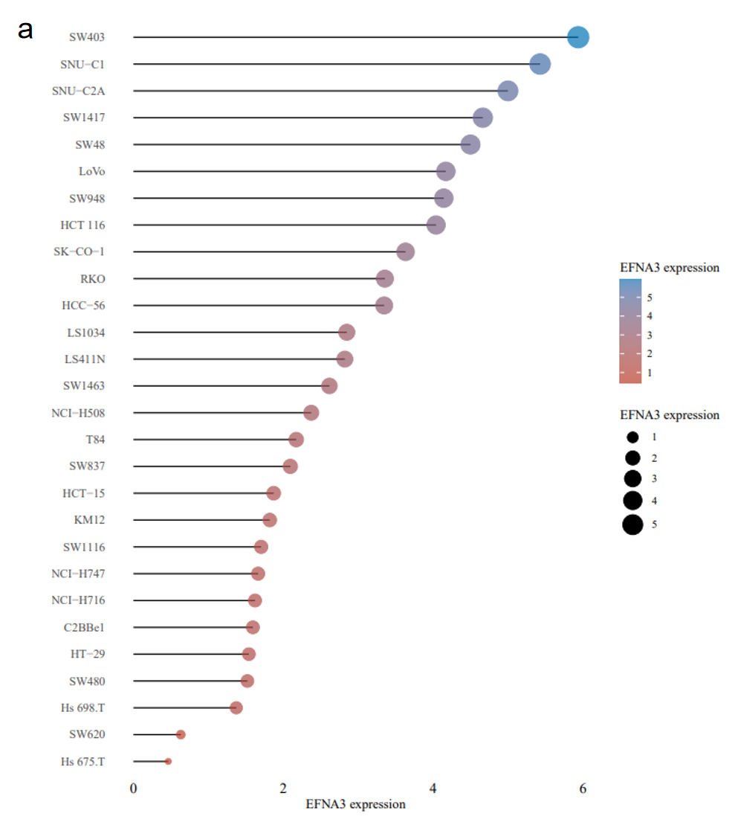
Figure S3. (a) EFNA3 expression in colorectal cancer cell lines from CCLE cohort
Table S1. Antibodies for western blot.
Antibody | Manufacture | Item number
P-mTOR | Cell Signaling Technology, USA | Cat #2971
mTOR | Cell Signaling Technology, USA | Cat #2983
P-AKT | Cell Signaling Technology, USA | Cat #9271
AKT | Cell Signaling Technology, USA | Cat #9272
Phospho-PI3 Kinase p85 | Cell Signaling Technology, USA | Cat #4228
PI3 Kinase p85 | Cell Signaling Technology, USA | Cat #4257
Flag | Sigma-Aldrich, USA | Cat# F1804
β-actin | Sigma-Aldrich, USA | Cat#A1978
goat anti-mouse IgG | ZSGB-BIO, China | Cat#ZB-2305
goat anti-rabbit IgG | ZSGB-BIO, China | Cat#ZB-2301

